Previous lesson:

La herencia árabe en [España](https://www.youtube.com/watch?v=Xx3VRElAokY)

* SAYING WHERE YOU ARE GOING: The **verb *IR***
* Visiting Cordoba
* Learning vocabulary of places and the Spanish culture (Andalucia).

Sesión 8 Hoteles con alma

**Introducción**

In this session you are going to talk about some city hotels in Havana, Valencia, Barcelona and Santiago de Cuba, and find out about their local amenities and suitability for tourism

**Key learning points**

* Talking about location
* Indicating approximate time and distance
* Revision of adjectives

# 8.1 Actividad

In this activity you are going to find out about two hotels, one in Havana and one in Valencia, what they look like and where they are situated.

## Actividad 8.1

### Part 1

Look at the pictures of the two hotels. Decide which words and phrases from the box best describe each picture and make a sentence with the description and the location of the hotels.

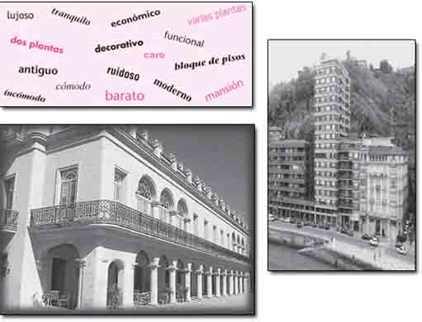

|  |  |
| --- | --- |
| Hotel Santa Isabel: típica mansión colonial cerca del mar (dejado) | Hotel Espartano: hotel muy céntrico cerca de restaurantes y cafeterías (derecho) |
|  |  |

**Part 2**

Now look where they are situated on the maps. Write which streets they are in and their location in relation to other buildings.

*Escriba dónde están los hoteles.*

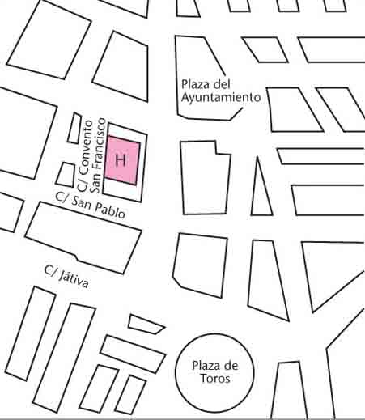

Hotel Santa Isabel 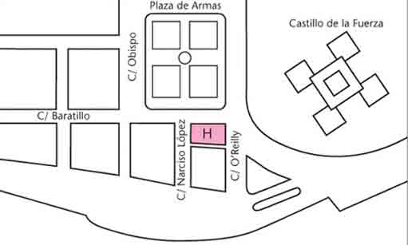

Hotel Espartano

**8.2 Actividad**

In this activity you are going to find out about three hotels situated in the old part of Barcelona and around the Ramblas, one of the main arteries of the city. You will also become familiar with ways of talking about approximate distance to or from a place.

**LAS RAMBLAS**

The *rambla*is an urban feature virtually unique to Catalonia, and there is one in most Catalan towns. Originally, the Rambla of Barcelona was a seasonal river bed, the name deriving from an Arabic word for river bank, *ramla*. Different sections of the Rambla in Barcelona have different names, as one descends from Plaza Catalunya: Rambla de Canaletes, Rambla dels Estudis, Rambla de San Josep, Rambla dels Caputxins and Rambla de Santa Mónica. Hence the plural is often used – *Rambles* (Catalan) or Ramblas in Spanish and English.

***Español de bolsillo***

|  |  |
| --- | --- |
| ¿Dónde está el hotel Oriente? | *Where is the Oriente hotel?* |
| A dos pasos del Teatro Liceo. | *A few yards from the Teatro Liceo.* (*Literally: Two steps from…*) |
| A cien metros de la Plaza Catalunya. | *A hundred metres from the Plaza Catalunya.* |
| A cinco minutos del puerto. | *Five minutes from the harbour.* |

**Actividad 8.2**

**Part 1**

Listen to the three advertisements for hotels in Barcelona. Then note the proximity to the city centre, and the exact address of each hotel. The following phrases may help you.

[Audio player](https://online.godalming.ac.uk/mod/folder/view.php?id=71253) 015: Barcelona hotels

[Show transcript](https://www.open.edu/openlearn/languages/spanish/beginners-spanish-getting-around/content-section-9.3)

[Download](https://www.open.edu/openlearn/ocw/pluginfile.php/86325/mod_oucontent/oucontent/711/5e74e29f/daad54c1/l194_1_015s.mp3?forcedownload=1)

Barcelona hotels**.** *Escuche y complete.*

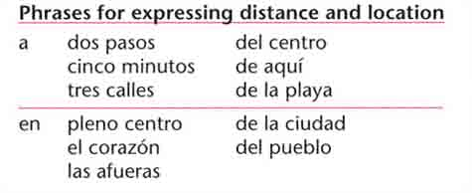

|  |  |  |
| --- | --- | --- |
|  | **Proximity to city centre** | **Exact address** |
| Hotel Duques de Bergara |  | Top of Form  Bottom of Form |
| Hotel Oriente |  |  |
| Hotel Rívoli |  |  |

Top of Form

 Bottom of Form

**Vocabulario**

|  |  |
| --- | --- |
| afueras (las) | *outskirts* |
| pueblo (el) | *village, town* |

Extra activity Click on [The National Hotel of Cuba](https://spark.adobe.com/page/mZbV79iXrZz9q/) read it and explain in Spanish where is that place and its meaning.

|  |
| --- |
|  |
|  |
|  |

**Part 2**

Now listen to the audio clip below and do the exercise.

*Escuche y participe.*

[Audio player](https://online.godalming.ac.uk/mod/folder/view.php?id=71253) 016: Where is the hotel?

[Show transcript](https://www.open.edu/openlearn/languages/spanish/beginners-spanish-getting-around/content-section-9.3)

[Download](https://www.open.edu/openlearn/ocw/pluginfile.php/86325/mod_oucontent/oucontent/711/5e74e29f/8d126900/l194_1_016s.mp3?forcedownload=1)

Where is the hotel?

|  |
| --- |
|  |
|  |
|  |

**Actividad 8.4**

Write a wish list for your perfect hotel. You may want to refer to location, proximity to local amenities and type of building. Use the prompts below to start you off. *Lea y escriba.*

Quiero un hotel…

|  |
| --- |
| cerca de… • en pleno centro • en las afueras • en el campo • a diez metros de… • a dos pasos de… • antiguo / moderno, etc. • enfrente de… |

Top of Form

Bottom of Form

|  |
| --- |
|  |
|  |
|  |
|  |