Component 1: Section A

Music Video

Context

Media Language

Representation

***Formation*** (2016)

[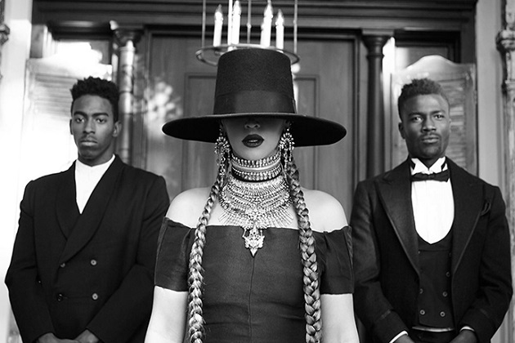](https://youtu.be/ociMBfkDG1w)

***Riptide*** (2013)

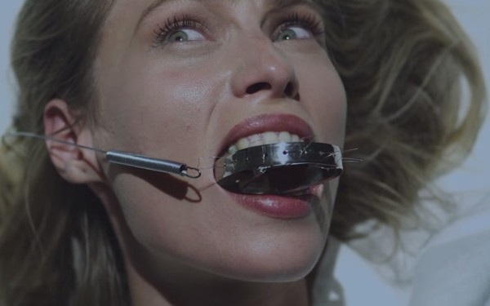

**Formation lyrics**

Y'all haters corny with that illuminati mess  
Paparazzi, catch my fly, and my cocky fresh

I'm so reckless when I rock my Givenchy dress (stylin')

I'm so possessive so I rock his Roc necklaces

My daddy Alabama, momma Louisiana

You mix that negro with that Creole make a Texas bamma

I like my baby hair, with baby hair and afros

I like my negro nose with Jackson Five nostrils

Earned all this money but they never take the country out me

I got a hot sauce in my bag, swag

I see it, I want it

I stunt, yellow bone it

I dream it, I work hard

I grind 'til I own it

I twirl on them haters

Albino alligators

El Camino with the seat low

Sippin' Cuervo with no chaser

Sometimes I go off, I go off/I go hard, I go hard

Get what's mine, take what's mine

I'm a star, I'm a star

'Cause I slay, slay/I slay, hey, I slay, okay/I slay, okay, all day, okay/I slay, okay, I slay okay

We gon' slay, slay

Gon' slay, okay

We slay, okay

I slay, okay

I slay, okay

Okay, okay, I slay, okay

Okay, okay, okay, okay

Okay, okay, ladies, now let's get in formation, 'cause I slay

Okay ladies, now let's get in formation, 'cause I slay

Prove to me you got some coordination, 'cause I slay

Slay trick, or you get eliminated

When he fuck me good I take his ass to Red Lobster, 'cause I slay

When he fuck me good I take his ass to Red Lobster, 'cause I slay

If he hit it right, I might take him on a flight on my chopper, 'cause I slay

Drop him off at the mall, let him buy some J's, let him shop up, 'cause I slay

I might get your song played on the radio station, 'cause I slay

I might get your song played on the radio station, 'cause I slay

You just might be a black Bill Gates in the making, 'cause I slay

I just might be a black Bill Gates in the making

I see it, I want it

I stunt, yellow bone it

I dream it, I work hard

I grind 'til I own it

I twirl on them haters

Albino alligators

El Camino with the seat low

Sippin' Cuervo with no chaser

Sometimes I go off, I go off

I go hard, I go hard

Take what's mine, take what's mine

I'm a star, I'm a star

'Cause I slay, slay

I slay, hey, I slay, okay

I slay, okay, I slay, okay

I slay, okay, I slay okay

I slay, okay

We gon' slay, slay

Gon' slay, okay

We slay, okay

I slay, okay

I slay, okay

Okay, okay, I slay, okay

Okay, okay, okay, okay

Okay, okay, ladies, now let's get in formation, I slay

Okay ladies, now let's get in formation, I slay

Prove to me you got some coordination, I slay

Slay trick, or you get eliminated, I slay

Okay ladies, now let's get in formation, I slay

Okay ladies, now let's get in formation

You know you that bitch when you cause all this conversation

Always stay gracious, best revenge is your paper

**"Formation" Lyrics: Meaning Behind Beyoncé's**

**New Black Power Anthem**

**By Chris Riotta**

<https://mic.com/articles/134573/formation-lyrics-meaning-behind-beyonc-s-new-black-power-anthem#.bk7yVjdix>

Beyoncé surprise-released a pro-black trap anthem, "Formation," on Saturday, the eve of her 2016 Super Bowl halftime performance with Coldplay, calling on black women to unite while marking her return to the music limelight. The song comes just after the musician's husband Jay Z's music streaming service announced it would be donating $1.5 million to Black Lives Matter and other racial equality-focused social justice groups and movements.

"Formation" is available for streaming and download exclusively on Tidal, with a music video also on YouTube. Throughout the song, Bey serves up lyrics that embrace her blackness and southern stereotypes while further aligning herself with the Black Lives Matter movement.

In the song's introduction, Beyoncé makes a nod to her haters, who continue to insinuate she and Jay Z are part of a larger Illuminati conspiracy theory, as well as her friend Riccardo Tisci, who has provided a custom Givenchy dress for her to attend the annual Met Gala each year since 2012:

It's once the beat picks up and the tempo begins to rise when the singer digs into her family roots, describing her mother's heritage as Louisiana Creole and her father as an African-American man from Alabama. There is a diverse and politicized racial landscape in Louisiana, where Creoles, or descendants of French settlers, are typically considered distinct from black, even if a person has African ancestry.

The musician and fashion icon also begins reclaiming stereotypes like "bamma," a term to describe someone lacking in style or flare, typically from the south:

"My daddy Alabama, Momma Louisiana / You mix that negro with that

Creole make a Texas bamma / I like my baby hair, with baby hair and afros / I like my negro nose with Jackson Five nostrils / Earned all this money but they never take the country out me / I got hot sauce in my bag, swag."

Then, in an ode to powerful black women around the world, Bey lines up with a group of dancers and begins the song's chorus:

"I see it I want it / I stunt, yeah, little hornet / I grind 'til I own it / I twirl on them haters / Albino Alligators / El Camino with the seat low sipping

Cuervo with no chaser / Sometimes I go off, I go hard / Get what's mine, take what's mine / I'm a star, I'm a star / Cause I slay, slay, I slay, hey, I slay, okay / I slay."

Though the song is largely a social justice anthem, Beyoncé does find time to fit in a few controversial lines, including one where she admits to bringing Jay Z to Red

Lobster after a good session under the sheets:

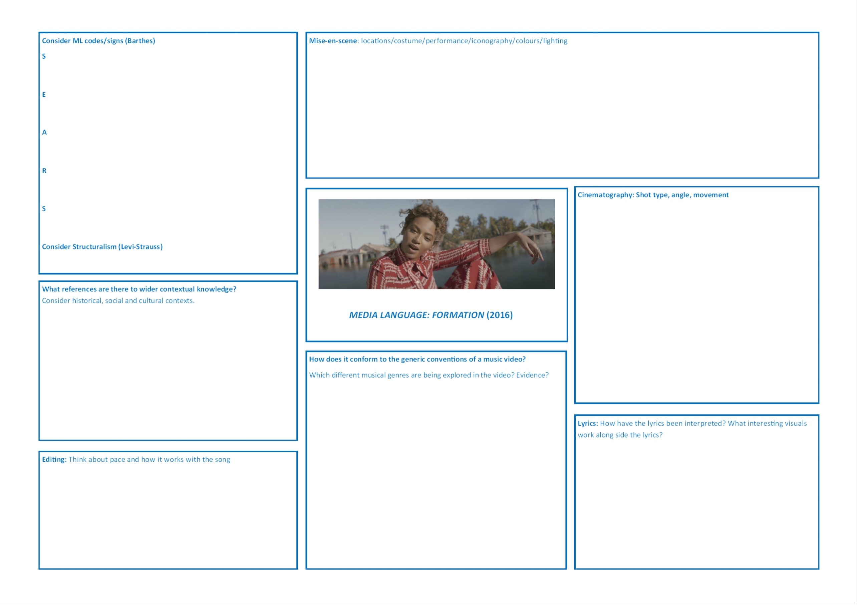

**FORMATION AND REPRESENTATION**

When analysing representation you need to think how media language constructs them. **Consider: Costume/Performance/Persona/Mode of address/body language/lighting and colour/lyrics in your response.**

|  |
| --- |
| **ISSUES** |
|  |
| What issues are being represented?  To what extent was the video designed to promote a political/cultural agenda or to simply generate publicity and make money? |

|  |
| --- |
| **GENDER** |
|  |
| Who is in control of this representation of gender?  How is gender being represented?  Is there some contradiction and complexity to Beyoncé’s representation of gender? |
| **ETHNICITY** |
|  |
| How are African-American’s being represented?  What is Beyoncé hoping to achieve with these representations? |

**Riptide Lyrics**

I was scared of dentists and the dark

I was scared of pretty girls and starting conversations

Oh, all my friends are turning green

You're the magician's assistant in their dream

 Oh, and they come unstuck

 Lady, running down to the riptide

Taken away to the dark side

I wanna be your left hand man

I love you when you're singing that song and

I got a lump in my throat 'cause

You're gonna sing the words wrong

 Is this movie that I think you'll like

This guy decides to quit his job and heads to New York City

This cowboy's running from himself

And she's been living on the highest shelf

Oh, and they come unstuck

Lady, running down to the riptide

Taken away to the dark sid

I wanna be your left hand man

I love you when you're singing that song and

I got a lump in my throat 'cause

You're gonna sing the words wrong

I just wanna, I just wanna know

If you're gonna, if you're gonna stay

I just gotta, I just gotta know

I can't have it, I can't have it any other way

I swear she's destined for the screen

Closest thing to Michelle Pfeiffer that you've ever seen, oh

Lady, running down to the riptide

Taken away to the dark side

I wanna be your left hand man

I love you when you're singing that song and

I got a lump in my throat 'cause

You're gonna sing the words wrong

Oh Lady, running down to the riptide

Taken away to the dark side

I wanna be your left hand man

I love you when you're singing that song and

I got a lump in my throat 'cause

You're gonna sing the words wrong

Oh lady, running down to the riptide

Taken away to the dark side

I wanna be your left hand man

I love you when you're singing that song and

I got a lump in my throat 'cause

You're gonna sing the words wrong

And I got a lump in my throat 'cause

You're gonna sing the words wrong

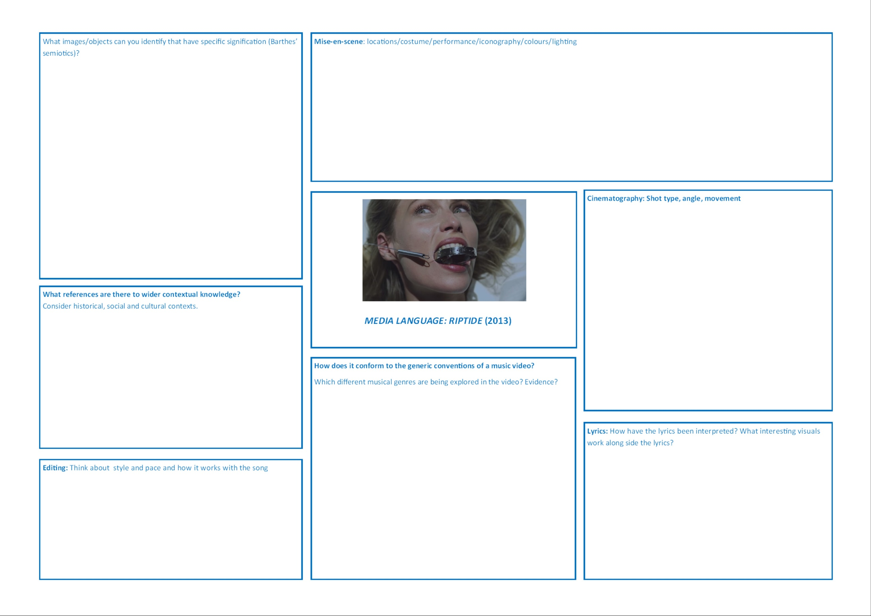

**MEDIA LANGUAGE THEORY**Now complete EARS

|  |  |
| --- | --- |
| **Barthes Codes (SEARS)** | **Analysis** |
| **Semantic** | “*Oh, all my friends are turning green*”.  Barthes’ idea that **constructed meanings can come to seem self-evident** canbe applied when considering the connotations of the colour green in relation to both money and envy. |
| **Enigma** |  |
| **Action** |  |
| **Referential** |  |
| **Symbolic** |  |

|  |  |
| --- | --- |
| **Levi-Strauss**  **Binary oppositions Structuralism** |  |

**NARRATIVE**

1. How is the narrative structured? Consider surrealist or avant-garde cinema (such as Buñuel). What impact do these references have on the meaning of the video?

**GENRE**

1. Does it reference *other genre styles* through the use of generic iconography? If so, which and whereabouts in the video?
2. In terms of genre, how does it challenge or subvert **music video conventions**? Remind yourself of the conventions we discussed in the first week of music videos.
3. What does this style of video *offer* audiences? Consider Steve Neale’s genre theory of *difference, variation and change*. Remind yourself of his theory. Look on GOL (*Media Language* section) for guidance.

***RIPTIDE* – REPRESENTATION**

[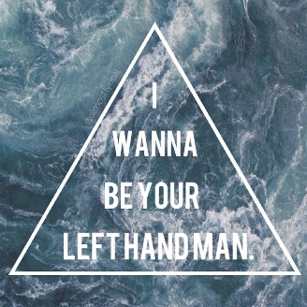](https://www.google.co.uk/url?sa=i&rct=j&q=&esrc=s&source=images&cd=&cad=rja&uact=8&ved=0ahUKEwiN1q2u1tvUAhWCvRQKHUQiAxcQjRwIBw&url=https://www.pinterest.com/explore/vance-joy/&psig=AFQjCNHvrK9WeDAGCRYB7TtAEIXCUEs6hw&ust=1498568606852833)[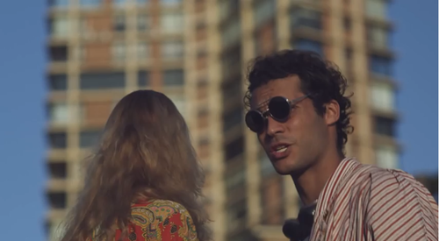](https://www.google.co.uk/url?sa=i&rct=j&q=&esrc=s&source=images&cd=&cad=rja&uact=8&ved=0ahUKEwiLhbfK3tHUAhXNSxoKHW1eAhIQjRwIBw&url=https://stcmdkpp1314.wordpress.com/2014/09/08/vance-joy-riptide-music-video-mise-en-scene-analysis/&psig=AFQjCNFzIwWIWGPEXDXn2Jt2p8A8IODY0A&ust=1498228368393816)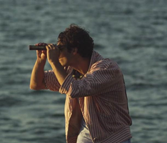

*Media representations convey values, attitudes and beliefs about the world.*

*This video offers many interesting examples of the representation of women; we need to consider whether or not it reinforces a* ***patriarchal*** *world view or is* ***subverting*** *the objectification of women in the media.*

1. Which key shots are used where the **women** in the video are repeatedly represented as **objects** to be watched?
2. Have the women been **sexualised** to provide audience pleasure (Mulvey’s theory of scopophilia) or represented in a way that **challenges** the sexualisation of women in many music videos?
3. Explore the **lip-synch sections** where a woman sings the lyrics of the song into a microphone. Discuss the extent to which this **challenges gender representations** in music videos and how it sits with the other representations of women in the video.
4. Along with the representations of women, the music video also presents a number of scenes that offer images of **violence**, such as a female hand being stabbed by a knife and a gun being pointed off screen. The lip-synching woman also clutches at her own neck and we see what seems to be blood over her hand. Why are these images used? Are they **trivialising or normalising** violence?

**Music Video Introduction Notes**