**Nestlé takes instant hit from India's Maggi noodle ban amid lead scare**

Manufacturer says goods worth billions of rupees have been taken off the shelves but claims product is safe and challenges action by food regulator

[[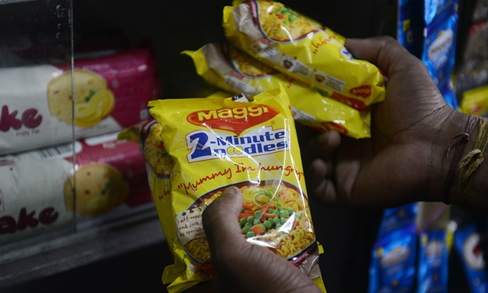](http://www.theguardian.com/business/2015/jun/16/nestle-takes-instant-hit-from-indias-maggi-noodle-ban-amid-lead-scare#img-1)](http://www.theguardian.com/business/2015/jun/16/nestle-takes-instant-hit-from-indias-maggi-noodle-ban-amid-lead-scare" \l "img-1)

Maggi instant noodles were taken off the shelves in India amid a scare over lead levels. Photograph: Diptendu Dutta/AFP/Getty Images Tuesday 16 June 2015

Nestlé has said India’s decision to ban its Maggi instant noodles over safety concerns has led to goods worth billions of rupees being withdrawn.

India’s food safety regulator banned the brand from sale over tests that it said showed the noodles contained excessive levels of lead.

The world’s biggest food company is challenging the 5 June order from the government’s food safety regulator.

The company had already been pulling the product from sale when the Food Safety and Standards Authority of [India](http://www.theguardian.com/world/india) (FSSAI) imposed the ban following similar moves by governments of some Indian states.

Nestlé, which says the noodles are safe to eat, has said it will keep the product off store shelves despite its court action challenging the ban.

The scare is a huge blow to the company, which has been selling its Maggi products for over three decades in India and has 80% of the country’s instant noodle market.

Maggi noodles grew increasingly popular as more and more Indians moved away from their homes to study or seek work. It emerged as one of India’s five most trusted brands in a consumer survey conducted in 2014.

Nestlé said its Indian unit had estimated the value of Maggi noodle stocks withdrawn from the shelves at 2.1bn rupees. Another 1.1bn rupees worth of Maggi stocks were in factories and with distributors, the company said. The total amounted to 3.2bn rupees’ worth (£32.3m/US$50.5 million).

<http://www.theguardian.com/business/2015/jun/16/nestle-takes-instant-hit-from-indias-maggi-noodle-ban-amid-lead-scare>

[/](http://pestleanalysis.com/swot-analysis-nestle/)