**Nestle Brands and Promises**

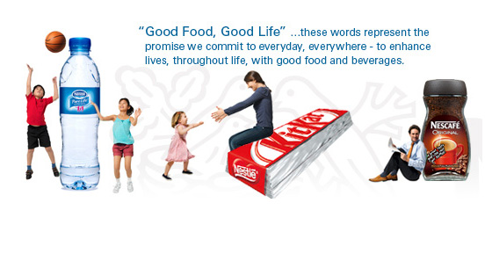

[](http://www.nestle.co.uk/csv2012/csv)

At Nestlé, quality goes well beyond the product itself. Throughout the world and across our brands, we’re involved in a broad range of social and environmental initiatives that together make quite a difference.

[**Tastier And Healthier**](http://www.nestle.co.uk/nutritionhealthwellness)

[](http://www.nestle.co.uk/nutritionhealthwellness)

We believe that all foods and beverages can be enjoyable and play an important role in a balanced and healthy diet and lifestyle. Nestlé is committed to contribute to this.