**Last updated: October 2015**

**Nestle boycott profile**

The boycott of [**Nestlé**](http://www.ethicalconsumer.org/companies.aspx?CompanyId=19119) is the world’s longest running. It began in 1977 in response to the aggressive marketing of Nestlé baby milk formula in poorer countries.

Nestlé is now one of the most boycotted brands in the UK.

**Breaking the rules**

Monitoring conducted by the [**International Baby Food Action Network**](http://www.ibfan.org/) (IBFAN) finds the company to be responsible for more violations of the World Health Assembly marketing requirements for baby foods than any other company.

It quotes [**UNICEF**](http://www.unicef.org.uk/), "Marketing practices that undermine breastfeeding are potentially hazardous wherever they are pursued: in the developing world, WHO estimates that some 1.5 million children die each year because they are not adequately breastfed. These facts are not in dispute."

IBFAN say the boycott will continue until Nestlé accepts and complies with its four-point plan for saving infant lives and ultimately ending the boycott.

**Mike Brady from Baby Milk Action on the Boycott**

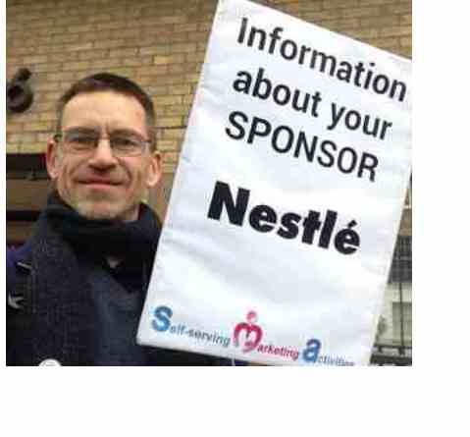There is no food more locally produced or sustainable than breastmilk. A breastfed child is less likely to suffer from gastroenteritis, respiratory and ear infections, diabetes, allergies and other illnesses. In areas with unsafe water a bottle-fed child is up to 25 times more likely to die as a result of diarrhoea.

Breastfeeding saves lives – and could save more. Estimates in 2013 suggested that 11.6% of under-five deaths could be prevented by breastfeeding. [**The World Health Organisation**](http://www.who.int/nutrition/publications/infantfeeding/statusreport2011/en/) (WHO) says: “Globally, breastfeeding has the potential to prevent about 800,000 under-five deaths per year if all children 0-23 months were optimally breastfed.” Aggressive company sales of breastmilk substitutes led to a series of campaigns and boycotts in the 1970s.

**Nestlé Boycott History**

The original Nestlé boycott in the 1970s led directly to the introduction of the International Code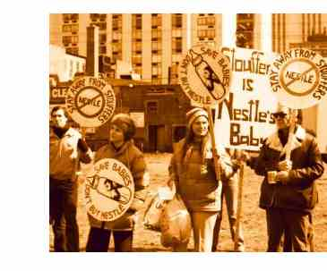 of Marketing of Breastmilk Substitutes by the World Health Assembly in 1981. That should have led to an end to the problem, particularly after Nestlé promised to abide by the Code in 1984, and the boycott was suspended. However, Nestlé broke its promises and the boycott was re-launched in 1989.  
  
The boycott also helps to alert policy makers to the need for legislation – and to be wary when Nestlé tries to persuade them it can be trusted to behave ethically without regulation. Today over 70 countries have legislation implementing the marketing rules that companies should follow. In some countries this is having a dramatic impact in protecting breastfeeding.

Nestlé has stopped some of its more outrageous marketing strategies after these have been exposed by the boycott campaign. For example, it eventually promised, on 14 October 2014, to stop claiming its formula is the ‘natural start’ after we exposed this in our campaigning, including a twitter campaign during its prestigious ‘Creating Shared Value Global Forum’ the week before.

As well as Nescafé, high profile Nestlé brands include: Perrier and Buxton bottled waters, Rowntree’s confectionery, Buitoni pastas, L’Oréal cosmetics (see [**perfume guide**](http://www.ethicalconsumer.org/buyersguides/healthbeauty/perfumesandaftershave.aspx)), and

Go-Cat and Winalot (see [**cat food guide**](http://www.ethicalconsumer.org/buyersguides/food/catfood.aspx)).

**Ongoing Violations**

Nestlé continues to push baby milk in ways that undermine breastfeeding, contributing to the unnecessary death and suffering of babies. Problem marketing strategies are now being seen in the UK since Nestlé took over the SMA formula brand. It has recruited a network of ‘Clinical Representatives’ whose “role is to work on the designated territory, visiting hospitals, doctors, health visitors and community midwives to develop key clinical relationships within local health Economies, leading to opportunities for the SMA brand and Nestlé Nutrition.”

Many health facilities prohibit company representatives from targeting staff, so Nestlé is holding its own ‘study days’ in nearby hotels and trying to entice staff along to those to promote SMA formulas. In August this year, Nestlé also began promoting the brand on street stalls at community festivals – providing an opportunity for demonstrations by Baby Milk Action supporters.

**Nestlé’s response to criticism**

Nestlé dismisses all criticisms, highlighting its inclusion in the FTSE4Good ethical investment index. The FTSE4Good criteria for marketing of breastmilk substitutes have been criticised by not only Baby Milk Action and IBFAN, but also Save the Children and UNICEF Lao. The Index, run by stock exchange listing company FTSE, assesses companies against their own policies, rather than the minimum UN marketing standards adopted by the World Health Assembly.

By Nestlé’s own admission when questioned by Baby Milk Action at its shareholder meeting, 90% of violations of these standards are allowed by Nestlé’s own policies. The Methodist Church conference received a report from its ethics committee this year documenting that Nestlé actually weakened its marketing policy to allow the advertising of formula brands prior to being included in FTSE4Good, knowing this would be the benchmark. In other words, FTSE4Good has made things worse, not better.

<http://www.ethicalconsumer.org/boycotts/boycottslist/nestleboycottprofile.aspx>

<http://thepeopleszero.com/the-nestle-boycott/overview-part-one/>