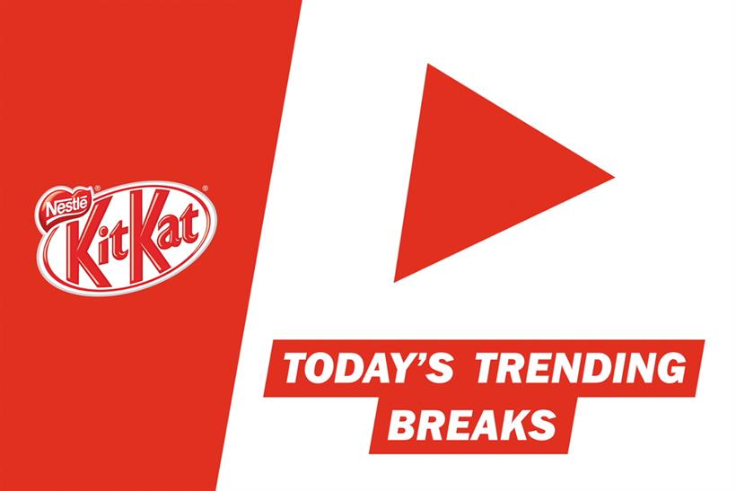

Kit Kat bars featuring wrappers that read "YouTube my break" are now on sale as a result of a partnership between Nestlé and Google, the parent companies of the two brands. In addition to the packaging, anyone who says the strapline to Google’s voice-search function will be greeted with an ad for the chocolate bar and a playlist of the top four trending YouTube videos in their area. The UK campaign, which was created by J Walter Thompson Dubai, forms part of Kit Kat’s "celebrate the breakers" positioning. Google named its Android operating system 4.4 update after the brand in 2013. The work was created by Ramsey Naja.

<http://www.brandrepublic.com/article/nestle-youtube-break-j-walter-thompson/1347035>