**Kit Kat sponsors Sky World Cup in UK's biggest mobile campaign**

by Sara Kimberley, 07.06.2010

Nestle's Kit Kat brand is to sponsor all the Sky World Cup coverage as part of the UK's largest dedicated mobile campaign to date.

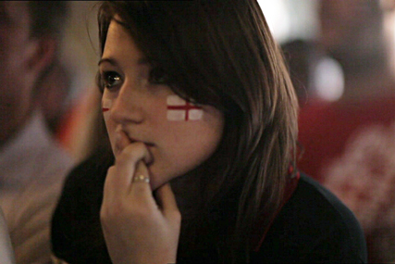Kit Kat: to sponsor Sky's World Cup coverage

The six-figure deal, brokered by Mindshare, will see Kit Kat sponsor Sky's World Cup coverage across iPhone, iPod Touch, Smartphones and all other WAP-enabled mobile devices.   
  
It will also include sponsorship of the Sky Sports Football Centre app and the Sky News app, as Kit Kat looks to capitalise on mobile media for the first time.

Since launching less than a year ago, Sky News and Sky Sports apps have attracted millions of active users across the iPhone and iPod Touch.

As part of Kit Kat's major through-the-line 'Cross your fingers' campaign, the sponsorship will encourage audiences to visit itunes to download a Kit Kat Red Card app, which will be downloadable for free. Banner ads will update users with World Cup statistics.

A Nestlé spokesperson said: "During the World Cup, websites tend to become very noisy with a wide range of advertisers vying for consumer attention. This led us to divert our attention to mobile as an interesting new platform to engage audiences. And as the pre-eminent provider of sports and news content on mobile devices, Sky was a natural destination for us." Nestle will also launch a new app in September, which is expected to be available on the iPad.

<http://www.mediaweek.co.uk/article/1008312/kit-kat-sponsors-sky-world-cup-uks-biggest-mobile-campaign>