**Kit Kat talks up ‘moment marketing’ drive as it celebrates growing sales**

Kit Kat says its recent reactionary campaigns have gone down well with the British public and driven sales “across all formats”, with further plans to increase its marketing spend for 2016.

By [Leonie Roderick](https://www.marketingweek.com/focus/leonie-roderick/) 2 Dec 2015 9:48 am

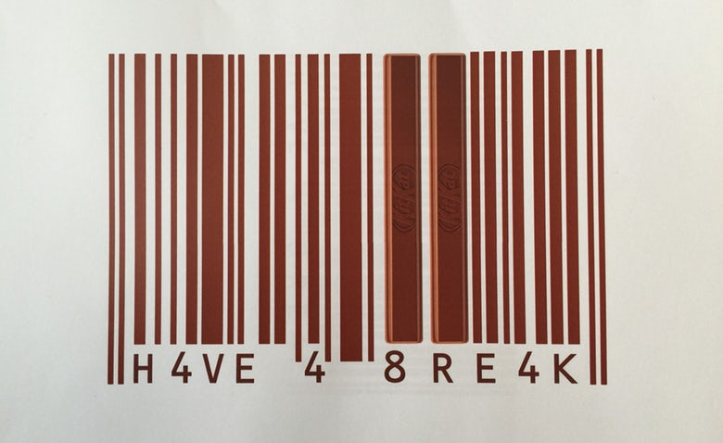

It has been almost 12 months since the confectionery brand rolled out its “Celebrate the breaks” campaign and [doubled its marketing spend to £10 million](https://www.marketingweek.com/2015/01/12/kit-kat-doubles-media-spend-to-reclaim-lost-sales/) in a bid to fight falling sales across the category.

According to Kit Kat, its reactionary activity, which saw the brand push out topical and humourous adverts relating to events such as the new James Bond film and Black Friday, have been particularly successful.

“We’ve been really pleased with the result and we have had sales increases across all of our formats,” Lisa May, Nestlé’s marketing director for confectionery in the UK and Ireland told Marketing Week.

“We’ve always been fairly topical as a brand. What we’re doing now and going forward is really ensuring that we maintain top of mind and stay relevant to the way people live their lives.”

The campaigns, which were created by J. Walter Thompson, have mainly been geared towards generating conversation online and for people to relate back to what the brand stands for. This is a strategy that the brand will continue to use in 2016.

“As we move forward, we need to become more relevant. In order to do that, we created many pieces of cut-through communications – something we like to call ‘moment marketing’ – that are personalised and hit people on a daily basis. The more relevant and personalised we can be, the better cut-through we get,” she explained.

To reflect the different ways consumers spend their breaks, Kit Kat [embarked on its biggest packaging redesign earlier this year](https://www.marketingweek.com/2015/05/12/kitkat-embarks-on-biggest-packaging-redesign-to-let-consumers-youtube-their-break/) and saw the brand change the logo on more than 100 million packets – including one with “YouTube my break” branding.

While May was not able to provide specifics on the brand’s marketing budget for 2016, she is hopeful it will increase once more.

“Marketing will continue to be a priority. If anything, we’d want to be increasing investment in the brand,” she commented.

According to IRI data, total Kit Kat sales were £194.0m in the 52 weeks ending 7 November 2015, compared to £186.7m in the previous year, marking an increase of 3.9%.

However, figures by Euromonitor show Kit Kat’s overall share of the chocolate snacking category has declined by 0.6 percentage points over the past year to 18.2%.

Current figures also show that Kit Kat’s sales have decreased from £243.30 million in 2014 to £229.40 million this year. This reflects a fall in the overall category, which has decreased by 10.30% between 2010 and 2015. It is predicted to decline further over the next five years by 9.6%.

<https://www.marketingweek.com/2015/12/02/kit-kat-talks-up-moment-marketing-drive-as-it-celebrates-growing-sales/>