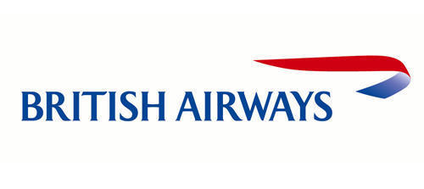

[British Airways](http://www.britishairways.com/) is the flag carrier airline of the United Kingdom headquartered in Waterside, Harmondsworth, England. It has a fleet size of 256 and flies to 169 destinations worldwide with annual revenue of €11.482 billion as of 2011.

British Airways is the second largest airline in the UK after EasyJet. It was also the official partner of the London 2012 Olympic Games

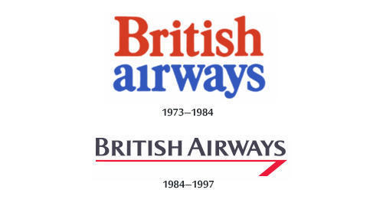

**Shape and Colors of the British Airways Logo**

The earliest known version of the British Airways logo was introduced in 1973, one year before the merger of BOAC and British European Airways. It was designed by the noted brand consultancy firm [Negus & Negus](http://www.independent.co.uk/news/obituaries/dick-negus-designer-celebrated-for-his-work-with-british-airways-and-other-national-institutions-2306210.html). A simple wordmark consisting of red and blue, indicating the colours of the British flag or Union Jack. The company unveiled a new version of the logo on December 4, 1984. Designed by the famous global branding agency [Landor Associates](http://www.landor.com/), it consisted of three colors, namely: “pearl grey, midnight blue and brilliant red”. There was also a noticeable change in the typeface. The current version of the British Airways logo was presented on June 10, 1997 as the old logo, apart from being “overly British”, started aging and appeared mired by consumer brand perceptions. It was created by British design agency [Newell & Sorrell](http://www.designweek.co.uk/news/interbrand-newell-and-sorrell/1115896.article). The logo consisted of a ribbon symbol which was termed as the “speedmarque” – reminiscent of the old BOAC speedbird symbol. The hues of white and blue were made brighter and the typeface was made a little “softer” as compared to that of the previous version.

**Font of the British Airways Logo**

The British Airways logo features a custom typeface designed specifically for the company.

<http://famouslogos.net/british-airways-logo/>