**British Airways fined £58.5m for fuel price-fixing**

**British Airways is to pay a reduced £58.5m fine for colluding with rival Virgin Atlantic on fuel surcharges, finally putting to bed an investigation that has lasted more than five years.**

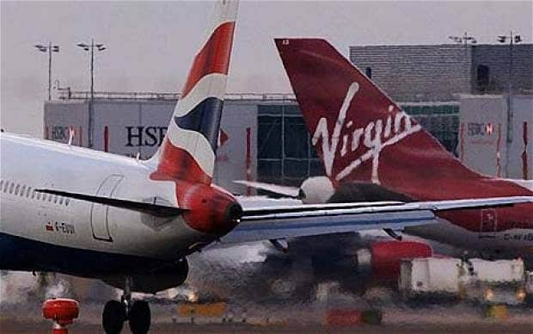

BA admitted in 2007 that it had colluded with Virgin over price fixing on long-haul flights between August 2004 and January 2006.

19 Apr 2012

BA admitted in 2007 that it had colluded with Virgin over price fixing on long-haul flights between August 2004 and January 2006.

At the time, BA agreed to pay a record fine of £121.5m imposed by the Office of Fair Trading (OFT), but later reassessed its position after the OFT's criminal case against a number of former BA executives collapsed.

The OFT said the fine had sent a "strong message" on price fixing to the industry, and added that the reduced fine reflected the level of BA's co-operation in the investigation.

Ali Nikpay, OFT senior director of cartels and criminal enforcement, said: "The size of the fine underlines that it is important for companies to take steps to ensure that they have an effective compliance culture. The fine would have been higher still but for the co-operation provided by BA throughout the OFT's investigation. Without this, together with BA's admission of the infringement, the case would have taken considerably longer to resolve."

A spokesman for BA said, "We are pleased that this matter, which concerned events between 2004 and 2006, has been settled."

Under the OFT’s leniency policy, Virgin, which blew the whistle on its agreement with BA, was not fined.

A spokesman for Virgin said, "VAA regrets its involvement in this matter but is pleased that a final determination has been reached. VAA reported this matter to the OFT in 2006 and has retained fully immunity since then.”

Last year, British Airways and Virgin Atlantic were hit with a fine of more than $200m (£127m) by Nigerian authorities for "colluding" on passenger fuel surcharges.

Both airlines [rejected the fine](http://www.telegraph.co.uk/finance/newsbysector/transport/8897127/BA-and-Virgin-reject-200m-Nigerian-fuel-surcharge-fine.html), which was later overturned by a judicial panel.

<http://www.telegraph.co.uk/finance/newsbysector/transport/9213267/British-Airways-fined-58.5m-for-fuel-price-fixing.html>