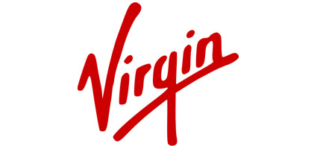



[Virgin](http://www.virgin.com/) is the brainchild of the famous British entrepreneur [Richard Branson](http://www.virgin.com/richard-branson/) who came up with the idea in 1970. The humble beginnings of Virgin, started as a record shop, went on to develop as a vast business empire ranging from business ranges from mobile telephone to transportation, financial services to media, and travel to music and fitness. Virgin has given birth to more than 200 companies globally and provides employment to around 50,000 people in 29 different countries. Unlike other competitors, Virgin’s corporate manifesto includes treating customers with respect, providing valuable services for less money and including fun in the customer experience. According to Investment Hunt in 2009, the estimated value of Virgin Group was more than $2.5 billion.

The largest of the 200 group of companies is the Virgin Atlantic Airways, Virgin Holidays and the Virgin Retail Group. The brand name “Virgin” propped up when Branson and one of his partners started their first-ever business, a record shop, and thought of themselves as virgins in the business.

The famous “Gemini” or “Twins” logo was created by Roger Dean, a well-known English artist and illustrator which depicted a young nude woman with a serpent body standing in front of a mirror and the word “Virgin” inscribed in Dean’s familiar script. Today’s Virgin logo has remained the same since 1979. Back then it was drawn on a paper napkin.

[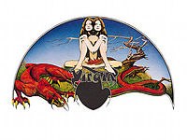](https://en.wikipedia.org/wiki/File:Virginrecordlogo.jpg)

Virgin logo designed by [Roger Dean](https://en.wikipedia.org/wiki/Roger_Dean_(artist)) for the fledgling Virgin Records label

**DESIGN ELEMENTS OF VIRGIN LOGO**

The Virgin logo is used on all its products and services, maintaining the core business principles across the board. The powerful yet simple logo has been attributed to the company’s success phenomenal success

**Shape of the Virgin Logo:**

Sir Richard Branson’s personality is the essence of the the Virgin logo. The steady right slant is projection of his self-confident, assertive and ambitious personality.

**Color of the Virgin Logo:**

Red is the only color that is used in the Virgin logo. Richard Branson’s personality is the reason behind the philosophy as red color epitomizes his courage, confidence and zeal for success.

**Font of the Virgin Logo:**

In contrast with other corporate logos, the Virgin Logo is handwritten which symbolises the merits of hard work and labour.

<http://www.famouslogos.us/virgin-logo/>

<http://www.fastcodesign.com/3038726/fast-forward/the-evolution-of-the-virgin-logo>