Frequency Formula | 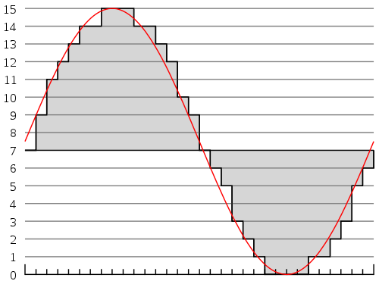 | Delay Formula
 | Numeracy
Digital Formula | 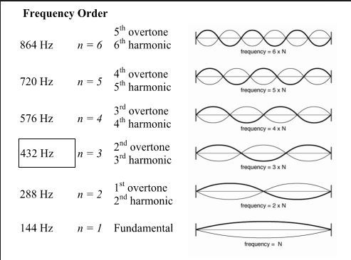 | Harmonics and Overtones

