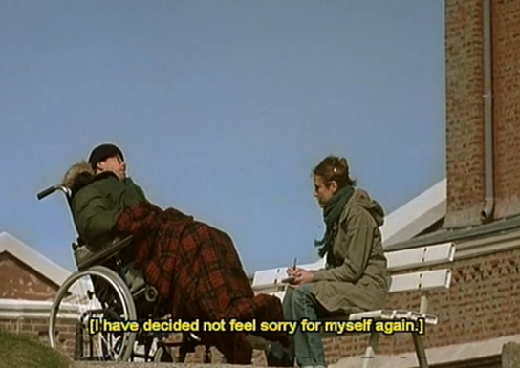**Key Scene Analysis – The Fantasy Sequence**

**Watch *the above sequence*** on estream. They have been chaptered. Take notes on the following areas.

|  |
| --- |
| **Representation:** Of Jean-Do, his lifestyle choices, his state of mind, the people around him, his life now.  **Aesthetics:** What is the overall mood of the scene? How is this created? Is there a particular colour palette? |

Comment on Film Form and Aesthetics for the scene. Use the following questions as guidance:

|  |  |
| --- | --- |
| **Cinematography:** The use of long and extreme long shots as we see Jean-Do and his nurse. The use of extreme close up of the butterfly and later wide epic action shots. | **Mise-en-Scène;** Jean-Do’s stillness in the wheelchair compared with later montage shots, the locations of the montage and the lifestyle they express, use of different images and meaning within. |
| **Sound:** Use of dialogue and tone of voice to add to the mood and narrative, use of music and rhythm and how it works alongside the images. | **Editing:** Discussion of his eye, imagination and memory being the only things not paralysed - edited along with a superimposed montage. Choice of images, pace of editing and accompanying sound choice. How does the final cut differ from the smooth montage . . . |