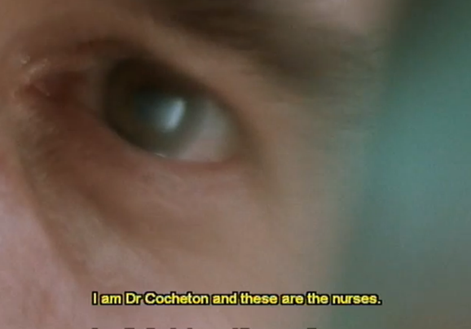**Key Scene Analysis – The Opening Sequence**

**Watch *the above sequence*** on estream. They have been chaptered. Take notes on the following areas.

|  |
| --- |
| **Representation:** Of Jean-Do, his lifestyle choices, his state of mind, the people around him, his life now. What can we say about his relationship with his family?  **Aesthetics:** What is the overall mood of the scene? How is this created? Is there a particular colour palette? |

Comment on Film Form and Aesthetics for the scene. Use the following questions as guidance:

|  |  |
| --- | --- |
| **Cinematography:** The POV shots coming in and out of focus. Extreme close ups. Cut away shots to roses and window. Change in depth of field and comments on composition. Emotional impact on the audience. | **Mise-en-Scène;** Setting of the hospital and the generic conventions of costume and props setting the location. Use of blue green and cuts to black. Props – flowers, photos and art on the walls. Performance and heightened breathing. |
| **Sound:** Use of dialogue and tone of voice to add to the mood and explain Jean-Do’s emotional state, images of son crying (flashback) without diegetic sound, heightened sound of breathing, at times muffled dialogue. | **Editing:** Mostly on camera effect, but these can still be discussed. Cuts to flash back memories and to Ines. Use of black and extreme bright sunlight. Disorientating cuts from person to person. |