**3.1.1.2 The Water Cycle**

**Concept Checker:**

* **Global distribution and size of major stores of water – lithosphere, hydrosphere, cryosphere and atmosphere.**
* **Processes driving change in the magnitude of these stores over time and space, including flows and transfers: evaporation, condensation, cloud formation, causes of precipitation and cryospheric processes at hill slope, drainage basin and global scales with reference to varying timescales involved.**

**Key terms:**

**Positive feedback**

**Negative feedback**

**Atmosphere**

**Lithosphere**

**Hydrosphere**

**Biosphere**

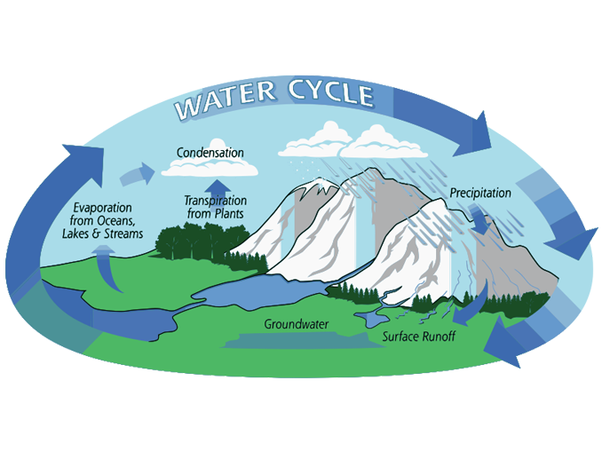

**Recap: systems in Geography**

A system comprises any set of inter-related components that are connected together to form a working unit.

Stores/ components

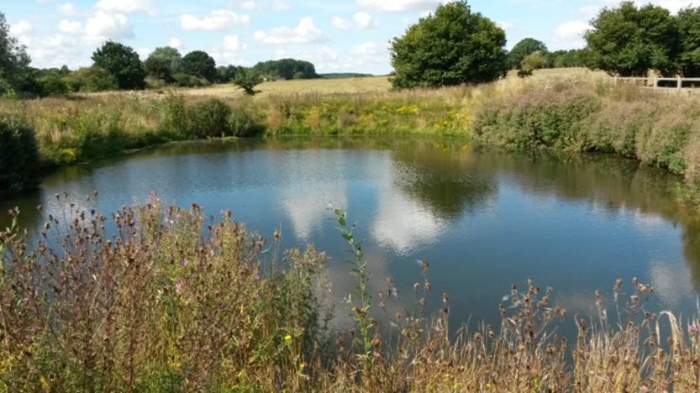Take this pond ecosystem:

Outputs:

Inputs:

Flows/ transfers:

Put the statements in the correct boxes.

**What are the elements of a system?**

Power or driving force

This represents a state of balance within a constantly changing system

Material or energy moving into the system from outside

A cyclical sequence of events that damps down or neutralises the effects of a system, promoting stability and a state of dynamic equilibrium

Material or energy moving from the system to the outside

The individual elements or parts of a system

The links or relationships between components

A cyclical sequence of events that amplifies or increases change. Positive feedback loops exacerbate the outputs of a system, driving it in one direction and promoting environmental instability

Input

Output

Energy

Stores/ Components

Flows/ transfer

Positive feedback

Negative feedback

Dynamic equilibrium

**What is the difference between an open system, a closed system and an isolated system?**

TASK:

1. Define and explain the three types of system. Give examples of each:
   * Open system
   * Closed system
   * Isolated system
2. Which do you think will be the most common type of system on Planet Earth? *Explain and justify your opinions.*

**Why do Geographers use a systems approach?**

* It’s a way of simplifying a complex world and it enables us to see the whole picture.
* We can apply it to physical systems like a drainage basin and to human systems such as farm operations.
* It helps us to understand how energy is transferred between the components and how the components can change.

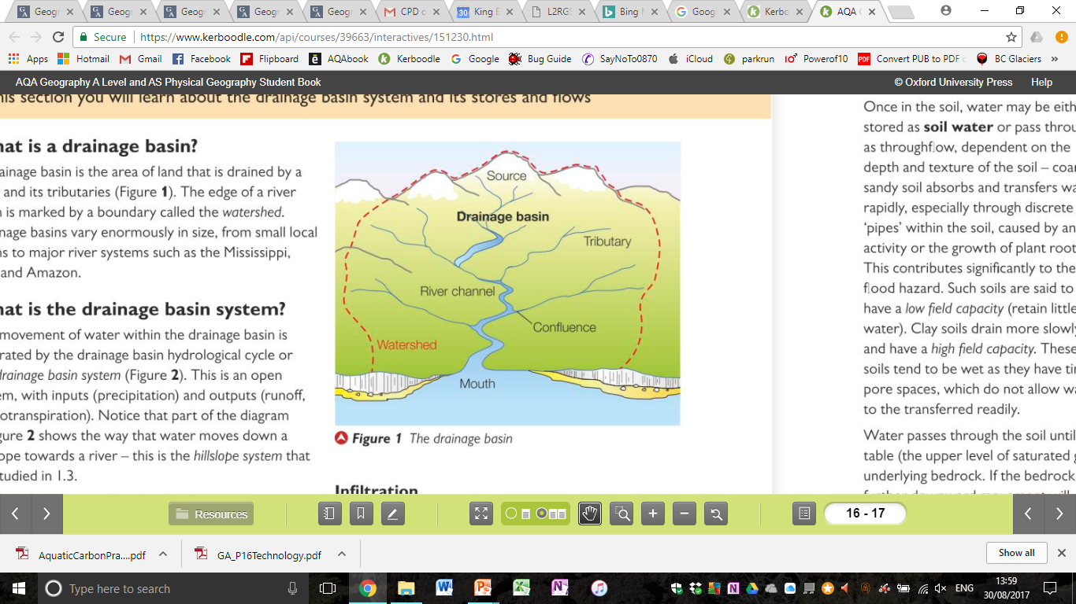**How can a drainage basin be represented as a system?**

TASK: draw the drainage basin as a system:



How many of these key words can you add to your drainage basin system diagram?

Key terminology

* Precipitation
* Interception
* Overland flow
* Surface storage
* Infiltration
* Percolation
* Groundwater
* Groundwater flow
* Throughflow
* Stream flow
* River channel
* Soil water

Can you include a key to indicate what is an input, output, flow, and store?

*How might this system change over the course of a year?*

**What is Dynamic Equilibrium?**

Systems work on a balance of inputs and outputs – When opposing forces, or inputs and outputs, are even, this produces a dynamic equilibrium.

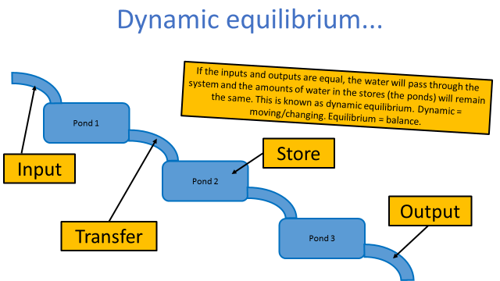

TASK

1. In your own words, explain the concepts of:
   1. A system
   2. Dynamic equilibrium

**What is feedback?**

If inputs or outputs suddenly change, then stores are forced to change and the equilibrium is upset – this is known as feedback.

There are two types of feedback – positive feedback and negative feedback.

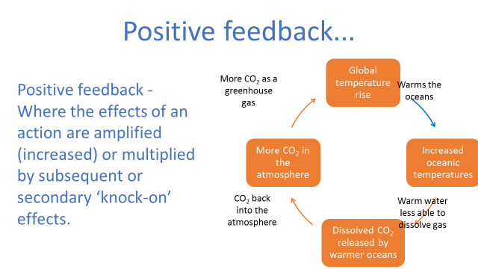

Work with a partner to sort the cards into the correct sequence for positive feedback.

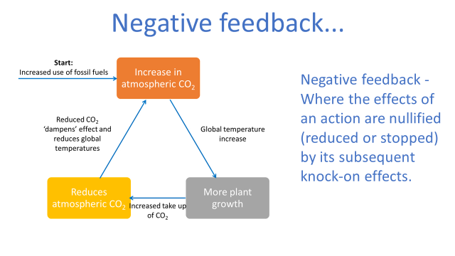

Now work in pairs again to sort the cards into the correct sequence for negative feedback.

TASK

1. In your own words explain the difference between negative feedback and positive feedback.

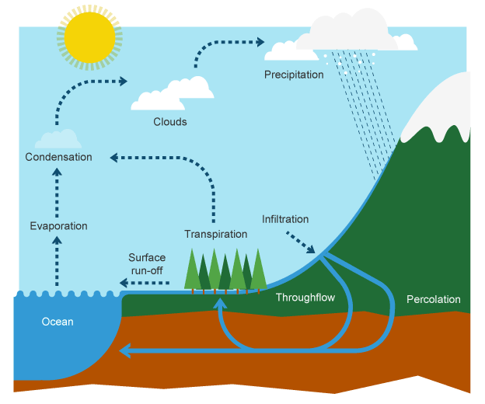

**The Water Cycle**

Like many systems, the water cycle is one large system made up of countless numbers of smaller ones.

Water is constantly being recycled, stored and transferred between the land, oceans and atmosphere.

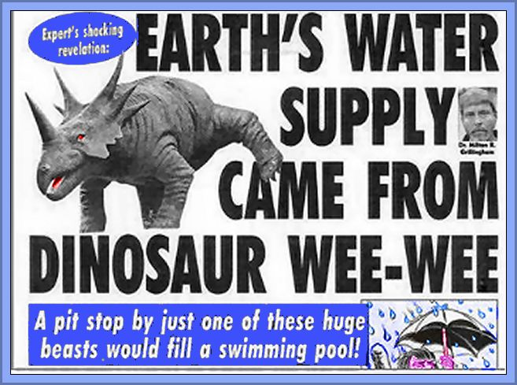

<https://www.youtube.com/watch?v=o_bbQ0m3wuM>

<https://www.youtube.com/watch?v=KK64DqpIy0s>

Watch the clip about the dinosaur pee headlines. Why have some scientists made this claim? How does it link to the water cycle?

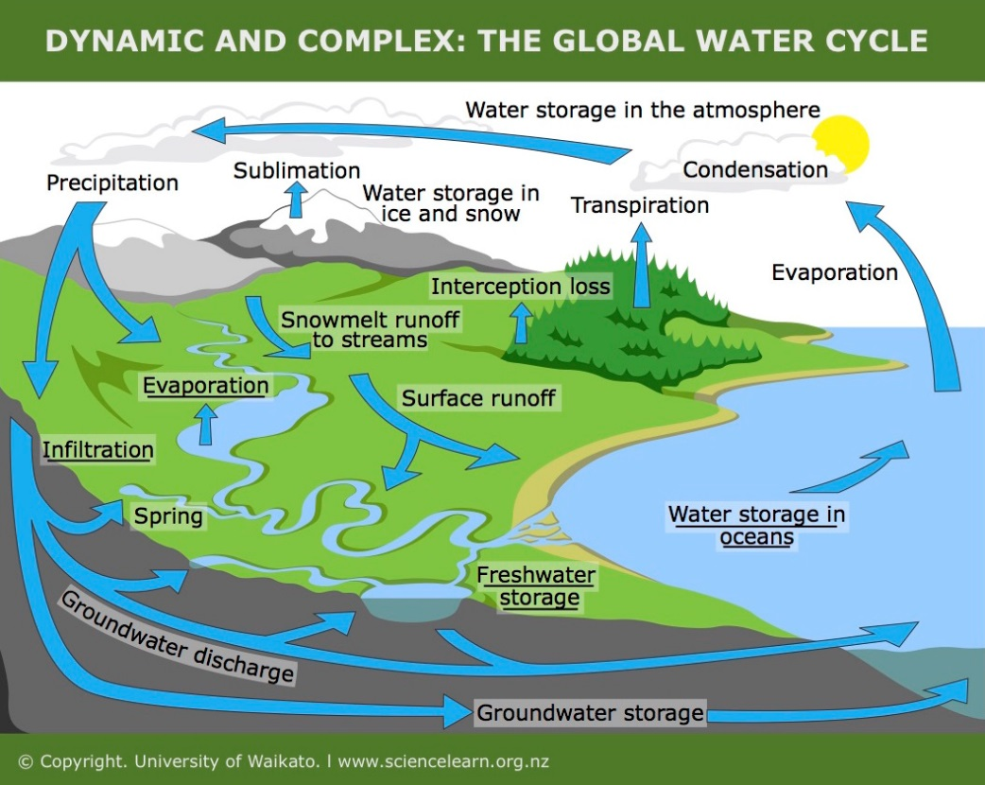Describe and comment on the flows and processes taking place in the global water cycle:

Name three **stores** in the water cycle.

Name three **flows** in the water cycle. Explain the process in your own words.

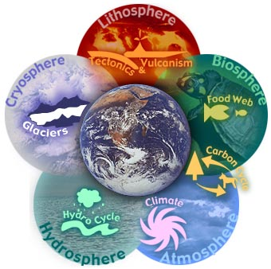The Earth as a whole can be considered a **closed system**. Energy comes in as **solar radiation**, balanced out by **radiant energy** lost by the Earth

There are 4 major **subsystems** on Earth in which water is stored:

* **Atmosphere** (air)
* **Lithosphere** (land - rocks)
* **Hydrosphere** (liquid water)
* **Cryosphere** (snow and ice)

A fifth subsystem, the **Biosphere**, is the part of the planet where life exists.

TASKS

1. Define the terms:

* Hydrosphere
* Cryosphere
* Atmosphere
* Lithosphere

1. Describe the links between the hydrosphere and one other sphere.

*Group task on the four spheres – complete the A3 research notes sheet.*

**TASK: Exam-style question**

“Systems are a useful approach in studying physical processes.” To what extent do you agree with this statement? (6 marks)

**Global water stores**

Most of Earth’s water is stored as saline (salt) water in the oceans.

Of the freshwater stores, ice sheets (Antarctica and Greenland) and groundwater are the main stores.

Rivers, lakes and the atmosphere contain remarkably small amounts of water.

*Did you know?*

The percentage of saline water on the Earth  
The percentage of freshwater on the Earth  
The percentage of freshwater which is stored as snow and ice  
The percentage of freshwater which is stored in the ground  
The percentage of freshwater which is surface freshwater

What are the headline facts from this diagram?

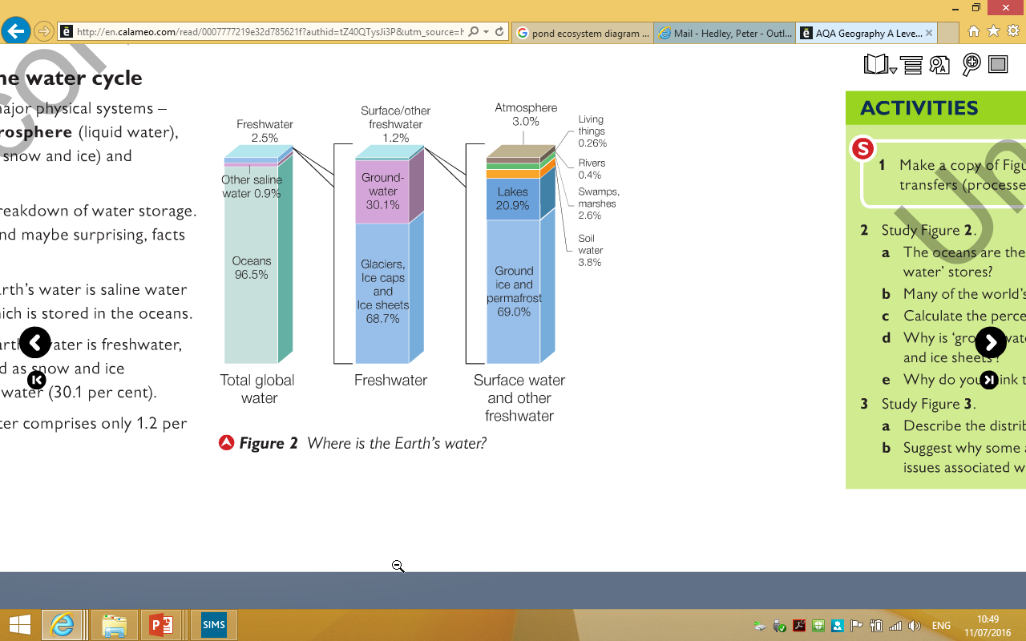

**TASKS**

1) What does saline mean?

2) What is groundwater?

3) How much of the freshwater available on earth is held in groundwater?

4) Why is this important?

Use the diagram to explain why readily available freshwater is a relatively rare resource on Earth.

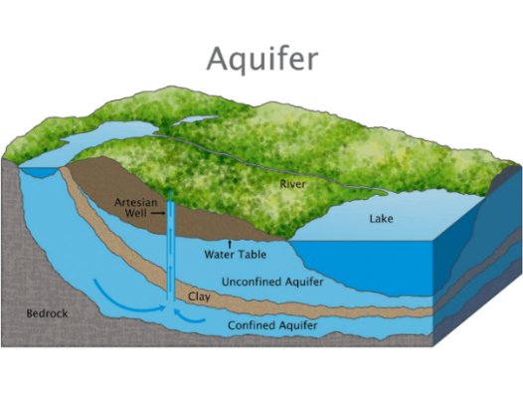

**Why is groundwater so important?**

30.1% of all freshwater is stored in rocks deep below the ground, forming vast reservoirs known as aquifers.

Aquifers are commonly found in porous (contain air pockets) and permeable (allow water through) rocks such as chalk & sandstone.

The aquifers found in the deserts of Africa, Middle East and Australia are called fossil aquifers & were formed thousands of years ago when the climate in these regions was much wetter.

Some areas of the world are heavily reliant on aquifers for their water needs. Many of these aquifers are being exploited unsustainably for irrigation. This increases the risk of them turning into saline aquifers as seawater can then infiltrate into the rocks.

*How and why do sandy and clay soils differ in terms of stores and transfers of groundwater?*

**The global distribution of water stores**

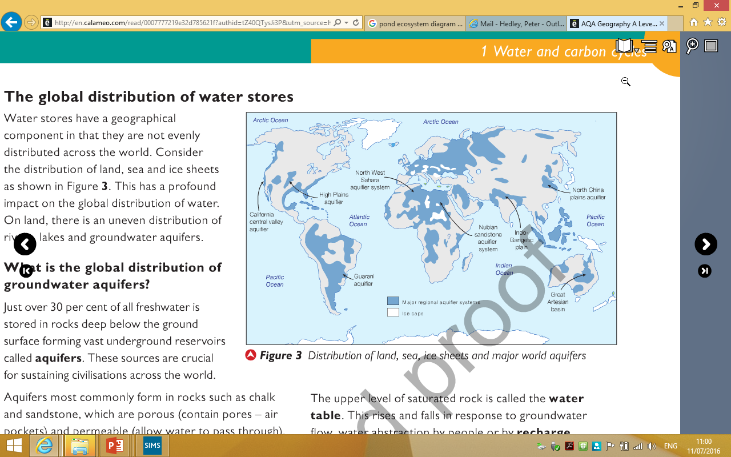

Water stores are not evenly distributed across the world. Annotate to identify the main areas.