**Purchasing**

The purchasing department is responsible for working with suppliers. Purchasing involves:

* Buying of materials, components, fuel, tools, machinery, equipment, stationery and services by the business.
* In manufacturing they work closely with production and finance department.

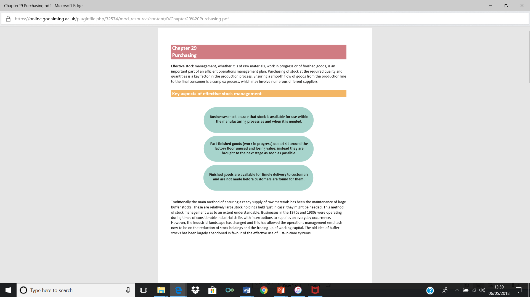**Key aspect of effective stock management**

|  |  |
| --- | --- |
| Centralised Purchasing | Purchasing for the whole business is carried out by one department. |
| Decentralised Purchasing | Purchasing officers in each department. |

|  |  |
| --- | --- |
| **Central Purchasing** | **Decentralised Purchasing** |
| * One department carries out all purchasing for an entire organisation * Develop relationship with key suppliers * Provides **economies of scale** along with standard products and quality * Allows for planning of distribution and storage if required | * Can reduce cost of running a specialist department (admin costs) * Departmental purchasing officers will have a better understanding of requirements of the department * Could result in increased motivation due to increased responsibility. |

**Criteria to take into account when choosing suppliers**

* Price – Good deal
* Payment Terms - short or longterm credit
* Quality – Must match organisation’s ethos
* Capacity – Ability to meet demand
* Reliability – Time issues, mistakes
* Flexibility - Ability to change orders

**Purchasing and Suppliers are important**

To meet customers’ expectations consistently, it is essential to have reliable suppliers of materials, components and business services.

* Better customer service
* Fewer production delays
* Lower costs
* More consistent quality
* More flexibility to cope with unusual customer requirements
* Improved communications as a result of similar IT systems

|  |
| --- |
| **Stock:** current asset held by a business to help meet the demand of customers |

**The nature of stocks**

* Raw materials and components
* Work-in-progress
* Finished goods   
    
  NOTE: the phrase, ‘a stock take’ is when all items in stock are counted and valued, at a point in time (usually one day of the year for preparation of the balance sheet)

**Stock Holding**

The amount of stock held will depend upon:

* The business’ attitude to risk
* The importance of speed of response as an operational objective
* Speed of change within the market
* Nature of the product e.g. perishable or long lasting

**Stock control diagram**

|  |
| --- |
| **Stock Control -**  process of making sure the correct level of stock is maintained to meet demand while keeping the costs of holding stock to a minimum |

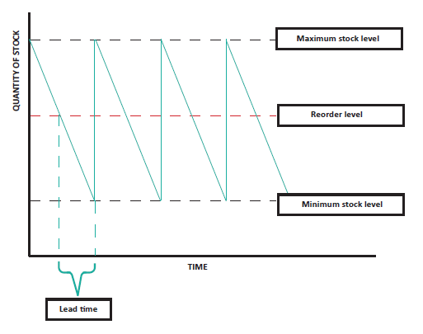

**Stock management and control**

Stock levels are managed and more stock is ordered when the stock falls below a certain level.

|  |
| --- |
| **Reorder level: This is the level of stock at which a new order is placed** |

* The level of stock which triggers an order, this may be done automatically by a computerised system
* The re-order level will be determined by both the lead time and the minimum stock level

|  |
| --- |
| **Reorder Quantity:** this is measured by the difference between the maximum and minimum stock holding levels |

* The point at which an order for new stock is placed, this will be dependent on buffer level of stock and lead time
* A computerised stock control system will automate this process so that when stock reaches this level an order is automatically sent to a supplier

|  |
| --- |
| **Lead Time:**  this is the amount of time taken for delivery to take place following the placement of an order |

* The time it takes between placing an order and receiving delivery
* The greater the lead time, the higher the minimum stock level
* Lead time can be measured on the horizontal axis of a stock control diagram as the distance from re-order level to minimum stock level

|  |
| --- |
| **Buffer Stock:** this is the stock level that will always be held in case of problems with delivery – i.e. the amount of stock below the minimum stock holding level and zero stock |

* Stock held by a business to cope with unforeseen circumstances e.g. sudden increase in demand, break down in supplies
* When a business reaches its minimum stock level it is left with just buffer stock
* **A Business operating a Just in Time** system will have zero buffer stock

|  |  |
| --- | --- |
| **Advantages of Buffer Stock** | **Disadvantages of Buffer Stock** |
| * Can meet customer demand * Quickly respond to increase in demand * Continue with production even if a problem with stock deliveries | * Money tied up in holding stock * Costs associated with stock holding e.g. storage * Risk of waste e.g. out of date, damage, obsolete |

**Stock Control**

Stock



Re-order level

Weeks

7000

6000

5000

4000

3000

2000

1000

0

0 1 2 3 4 5 6

1. What is the buffer stock level? /2 marks

__________________________________________________________________________________________________________________________________________________________________

1. What is the lead time? /2 marks

_________________________________________________________________________________________________________________________________________________________________

1. What is the maximum stock holding? /2 marks

_________________________________________________________________________________________________________________________________________________________________

1. What is the re-order quantity? /2 marks

_________________________________________________________________________________________________________________________________________________________________

1. If stock ordered in week 1 was not delivered until week 4 after how long would the business have run out of stock? /2 marks __________________________________________________________________________________________________________________________________________________________________________________________________________________________________________________

**Stock Control Methods**

|  |  |
| --- | --- |
| **Computerised stock control** |  |
| **JIT** |  |
| **Stock Management system** |  |

**Factors affecting the level of stock**

* Rate at which stock is used
* Warehouse space available for storage
* Nature of the product (perishable, fragile etc)
* Reliability of suppliers
* Suppliers’ lead time
* Opportunity cost of holding stock

|  |  |
| --- | --- |
| **Advantages of effective stock management and control** | **Implications of poor stock control** |
| * Reduction in working capital * Improved relationships with customers * Freeing of storage space * Less stock wastage and discounting * Easier stock rotation | * Waste of resources * Unable to meet customer needs * Damaged reputation * Under utilisation of other resources e.g. labour and machinery standing idle * Loss of competitiveness |

**Benefits and Problems of high stock levels**

|  |  |
| --- | --- |
| Advantages | Disadvantages |
| * Meet customer expectations * Maximise sales revenue * Gain market share if competitors cannot match * Create a USP – always available. E.g. garage convenience stores ‘guarantee’ to have milk, tea and bread.   Cope with disruption to the supply chain | * **Opportunity cost** of the cash and other resources ‘tied up’ in stock * **Storage costs** – rent, heating, lighting * Spoilage, wastage or theft costs * Administrative and financial costs |

**Risks of holding too little stock:**

* Missed sales opportunities (unexpected orders)
* If disruption to supplies, still have cost of unproductive staff and equipment
* Risk failing to meet order deadlines if any issues – dissatisfied customers
* Possibly more orders more frequently – lose bulk buying opportunities

**Evaluate the importance and impact on businesses and their stakeholders of holding too much or too little stock**

|  |
| --- |
|  |

**Activities**

Read through pages 491- 495

Complete Q2 on page 493 and Q’s A-D page 495

