**Finance For Business Plan Guide**

**Objective:**

Fill in all the purple sections.

**Theory:**

For this document you need to understand the difference between Start Up Costs, Fixed Costs and Variable Costs.

|  |  |  |
| --- | --- | --- |
| **Start Up Costs** | **Fixed Costs** | **Variable Costs** |
| These are the essential items you need to buy to get your business started. For example think of anything you need to buy in order to operate effectively. This may be a till, blender, vehicle, cooker etc | These are costs which do not vary with output. For example these costs would be anything you have to pay each month no matter whether you sell something or not i.e. rent, salaries, utilities. | These costs do vary with output. For example these costs will increase the more you sell i.e. raw materials, wages. |
| **Below is a list of costs for a ‘dog walking business’ divided into the relevant sections** | | |
| Van – £4,000  Advertising – £500  Dog Leads – £30 | Salary - £2,500 (remember its per month) | Dog Treats – £10  Poop Bags – £20  Petrol - £60 |
| **Below is a list of costs for a ‘hot dog stall’ divided into the relevant sections** | | |
| Advertising – £500  Cooker – £800 | Rent – £1,500  Salaries – £2,500  Utilities – £300 | Food (buns, onions, sauce etc) – £1,800  Drinks – £900 |

**Task 1:**

Fill in your Start Up, Fixed and Variable Costs by explaining what they are and then putting the price of how much it should cost you.

If you need to add more than three costs to each section you need to insert in another line. This can be done by right clicking on **5** on the left hand side and selecting **INSERT**. If you have to insert an extra line then you must alter the calculations otherwise the document will become incorrect. To do this click on the total box i.e. either the red or yellow boxes (see below – boxes circled in black)

You will see in the task bar at the top a calculation that looks like SUM=(C3:C5) for the red box. This sum means that all items from C3 to C5 have been added together. If you inserted a new line you will need to change this to SUM=(C3:C6) or SUM=C3:C7 – depending on how many lines you have inserted. If you need to do the yellow box calculations the principle remains the same but instead of C you are using F and I as these are the F and I columns. If you get really stuck with this. Upload your Finance for Business Plan to GoL under the submission link ‘Finance for Business Plan DRAFT’ and email me (Ellen – [egb@godalming.ac.uk](mailto:egb@godalming.ac.uk)) and I will check it out and correct it if needed.

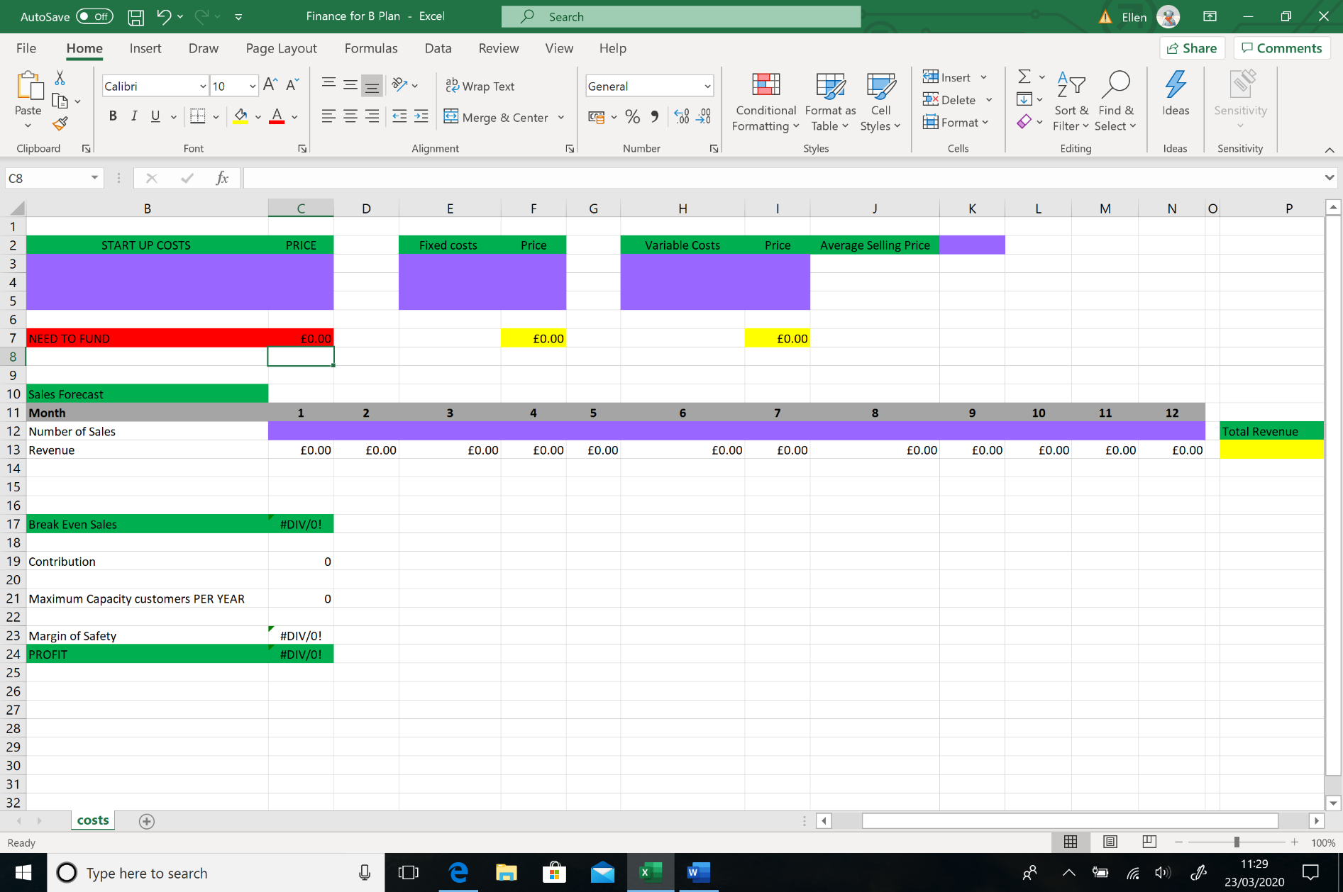

Once your costs are all in you will see that the document automatically calculates them by adding them together and putting the total in the red and yellow boxes. The red amount shows how much you need to start up for business. The yellow boxes show your total fixed and variable costs.

**Task 2:**

Is to work out your average selling price and place it in the purple box (see below circled in black). If you have a number of goods that you sell you need to work out roughly how much customers may spend. So for my Dog Walking Business, my selling price may be £15 per dog walk. If it’s the Hot Dog Stall, customers may buy a hot dog (£2) and a drink (£0.70) so totalled my average selling price may be £2.70.



**Task 3:**

Now you need to work out roughly how many customers you may get each month and fill in the row of purple boxes for NUMBER of SALES (see below circled in black). Be realistic. If I am a dog walker I can only by law walk 5 dogs at a time. If I do that 3 times a day that will be 15 dogs a day. I will be working 5 days a week so 15 x 5 equals 75 dogs a week. Need to times that by 4 to get the month amount, which in this case would be 300. Now this would mean I am running my business at full capacity but in the first couple of months I doubt that would be the case. I need to build a customer base and so 300 would be my maximum per month but it will fluctuate and probably be lower in the first few months. My sales may be something like:-

* 1 - 100
* 2 - 120
* 3 – 140
* 4 – 150
* 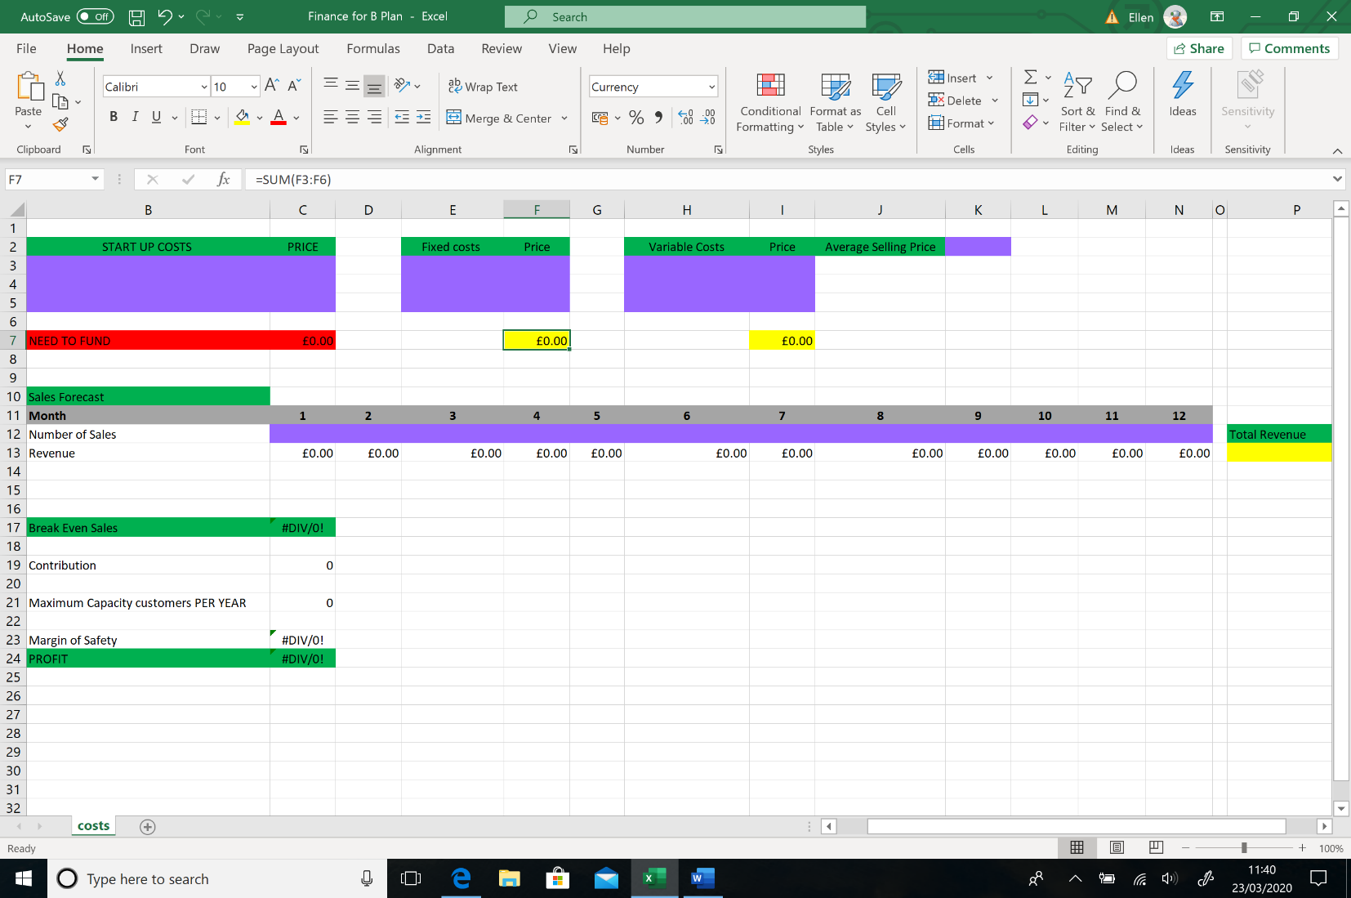And so on

If you are a seasonal business you may want to think that either Summer or Winter months may be more popular for you.

Once all your Number of Sales are done you will see your Revenue underneath for the month and at the end of the rows you will see a yellow box which will tell you your Total Revenue for the Year.

**Task 4:**

Your Finances are now complete. The section at the bottom starting with Break Even should automatically calculate by itself.

* **Break Even** will tell you how many sales you need to make to cover your costs.
* **Contribution** will tell you how much is left over per sale to pay for fixed costs.
* **Maximum capacity** lists your total number of sales per customer.
* **Margin of Safety** will tell you the difference between your break even point and your current projected output (sales).
* Lastly you will find **Profit**. This needs to be a positive figure. You do not want to be making a loss. If this is negative you may want to play around with the figures, for example:-

1. Can you increase the number of sales per month?
2. Can you increase the average selling price?
3. Can you find cheaper start up, fixed and variable costs?

If you are worried your finances may be incorrect or not sure if it looks ok then upload it to GoL under Unit 3 submission link ‘Finance for Business Plan DRAFT’ and email Ellen [egb@godalming.ac.uk](mailto:egb@godalming.ac.uk) to let me know its there and I will double check it. If you are happy with it or I have checked it and said its ok then you need to screen shot it and put it into your business plan under the finance section.