**Composite Applied June 2016 Mark Scheme**

|  |  |  |
| --- | --- | --- |
| **Qn** | **Scheme** | **Marks** |
| **1. (a)** |  | M1 |
|  |  | A1 |
|  |  | A1 |
|  | or  or | B1 |
|  | , | M1 |
|  | (500g), (80g) | A1 **(6)** |
| **(b)** | **Must be using work-energy.** |  |
|  | KE lost = PE gained + WD against R | M1 |
|  |  | A1 |
|  |  | A1ft |
|  | (m) | A1 **(4)** |
|  |  | **[10]** |

|  |  |  |
| --- | --- | --- |
| **2.** | Since this question is about the magnitude of the impulse, condone subtraction in the "wrong order" throughout. | |
|  |  | M1 |
|  |  | A1 |
|  | Magnitude | DM1 |
|  |  | A1 |
|  | The next two marks are not available to a candidate who has equated a scalar to a vector. | |
|  |  | DM1 |
|  |  | A1 **(6)** |
|  |  | **[6]** |

|  |  |  |
| --- | --- | --- |
| **3.(a)** |  |  |
|  | CLM: | M1 |
|  |  | A1 |
|  | Impact: | M1 |
|  |  | A1 |
|  |  | DM1 |
|  | = *vB* | A1 |
|  | , *vA =* | A1 **(7)** |
| **(b)** | Speed of *B* after hitting wall | M1 |
|  | Impulse | M1 |
|  | , | A1 **(3)** |
| **(c)** | Speed of *B* after second impact = | B1ft |
|  | Same velocity (and *A* has a head start), so no collision. | B1 **(2)** |
|  |  | **[12]** |

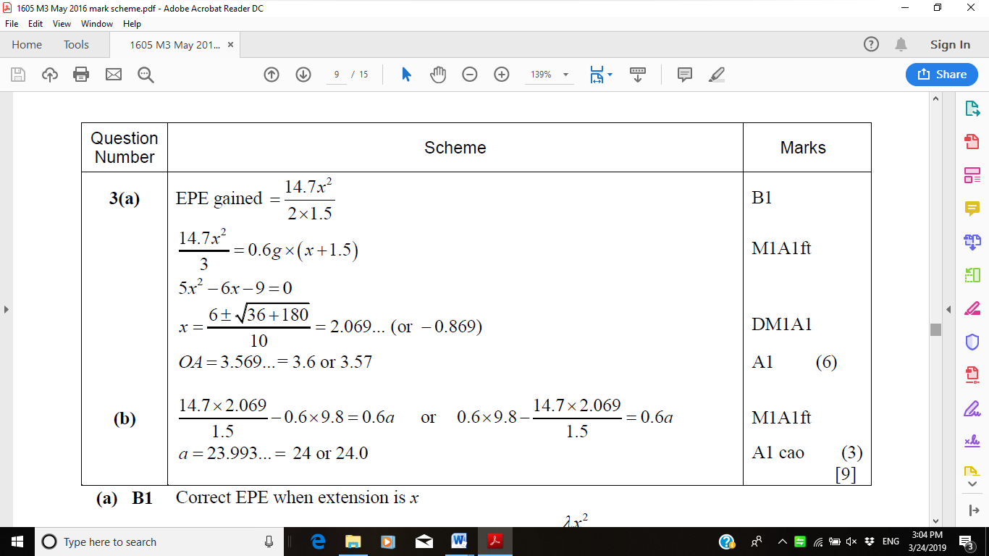

**4**

|  |  |  |
| --- | --- | --- |
| **5.** |  |  |
|  | Along line of centres: |  |
|  | Con of mom: | M1 |
|  |  | A1 |
|  | NLR: | M1 |
|  |  | A1 |
|  |  |  |
|  | Perp to line of centres: no change to velocity so vel | B1  (A1) |
|  | Deflected through | B1 |
|  |  | M1 |
|  | or 0.4472.... | A1 |
|  |  | **[8]** |

|  |  |  |
| --- | --- | --- |
| **6.** |  |  |
|  | First impact: |  |
|  | Component parallel to wall: | B1 |
|  | Perp to wall: NLR: | M1 A1 |
|  |  | A1 |
|  | Second impact: |  |
|  | parallel to wall vel after | B1 |
|  | Perp to wall | B1 |
|  | Direction at  to the wall | B1 |
|  | or | M1 |
|  | or | A1 |
|  |  | A1 |
|  |  | **[9]** |

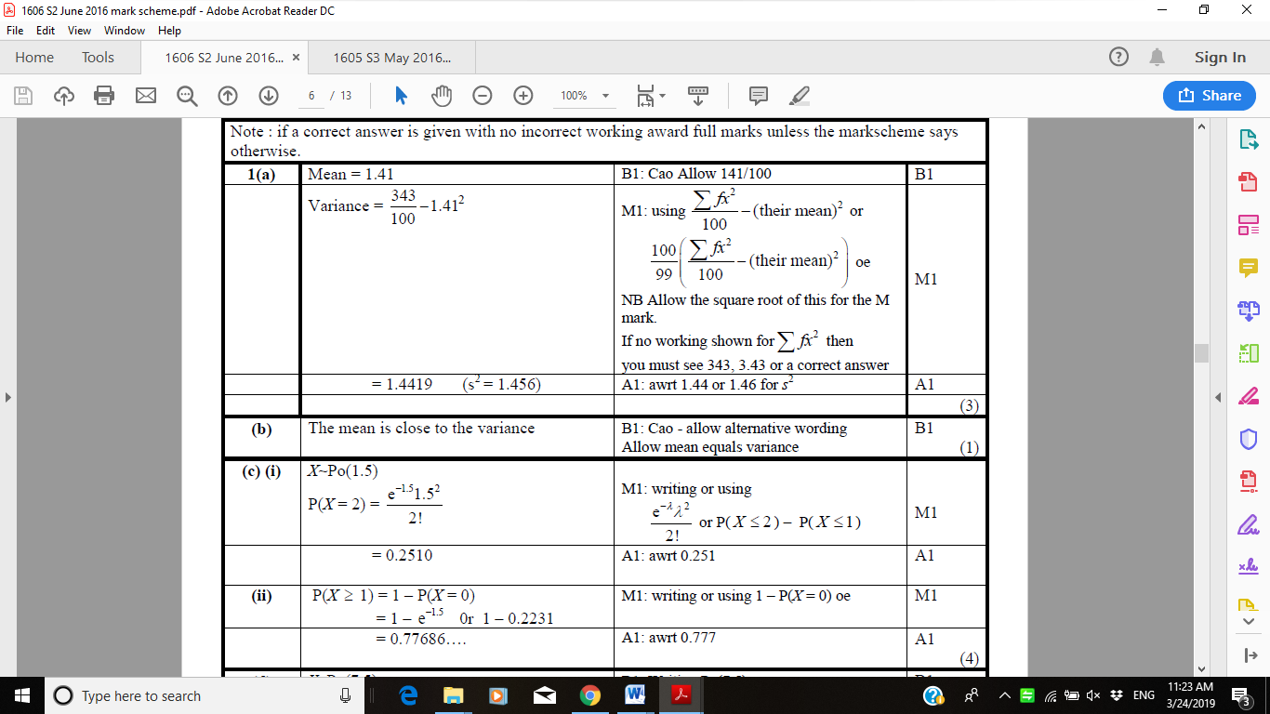

**7**

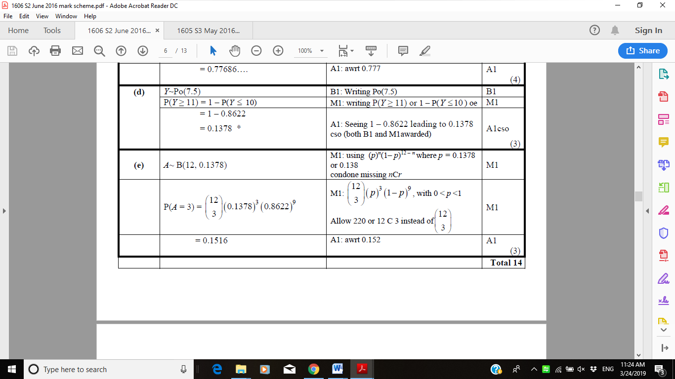

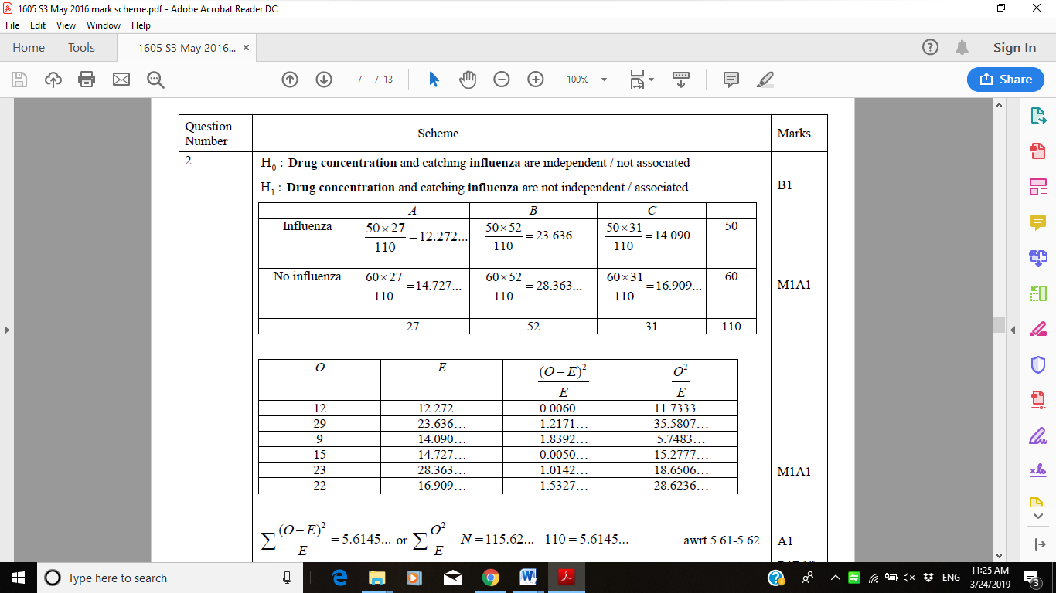

**8.**

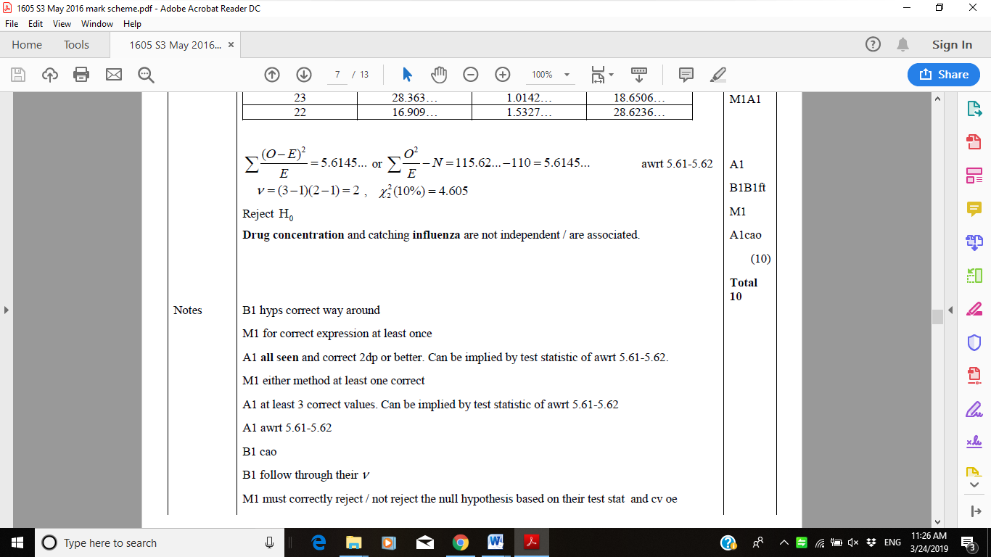

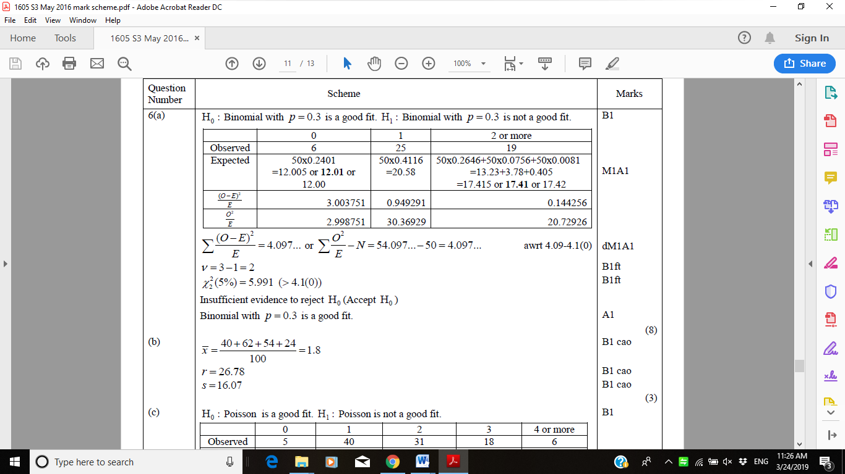

**9(a)**

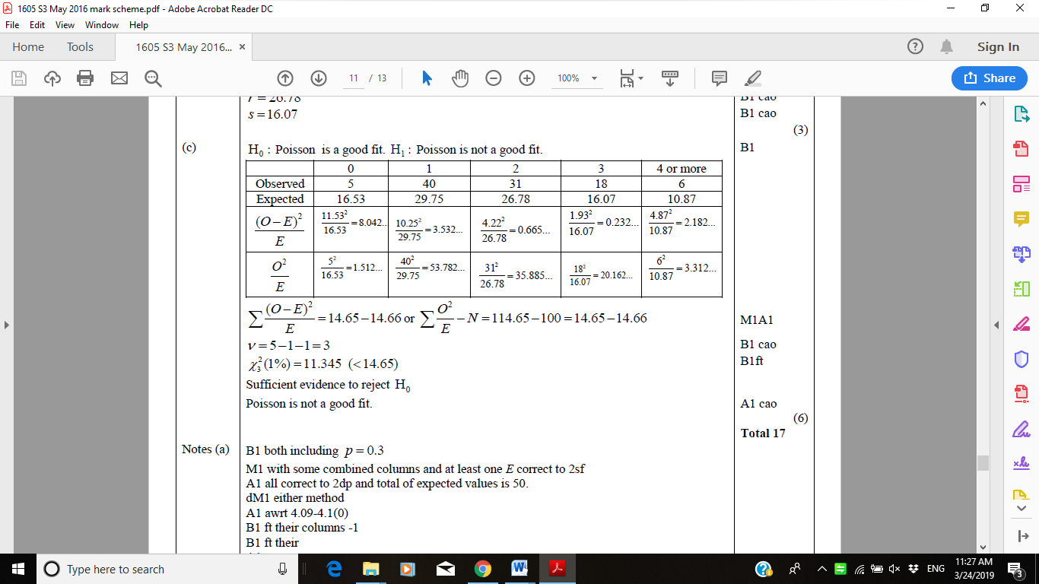

|  |  |  |
| --- | --- | --- |
| **Question Number** | **Scheme** | **Marks** |
| **10.** (a) | *X* = No of soft centres. |  |
|  | *X* ~ B(20, 0.5) |  |
|  | Critical region *X* ≤ 5 or *X* *≥* 15 | B1 B1 **(2)** |
| (b) | P(Type I error) = P(*X* ≤ 5 | *p* = 0.5) + P(*X* *≥* 15 | *p* = 0.5) |  |
|  | = 0.0207 + 0.0207 | M1 |
|  | = 0.0414 | A1 **(2)** |
| (c) | P(Type II error) = P(*X* < 15 | *p* = 0.25) – P(*X* < 6| *p* = 0.25) | M1 |
|  | = 1 – 0.6172  = 0.3828 | A1 **(2)** |
|  |  | **Total 6** |
|  |  |  |
| **11.** (a) | Size of test A = P(Y ≤ 2) |  |
|  | = 0.0547 | **B1 (1)** |
| (b) | Size of test B = P(Rejecting H0 | p = 0.5) |  |
|  | = P(X = 0) + (1 – P(X = 0))  P( X = 0) | **M1** |
|  | = 0.55 + ( 1 – 0.55)(0.55) | **A1** |
|  | = 0.03125 + (0.96875)(0.03125) |  |
|  | = 0.0615/0.0614 | **A1 (3)** |
| (c) | Power function of test B = P(0 long screws in first 5) + P(0 long screws in second 5| > 0 long screws in first 5) |  |
|  | = P(X = 0 | p) + [ 1 – P(X = 0 |p)] P( X = 0 | p) | **M1** |
|  | = (1 – p)5+[1 – (1 – p)5](1 – p)5 | **A1 (2)** |
|  | = 2(1 – p)5 – (1 – p)10 |  |
| (d) | r = 0.68 | **B1** |
| (e) | Test A as it is more powerful for values of p < 0.4 | **M1 A1 (2)** |
|  |  | **Total 8** |