Film Studies yr1

Exam essay writing best practice - Component 2: European British film

*Sweet Sixteen* and *Fish Tank*

**Q. 1b and 1c**

In the exam you will choose one question to respond to

These questions are worth 40 marks. You should spend no more than 40 minutes on the question you choose. Approximately 5 minutes for an introduction, then 15 minutes each per text is a good amount. Try to make time for a formal conclusion. Spend a couple of minutes for a conclusion and proofread both essays once finished.

**Structuring your response**

**Introduction** – write a detailed intro 4 - 5 sentences is a good amount- you may need to define / explain a term such as Narrative, or the importance of something (a key word like structure, if mention in the question). Use the wording of the question in your intro. Introduce which film texts you have studied and will be writing about. It is ok to use the phrase ‘in this essay…’ in your intro.

**Main body** - Begin to answer question using scene specific examples from your chosen texts. Use some reference to contexts (time, location, director’s credentials etc.) to show off wider knowledge. You may wish to write a brief synopsis for each film. Use scene specific examples (with film form details), to illustrates your point. 3 paragraphs per film text is roughly a good amount. Remember you won’t be writing this essay as a compare and contrast (unlike your *Casablanca* / Bonnie *& Clyde*), thus your structure should be 1, 1, 1, 2, 2, 2, etc. It’s ok to occasionally rephrase the question in your response, to ensure you are always answering the question.

**Conclusion** - Try to sum up your ‘argument’ in a very brief paragraph, it is ok to be a little repetitive here (take aspects from your introduction and main body of the essay). Avoid new information. Try to sign off poetically (easier said than done). “In conclusion...” and “to summarise...” is a good way to start a conclusion.

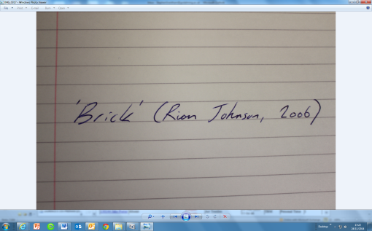The first time you reference a film text include the title in ‘inverted commas’, the name of the director and then the year of release in brackets:

If you are typing on a computer, then having the title of the film in *italics* would be beneficial.

The first time you reference a character, try to include the actor’s name in brackets: Liam (Martin Compston).

Show off your vocabulary and use as much film terminology as you can to demonstrate / apply your knowledge of both films: Social realism / British Social Realism, non-professional actors, hand held camera, jump cut editing, location shooting, natural lighting, no non-diegetic music, realistic depictions, working class, underclass, Chav, ASBO, NEET, Ned etc.

Remember, there is an emphasis on **Narrative** for both 1b and 1c questions, so having knowledge of terms such as: linear, non-linear, in medias res, bildungsroman, episodic, meandering, cyclical, equilibrium, disequilibrium, new equilibrium, resolution, narrative enigmas, symbolic prop, cause and effect, disruption, narrative goals, protagonist, antagonist, narrative devices, binary opposites etc. is important.

Always try and answer the question. Always try and answer the question that has been **set**, not the one you’ve practiced and prepped for. As it says above- It’s ok to occasionally repeat / rephrase the question in your response, to ensure you are always answering the question.

Write as neatly as you can. If the marker can’t read your writing, you may miss out on vital marks. You won’t get marked down for writing something incorrect, but you will miss out on marks if your handwriting is illegible.

The tone of your writing should be formal. Avoid using chatty, slang or ‘text message’ language. Think your best phone voice. You should also keep contractions, e.g. “can’t”, “won’t”, “etc.” to an absolute minimum.

Be prepared. Always try to do your best. With every essay attempt, you should try to make incremental improvements.