|  |  |
| --- | --- |
| REVISION GUIDE | |
| *VOGUE* (July 1965) | **MAGAZINE (1)** |
| COMPONENT 2: MEDIA FORMS AND PRODUCTS IN DEPTH | |
| SECTION B: MAGAZINES – MAINSTREAM AND ALTERNATIVE MEDIA | |

**As well as the front cover, the set edition includes:**

Contents page  
Money Q & A (2 pages)  
Cutex Advert  
Imperial Leather Advert  
Picnics Probable & Improbable photoshoot (10 pages)  
Heatwave Holiday photoshoot (6 pages)

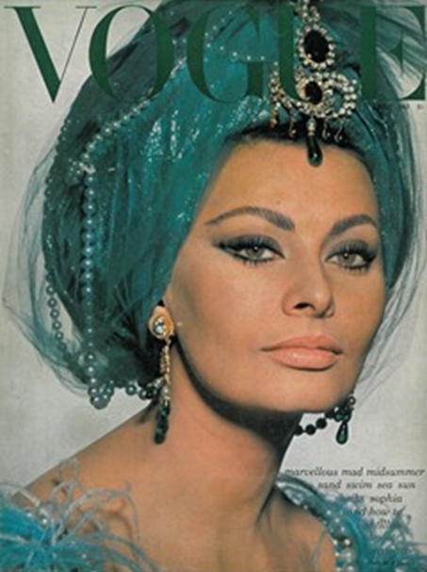

**What you need to revise**

|  |  |
| --- | --- |
| Media Language | Semiotic Analysis  How the elements of media language influence meaning  Mode of address  Codes and conventions of magazines (not just the front cover), including fashion magazines and the specific terminology associated with different elements (e.g. mast head, cover lines etc…)  How audiences respond to and interpret media language  All relevant theorists |
|
|
| Representation | The way the individuals, issues and social groups (gender, ethnicity age…) are represented and why they might be represented in these ways  Stereotyping  Relationship between context and representation (historical, political, social and cultural)  How representations convey values, attitudes and beliefs about the world  All relevant theorists |
|
| Institution | Processes of production, distribution and circulation by Condé Nast and *Vogue*  Understand the significance of ownership and control, including conglomerate ownership, vertical and horizontal integration  Regulation: IPSO; what they do and how they can affect *Vogue*  All relevant theorists |
| Audience | Demographic and psychographic profile  How audiences are targeted, attracted, reached and addressed  How audiences interpret the media, including how and why audiences may interpret the same media in different ways (reflecting social, cultural and historical circumstances)  How audiences use media in different ways, reflecting demographic factors as well as aspects of identity and cultural capital  All relevant theorists |

**Context prompts**

The 1960s was a decade of great change in British society

The economy was growing, and employment rates were high. This led to a growth in consumer goods, the number of people travelling abroad and an explosion in popular culture.

Traditional boundaries relating to social class and gender were shifting, and the feminist and civil rights movements had a significant impact.

**Example Exam Questions**

**Please answer the question highlighted in red**

**Representation**

How far are the representations constructed in the set edition of *Vogue* stereotypical? Explore three different pages in your response. [15]

How far do the representations in the set edition of *Vogue* (1965) reflect social and cultural contexts? [15]

**Explain the strategies that producers of magazines use to attract their target audiences. Refer to the set edition of *Vogue* magazine in your response. [15]**

|  |  |
| --- | --- |
| REVISION GUIDE | |
| *THE BIG ISSUE* (17-23 October 2016) | **MAGAZINE (2**  **)** |
| COMPONENT 2 | |
| SECTION B: MAGAZINES – MAINSTREAM AND ALTERNATIVE MEDIA | |

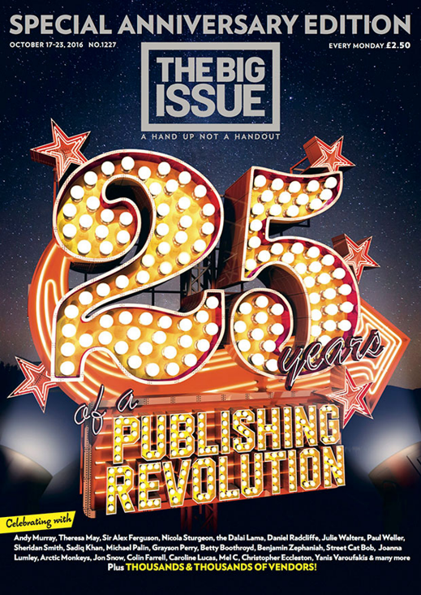

**As well as the front cover, the set edition includes:**

Contents page  
The Editor  
Letter to My Younger Self

Moving On

No Soggy Bottoms

My Pitch

Classified ads

**What you need to revise**

|  |  |
| --- | --- |
| Media Language | Semiotic Analysis  How the elements of media language influence meaning  Mode of address  Codes and conventions of magazines (not just the front cover), including fashion magazines and the specific terminology associated with different elements (e.g. mast head, cover lines etc…)  How audiences respond to and interpret media language  All relevant theorists |
|
|
| Representation | The way the individuals, issues and social groups (gender, ethnicity age…) are represented and why they might be represented in these ways  Stereotyping  Relationship between context and representation (historical, political, social and cultural)  How representations convey values, attitudes and beliefs about the world  All relevant theorists |
|
| Institution | Processes of production, distribution and circulation by Condé Nast and *Vogue*  Understand the significance of ownership and control, including conglomerate ownership, vertical and horizontal integration  Regulation: IPSO; what they do and how they can affect *Vogue*  All relevant theorists |
| Audience | Demographic and psychographic profile  How audiences are targeted, attracted, reached and addressed  How audiences interpret the media, including how and why audiences may interpret the same media in different ways (reflecting social, cultural and historical circumstances)  How audiences use media in different ways, reflecting demographic factors as well as aspects of identity and cultural capital  All relevant theorists |

**Context prompts**

Who formed *The Big Issue*, when and why

The ethos of the organization

The magazine’s USP

**Example Exam Questions**

**Please answer the question highlighted in red**

**How significant are economic factors in the magazine industry? Refer to the set edition of *The Big Issue* in your answer. [15]**

Explain the strategies that producers of magazines use to attract their target audiences. Refer to the set edition of *The Big Issue* magazine in your response. [15]