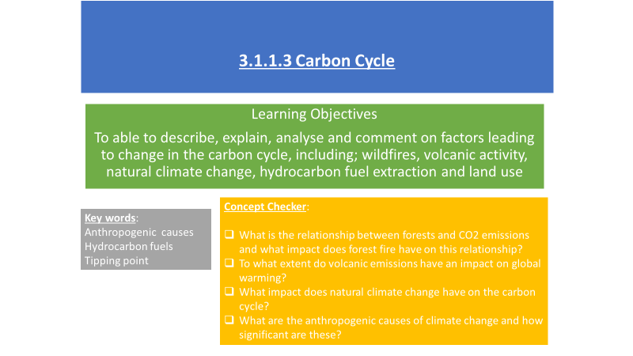

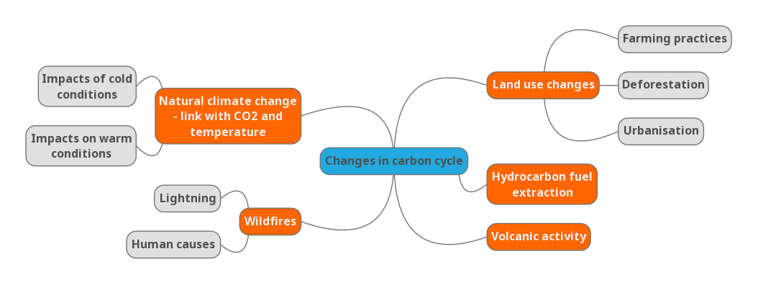

**Use the Oxford and Hodder textbooks (p 30-36 Oxford and p30-33 Hodder) to make notes on the causes of change in the carbon cycle.**

**Your notes can be completed in whatever format you like e.g. a mind map, bullet points etc. However, you will need to ensure that all the topics in the mind map above are included.**

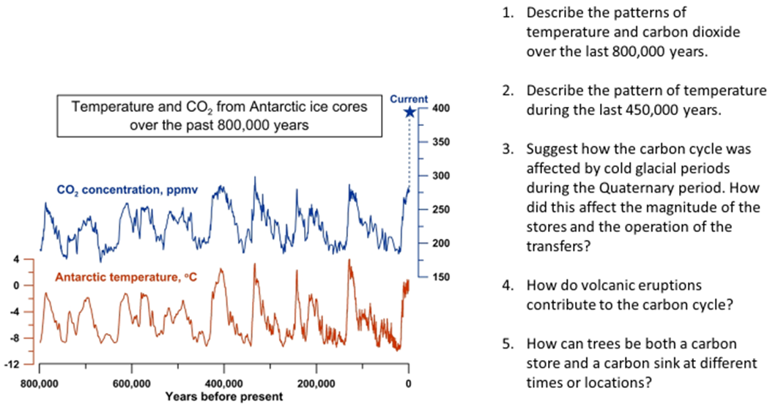

**Complete the following exam question-**

**Assess the extent to which changes to carbon stores are a result of human action or natural systems (20 marks) Tutor 2 U**



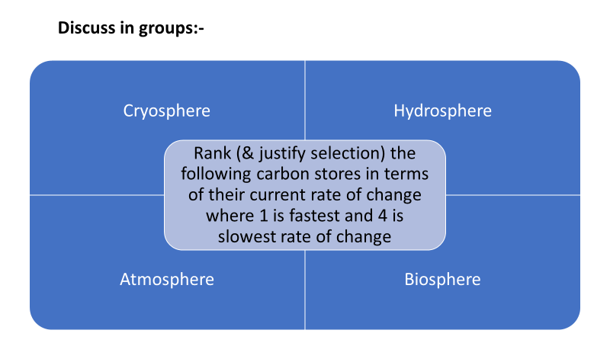

**Make notes from your discussions and the powerpoint slides to justify the rankings.**

**REVISIT THE CONCEPT CHECKER AT THE FRONT OF THE BOOKLET. Can you answer all the questions?**