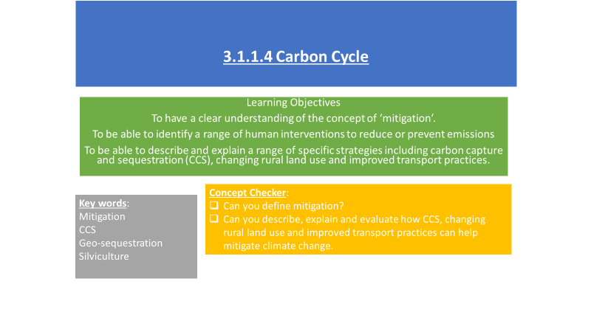

**Definition of mitigation –**

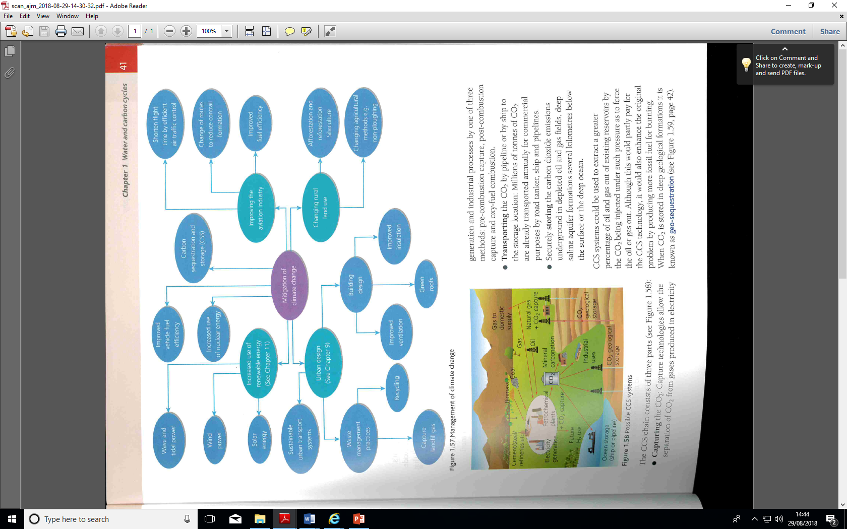**Read the Geography Review article – How can we manage global warming?**

Answer the following questions

1. What does the Intergovernmental Panel on Climate Change (IPCC) say may happen if the climate warms by 2°C above pre-industrial levels?
2. What does the 2015 Paris Agreement commit the world’s governments to do?
3. Why is ‘transnational governance’ required?
4. Do you think that the Paris Agreement will work? Why?
5. How long does the IPPC think that we have in the ‘carbon budget’, after which time we will be experiencing warming over 1.5°C?
6. What is the biggest problem that is making it hard to reduce emissions?
7. Why are some countries arguing that they should follow China and Brazil and base future economic growth on GHG – emitting fuel sources?
8. What are NETs? Explain the different NETs summarised in Figure 1
9. What is SRM? How does it work?
10. What are the difficulties of reforestation as a form of carbon capture and storage?
11. What are the difficulties with bioenergy with carbon capture and storage?
12. What are the issues with large scale SAI?
13. What is Plan A and why is it politically unpopular?
14. What is Plan B and what are the problems with this plan?
15. Why might geopolitical tensions rise?

**Essay question**

**Critically evaluate the different mitigating strategies for reducing global CO2 levels (20 marks)**

Research three areas of mitigation:-

1. Carbon capture and sequestration (CCS)
2. Changing rural land use
3. Improved transport practices

.

You will need to describe and explain the methods of mitigation, give examples of where it has been used and evaluate how successful it has been. It may be helpful to create a list/table of advantages and disadvantages of each method.

Use the Oxford and Hodder textbook information but also research online as there is a wealth of information on the topic.