***Part 1: Lifestyle factors in the maintenance of health & well-being***

*Alcohol*

What is alcohol?

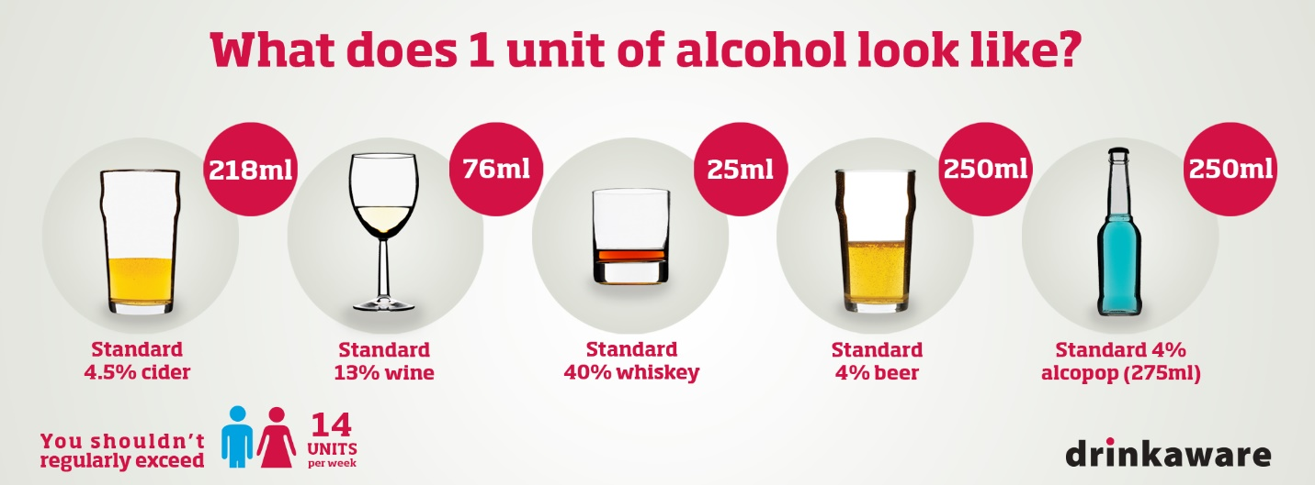How much is a unit in terms of level of alcohol?

What are the national government guidelines for alcohol consumption for males and females?

How many days alcohol-free should you have per week?

Risks associated with excessive drinking include strokes, cirrhosis, hypertension, depression and many others.

What is a stroke and why does excessive alcohol consumption cause a stroke?

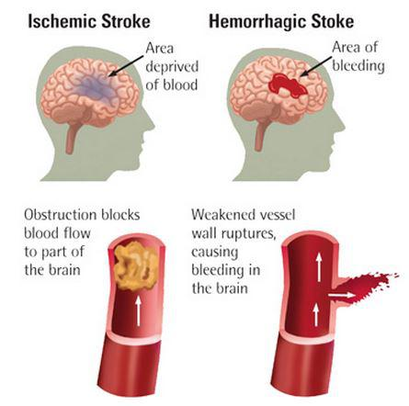

Alcohol consumption has been identified as the leading cause of liver cirrhosis, and liver cirrhosis accounts for 10% of the total disease burden attributable to harmful use of alcohol.

What is cirrhosis and why does excessive alcohol consumption cause a cirrhosis?

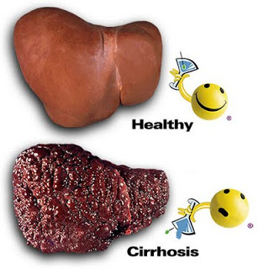

What is hypertension and why does excessive alcohol consumption cause it?

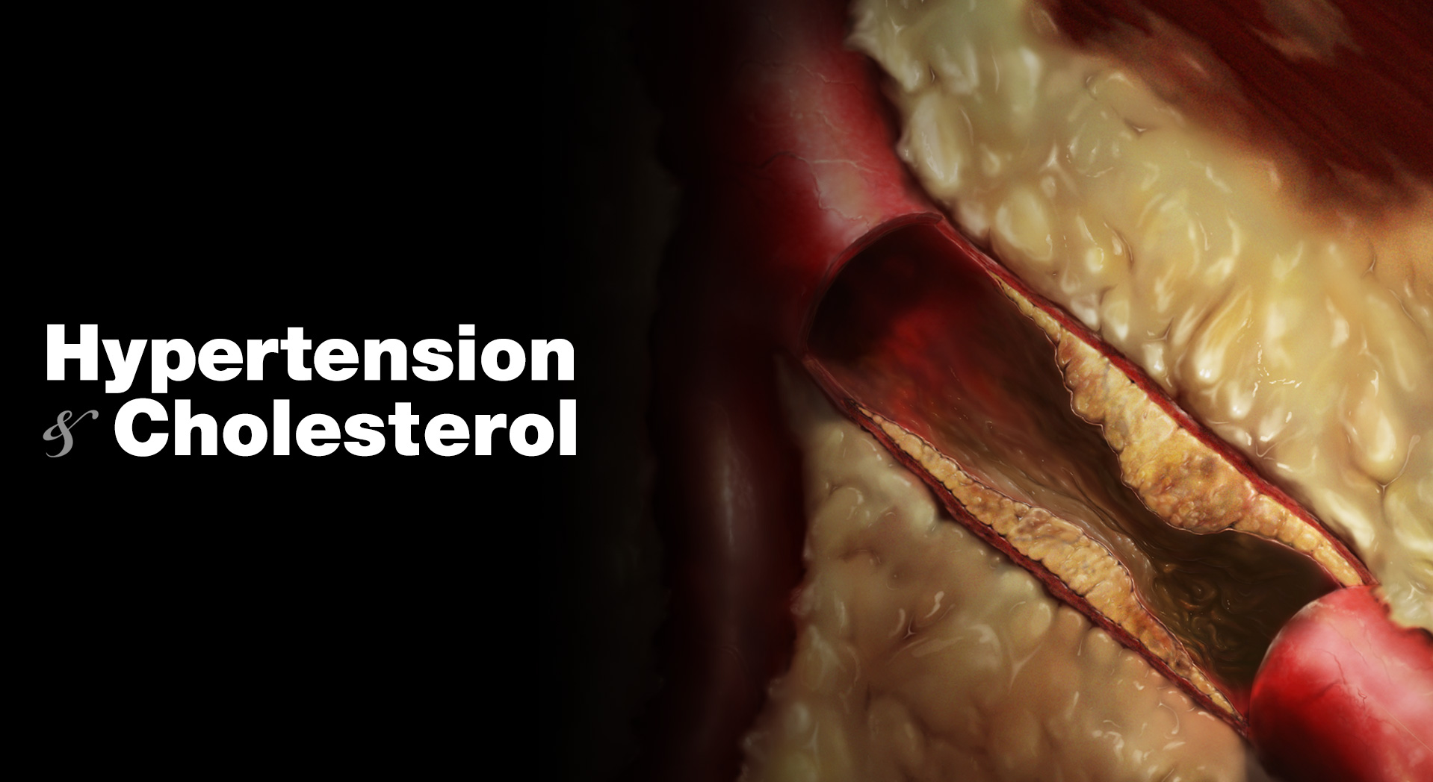

What is depression and why does excessive alcohol consumption cause it?

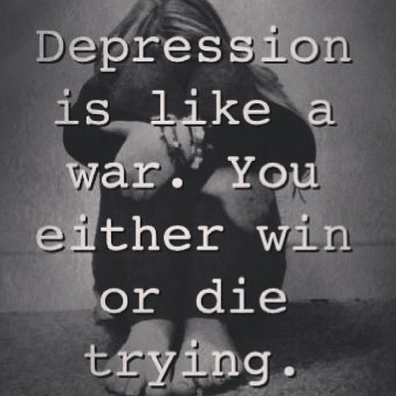

Studies consistently show alcohol increases the risk of cancer and 20 percent of all alcohol-related deaths are due to cancer. Cancers of the mouth, oropharynx, oesophagus, colorectal, liver and breast are all causally related to alcohol.

What is cancer and why does excessive alcohol consumption cause it?

