***Part 1: Lifestyle factors in the maintenance of health & well-being***

*Diet*

What is diet?

What are the benefits of a healthy diet?

Some of the risks of an unhealthy diet include nutritional deficiencies, coronary heart disease, obesity and type 2 diabetes. Describe what they are and why an unhealthy diet can cause them.

What is a nutrient deficiency and why does an unhealthy diet cause it?



What is coronary heart disease and why does an unhealthy diet cause it?

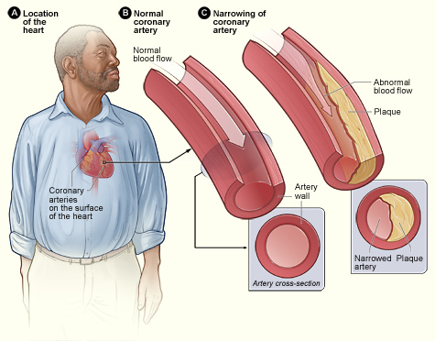

What is obesity and why does an unhealthy diet cause it?



What is Type 2 diabetes and why does an unhealthy diet cause it?

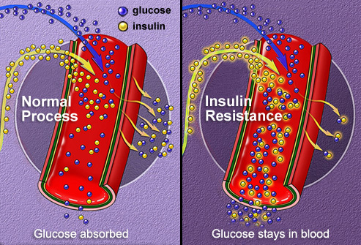

The Food Standards Agency (FSA) launched the Eatwell Plate on 16 September 2007, a visual tool that illustrates the types and proportions of foods that make up a balanced diet.

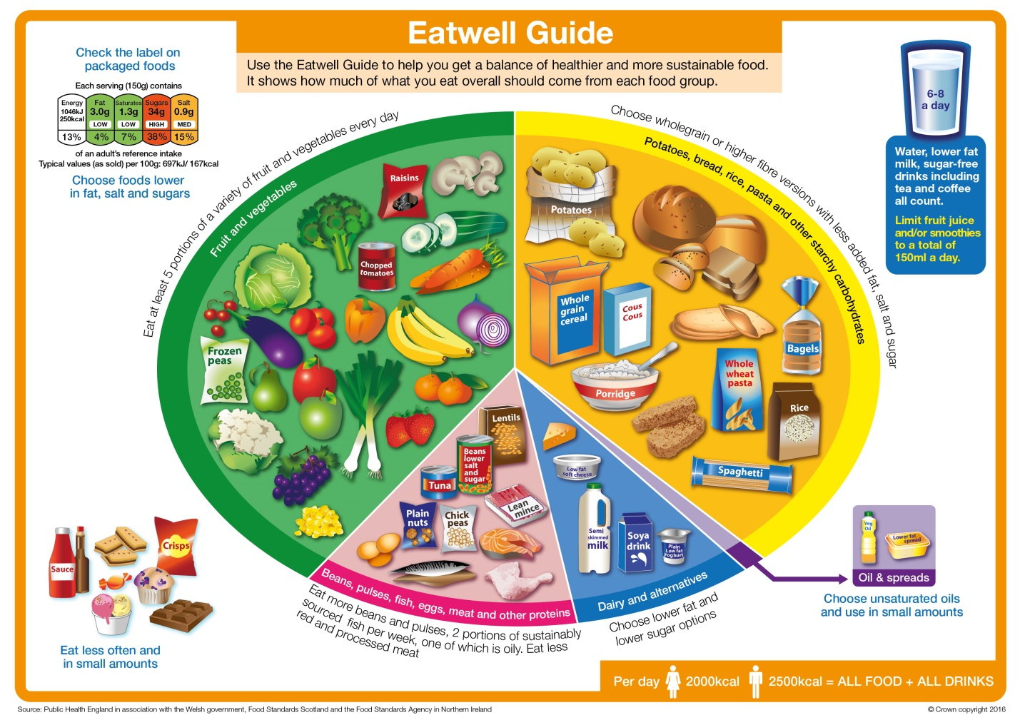

Using the Eatwell Plate summarize what the recommendations are for a healthy diet from the FSA.