***Part 1: Lifestyle factors in the maintenance of health & well-being***

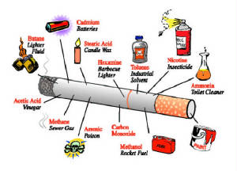*Worksheet 3: Smoking*

Define smoking

What are the national guidelines in the UK for smoking?

Health risks associated with smoking include coronary heart disease, cancer and lung infections such as bronchitis, emphysema and pneumonia.

What is coronary heart disease and why does smoking cause it?

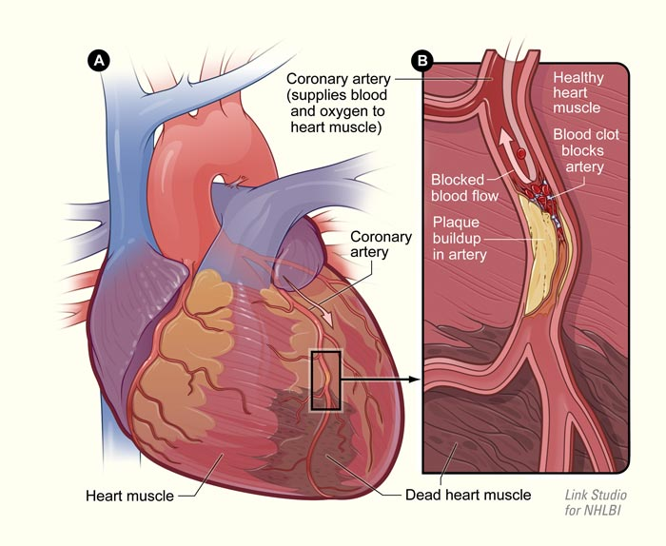

What is cancer, what cancers can smoking cause and why does smoking cause it?

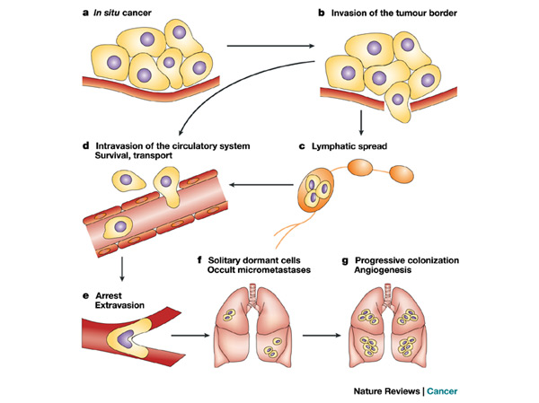

What are emphysema, bronchitis and pneumonia and why does smoking cause them?

