***Part 1: Lifestyle factors in the maintenance of health & well-being***

*Stress*

Provide a dictionary definition of stress

Health risks associated with high stress levels include hypertension, angina, strokes, heart attacks and ulcers.

What is hypertension and why does stress cause it?

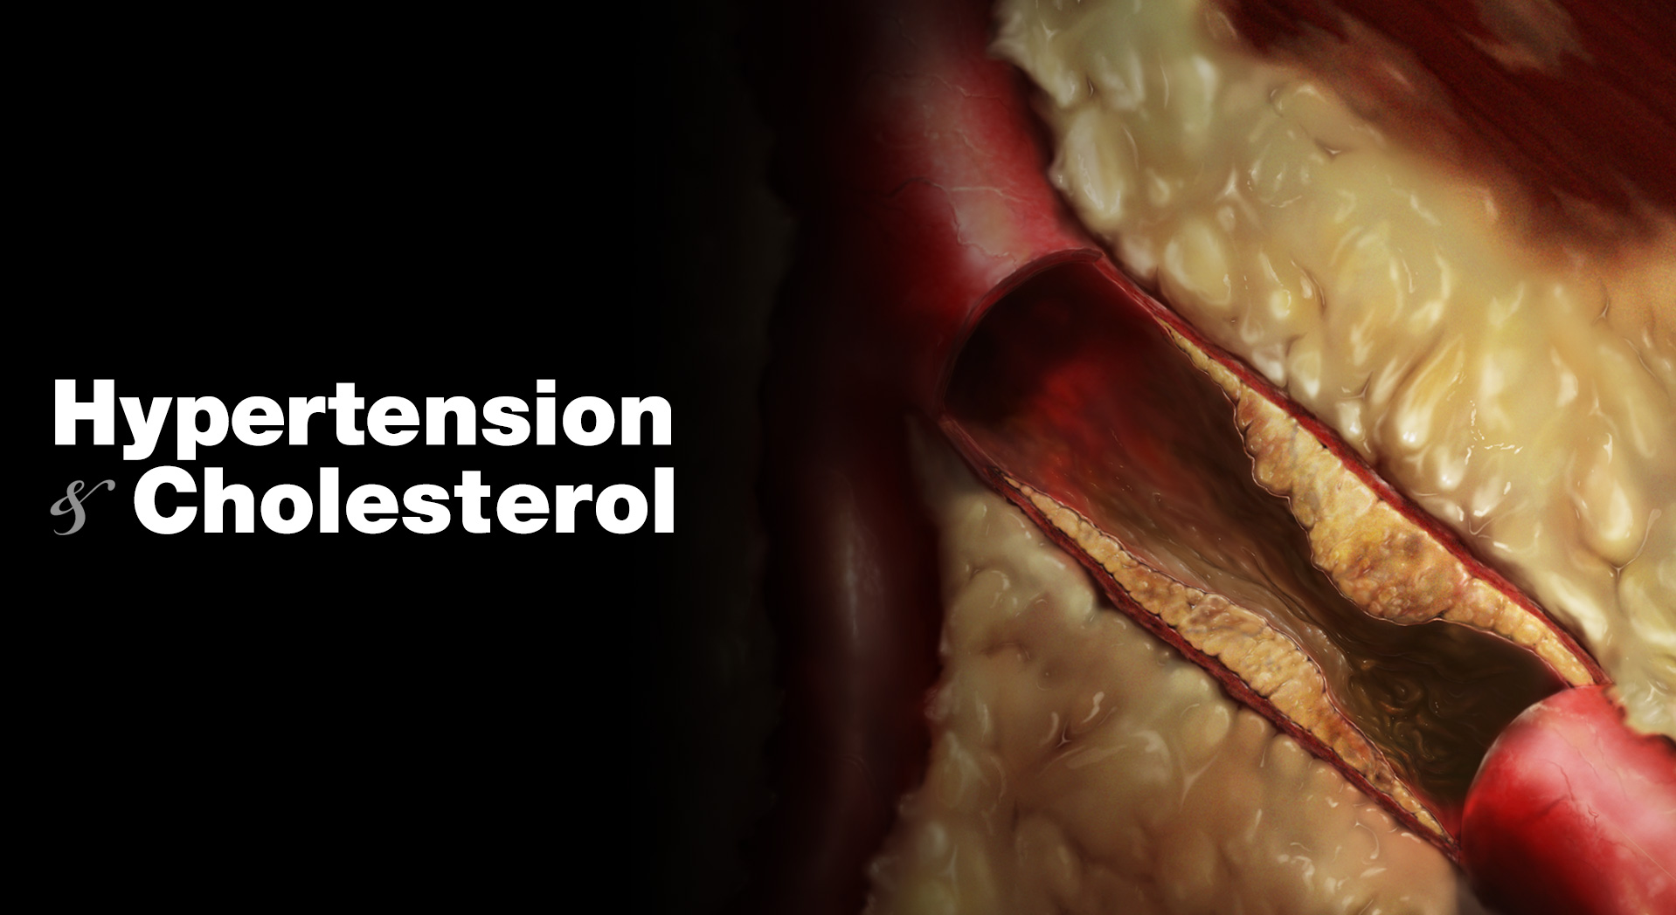

What is angina and why does stress cause it?

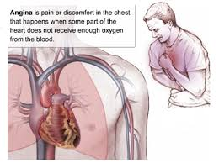

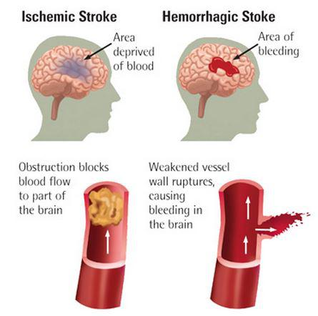What is a stroke and why does stress cause a stroke?

What is a heart attack and why does stress cause it?

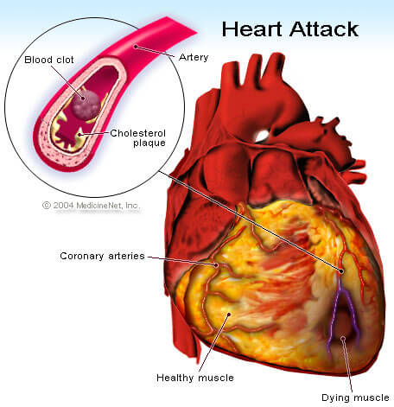

What is a stomach ulcer and why does stress cause it?

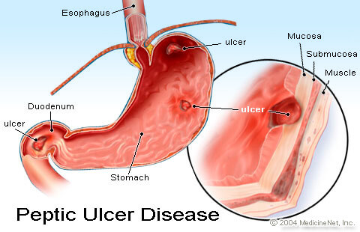

Stress can cause physiological issues as stated above but what other effects can stress have on your behavior and mood? How can someone react if they are clinically stressed?