**Carbon Review Notes – Handouts 1 & 2**

**Distribution, size and stores and factors driving change in the stores**

**An understanding of the greatest stores and the greatest fluxes from the diagram below. Make sure that you are able to quote some figures.**

**What are Gt and Pg and how many tonnes of carbon are they equivalent to?**

**Where is carbon found?**

**Why is carbon so important?**

**How is carbon stored?**

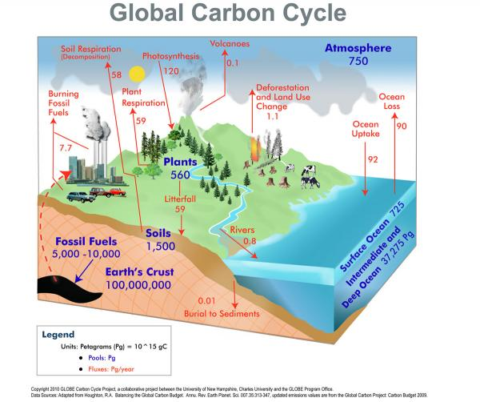

**Which two of the world’s biomes stores the most carbon?**

**Why are tropical forests under threat?**

**Why might boreal forests increase in area in the future?**

**Describe and explain the major stores of carbon.**

* **The lithosphere**
* **The hydrosphere**
* **The cryosphere**
* **The biosphere (and pedosphere)**
* **The amosphere**

**How and why does vegetation carbon storage and atmospheric CO2 levels vary throughout the year, both in the northern and the southern hemisphere?**

**What is carbon sequestration?**

**What examples of carbon sequestration are there?**

**The slow carbon cycle**

**How is the slow carbon cycle measured?**

**Explain the role and processes of each of the following in the slow carbon cycle.**

* **Burial and compaction**
* **The geological carbon cycle and the role of weathering**

**Where is the primary source of carbon from?**

**The fast carbon cycle**

**How is the fast carbon cycle measured?**

**Explain the role and processes of each of the following in the fast carbon cycle.**

* **Photosynthesis**
* **Respiration**
* **Decomposition**
* **Biomass combustion**
* **Ocean atmosphere exchange**
* **The biological carbon pump**

**Carbon can be transferred on a range of scales from local, to seral to global.**

* **Explain how a tree demonstrates transfers on a local scale? What processes are in operation?**
* **Explain how carbon is transferred on a seral scale through succession. Use either a psammosere (sand dune), halosere (saltmarsh) or deciduous woodland as an example. At this point you may wish to consider that seral succession could mean that deforestation in the Amazon may not result in irreversible changes, but that the forest may recover.**
* **Global scale (see diagram overleaf)**

**What are transfers and fluxes, net carbon sinks and net carbon stores? Give examples for each.**