FILMING ON YOUR PHONE

(or DSLR)

*A SURVIVAL GUIDE*

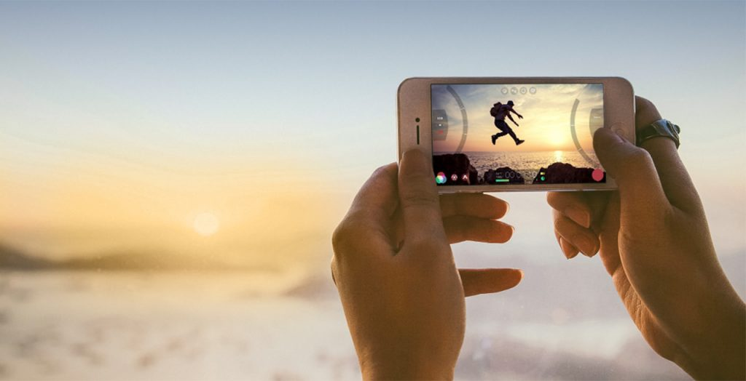

By now you would normally have had a camera workshop and would be playing around with a nice shiny college DSLR. However current events mean that this is not possible right now. I am hoping that the information provided below will help you out with shooting your NEA project over the summer break. If you are still having issues or questions, then you can contact me directly at [**jonoholmes@godalming.ac.uk**](mailto:jonoholmes@godalming.ac.uk)and I will get back to you as soon as I can.

**DSLR owners**

Hello DSLR owners! I’m guessing if you already have a nice camera, then you know how to use it, so I’m not going to say much here. However, I will ask you to follow these two simple rules.

* **Music video makers**, please can you shoot at 1080p. The college macs are wonderful, but not the fastest, so editing 4K footage is going to lead to frustrations.
* **Music video, magazine and film marketing** – please avoid taking photos or shooting film in RAW. Whilst filming RAW is very professional it also fills up the mac three times quicker than footage not recorded in RAW. The issue of taking photos in RAW is that the college PCs don’t have the codec to read RAW files, so you will be unable to use them.

And that’s it! Just two rules. Now, if you have no idea what I am talking about but you are worried you may do one of those things by mistake, either contact me with your make and model of camera, or Google it.

Also, remember basic stuff like clean your lens with a soft cloth, make sure you have a charged battery and a clean, recently formatted SD card.

**Phone users**

Hello phone users! I’m going to give you some information that could prove really useful when taking pictures or filming for your coursework.

Starting off with something simple - holding your phone. When did you last watch a film that was shot in ‘portrait’? Probably never, so ensure you that you film in the more widely used ‘landscape’ format.

If you’re a magazine maker you *will* need to take photographs in portrait mode for the front cover. Therefore, I would suggest you take a range of landscape and portrait photographs so you have plenty to work with.

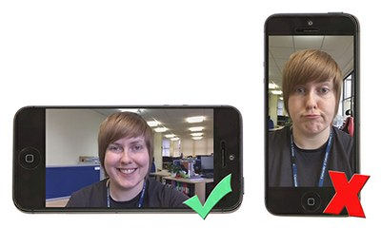

Settings

There aren’t many settings on a phone camera but you want to make sure you are recording footage in 4K at a frame rate of **24fps, 25fps or 30fps**. Phones have a very small sensor behind the lens, so you will need the best quality you can get when filming and shooting in 4K. This will really help that poor phone quality improve.

If you are unsure of how to do this on your specific phone then I would suggest checking Google or YouTube.

Saving your work

Save your work! Phones break and things get accidentally deleted. Also, phones with small storage may be left with no storage after shooting.

I would suggest that you save your work to a good quality USB – this will ensure that when uploading footage and photos next academic year, it is guaranteed to go smoothly. You can use online storage like Google Drive, however, with the security that exists on the college network, online storage may prove to be tricky and time consuming.

A useful app

All though this PDF is not sponsored, I should mention Yamera, a manual camera. The initial app is free but costs only £1.99 to fully unlock. This apps turns you phone into a DSLR, allowing you to control the exposure settings, aspect ratios, white balance and many others things. I insist you download and have a look. Available on many different devices.