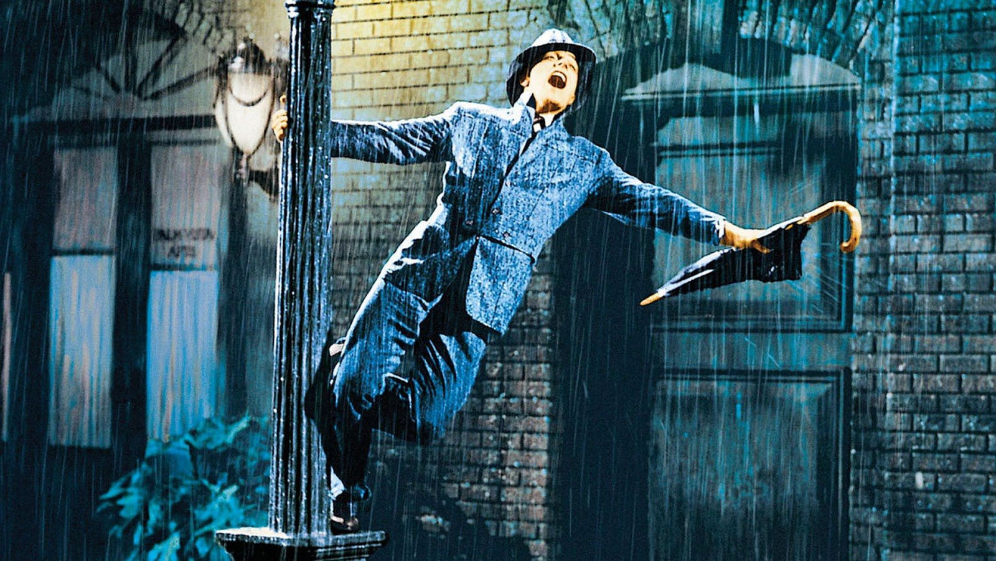**Scene Analysis – Singin’ in the Rain - musical number**

**Watch the above sequence on YouTube.** <https://www.youtube.com/watch?v=D1ZYhVpdXbQ>

Take notes on the following areas:

|  |
| --- |
| **Representation:** Of Don Lockwood (Gene Kelly), his lifestyle, his state of mind, the people he interacts with.  **Aesthetics:** How does this scene make you feel as a spectator? What is the overall mood of the scene? How is this created? How does the music and performance enhance this? |

Comment on all elements of Film Form. How have they been used to create meaning?

|  |  |
| --- | --- |
| **Cinematography:** | **Mise-en-Scène:** |
| **Sound:** | **Editing:** |