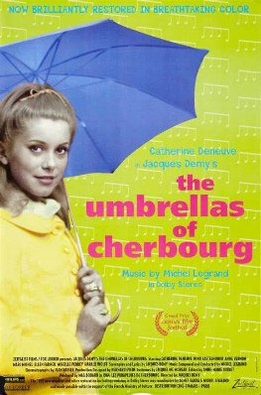

**A Level Film Studies**

*Umbrellas of Cherbourg* (1964)

*During the screening, try to jot down your initial responses to- cinematography, editing, sound, mise en scene, narrative structure and representation.*

Jotting down as much detail as possible, will help with future tasks