**Editing** – *Continuity or non-continuity? Interesting effects and transitions? Shot Length?*

**Cinematography** – Describe the cinematography- *Dynamic camerawork? Fluid? Lighting? Shot on location? Notable scenes?*

**Narrative** – *What is the structure of the story? What are the cause and effect elements? Narrative resolution or closure?*

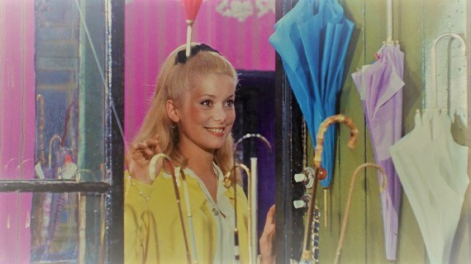

**Mise en scène** – *Notable* *costumes (costume changes), props, locations / décor and performance? Interesting use of colour ?*

**Characters** *–Name the main characters. How are they represented? Consider Age/Gender/Class. Make notes on PERFORMANCE too.*

**Sound** *– Describe the musical score and non-diegetic music chosen? Think about the lyrics used and their relevance to the story?*