BTEC Applied Science: SUPPORT SHEET FOR STUDENTS AND PARENTS
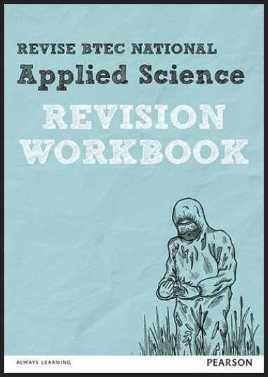


Teachers
Harriet Broughton (Course Leader) hgb@godalming.ac.uk
Mona Chaudhury msc@godalming.ac.uk
Fiona Kennard fvk@godalming.ac.uk

Exam board Pearson (often known as Edexcel)

How to succeed at applied science:
- Show up
Recommended revision guide (available in the library) and workbook
- Do the work
- Ask if you get stuck

Drop in help sessions: Every Friday 1-2pm in lab 141 (you can bring your lunch)

Course structure for year 1:
Unit | Assessment | Proportion of the  2-year course
1: Principles and applications of science | 90 minute exam in May | 25%
2: Practical scientific procedures and techniques | Four internal assignments:  A: Keeping up the standards  B: Keeping your cool  C: Separate to identify  D: How am I doing? | 25%
For the BTEC course you have to pass all units in order to qualify for the qualification. You also must meet all deadlines set for the internal assignments

Students: Where can students get help for themselves?
Teachers are there for guidance with your studies but we maybe different from your school in that we would expect you to have accessed support materials and tried to work out any misunderstandings yourself before seeking out extra help. Rather than coming to a teacher saying ‘I do not get moles’, try to look at websites, textbooks etc. to answer the question yourself first, there is guidance on how to do things in you packs. You can then approach the teacher with more specific questions, either in the lesson or at the drop in help session on Friday lunchtimes. The onus is then on you to take responsibility for your learning. If you have finished the work set and still have some of your 4-5 hrs left the packs will also give guidance of the extra work you could be doing.

Parents: How can you help?
We often get asked by parents of students studying for the BTEC what things they can be doing to help them achieve the best possible grade. Whilst almost all the work that is required to be successful at BTEC must come from the student there are some things that parents can do that can help :-
- Students work through booklets which build into a complete set of notes for the course. These packs contain notes as well as questions and should be completed to the best of their ability. They should be spending 4-5hrs per week on their work outside of lessons.
- For unit 2 which is coursework based. Students should use their notes to help write up their reports, a structure to the report, as well as supporting notes, is available on Godalming Online.
- For unit 1 which is an exam, students could be supported at home by revising and testing their knowledge on the unit as they go through the year. During the year they will be given benchmark assessments which will test them on the knowledge they have learnt so far - encourage them to spend time revising and consolidating content ahead of it.
- Encourage them to attend the drop in workshops run by the Department on Friday lunchtimes for extra help with topics they are finding difficult.
- Learning cannot happen just in the classroom. They have to be responsible for that learning as well. It is something we drill into them from the beginning of their studies. 50% of their learning is expected to happen in the classroom but 50% is also expected OUTSIDE the classroom.

BTEC Applied Science Benchmarks
 | Topic | Dates | Time
Benchmark 1 | Unit 1 | w/b 29/10 | 2 x 45min
Benchmark 2 | Unit 1 | w/b 07/01 | 2 x 45min
Benchmark 3 | Unit 1 | w/b 23/04 | 2 x 45min
Benchmark 4 | Actual examined paper in May |  | 3 x 40min

BTEC Applied Science Papers in 1st year
Unit 1: Biology (40 min)
Unit 1: Chemistry (40 min)
Unit 1: Physics (40 min)

What happens if a student is underperforming?
At Godalming College, there is an ethos of ‘dealing with the student first’. We will work with you to achieve your studies as best we can and parents are only contacted at the review times of January, June in the first year and November and March of the second year. However some students struggle with Applied Science and find they are unable to learn effectively for whatever reason. If your teachers are significantly worried about your progress, we will place you onto a ‘Departmental Action Plan’ (DAP) outside of these review periods. This is where we formalise contact with your parents through a bespoke action plan so that you, the department and your parents can all help you to achieve your potential. These action plans are a supportive mechanism to get you back on track. A failure to meet the action plan will mean that you are referred to your Senior Tutor for further support. Where a student is culpable for their underperformance, the Senior Tutor may decide to place you onto a Formal Warning under the College’s disciplinary procedures. Where a student is struggling for health or other extenuating circumstances, the Senior Tutor may place you onto a ‘Supportive Warning’ to further support your studies.

