# Introduction to Atoms and Elements.

Everything we see around us, benches, computers and you are made of atoms. At one time these atoms were part of something else. Some may have been in the soil, the air or even part of someone else. In other words one of the atoms that make up you could have been in your neighbour’s great grandad.

There are 92 naturally occurring types of atoms, we call these Elements.

Define:-

**ELEMENT** ………………………………………………………………………………………

………………………………………………………………………………………

You will need to be familiar with the symbols for the first 36 elements. For the moment check that you know symbols for the first 30.

## Bohr’s Theory of the atom:

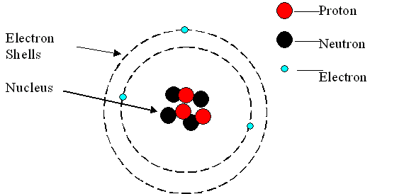

Atoms have a tiny central NUCLEUS containing:

* ……………………………………………………………………………….
* ……………………………………………………………………………….

The nucleus is surrounded by a cloud of

* ………………………………………………………………………………….

These are arranged in shells having different energy levels

The diagram above is of a Lithium atom. How do we know this?

………………………………………………………………………………………………………………………………………………

……………………………………………………………………………………………………………………………………………….

It is the number of **protons** in the nucleus which determines the element. An atom with 6 protons would be the element carbon. This number is called the **ATOMIC NUMBER** of the element, the number of protons also determines its position in the Periodic Table

**Changing the number of neutrons, or electrons does not change the element.**

Find the element:-

|  |  |
| --- | --- |
| No of Protons  (or atomic number) | Name |
| 77 |  |
| 53 |  |
| 47 |  |
| 6 |  |
| 10 |  |
| 92 |  |

# Ions

If the number of electrons surrounding the nucleus is equal to the number of protons inside it, the atom is neutral. If the number of **electrons does not equal the number of protons** it is no longer an atom it is now an ion

**ION** ……………………………………..……………………………………………………………………………………………………..

……………………………………………………………………………………………………………………………………………………

Identify the following ions or atoms, giving the correct symbol

|  |  |  |
| --- | --- | --- |
| **No protons** | **No electrons** | **Symbol** |
| 17 | 18 | Cl- |
| 55 | 54 |  |
| 13 | 10 |  |
| 23 | 21 |  |
| 7 | 10 |  |
| 7 | 4 |  |
| 35 | 36 |  |
| 9 | 9 |  |
| 29 | 28 |  |
| 25 | 23 |  |

# The Periodic Table layout

Elements are arranged on the periodic table according to:

* + - Increasing atomic number
    - The arrangement of electrons in shells.

##### Li

Mass Number

Atomic number

7

3

This information is expressed:

Complete the following table:

|  |  |  |  |  |  |
| --- | --- | --- | --- | --- | --- |
| **Atom** | **Atomic**  **number** | **Mass**  **number** | **Number of**  **protons** | **Number of neutrons** | **Number of electrons** |
| 12C  6 |  |  |  |  |  |
| 23Na  11 |  |  |  |  |  |
|  | 9 | 19 |  |  |  |
|  |  | 40 | 18 |  |  |
|  |  |  | 19 | 20 |  |
|  |  |  |  | 14 | 13 |
| 197Au  79 |  |  |  |  |  |
|  | 35 |  |  | 44 |  |
|  |  | 238 |  |  | 92 |

Websites

Scale of the universe <http://scaleofuniverse.com/>

Videos:

History of the discovery of the atom <http://estream.godalming.ac.uk/View.aspx?ID=3223~4k~jEaGVgFQ> (Bohr 22.24 – 30.02)

Crash course Chemistry - Atom and the nucleus

<https://www.youtube.com/watch?v=FSyAehMdpyI&list=PL8dPuuaLjXtPHzzYuWy6fYEaX9mQQ8oGr>

