A1 Equations and reactions

|  |  |  |  |  |
| --- | --- | --- | --- | --- |
| **Essential**  **Content A1 Structure and bonding** | **Additional Guidance** | **☺** | **😐** | **☹** |
| * balanced equations | * know the formula of common substances such as water, carbon dioxide, oxygen, hydrogen, nitrogen and the halogens * be able to work out the formulae of common ions of elements from their position in the periodic table * know the formulae of ions containing more than one element, such as hydroxide (OH-), carbonate (CO32-), sulfate (SO42-), nitrate (NO3-), ammonium (NH4+) * be able to work out the formulae for ionic compounds from the charges on their ions * be able to write balanced chemical and ionic equations for reactions in this learning aim * know the state symbols (s), (l), (g) and (aq), and use them in balanced equations |  |  |  |
| * atomic number and relative molecular mass | * be able to calculate relative molecular mass (or relative formula mass) of a compound from the sum of the relative atomic masses of all the atoms present |  |  |  |
| * moles, molar masses and molarities. | * know that 1 mole of any substance contains the same number of particles as there are atoms in 12.00g of carbon-12 * that the number of particles in 1 mole is 6.02 x 1023 (known as the Avogadro constant) * be able to convert moles into number of particles using the Avogadro constant (and the reverse) * know that the molar mass of a substance is the mass in grams of 1 mole of the substance (and is the same as the relative atomic mass or relative formula mass expressed in g mol-1) * know that the molarity is the number of moles of a substance dissolved in water to produce a volume of 1 dm3  of a solution and has units of mol dm-3 |  |  |  |

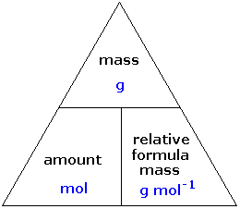

**The mole**

Atoms are tiny, no really tiny

<https://www.ted.com/talks/just_how_small_is_an_atom>

So as scientists we need to come up with some way of counting these very tiny atoms. Think of an equation

H2 + ½ O2 🡪 H2O

What this is telling us is that one hydrogen molecule reacts with ½ an oxygen molecule to make 1 water molecule.

But you cannot weigh out 1 hydrogen molecule it’s too small. So instead we use a concept called the mole

<https://www.youtube.com/watch?v=TEl4jeETVmg>

So 1 mole of anything contains the same number of things 6.02 x 1023 so looking at our equation again we have

6.02x1023 H2 + 3.01x1023 O2 🡪 6.02x1023 H2O

This is horrible so we don’t use it as it makes life far too complicated, but we can say that 6.02 x 1023 = 1 mole so our equation now looks much better

H2 + ½ O2 🡪 H2O

1 mole of Hydrogen reacts with ½ mole of oxygen to make 1 mole of water. This is a balanced equation. It tells us the ratio in moles of how things react together.

So how do we translate this into something a bit more useful, like mass. Well this is where the periodic table comes in. The mass number = mass of 1 mole of that element so

H2 = 2g in 1 mole

O2 = 32g in 1 mole

H2O = 18 g in 1 mole

So if I took 2g of Hydrogen and 16g of oxygen they would make 18g of water.

How do we work out that 1 mole of water = 18g. We have to calculate the Relative molecular mass. This is very similar to the relative atomic mass but for molecules rather than atoms.

**Relative molecular mass**

Finding the RMM relative molecular mass (sometimes called the molar mass)

The relative molar mass of a compound is equal to the sum of the relative atomic masses.

e.g. Calculate the relative molar mass of calcium hydroxide, Ca(OH)2.

Mass of Ca(OH)2 = mass of + mass of + mass of

1 mole of calcium 2 moles of oxygen 2 moles of hydrogen

= 40 + (2 × 16) + (2 × 1)

= 74

Complete the table using your periodic table to look up the relative atomic masses. Be careful to read off the correct values and not confuse them with the atomic numbers.

New exercise

|  |  |  |
| --- | --- | --- |
| **Compound** | **Working** | **RMM** |
| H2SO4 |  |  |
| CH3COOH |  |  |
| C6H12O6 |  |  |
| Fe(NO3)3 |  |  |
| MgCO3 |  |  |

Worksheet

You will need to know the formula of some basic ions, elements and compounds

Compounds and elements

|  |  |
| --- | --- |
| Name | Formula |
| Water |  |
| Oxygen |  |
| Hydrogen |  |
| Nitrogen |  |
| Fluorine, Chlorine, Bromine, Iodine |  |
| Carbon Dioxide |  |

Ions

|  |  |
| --- | --- |
| Hydroxide |  |
| Carbonate |  |
| Sulfate |  |
| Nitrate |  |
| Ammonium |  |

We can use this to write out balanced equations. Remember you cannot change the formula of a compound but you can change the number of moles needed.

Balance the equations below.

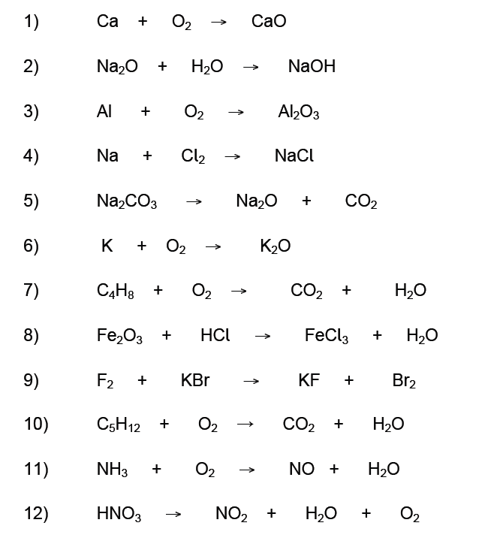

**Test Tube Reactions**

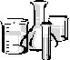A series of experiment to practice writing out equations and making observations

**Method**

1. Into test tube 1 put 2cm3 of sodium chloride then add 2 cm3 silver nitrate
2. Into test tube 2 put 2cm3 of copper sulfate then add a spatula tip of zinc.
3. Into test tube 3 put 2cm3 of sodium carbonate then add 2cm3 of hydrochloric acid
4. Into test tube 4 put a small piece of magnesium ribbon then add 2cm3 of hydrochloric acid

**Results**

In the table below write out your observations and a balanced equation for each reaction. It is important to describe the **initial** **appearance** of the substancesas well as **how they change** and their **final appearance.**

Key words to use correctly:

*solid solution white colourless*

*dissolves reacts crystals powder*

*effervesces*

**Use correct scientific terms**

|  |  |  |
| --- | --- | --- |
| Test tube | Observations | Equation |
| 1 |  | Sodium chloride + silver nirate 🡪 |
| 2 |  | Copper sulfate + zinc 🡪 |
| 3 |  | Sodium carbonate + hydrochloric acid 🡪 |
| 4 |  | Magnesium + Hydrochloric acid 🡪 |

Now we have a basic understanding of the mole we can use it to work out reacting quantities, percentage yields as well as volume and concentration of solutions

Reacting quantities

We have seen that a balanced equation gives us the molar ratio in which things react but before we can do the calculations we need to work out the number of moles given the mass and the mass given the number of moles

To work out the mass we need the formula

**Mass = moles x relative molecular mass**

For example if 1 mole weight 25g then 2 moles will weigh 50 g (ie 2 x 25)

1. Calculate the mass of:
2. 2 moles of C
3. 0.1 moles of Si
4. 0.5 moles NH3
5. 0.25 moles of HNO3
6. 5 moles of CH4

We can also work out the number of moles given the mass

**Mole = mass / relative molecular mass**

1. Calculate the number of moles of:
2. 100g of Fe atoms
3. 8g of Br atoms
4. 24g of MgSO4
5. 10.1g of KNO3

Now we can move on to look at reacting masses and percentage yields

Ppt reacting masses (grimes)

**Step 1** Write ✓ for the substance whose mass is given and ? for the substance whose mass is to calculated on the balanced equation

**Step 2** Find the moles of the  ✓ substance ( using 𝒎𝒐𝒍𝒆𝒔 = 𝒎𝒂𝒔𝒔 / 𝑴𝒓 )

**Step 3** Use the balanced equation and your answer from step 2 to find the moles of the ? substance

**Step 4** Find the mass of the ? substance (using **mass- moles x Mr**)

1. What mass of oxygen reacts with 12g magnesium

2Mg + O2 🡪 2MgO

1. What mass of calcium hydroxide is made from 14kg of calcium oxide

CaO + H2O 🡪 Ca(OH)2

1. What mass of aluminium is needed to react with 640g of iron oxide

Fe2O3 + 2Al 🡪 2Fe + Al2O3

1. What mass of titanium chloride reacts with 460g of sodium

TiCl4 + 4Na 🡪 Ti + 4NaCl

More practice on separate work sheets

These work very well for solids but when it comes to solutions things are more complicated we need to uses concentrations to work out the number of moles. Concentration is simply the umber of moles present in a fixed volume. In chemistry this is 1dm3

So a solution of 1.1 concentration contains 1.1 moles in every 1dm3

A solution of 2.5 concentration contains 2.5 moles in every dm3

A solution of 0.25 concentration contains 0.25 moles in every dm3.

If we wanted to have 1 mole of a substance using a solution of concentration 0.25 how many dm3 would we need? Show your working

If we needed 0.1 mole of a solution of concentration 1 how many dm3 would we need?

If we wanted 0.115 moles of a solution of concentration 1 how many dm3 would we need?

If we wanted 0.0118 moles of a solution of concentration 2, how many dm3 would we need?

All we are doing is scaling up and down from the concentration. If we had to write this as a formula what would it be?

We can rearrange the formula or just scale up and down to find the number of moles in a solution of give concentration where we know the volume

How many moles in a solution of volume 2dm3 and of concentration 2 moles/dm3 (M)

How many moles in a solution of volume 0.5 dm3 and of concentration 1.5 M

(We often use cm3 in titrations so to covert from cm3 to dm3 we divide by 1000)

How many moles in a solution of volume 250cm3 and concentration 1 M

How many moles in 25cm3 of a 1 M solution

How many moles in 18cm3 of a 2 M solution

How many moles in 11.50 cm3 of a 2 M solution

Write out the formula for working out moles of a solution

Lastly given the moles and volume we can work out the concentration remembering that concentration is the number of moles in 1 dm3 (1000 cm3)

What is the concentration of a solution that has 1 mole in 2 dm3

What is the concentration of a solution that has 1 mole in 0.5 dm3

What is the concentration of a solution that has 0.1 mole in 500 cm3

What is the concentration of a solution that has 0.001 moles in 25cm3

What is the concentration of a solution that has 0.000118 moles in 12cm3

What is the concentration of a solution that has 0.000011 moles in 35cm3

Can you write out the formula for finding the concentration