A2 Chemical properties

Properties of the elements

|  |  |
| --- | --- |
| * Understand the physical properties of elements: | The following relate to periods 2, 3 and 4, and groups 1, 2 and 7 |
| * first ionisation energy | * know that the first ionisation energy is the energy required to remove one mole of electrons from one mole of atoms in their gaseous state * understand why first ionisation is always an endothermic process * be able to write an equation to show first ionisation energy for an element using the general equation, X(g) 🡪 X+ (g) + e- |
| * reasons for trends in ionisation energy across Periods 2–4 and down groups 1, 2 and 7 | * know that the trend in ionisation energy decreases down a group * know that the general trend in ionisation energy increases across a period but that there are anomalies at group 3 and group 6 * be able to explain trends in ionisation energy in terms of nuclear attraction, nuclear charge, shells, shielding and atomic radius * be able to explain anomalies in ionisation energy trends in terms of changes in energy level, subshell or electron pairing * understand that successive ionisation energies provide evidence of quantum shells and the group to which the element belongs * understand that the first ionisation energies of successive elements provide evidence for the existence of electron subshells |
| * electron affinity | * know that the first electron affinity is the energy released when 1 mole of gaseous atoms gain one mole of electrons * understand why first electron affinity is an exothermic process, but successive electron affinities are endothermic * be able to write an equation to show first electron affinity for an element using the general equation, X(g) + e- 🡪 X- (g) |
| * atomic radius | * know how atomic radius changes across a period and down a group * be able to explain trends in atomic radius changes in terms of electron shells, nuclear attraction, nuclear charge and shielding |
| * ionic radius | * know how ionic radius changes across a period and down a group, for both positive and negative ions * be able to explain differences in size between atomic radii, ionic radii of positive ions and ionic radii of negative ions |
| * electronegativity | * know that electronegativity is a measure of the tendency of an atom to attract a bonding pair of electrons in a covalent bond * be able to explain trends in electronegativity across a period and down a group |
| * type of bonding in the element | * know that the type of bonding changes from metallic to covalent across a period * know that the type of structure changes from giant structures to simple molecular structures across a period * be able to explain the change in bonding and structure across a period * know that bonding in elements becomes more metallic in character down a group * be able to explain why the bonding in elements becomes more metallic down a group   **(NB Knowledge and understanding of the bonding in metalloid elements is not required)** |
| * trends – melting point and boiling point | * be able to explain changes of state (at melting and boiling point) in terms of particle movement and energy * know the trends in melting and boiling point across a period and down a group * be able to explain trends in melting point and boiling point in terms of bonding and structure of elements |
| * physical properties of metals – electrical conductivity, thermal conductivity, malleability, ductility | * know the physical properties of metals (electrical conductivity, thermal conductivity, malleability and ductility) * be able to explain the physical properties of metals in terms of bonding and structure * be able to compare the physical properties of metals with those of non-metals |

The periodic table

All elements are either metals or non-metals. Metals bond using metallic bonds and non-metals with covalent bonds. There is no such thing as an ionic element. Ionic bonds form between a metal and a non-metal.

On the periodic table colour in the metals in one colour and the non-metals in a different colour. The elements along the dividing line are sometimes called metalloids as they can have both metallic and non-metallic properties

|  |  |  |  |  |  |  |  |  |  |  |  |  |  |  |  |  |  |  |
| --- | --- | --- | --- | --- | --- | --- | --- | --- | --- | --- | --- | --- | --- | --- | --- | --- | --- | --- |
|  |  |  |  |  |  |  |  |  |  |  |  |  |  |  |  |  |  |  |
|  |  |  |  |  |  |  |  |  |  |  |  |  |  |  |  |  |  |  |
|  |  |  |  |  |  |  |  |  |  |  |  |  |  |  |  |  |  |  |
|  |  |  |  |  |  |  |  |  |  |  |  |  |  |  |  |  |  |  |
|  |  |  |  |  |  |  |  |  |  |  |  |  |  |  |  |  |  |  |
|  |  |  |  |  |  |  |  |  |  |  |  |  |  |  |  |  |  |  |
|  |  |  |  |  |  |  |  |  |  |  |  |  |  |  |  |  |  |  |

**Atomic radius**

The atomic radius depends on

1. The number of protons in the nucleus.
2. The number of shells

As you go down a group the atomic radius increases because ……………………………………………………………………………………………………………………………………………………………………………………………………………………………………………………………………………………………………………………………………………………………………………………………………………………………………………….

As you go across a period the atomic radius decreases because ……………………………………………………………………………………………………………………………………………………………………………………………………………………………………………………………………………………………………………………………………………………………………………………………………………………………………………….

**Ionic radius**

The same principle applies to ions as well as atoms, so as you go down a group the size increases due to an increased number of shells

Cations

Cations are + ve ions, they have lost electrons so are smaller than the parent atom

Anions are –ve ions, they have gained electrons so are larger than the parent atom.

Atoms react with each other so that they get full outer shells of electrons.

• The easiest way for **metal** atoms to get a full outer shell is to **lose** electrons.

• The easiest way for **non-metal** atoms to get a full outer shell is to **gain** electrons.

**Ionisation energy**

Ionisation energy is the energy needed to remove the outermost electron from a gaseous atom to make a + ion. This is the way metals react.

The strength of this ionisation energy depends on (the weaker the better)

1. The number of protons in the nucleus. More protons = stronger force
2. The distance between the electron and the nucleus. Greater distance = less force
3. The number of inner shells between the electron and the nucleus, we call this shielding. More shielding (ie more shells) = less force

Define the first ionisation energy of an element. ………………………………………………….

………………………………………………………………………………………………………………………………………………………………………………………………………………………………………………………………………………………………………..

……………………………………………………………………………………………………

**Group 1, 2 and 7**

The change in ionisation energies going down any group is explained in the same way.

As you go down a group what happens to the

Radius of the atom ………………………………………………………………………………………………………

No of protons………………………………………………………………………………………………………………

No of inner shells (and hence shielding)……………………………………………………………………..

Of these three the most important is distance. If that increases the ionisation energy will decrease.

So down any group the ionisation energy will increase/decrease

Explain why the first ionisation energy of Na is greater than that of K

……………………………………………………………………………………………………………………………………………………………………………………………………………………………………………………………………………………………………………………………………………………………………………………………………………………………………………….

Explain why the first ionisation energy of Phosphorus is greater than that of Arsenic ……………………………………………………………………………………………………………………………………………………………………………………………………………………………………………………………………………………………………………………………………………………………………………………………………………………………………………….

Explain why the first ionisation energy of Chlorine is greater than that of Bromine …………………………………………………………………………………………………………………………………………………………………………………………………………………………………………………………………………………………………………………………………………………………………………………………………………………………………………….

Trend in ionisation energy across periods 2-4

Again the same arguments apply we need to consider distance, proton number and shielding.

As you go across a period

Radius of the atom ………………………………………………………………………………………………………

No of protons………………………………………………………………………………………………………………

No of inner shells (and hence shielding)……………………………………………………………………..

Hence in general the ionisation energy increases/decreases

Write on the chart below the symbols for the first 20 elements

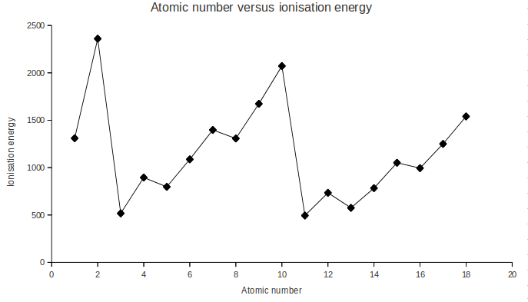

Although you should note that the general trend is upwards there are a couple of ‘blips’ and some big changes

Big changes are between periods He to Li or Ne to Na. This is because we are adding a whole new shell

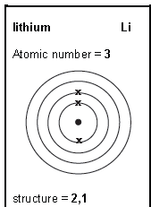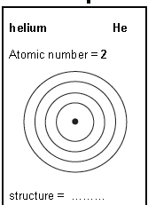

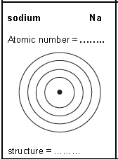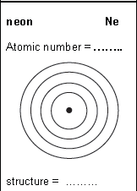

Circle the electron being removed. The big jumps are where we are moving up to a new shell.

This helps identify which group the element is in as we can count the number of electrons removed before the big jump.

However this does not help with the small jumps between Be and B or Mg and Al, or the jumps between N and O or P and S

Jumps between group 2 & 3

Draw out the electron configuration for

Be

B

Mg

Al

You should have noticed that the last electron for B and Al is in a p subshell, but for Be and Mg it is in an s subshell. **The p subshell electron is easier to remove**.

Jumps between group 5 & 6

Draw out the electron configuration for

N

O

P

S

This time there is no change in the subshell but in O and S the element has 4 electrons in the p subshell which means they have to share an orbital. Electrons repel each other hence the **paired electron is easier to remove than an unpaired electron**.

Electron Affinity

Metals react by losing electrons, non-metals by gaining electrons. The process of removing electrons is called ionisation, the process of adding electrons is called electron affinity.

Define the electron affinity of an element. ………………………………………………….

………………………………………………………………………………………………………………………………………………………………………………………………………………………………………………………………………………………………………..

……………………………………………………………………………………………………

Just like all atoms can undergo ionisation, all atoms can have an electron added. Although for metals it is so high that we don’t bother with it.

Electron affinity depends on

1. The number of protons in the nucleus. More protons = stronger force
2. The distance between the electron and the nucleus. Greater distance = less force
3. The number of inner shells between the electron and the nucleus, we call this shielding. More shielding (ie more shells) = less force

This is exactly the same as ionisation energy, only this time we want to add an electron not take one away so a stronger force is better.

The change in electron affinity going down any group is explained in the same way.

As you go down a group what happens to the

Radius of the atom ………………………………………………………………………………………………………

No of protons………………………………………………………………………………………………………………

No of inner shells (and hence shielding)……………………………………………………………………..

Of these three the most important is distance. If that increases the electron affinity will decrease.

So down any group the electron affinity will increase/decrease

Explain why electron affinity of Chlorine is greater than that of Bromine …………………………………………………………………………………………………………………………………………………………………………………………………………………………………………………………………………………………………………………………………………………………………………………………………………………………………………….

Period 2 Electron affinity

The elements in period 2 have lower electron affinities than the elements in period 3 of the same group.

You might expect this to be the other way round as Fluorine is smaller than chlorine so should have a higher electron affinity. However we are trying to add an electron to a region that is already full of electrons so there is repulsion between the incoming electron and the electrons in the outer shell.

**Electronegativity** (Do not confuse this with electron affinity)

Electronegativity is the ability of an atom to attract a bonding pair of electrons. Again we need to consider

1. The number of protons in the nucleus. More protons = stronger force
2. The distance between the nucleus ad the bonding pair of electrons. Greater distance = less force
3. The number of shells between the nucleus and the bonding pair, we call this shielding. More shielding (ie more shells) = less force

The atom with the best ability to attract a boding pair of electrons is fluorine, due to its size. It is given a value of 4.0 the highest of all the elements

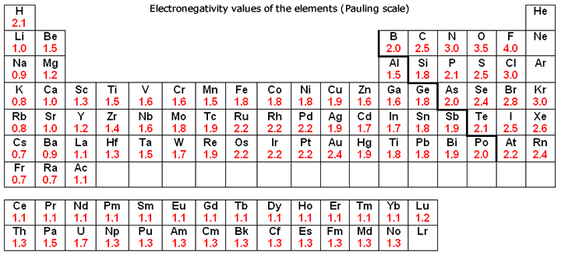

The bigger the difference in electronegativity the more ionic the bond the closer the more covalent.

**Method 2** **Finding Bonds With Electronegativity**

1. Find the electronegativity difference between the two atoms. ...
2. If the difference is below about 0.5, the bond is nonpolar covalent. ...
3. If the difference is between 0.5-1.6, the bond is polar covalent. ...
4. If the difference is over 2.0, the bond is ionic.

So work out if the flowing compounds are covalent or ionic

NaCl Difference in electronegativity = ……………………………………………………………………………………

So NaCl is …………………………….

HCl Difference in electronegativity = ……………………………………………………………………………………

So HCl is …………………………….

NO Difference in electronegativity = ……………………………………………………………………………………

So NO is …………………………….

Al2O3 Difference in electronegativity = …………………………………………………………………………………

So Al2O3 is …………………………….

AlCl3 Difference in electronegativity = ……………………………………………………………………………………

So AlCl3 is …………………………….

Note Al can be covalent or ionic. It all depends on what it is bonded to.

**Type of bonding in the element**

Elements are either covalently bonded or metallically bonded, **never** ionically bonded.

Period 2 elements Metallic, Simple Covalent, Giant covalent

|  |  |  |  |  |  |  |  |  |
| --- | --- | --- | --- | --- | --- | --- | --- | --- |
| **Element** | **Lithium** | **Beryllium** | **Boron** | **Carbon** | **Nitrogen** | **Oxygen** | **Fluorine** | **Neon** |
| Type of bonding/  structure |  |  |  |  |  |  |  |  |
| State at room temp |  |  |  |  |  |  |  |  |
| Hi  kJ mol-1 | 519 | 900 | 799 | 1090 | 1400 | 1310 | 1680 | 2080 |
| M.Pt.  (oC) | 180  LOW | 1278 | 2300 | 3500    HIGH | -210 | -218 | -220 | -249  LOW |

Why cannot the elements be bonded ionically?..........................................................................................................................................................

Giant Covalent elements have very high melting and boiling points, Why?

Period 3 elements

|  |  |  |  |  |  |  |  |  |
| --- | --- | --- | --- | --- | --- | --- | --- | --- |
| **Element** | **Sodium** | **Magnesium** | **Aluminium** | **Silicon** | **Phosphorus**  **(white)** | **Sulphur** | **Chlorine** | **Argon** |
| Type of bonding/  structure |  |  |  |  |  |  |  |  |
| State at room temp |  |  |  |  |  |  |  |  |
| Hi  kJ mol-1 | 494 | 736 | 577 | 786 | 1060 | 1000 | 1280 | 1520 |
| M.Pt.  (oC) | 98  LOW | 639 | 660 | 1410    HIGH | 44 | 113 | -101 | -189  LOW |

Simple (molecular) covalent elements have very low bp, this is due to the weak forces between molecules not the strong forces between the atoms in the molecules (we will study this in detail when we look at intermolecular forces)

Trends in melting and boiling points

Plot a graph of the melting points of the elements in period 2

|  |  |  |  |  |  |  |  |  |
| --- | --- | --- | --- | --- | --- | --- | --- | --- |
| Element | **Li** | **Be** | **B** | **C** | **N** | **O** | **F** | **Ne** |
| M.Pt./oC | 180 | 1278 | 2300 | 3500 | -210 | -218 | -220 | -249 |

Now on the same graph plot the melting points of the elements in period 3

|  |  |  |  |  |  |  |  |  |
| --- | --- | --- | --- | --- | --- | --- | --- | --- |
| Element | **Na** | **Mg** | **Al** | **Si** | **P** | **S** | **Cl** | **Ar** |
| M.Pt./oC | 98 | 639 | 660 | 1410 | 44 | 113 | -101 | -189 |

Colour the metals, simple covalent, giant covalent elements

Metals

What is the trend across the period for the metals ……………………………………………………………

Why?

Notice giant covalent are much higher than simple covalent, in giant covalent to melt we have to break covalent bonds lots of energy needed, in simple covalent we only have to break weak intermolecular forces, much less energy required.

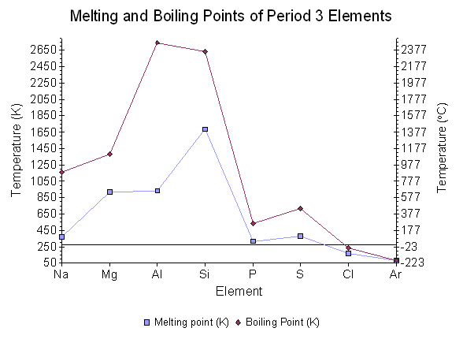

Notice boiling points follow a similar pattern to melting points, for the same reasons

Metals

Metallic bonding

Metals make up the largest part of the periodic table they form regular lattice structures of cations (positively charges ions) surrounded by a sea of delocalised electrons

**DEFINITION**: Metallic bonding is the electrostatic attractions between positive metal cations and the delocalised electrons.

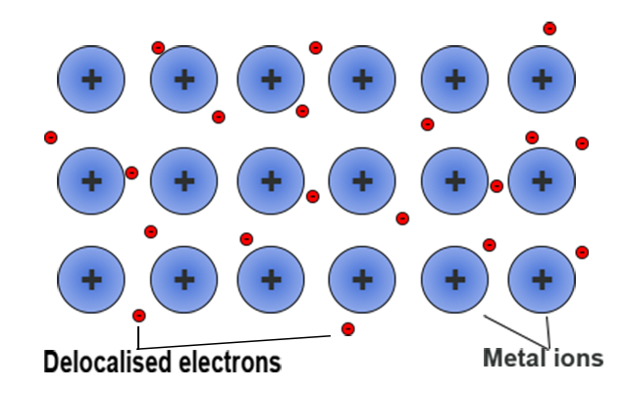

Properties of the metals; electrical conductivity, thermal conductivity, malleability, ductility.

**Electrical and Thermal conductivity**

Metals conduct electricity because they have a metallic structure with delocalised electrons which are carry charge.

In the same way metals conduct heat because the delocalised electrons can carry kinetic energy (Heat energy)

Malleability – The ability to be hammered into shape without breaking

The cations are in rows that can slip or move over each other, this allows the metal to be hammered into different shapes

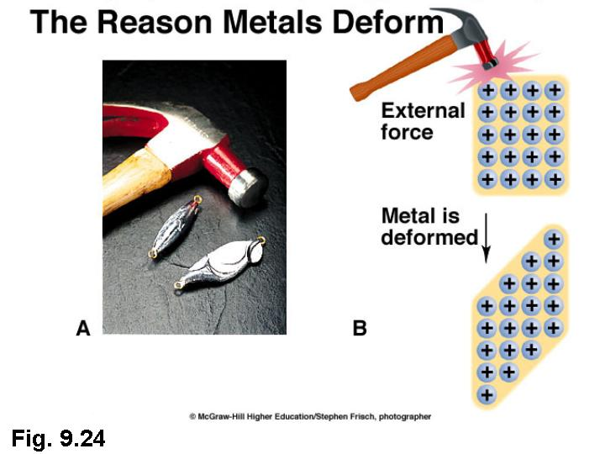

Ductility – The ability to be hammered or stretched into wires without breaking

The cations are in rows/layers that can slide/move over each other so the metal can be drawn into wires without breaking

<https://www.youtube.com/watch?v=vOuFTuvf4qk>

<https://www.youtube.com/watch?v=eVv3TpaQ2-A>







