A2 Chemical properties

Chemical properties of the elements

|  |  |
| --- | --- |
| * Understand the chemical properties of elements: |  |
| * products and reactivity of all Period 2 and 3 elements with oxygen | * know how all period 2 and period 3 elements react with oxygen * be able to predict the formulae of simple oxides of period 2 and 3 elements * be able to write balanced equations for the reactions of these elements with oxygen * understand why incomplete combustion might take place and predict the products * know the bonding and structure of simple oxides of period 2 and 3 elements * know how the bonding of simple oxides changes across periods 2 and 3, from ionic to covalent * know how the structure of simple oxides changes across periods 2 and 3, from giant structures to simple molecular structures * know and be able to explain the properties of simple oxides of period 2 and 3 elements (melting and boiling points, solubility in water and acid-base nature) |
| * products and reactivity of metals with oxygen, water, dilute hydrochloric acid and dilute sulfuric acid | * be able to predict the reactions of metals (groups 1 and 2, and period 4 transition metals) with:   + oxygen to give oxides   + water (cold, hot and steam) to give hydroxides or oxides, and hydrogen   + dilute acids (HCl or H2SO4) to give chlorides or sulfates, and hydrogen * be able to provide expected observations, such as fizzing and flame colour, where a reaction takes place * be able to predict the formulae of the products from these reactions * be able to write balanced chemical and ionic equations for these reactions * know the bonding and structure of products from these reactions * know and be able to explain the properties of these products (melting and boiling points, solubility in water and acid-base nature) |
| * position of metals in the reactivity series in relation to position in the periodic table | * know that the trend in reactivity of metals increases down groups 1 and 2 and decreases across periods 2 and 3 * be able to explain the trend in reactivity of metals down groups and across periods in terms of nuclear attraction for outer shell electrons, nuclear charge, shielding and atomic radius * be able to predict the position of a metal in the reactivity series from its position in the periodic table |
| * oxidation | * understand that oxidation is the loss of electrons or the gain of oxygen * be able to determine the oxidation number (oxidation state) of an element on its own, in a compound or in an ion * be able to identify an element that is oxidised in an equation * be able to show how an element is oxidised, in terms of an increase in oxidation number (oxidation state) * be able to write chemical equations and half equations showing oxidation |
| * reduction | * understand that reduction is the gain of electrons or the loss of oxygen * be able to identify an element that is reduced in an equation * be able to show how an element is reduced, in terms of a decrease in oxidation number (oxidation state) * be able to write chemical equations and half equations showing reduction |
| * variable oxidation states of transition metal ions | * understand that transition metals can have ions with different oxidation numbers (oxidation states) * be able to determine the oxidation number (oxidation state) of a transition metal in an ion or ionic compound |
| * displacement reactions of metals/halogens | * understand that displacement reactions are redox reactions (simultaneous reduction and oxidation) * be able to predict the outcome of displacement reactions between a metal and a compound of a different metal, based upon the relative reactivity of the metals for group 2 and 3 metals and period 4 transition metals * be able to predict the outcome of displacement reactions between a halogen and a halide, based upon the relative reactivity of group 7 elements * be able to provide expected observations, such as colour change and heat given out, when a displacement reaction takes place * be able to write balanced chemical equations, ionic equations and half equations for displacement reactions |
| * uses and applications of substances produced within this learning aim | * know the uses and applications of oxides of period 2 and 3 elements, based upon their properties, bonding and structure * know the uses and applications of oxides, hydroxides, chlorides and sulfates of group 1 and 2 elements, and period 4 transition metals, based upon their properties, bonding and structure   **(NB Only the general properties of ionic, simple molecular and giant covalent compounds are expected to be known)** |

Understand the chemical properties of elements:

products and reactivity of all Period 2 and 3 elements with oxygen

The elements of period 2 and 3 can react with oxygen to form the oxide.

**For Period 2**, remember to balance

Group 1 (metal) Li + O2 🡪

Group 2 (metal) Be + O2🡪

Group 4 (non metal) C + O2 🡪

**For Period 3**

Group 1 (metal) Na + O2 🡪

Group 2 (metal) Mg + O2 🡪

Group 3 (Metal) Al + O2 🡪

Group 4 (Non Metal) Si + O2 🡪

Group 5 (non Metal) P + O2 🡪

Group 6 (non Metal) S + O2 🡪

Group 7 (non Metal) Cl2 + O2 🡪

When a non metal reacts with oxygen the product has ………………………………. Bonding. When

a metal reacts with oxygen the product has …………………………. Bonding

All of these assume that you have enough oxygen. However, this is not always the case. With carbon, you can get incomplete combustion, to form carbon monoxide

2C + O2 🡪 2CO This is dangerous because Carbon monoxide is poisonous.

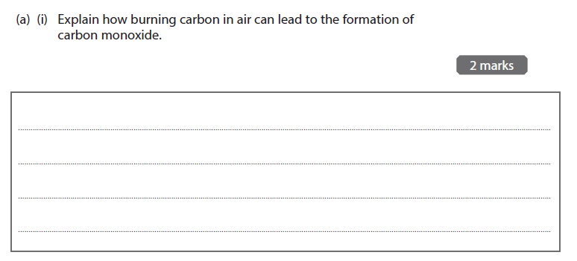

When the non metals react with oxygen eg Carbon, we get simple covalent oxides with low boiling points, which dissolve in water to make an acidic solution

When the metals react with oxygen eg Magnesium we get giant ionic oxides, with high melting points, which if soluble in water make an alkali solution.

Flame Tests

As we saw in the Physics topics , when elements are heated they can give off specific frequencies of light.

Each element has a unique pattern of spectra lines which can help to identify the element

<https://www.youtube.com/watch?v=TfHLxDQNu70>

|  |  |  |  |
| --- | --- | --- | --- |
| **Group I element** | **Flame colour** | **Group II element** | **Flame colour** |
| Lithium |  |  |  |
| Sodium |  | Magnesium |  |
| Potassium |  | Calcium |  |
| Caesium |  | Barium |  |

Products and reactivity of metals with dilute hydrochloric acid and dilute sulfuric acid

Metals react with hydrochloric acid to produce hydrogen and a chloride

Metals react with sulfuric acid to produce hydrogen and a sulfate (SO42-)

Metals + Sulfuric acid

Group 1 (metal) Na + H2SO4 🡪

Group 2 (metal) Mg + H2SO4 🡪

Transition (Metal) Fe + H2SO4 🡪

Metals + Hydrochloric acid

Group 1 (metal) Na + HCl 🡪

Group 2 (metal) Mg + HCl 🡪

Transition (Metal) Fe + HCl🡪

We can tell which group in the periodic table an element belongs to and hence its reactivity by looking at ionisation energies.

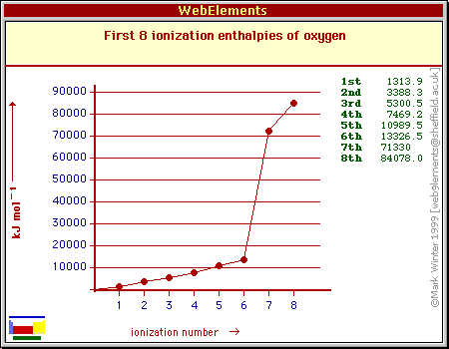

This element is in Group 6

We can tell this because it has 6 electrons before the big jump. Therefore it has 6 electrons in its outer shell

[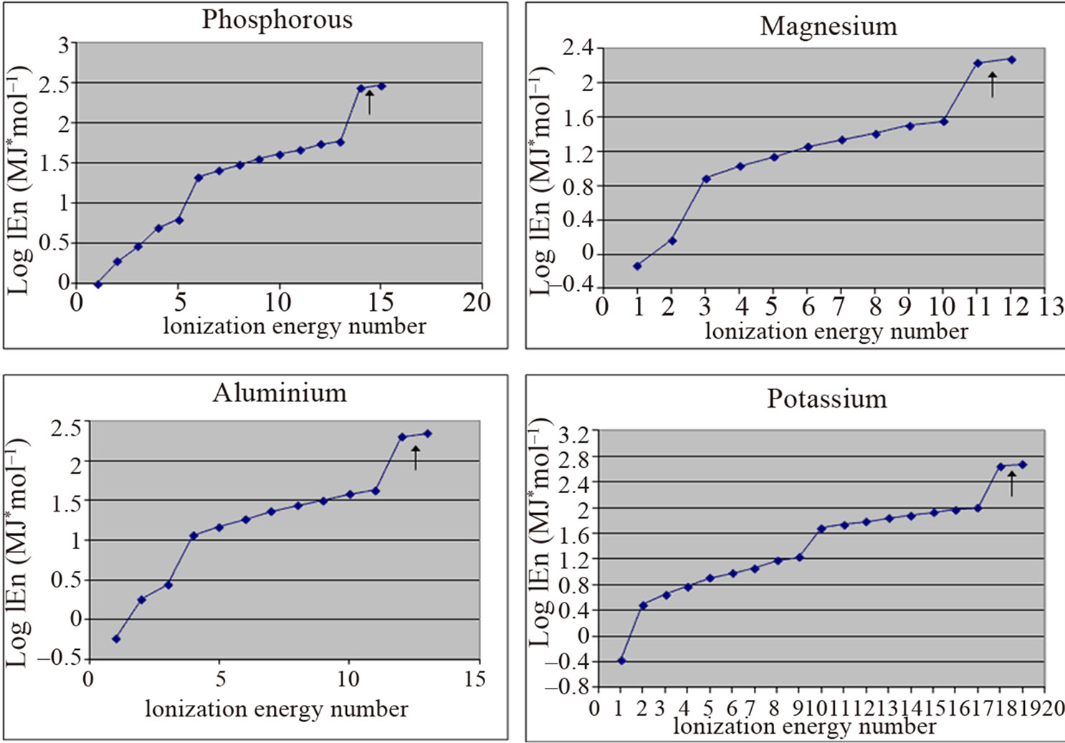](http://file.scirp.org/Html/9-1230088_24981.htm)

Phosphorous has 5 electrons in its outer shell. Hence the big jump between the 5th and 6th electrons

Draw the Dot cross Diagram for Phosphorous match the shells to the graph

[](http://file.scirp.org/Html/9-1230088_24981.htm) Draw the Dot cross Diagram for Mg

Draw the Dot cross Diagram for Al

[](http://file.scirp.org/Html/9-1230088_24981.htm)

Draw the Dot cross diagram for K

[](http://file.scirp.org/Html/9-1230088_24981.htm)

Position of metals in the reactivity series in relation to position in the periodic table

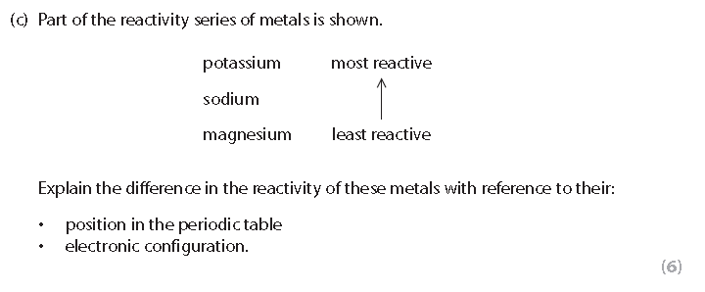

……………………………………………………………………………………………………………………………………………………………………………………………………………………………………………………………………………………………………………………………………………………………………………………………………………………………………………………………………………………………………………………………………………………………………………………………………………………………………………………………………………………………………………………………………………………………………………………………………………………………………………………………………………………………………………………………………………………………………………………………………………………………………………………………………………………………………………………………………………………………………………………………………………………………………………………………………………………………………………………………………………………………………………………………………………………………………………………………………………………………….

General points

Reactions with Water

Group 1 elements all react violently with water. As the reactivity increases down the group they become more reactive with water

Eg

Li + 2H2O 🡪 Li(OH) + H2

What are your observations?

………………………………………………………………………………………………………………………………………………………………………………………………………………………………………………………………………………………………

Na + 2H2O 🡪 Na(OH) + H2

What are your observations?

………………………………………………………………………………………………………………………………………………………………………………………………………………………………………………………………………………………………

K + 2H2O 🡪 K(OH) + H2

What are your observations?

………………………………………………………………………………………………………………………………………………………………………………………………………………………………………………………………………………………………

Group 2 are less reactive than group 1. So Magnesium needs steam to react. It produces the oxide rather than the hydroxide

Mg + H2O 🡪 MgO + H2

What are your observations?

………………………………………………………………………………………………………………………………………………………………………………………………………………………………………………………………………………………………

Barium and the other group 2 metals are more reactive and produce the hydroxide and hydrogen in the same way as the group 1

Ba + 2H2O 🡪 Ba(OH)2 + H2

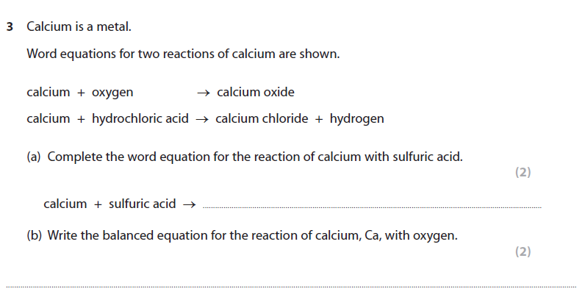

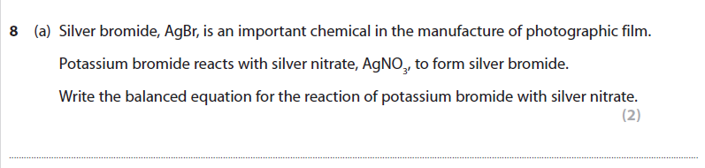

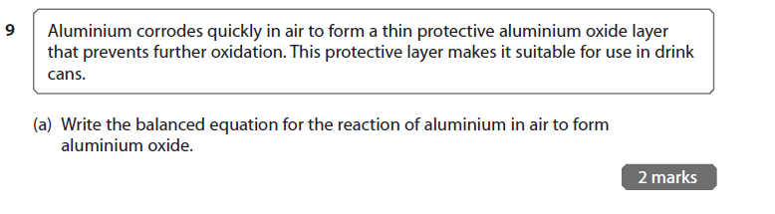

Oxidation and reduction

Oxidation is defined as the loss of electrons OIL Reduction is defined as the gain of electrons RIG

**OIL RIG**

Metals undergo loss of electrons (OXIDATION) easily because they have low ionisation energies

Non Metals undergo gain of electrons (REDUCTION) as they have high electron affinity

Oxidation Numbers

We can give oxidation numbers to species, this is the charge the species would have if the bonding was 100% ionic. It is usually the same as the charge. Elements are Zero

Remember your charges on ions

Oxide …………………………

Sulfate………………………….. Nitrate…………………………

Chloride………………… Bromide…………………. Iodide………………………

All group 1 ions …………………………. All group 2 ions ………………………..

Eg

Label the oxidation state of each element in:

1. Na2S
2. SO2
3. CaO
4. Pb2+

Once you have assigned oxidation numbers you can use them to do redox equations, and work out what is being oxidised and reduced, by adding electrons so that the charges add up

1) Br2 + e- 🡪 Br-

2) I2 + e- 🡪 I-

3) Fe2+ 🡪 Fe3+ + e-

4) Na 🡪 Na+ + e-

5) Pb4+ + e- 🡪 Pb2+

If the oxidation number goes up the atom has been oxidised if it goes down it has been reduced.

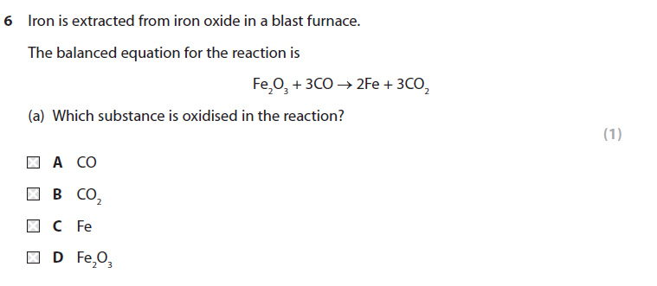

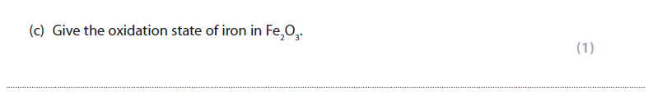

Explain why these are all redox reactions

1. Cl2 + 2NaBr 🡪 2NaCl + Br2
2. CuSO4 + Zn 🡪 ZnSO4 + Cu
3. 2Mg + O2 🡪 2MgO

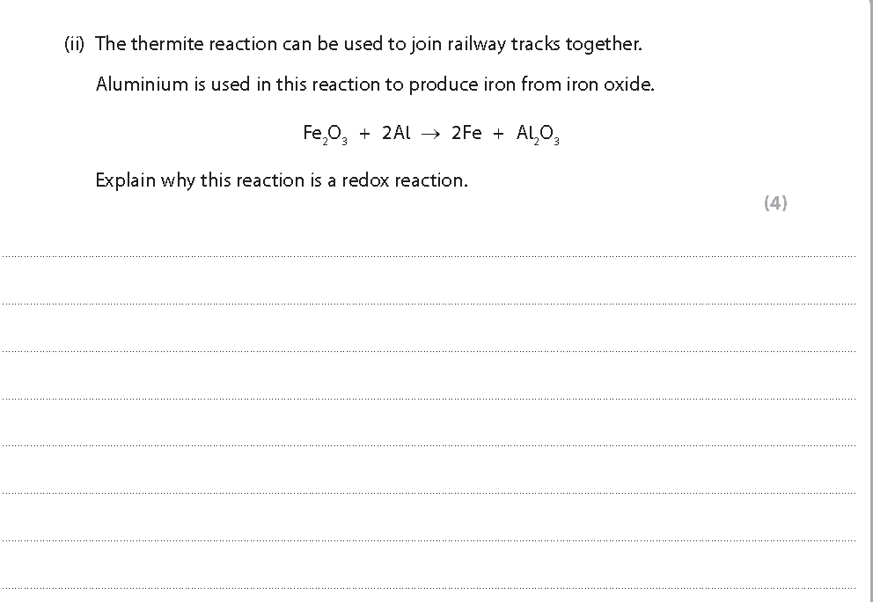

A more reactive metal will displace a less reactive ones based on their position in the reactivity series. However, these are all redox reactions as they involve a change in oxidation number

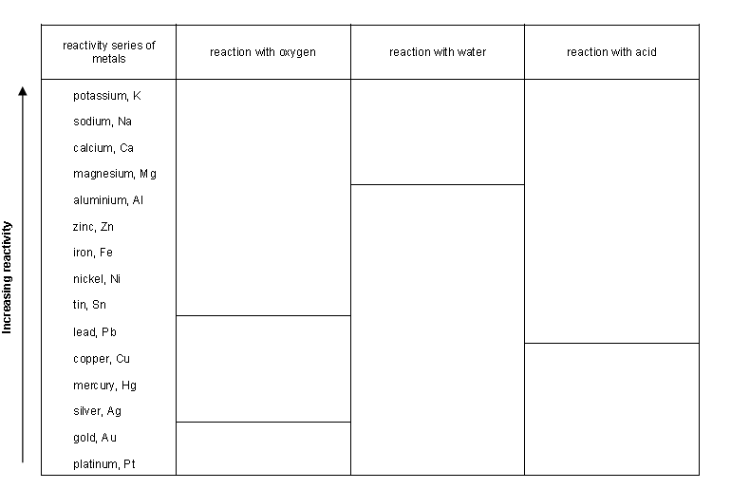

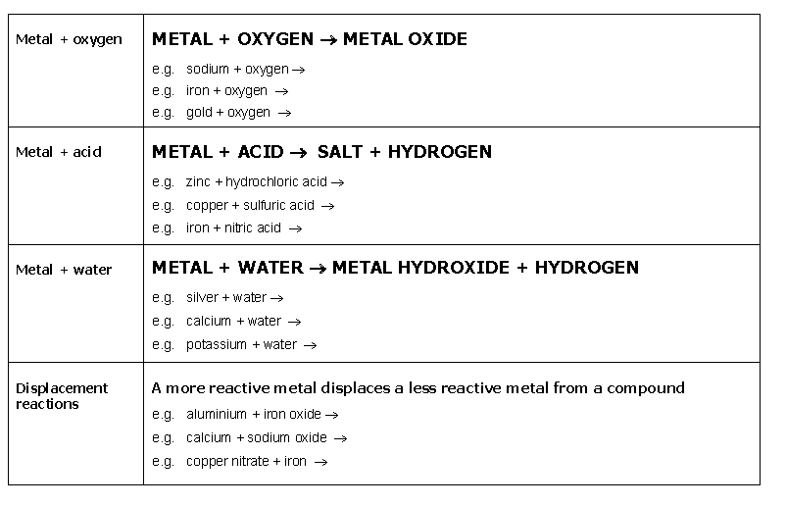

The Halogen reactions provide good examples of displacement reactions (oxidation and reduction reactions)

A more reactive halogen will displace a less reactive one

Fluorine Most reactive

Chlorine

Bromine

Iodine Least reactive

Fill in the boxes with your observations

|  |  |  |  |
| --- | --- | --- | --- |
|  | Potassium chloride  solution | Potassium bromide solution | Potassium iodide solution |
| Chlorine |  |  |  |
| Bromine |  |  |  |
| Iodine |  |  |  |

Equations _ Predict the products of the following reactions (if no reaction occurs say so)

1. NaCl + Br2 🡪
2. Cl2 + CaI2 🡪
3. Br2 + KI 🡪
4. I2 + NaBr 🡪

Transition metals

These metals fill up the block in the middle of the period table. They are defined as

An element that has one or more stable ions with incompletely filled d-orbitals.



These ions give the transition metals their properties

1. They are all metals
2. They form coloured compounds
3. They are good catalysts

Use your knowledge of group 1 and transition metal to complete the Venn diagram

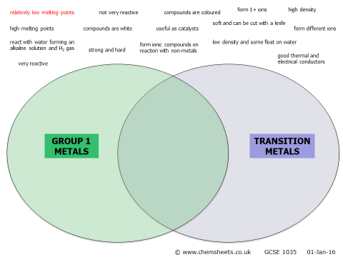

Ionic Equations

In chemistry we are only interested the the species taking part in the reaction, not in the spectator ions which do not take part

Eg

**Step by Step guide to writing ionic equations**

**1** Write down the balanced equation, with **state symbols**

FeSO4(aq) + 2NaOH(aq) → Fe(OH)2(s) + Na2SO4(aq)

**2** Convert those chemicals that are ions **in solution (anything with aq state symbol)** into their ions

Fe2+(aq) + SO42- (aq) + 2Na+(aq) + 2OH-(aq) → Fe(OH)2(s) + 2Na+(aq) + SO42-(aq)

**3** Cross out those ions that appear on both sides of the equation (**spectator ions**)

Fe2+(aq) + ~~SO~~~~4~~~~2-~~ ~~(aq)~~ + ~~2Na~~~~+~~~~(aq)~~ + 2OH-(aq) → Fe(OH)2(s) + ~~2Na~~~~+~~~~(aq)~~ + ~~SO~~~~4~~~~2-~~~~(aq~~

**4.** Check that the atoms **and** the charges balance.

**Ionic equation:** Fe2+(aq) + 2OH-(aq) → Fe(OH)2(s)

Write ionic equations for the following reactions:

Sodium chloride solution + silver nitrate solution 🡪 silver chloride solid precipitate + sodium nitrate solution.

Full symbol equation, with state symbols

………………………………………………………………………………………………………

Ionic equation with ALL the **ions** identified:

………………………………………………………………………………………………………

Cross out spectator ions in the equation above and write the resulting ionic equation:

………………………………………………………………………………………………………

1. Copper sulfate solution + zinc 🡪 zinc sulfate solution + copper

Full symbol equation, with state symbols:

………………………………………………………………………………………………………

Ionic equation with ALL the **ions** and **atoms** identified:

………………………………………………………………………………………………………

Cross out spectator ions in the equation above and write the resulting ionic equation:

………………………………………………………………………………………………………

1. Sulfuric acid solution + zinc 🡪 zinc sulfate solution + hydrogen gas

Full symbol equation, with state symbols:

………………………………………………………………………………………………………

Ionic equation with ALL the **ions, atoms** and **molecules** identified:

………………………………………………………………………………………………………

Cross out spectator ions in the equation above and write the resulting ionic equation:

………………………………………………………………………………………………………

1. Sodium carbonate solution + hydrochloric acid solution 🡪 sodium chloride solution + carbon dioxide + water

Full symbol equation, with state symbols:

………………………………………………………………………………………………………

Ionic equation with ALL the **ions** and **molecules** identified:

………………………………………………………………………………………………………

Cross out spectator ions in the equation above and write the resulting ionic equation:

………………………………………………………………………………………………………

Ionic Equations Worksheet

1. _____ Zn (s) + _____ AgNO3 (aq)  _____ Zn(NO3)2 (aq) + _____ Ag (s)

2. _____ NaCl (aq) + _____ AgNO­3 (aq)  _____ NaNO3 (aq) + _____ AgCl (s)

3. _____ Ca(OH)2 (aq) + _____ H3PO4 (aq)  _____ H2O (l) + _____ Ca3(PO4 )2 (aq)

4. _____ HNO3 (aq) + _____ Ni (s)  _____ Ni(NO3)2 (aq) + _____ H2 (g)

5. ____ Ba(HCO3)2 (aq) + ___ HCl (aq) ____ BaCl2 (aq) + ___ H2O (g) + ___ CO2 (g)

6. _____ BaCl2 (aq) + _____ Na2SO4 (aq)         _____ NaCl (aq) + _____ BaSO4 (s)

7. _ Al2(CO3)3 (aq) + ____ HNO3 (aq) ____ Al(NO3)3 (aq) +___H2O (l) + __CO2 (g)

Research the uses and applications of oxides of period 2 and 3 elements, based upon their properties, bonding and structure.

Research the uses and applications of oxides, hydroxides, chlorides and sulfates of group 1 and 2 elements, and period 4 transition metals, based upon their properties, bonding and structure