C2 Waves in Communication

|  |  |
| --- | --- |
| **C2 Waves in communication** |  |
| * Understand the principles of fibre optics: | * know that fibre optics depends upon the total internal reflection of light rays travelling through tiny glass fibres * know that a fibre optic cable consists of large numbers of these fibres * know that the cladding around the glass fibre has a lower refractive index than the glass fibre. The material is chosen to maximise total internal reflection in the fibre * be able to use the refractive index equation both from an optically less dense into an optically more dense material, to include air into glass (ang), or from a(n optically) more dense material into a(n optically) less dense material e.g. from glass into air, (1/ ang) * be able use the correct equation to calculate a value from:   *n = c/v*  or  *n = sin i/ sin r*  or  *c/v = sin i/sin r*   * be able to draw diagrams to illustrate the effect of refraction at an interface * know that refraction occurs because of a change in wave speed at the boundary between two mediums with different refractive indices * be able to draw accurate diagrams to show total internal reflection at an interface * understand a range of different applications of total internal reflection and critical angle to include fingerprinting devices e.g. for mobile phones, and rain detectors e.g. for car windscreens * calculate the critical angle given the refractive index of the more dense medium using *sin c = 1/n,* i.e. * be able to substitute a value for either the critical angle, *c* or the refractive index of the more dense medium, *n* into this equation and calculate a value of the other term |
| * Understand the applications of fibre optics in medicine to include endoscopes | * understand how a light ray passes by total internal reflection through a bundle of optical fibres in an endoscope to illuminate an area of interest * know that light is reflected from this area and enters a second bundle of optical fibres * know that the image is returned to be viewed through this second bundle of optical fibres by total internal reflection * know that each fibre gives a small part of the complete image |
| * Understand the applications of fibre optics in communication, to include: |  |
| * analogue and digital signals: analogue-to-digital conversion, broadband | * understand and be able to describe and draw analogue and digital signals * understand the advantages and disadvantages of digital signals compared with analogue signals e.g. that digital signals are less affected by noise and have less energy loss (attenuation) than analogue signals and can therefore travel further * know that a continuously varying analogue signal is sampled at fixed intervals of time * know that the sample values are then converted into a digital binary code to be transmitted as a stream of pulses * know that broadband is the system that gives rapid internet access through cables, optical fibres or satellites using electromagnetic waves with a range of frequencies * know that the frequencies are divided into separate bands, each band carries a separate channel of data * know that in a fibre optic cable, light of different frequencies travel down the cable at the same time * know that each frequency carries data, this is multiplexing * know that that broadband can be analogue or digital |

Waves in Communication

Waves can be used to transmit information for example in fibre optics, Broadband, microwaves, all use waves to transmit information

We will first look at fibre optics and in C3 we will look at electromagnetic waves

To understand fibre optics we first need to look at refraction refractive index and total internal reflection

**Refraction**

Refraction is the bending of light as it passes from one medium to another. The bending is caused by the difference in density between the two substances. The denser the material the slower the light.

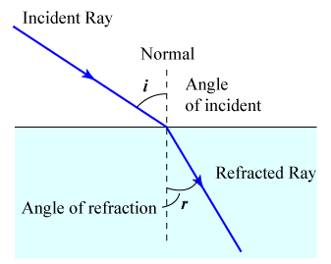

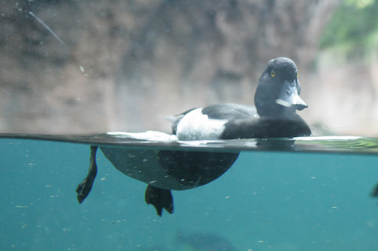Notice the angle is always measured between the ray and the normal line.

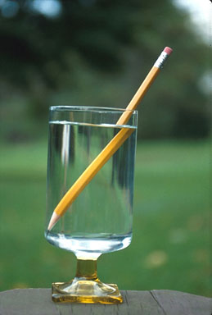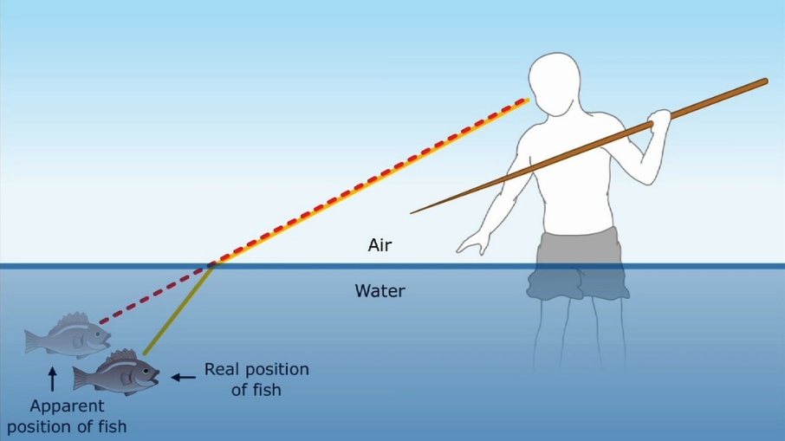

Refractive index

The refractive index of a transparent medium is the ratio of the speed of light in a vacuum to its speed in the medium

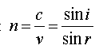

Where n = refractive index

C = speed of the wave in a vacuum

V= speed of the wave in the medium

i= angle of incidence

r=angle of refraction

We can use this to calculate different values from the angles of incidence and refraction to the speed of waves

Please note that you do NOT need to learn this just be able to apply it and know what the letters mean.

Mark on the diagram (*i*) for the angle of incidence and (*r*) for the angle of refraction for the ray of light shown.

**(2)**

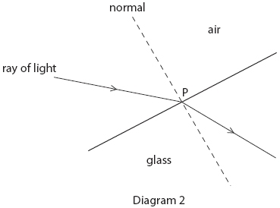

<https://www.youtube.com/watch?v=7aU8sX8cFNs>

<https://www.youtube.com/watch?v=bbcuFhD5zqc>

Disappearing pencil trick

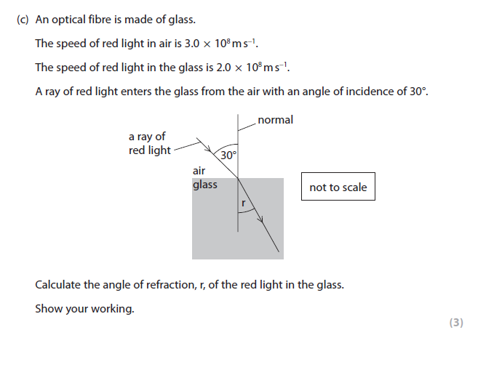

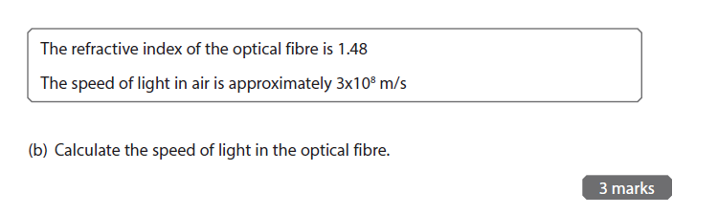

Total internal reflection and calculation of critical angles

Waves going from a dense medium to a less dense medium speed up at the boundary. This causes light rays to bend when they pass from glass to air at an angle other than 90º.

The change in speed at the boundary causes the way to be refracted, as long as the two mediums have different refractive indices.

Beyond a certain angle, called the **critical angle**, all the waves reflect back into the glass. We say that they are totally internally reflected.

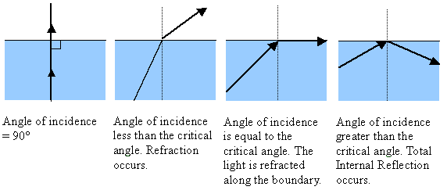

We can calculate the critical angle, ie the angle of incidence above which we get total internal reflection using the equation

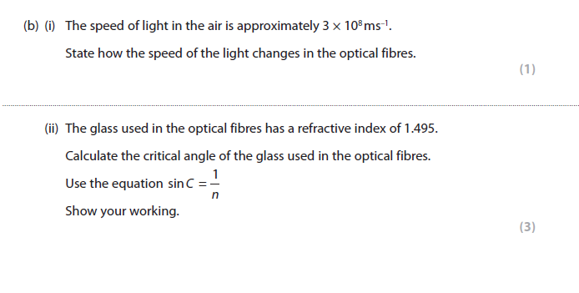Sin C = 1/n where C is the critical angle and n is the refractive index.

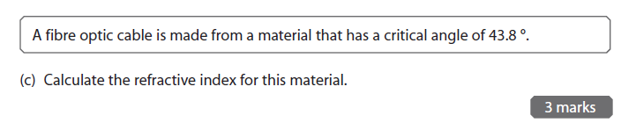

This is how we use fibre optics to carry signals

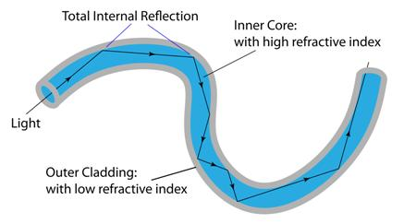

Fibre optics depend on the total internal reflection of light rays travelling through tiny glass fibres, large numbers of these fibres are bundled up into cables. The outer cladding has a much lower refractive index, this maximises the total internal reflection in the fibre and stops the signal being lost.

In fibre optics the rays of light get totally internally reflected and keep bouncing down the length of the fibre. No wave energy is lost through the walls of the fibre, although some is gradually absorbed. When the light waves arrive at the far end of the fibre, up to a few km away the intensity of the light is still large enough to measure as a signal.

In the fibre optic cable light of different frequencies travel down the cable at the same time, each frequency carries data, this is called multiplexing, the frequencies are then divided into separate ‘bands’, each band carries a separate channel of data. This allows a large quantity of data to be passed down a thin cable.

This make light in optical fibres a much more efficient way of transmitting signals then sending electrical pluses down copper cables. Copper cables suffer from quite large losses due to electrical resistance meaning that after a few hundred meters most of the signal has been lost and an amplifier is needed to boost it up again.

Modern fast broadband uses fibre optics older slower broadband uses copper

Applications of fibre optics in medicine to include endoscopes

Fibre optics can be used in medical application eg endoscopes to illuminate an area of the body without the need for surgery. It consists of two bundles of optical fibres, one to illuminate the area, the reflected light is then returned to the view by a second bundle, each individual fibre giving a small part which when combined give an overall picture.

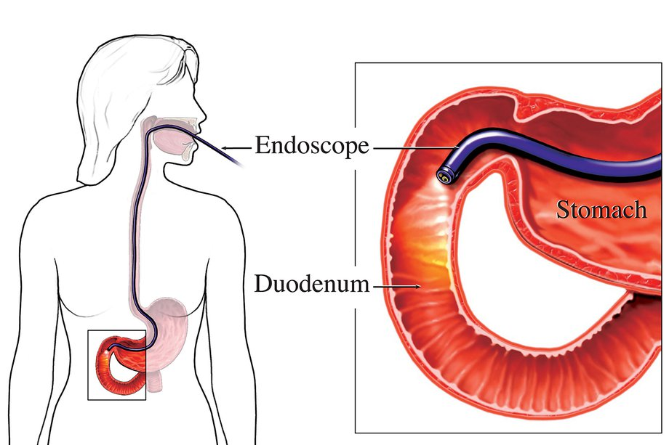

Other uses for total internal reflection are fingerprinting devices for mobile phones and rain detectors in cars

<https://www.youtube.com/watch?v=0MwMkBET_5I> 0.0-2.28

<https://www.youtube.com/watch?v=AnnHLaBG2tg>

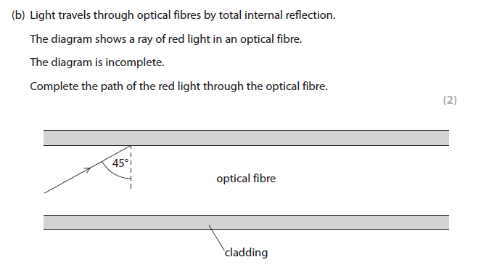

Research either

1. fingerprint devices for moble phones
2. rain detectors in cars

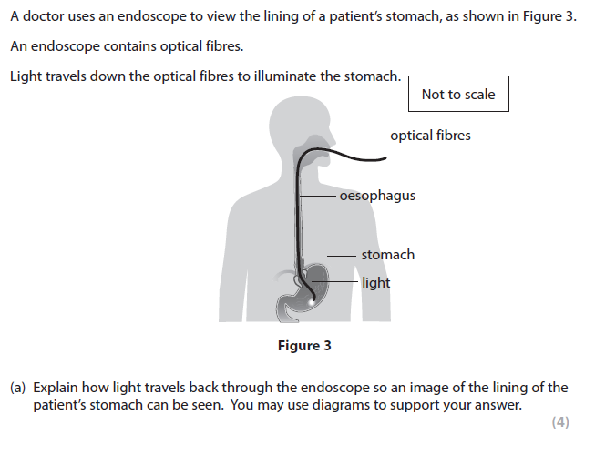

Analogue and digital signals

An Analogue signal is a continuously variable signal, it can have any value

A Digital signal can only have two values on or off ( 0 or 1)

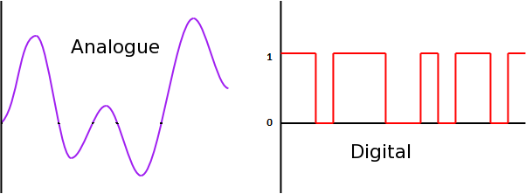

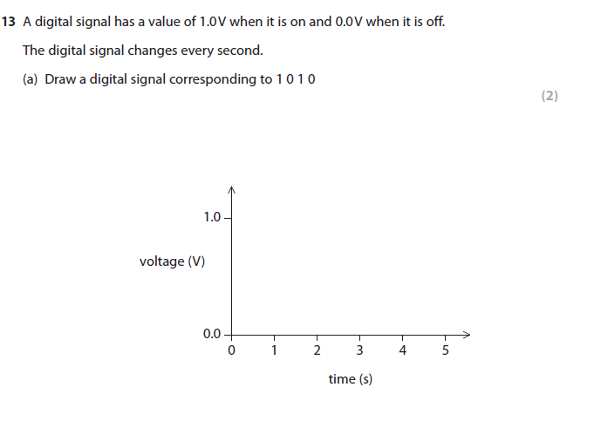

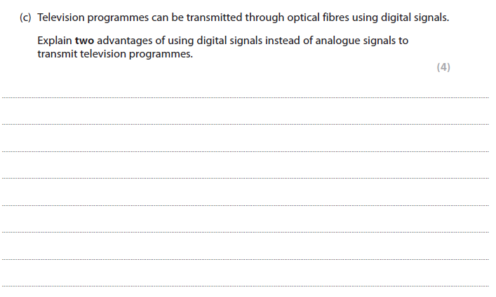

Draw a flow diagram for the Analogue to digital conversion

Broadband is the system that gives rapid internet access through cables, optical fibres or satellites using electromagnetic waves with a range of frequencies, it can be analogue or digital. The frequencies are divided into separate bands, each band carries a separate channel of data. In a fibre optic cable, light of different frequencies travel down the cable at the same time, each frequency carries data, this is called multiplexing

