# Converting Denary to binary

### Subtraction Method

Dim currentBITValue, remainingVal, Denary As Integer

Dim binstring As String

'input

Console.WriteLine("enter number")

Denary = Console.ReadLine()

remainingVal = Denary

' loop through 8 bits starting at 2^7 --> 2^0

For n = 7 To 0 Step -1

currentBITValue = 2 ^ n

If remainingVal >= currentBITValue Then ' is current bit graeter that 2^n

binstring = binstring & "1"

remainingVal = remainingVal - currentBITValue

Else

binstring = binstring & "0"

End If

Next

Console.WriteLine(binstring)

Console.ReadLine()

### The Divide by 2 algorithm

The Divide by 2 algorithm assumes that we start with an integer greater than 0. A simple iteration then continually divides the decimal number by 2 and keeps track of the remainder. The first division by 2 gives information as to whether the value is even or odd. An even value will have a remainder of 0. It will have the digit 0 in the ones place. An odd value will have a remainder of 1 and will have the digit 1 in the ones place. We think about building our binary number as a sequence of digits; the first remainder we compute will actually be the last digit in the sequence.

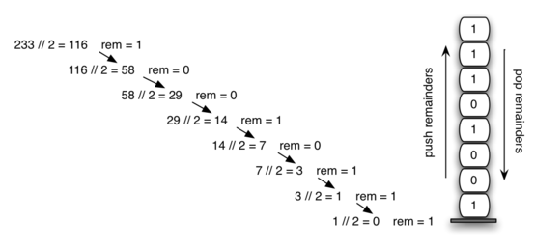

Solution in Vb.net

Dim remainingVal, Denary As Integer

Dim binstring As String

'input

Console.WriteLine("enter number")

Denary = Console.ReadLine()

remainingVal = Denary

Do

binstring = Denary Mod 2 & binstring

Denary = Math.Floor(Denary / 2)

Loop Until Denary < 1

Console.WriteLine(binstring)

Console.ReadLine()