Visual Basic Handbook

Contents
Contents 2
Introduction to Handbook. 1
Deadlines and Course Structure 1
Course Structure and Deadlines 1
Preface 5
Common errors: 5
Conventions used in this book: 5
Introduction to Visual Basic 6
Chapter 1 – Your first program 7
Hello World! 7
Exercises 8
Chapter 2 – Using Variables 9
Variables 9
The Assignment Statement 10
The Console.Writeline() Statement 11
The Console.Readline Statement 11
Arithmetic Expressions 14
Comments 14
Exercises 14
Chapter 3 – Data types 15
Integer 15
Byte 15
Decimal 15
Single/Double 15
Char 15
String 16
Boolean 16
Date 17
Ordinal data types 18
Simple types 18
Constants 18
Advantages of using named constants 18
Exercises 19
Extension exercises 20
Chapter 4 – Selection 21
If … Then 21
Exercise 22
If … Then … Else 22
Exercises 22
Nested If statements 23
Exercises 23
Indentation 23
Select Case 24
Exercises 25
Chapter 5 – Iteration (repetition) 26
For loop 26
Exercises 26
Repeat Loop 28
Do While 29
Exercises 29
Chapter 6 – Arrays 30
One-Dimensional Arrays 31
Exercises 31
Two-Dimensional Arrays 32
Exercises 33
Enumerated Types 33
Sets 34
Chapter 7 – Functions 35
Built-in Functions 35
Exercises 36
Random Numbers 36
Exercises 37
User-defined functions 38
Local Variables 38
Exercise 39
Chapter 8 – Procedures 40
Worked Example: 40
Parameters 42
Value and Variable Parameters 44
Exercise 44
Chapter 9 – Records 45
Exercises 46
Arrays of Records 46
Exercises 46
Chapter 10 – Files 48
Text Files 48
Exercises 48
Serial Files 49
Sequential Files 49
Direct Access Files 49
Exercises 51
Chapter 11 Windows Forms Applications 52
Hello world Program 52
TextBoxes 54
Changing Properties 55
Chapter 12 – The Basic Calculator. 57
Program Listing for Basic Calculator Program 60
Chapter 13 – Using VBA (Visual Basic for Applications) 64
Exercises 65
Event Driven Programming in VBA 66
Exercises 66
Variables 66
Functions 68
Exercises 68
User Defined Functions 68
Exercises 68
The DoCmd 69
Exercises 69
Properties 69
Exercises 70
Amending Queries 71
Chapter 14 – Record sets in VBA 73
Opening a table 73
Referring to fields 74
Recordset Functions 75
Exercises 76
1) Final Open Ended Challenge Simulating checkout software 77
Appendix A: Progress Self-Assessment 80

Introduction to Handbook.
This is the computing handbook that will guide you through your BO65 Unit.

You will be using a language called Visual Basic which is nice language that has application in real world systems. We will be using this language to help you understand the basic concepts of programming. The second half of this handbook contains all your Visual Basic Chapters and tasks.

Preface
This guide is intended to provide an introduction to the concepts of programming in an imperative high-level programming language. The book is designed to be worked through in sequence, each chapter building on the previous one; building up a basic knowledge of programming concepts that can be applied to every high-level language.

The exercises will be marked by your teacher against the following criteria (all programs should be pseudo-coded or annotated):
- 5 : Efficient use of code and good coding layout (indentions etc..)
- 4: No help, problem solved.
- 3: Little help, problem solved.
- 2: Problem solved with help.
- 1: Problem not solved.

You will also have a written programming test after the unit of work on the concepts outlined in this book. Also, as this guide has been prepared against the AQA AS Computing specification you should ensure you are familiar with all of the content.

Common errors:
- Overcomplicating programs – always look for the simplest solution
- Writing pseudo-code after writing the program – it does help you to solve a problem use it!
- Asking your teacher for help before you check your own code – there is a useful checklist of common errors at the back of this book (Appendix A).

Conventions used in this book:
Each major concept is introduced in a new chapter and any code will be highlighted in the following way:

This is programming code;

Introduction to Visual Basic

VISUAL BASIC is a high level programming language which evolved from the earlier DOS version called BASIC. BASIC means Beginners' All-purpose Symbolic Instruction Code. It is a very easy programming language to learn. The code look a lot like English Language. Different software companies produced different versions of BASIC, such as Microsoft QBASIC, QUICKBASIC, GWBASIC ,IBM BASICA and so on. However, people prefer to use Microsoft Visual Basic today, as it is a well developed programming language and supporting resources are available everywhere. Now, there are many versions of VB exist in the market, the most popular one and still widely used by many VB programmers is none other than Visual Basic 6. We also have VB.net, VB2005, VB2008 and the latest VB2010. Both Vb2008 and VB2010 are fully object oriented programming (OOP) language. (source - http://www.vbtutor.net/lesson1.html)

Chapter 1 – Your first program
The environment which we will be using to learn Visual Basic is Microsoft Visual Basic 2010 Express. For the purpose of teaching programming basics we will be using a console application project although towards the end we will look at the event driven visual side of VB Programming.

When you create a new Console Application project – you should see the following in the code editor.

Module Module1

Sub Main()

End Sub

End Module

Hello World!
Type the code below into the window between the Main() and End Sub statements.

Console.Write("Hello World")
Console.Read()

This code writes the text “Hello World” to the screen, and the “Read” keeps the window open.

To make your program work, first of all save your work by pressing the following icon

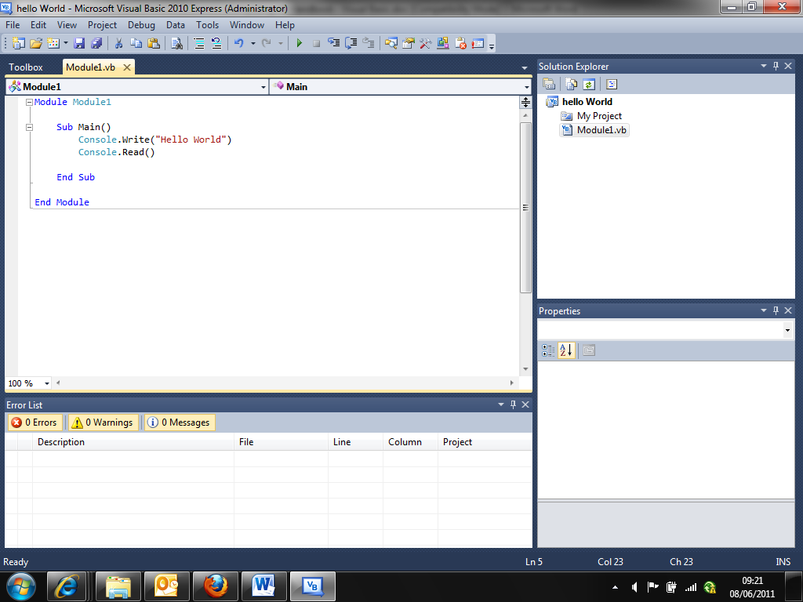

Then debug your program by pressing the play icon on the top bar.

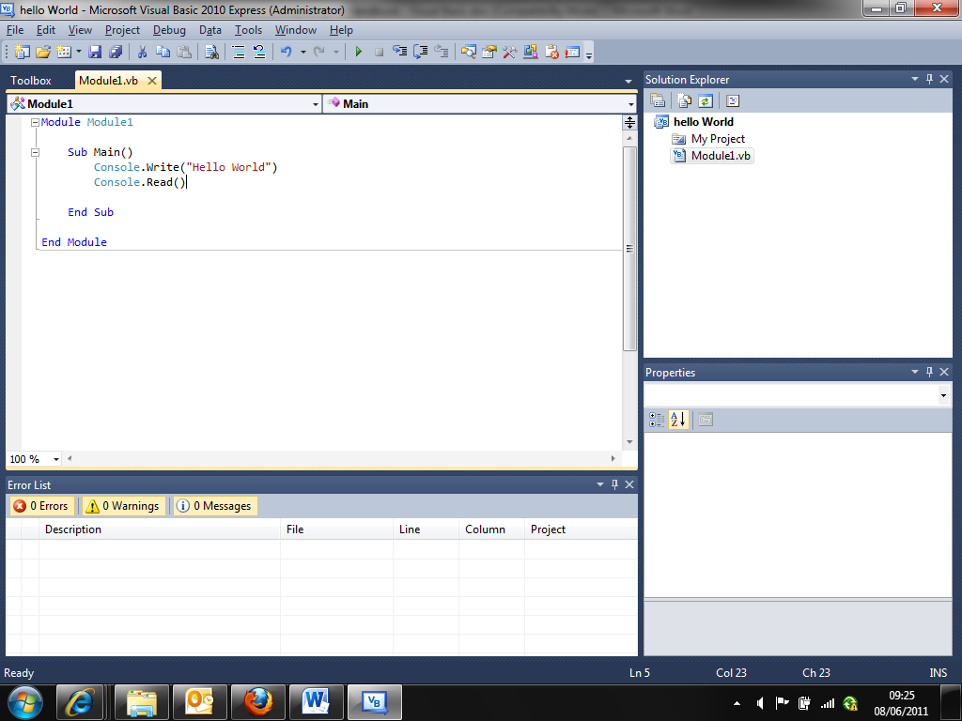
You have written your first computer program!

Similar to Console.Write there is Console.WriteLine which inserts a carriage return. See how that works…

Exercises

- Write a program that will output two messages of your choice on the screen, on separate lines.
- Write a program that will output this rocket on the screen:

*
***
*****
*******
*******
*******
*******
*******
*******
*******
*******
***
*****

Chapter 2 – Using Variables
Computer programs normally use (process) data in some way to produce results. This normally relies on an INPUT from the program or user, which is PROCESSED by the program then displayed in the console window, OUTPUT.

INPUT

PROCESS

OUTPUT

The input to the program is often supplied by the user whilst the program is running.

Variables
In a computer program, variables can be imagined as labelled boxes that store data for use in the program. You tell the computer what will be stored in the variable when you ‘declare’ it.

Using the example of a program that adds two numbers together and displays the sum: 3 variables are required as below:

Number1 | Number2 | Sum

You can imagine the variables as boxes like this, but in reality they are locations in the computer’s main memory.

The ‘Box labels’ are known as identifiers. As a programmer you must choose an appropriate identifier for each variable you use in your program. A valid identifier must start with a letter and can consist of any combination of letters, numerals and the underscore character (_), but not spaces.

For ease of understanding by other programmers, (your teacher!) or yourself later on, you should choose an identifier that explains the purpose of your variable. This is good practice and very useful when your programs get more complicated. E.g. NumberOfEntries rather than n5 or number.

NB: Visual Basic is not case-sensitive, so that Number, number, nUMBER, NUMBER are all equivalent.

Visual requires you to declare what type of data you are going to store in your chosen variables. Therefore if we want to store whole numbers we need to declare them as integers at the beginning of our program code. VB doesn’t require you to declare at the beginning of a module, program or function – but it is good practice to do so.

Module Module1

Sub Main()

Dim Number1, Number2, sum As Integer

End Sub

End Module

Note the use of the keyword DIM at the beginning. Then it is the variable names followed by AS then the type itself.

The Assignment Statement
To store something in a variable you need to use an assignment statement. For example:
Number1 = 8;
This stores the value 8 to the variable Number 1.

The ‘=’ is the assignment operator; the value to the right is what is stored in the variable that is identified on the left of the assignment operator. It can be read as “becomes equal to” or “takes the value”.

An assignment statement can also contain an expression on the right side of the ‘=’, which will be calculated when that statement is executed.

Number1 = 8
Number2 = 15
sum = Number1 + Number2

The above statements will result in putting the value 23 into the variable Sum.

The Console.Writeline() Statement
If you want to display the contents of a variable, you need to use the Console.Writeline statement and provide the variable identifier in brackets:

Console.WriteLine(Number1)

Note the difference between displaying the contents of Number1 and displaying the text string ‘Number1’.

Console.WriteLine("Number1")

You can combine several variable identifiers and/or messages in one statement. For example:

Console.WriteLine(Number1 & " + " & Number2 & " = " & sum)

Note that spaces also need to be added inside the quotes.

The Console.Readline Statement
If you want the user to be able to type in values that are used in the program is running, you need to use the Console.Readline statement. To store the value typed by the user in a variable use the Console.Readline statement with the variable identifier before the call:

Number1 = Console.ReadLine()

To display the sum of two numbers that the user types in, we can write:

Module Module1

Sub Main()

Dim Number1, Number2, sum As Integer

Number1 = Console.ReadLine
Number2 = Console.ReadLine

sum = Number1 + Number2

Console.WriteLine(sum)
Console.Read()

End Sub

End Module

Save the file and run the program. This will produce the required result. However, it is not very user-friendly: we need to prompt the user for what to do. Add some lines to your program as follows:

Module Module1

Sub Main()

Dim Number1, Number2, sum As Integer

Console.Write("Please enter in a number: ")
Number1 = Console.ReadLine
Console.Write("Please enter in another number: ")
Number2 = Console.ReadLine

sum = Number1 + Number2

Console.WriteLine(Number1 & " + " & Number2 & " = " & sum)
Console.Read()

End Sub

End Module

This will produce the following output:

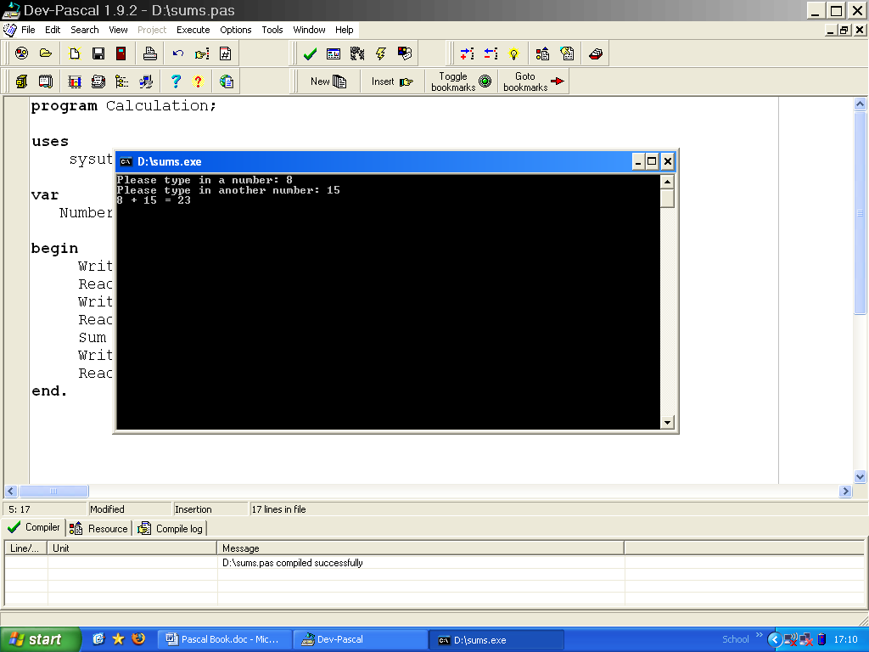

NB:
Writeline without the brackets (parameters) will just output a new line.
Write rather than Writeline will stay on the same line.

The statement

Console.WriteLine(Number1 & " + " & Number2 & " = " & sum)

Produces the same result as

Console.Write(Number1)
Console.Write(" + ")
Console.Write(Number2)
Console.Write(" = ")
Console.Write(sum)

Although the Read statement exists, its use is very specific as it leaves the Enter character in the input buffer. If you try it, your program may not operate as you expect.

Arithmetic Expressions
We can write more complicated arithmetic expressions, using the following symbols:

Arithmetic Operator | Operation | Operand data types | Result data type | Example
+ | Addition | Integer, real | Integer, real | X + Y
- | Subtraction | Integer, real | Integer, real | Result – 1
* | Multiplication | Integer, real | Integer, real | P * InterestRate
/ | Real Division | Integer, real | Real | X / 2
DIV | Integer division | Integer | Integer | Total DIV UnitSize
MOD | Remainder | Integer | Integer | Y MOD 6

NB:
Division using / will produce a result that may not be a whole number. We need to declare a variable receiving such a result as a Real data type, so that it may have a decimal point and a fractional part. For more data types, see the next chapter.

Comments
For all of the programs from now onwards you are expected to pseudo-code your work. This means writing what the code will do in ‘plain English’ rather than writing in Pascal code straight away.

Pseudo-code/comments also help other people understand the program, and allow you to add useful notes to aid development of the code and provide basic documentation. The compiler ignores these, so your application will not take up more space because of comments.

The structure for comments is as follows – Note the apostrophe at the beginning.

'this is a comment that goes on for one line.

Exercises

- Write a program that will read in three integers and display the sum.
- Write a program that will read two integers and display the product.
- Enter the length, width and depth of a rectangular swimming pool. Calculate the volume of water required to fill the pool and display this volume

Chapter 3 – Data types
All variables have to be declared before they can be used. The compiler will allocate memory to each variable depending on what type it is. Visual Basic provides many built-in types, some of which are listed below. You can also define your own data types, you will learn about this later.

Variable Declarations - Global
Global variables are variables declared at the beginning of the program and accessible from anywhere in the program. It is not always desirable to use a global variable as its values may get changed accidentally if you have multiple functions in your program

Local variables
Rather than declaring variables globally, it is good programming style to declare variables locally within the block where the variable is going to be used

When you start writing programs with routines – procedures or functions – you should declare local variables within the routines. Any variable value that is required by another routine should be passed as a parameter. A routine or subroutine is a subprogram.

Below are some data type declarations.

Integer
This data type supports positive and negative whole numbers. Memory allocated 4 bytes. Range: -2147483648 to 2147483647. Whenever possible you should use Integer variables rather than Real variables, because they use less memory and the store values more accurately.

Byte
This data type supports unsigned integers in the range 0 to 255. Memory allocated: 1 byte

Decimal
This data type supports signed numbers with a decimal point and fractional part. Memory allocated: 16 Bytes. This is a good type to use for currency.

Single/Double
This data type supports floating point numbers. This is similar to decimal but allows storage of larger fractions.

Char
This is a single character. Memory allocated: 1 byte. You can assign a single character to a Char variable:

Letter1 = “A”;

String
A string is a sequence of characters. A string variable can store up to 2³¹ characters. However a string constant is limited to 255 characters (more on this later).

“Hello World”  “012 34£$%^” | Examples of string literals
“He said “”hello” | If you want to include the quotes in a string literal you need to type two quotes
“ “ | This string literal contains a space
“” | This string is known as a null string

You can assign a string literal to a string variable:

FirstName = “Thomas”

You can concatenate strings (join one string to the end of another) using the string operator +

Message = “Hello “ + “World” ‘note the space left after hello
FullName = FirstName + Surname

Boolean
This data type supports just two values: True and False. For example:

Found = False
Finished = True

Memory allocated: 1 byte. Visual Basic represents True as 1 and False as 0 in memory. Boolean operators are mainly used for selection and iteration in a programming context (you will learn more about these in the next 2 chapters).

The following Boolean operators can be used in expressions with Boolean variables:

Boolean Operator | Logical operation | Explanation | Example assuming  Found = True  Finished = False | Value of example
Not | Inversion | Turns True to False and vice versa | Not Finished | True
And | AND | Both values must be true for the result to be true | Found and finished | False
Or | Inclusive OR | Either or both values must be true for the result to be true | Found or not Finished | True
Xor | Exclusive OR | Only one value must be true for the result to be true | Found xor not Finished | False
The results of a Boolean expression can be assigned to a Boolean variable. For example:
Searching = not Found or not Finished
GiveUp = not Found and Finished

Date
This data type supports dates. Visual Basic stores the date as a real number. The integral part of the value is the number of days that have passed since 01/01/0001. The fractional part of the value is the fraction of a (24-hour) day that has elapsed.

You can perform calculations with date variables. If ‘Today’ has today’s DateTime value stored:

Dim Today, Tomorrow, Yesterday As Date

Today = Now()
Tomorrow = Today.AddDays(1)

Console.WriteLine(Today)
Console.WriteLine(Tomorrow)

Ordinal data types
Ordinal types include integer, byte, character and Boolean. An ordinal type defines an ordered set of values. These types are important in later chapters.

Simple types
Simple types include ordinal types, double and Decimal. Later on you will lean about types that are not simple types, known as structured types. An example of a structured type is the String data type.

Constants
If you want to use values that will not change throughout the program, we can declare them as constants rather than variables at the beginning of the program in the const section, where you also initialise them.
Constants are declared before variables.
Module Module1

Const VatRate = 0.175
Rounds to 2 decimal places – indicated by “N2”
Sub Main()

Dim cost, tax As Decimal

Console.WriteLine("Enter the cost of goods: ")
cost = Console.ReadLine
tax = cost * VatRate
Console.WriteLine("The VAT is " & tax.ToString("N2"))
Console.Read()

End Sub

End Module

Advantages of using named constants
…Rather than variables:
- The value of a constant cannot be accidentally changed during the running of the program.
- The program runs faster because all references to the constant are replaced by its value at compile time, whereas a variable’s value has to be retrieved from main memory at run time.

…Rather than the actual value:
- If the value needs to be changed at a later date, such as the VAT rate changes, only the constant declaration needs to be changed.
- Expressions using the value are much easier to understand if a carefully chosen identifier represents the value.

Exercises

- Write a program that will ask the user for their first name. The program should then concatenate the name with a message, such as ‘Hello Fred. How are you?’ and output this string to the user
- Write a program that asks the user to enter two real numbers and displays the product of these two numbers to 2 decimal places, with user-friendly messages.
- Write a program to enter a temperature in degrees Fahrenheit and display the equivalent temperature in degrees Centigrade.
[The formula for conversion is Centigrade = (Fahrenheit – 32) * (5/9)]
- Write a program to convert a person’s height in inches into centimetres and their weight in stones into kilograms. [1 inch = 2.54 cm and 1 stone = 6.364 kg]

Extension exercises

- Write a program to enter the length, width and depths at the deepest and shallowest ends of a rectangular swimming pool. Calculate the volume of water required to fill the pool, and display this volume.
- Write a program to enter the length and width of a rectangular-shaped garden. Calculate the area of the garden and the cost of turfing a lawn if a 1m border is around the perimeter of the garden. Assume the cost of turf is £10 per square metre. Display the result of these calculations.

Chapter 4 – Selection
When you are writing programs, you will often want a computer to take different routes through the program depending on various conditions. For this you can use one of the following structured statements Visual Basic provides:

If ... then
If ... then ... else
Select case

(structured statements are built from other statements, they are normally made when you want to execute other statements sequentially, conditionally, or repeatedly.)

If … Then
When you want a program to execute a statement only if a certain condition is met, you use:

If BooleanExpression then statement

A Boolean expression returns a Boolean value True or False (See last chapter for Boolean data type). If the BooleanExpression is true the statement after then is executed.

Examples of Boolean expressions:

Age > 18
(Number > 10) and (Number <=25)

You can use the following comparison operators:

= equal to
<> not equal to
> greater than
< less than
>= greater than or equal to
<= less than or equal to

Example of an if … then statement:

Dim number, sum As Integer

number = 1

If number > 0 Then
sum = sum + number
End If

Exercise
- Write a program that asks for two numbers from the user and then displays a suitable message if the two numbers are the same.

If … Then … Else
When you want your program to do one statement if a certain condition is met, and another statement if the condition is not met, you need to use:

If BooleanExpression Then statement1 else statement2

Example of an if … then … else statement:

If number < 0 Then
Console.WriteLine("This is a negative number")
Else
Console.WriteLine("This is a positive number")
End If

Exercises
- Write a program that will read in a person’s age and display a message whether they are old enough to drive or not.
- Write a program that checks whether a number input is within the range 21 to 29, inclusive, and displays an appropriate message.
- Write a program that asks the user to enter 2 numbers and displays the larger of the two numbers.

Nested If statements
The statement in a then and/or else part of an if statement can itself be an if statement.

Example:

If (letter >= "A" And letter <= "Z") Or (letter >= "a" And letter <= "z") Then
Console.WriteLine("Letter")
Else
If (letter >= "0" And letter <= "9") Then
Console.WriteLine("numeral")
Else
Console.WriteLine("special character")
End If
End If

Exercises
- Extend program ‘3’ so a number out of range will cause a message saying whether it is above or below the range.
- Adapt program ‘4’ to determine which is the largest of three given integers.

Indentation
With the introduction of structured statements, you need to take care over the layout of your code, to keep it easy to find possible errors. Visual Basic does not mind where you put white space (spaces, indents, new lines). However, to follow the code, especially during error-finding sessions you will appreciate clearly laid out code. Also, to get full marks from your teacher, you are expected to lay your code out using the following convention:

- Every statement on a new line.
- An IF always must be matched by an End If.

Because of the nature of the Visual Express IDE however it automatically indents code for you – but even if it doesn’t make sure you are indenting your work after each IF statement.

- Split if statements and indent in this way:
Note that there must be no semicolon here. This is a common syntax error.
If BooleanExpression
Then statement1
Else statement2
End If

Select Case
Nested if statements can get very complicated and sometimes it is easier to use a case statement:

Select Case OrdinalExpression
Case <item or list>
Statement1
...
Case <itemn or listn>
Statementn
Case else
Statement
End Select

The value of the ordinal expression (see Chapter 3, Ordinal Type) will determine which statement is executed. Each Case must be a constant, a list of constants or a subrange. Each value in the case must be unique in the case statement, and subranges and lists must not overlap. See examples below.

If Month is an integer variable:

Select Case month
Case 1, 3, 5, 7, 8, 10, 12
NoOfDays = 31
Case 4, 6, 9, 11
NoOfDays = 30
Case 2
NoOfDays = 28
Case Else
Console.WriteLine("Not a month")
End Select

If Ch is of type Char:

Select Case letter
Case "A" To "Z", "a" To "z"
Console.WriteLine("Letter")
Case "0" To "9"
Console.WriteLine("Number")
Case Else
Console.WriteLine("Special Character")
End Select

Exercises
- Write a program that asks the user for a month number and displays the number of days that month has (ignore leap years for now).
- Write a program that lets the user enter a number between 1 and 12 and displays the month name for that month number. The input 3 would therefore display March.
- Write a program that reads in the temperature of water in a container (in Centigrade) and displays a message stating whether water is frozen, boiling or neither.
- Write a program that asks the user for the number of hours worked this week and their hourly rate of pay. The program is to calculate the gross pay. If the number of hours worked is greater than 40, the extra hours are paid at 1.5 times the rate. The program should display an error message if the number of hours worked is not in the range 0 to 60.
- Write a program that reads in an exam mark and displays the relevant grade. The grade boundaries are:
0 to 40 marks grade U
41 to 50 marks grade E
51 to 60 marks grade D
61 to 70 marks grade C
71 to 80 marks grade B
81 to 100 marks grade A
- Extend your program for Exercise 7 to include leap years. A year is a leap year if the year divides exactly by 4, but a century is not a leap year unless it is divisible by 400. For example the year 1996 was a leap year, the year 1900 was not, the year 2000 was a leap year. (tip: use the operators / and MOD)

Chapter 5 – Iteration (repetition)
We often want computers to repeat some process several times. This is called iteration. In Visual Basic there are 3 different structures to repeat a set of statements:

Definite Iteration (when you know before entering the loop how often you want to repeat)
For loop

Indefinite Iteration ( when you do not know beforehand how often you want to repeat)
Do Until loop
Do While loop

For loop

For Counter = StartValue to EndValue step StepAmount
Statement;
Next Counter

Counter is called the control variable and must be declared as an ordinal type, often integer (see chapter 3).
StartValue & EndValue must be expressions of the same type as Counter.

Examples:

For i = Counter To 10 Step 1
Console.WriteLine("This is a line")
Next Counter

For Counter = 10 To 1 Step -1
Console.WriteLine(Counter)
Next Counter

Exercises
- Make each of the two examples above page into a program to test what it does. (don’t forget to put a ‘Console.Readline()’ at the end of each one)
- Write a program that displays the word ‘Hello’ on the screen 4 times on the same line using the for loop.
- Write a program that prompts the user to enter a short message and the number of times it is to be displayed and then displays the message the required number of times.
- Write a program to display the squares of all the integers from 1 to 12 in two columns headed ‘Number’ and ‘Square of Number’.
- Write a program that asks the user to enter the number of stars per row and the number or rows to be displayed. For example, entering 5 and 3 should display:
*****
*****
*****
- Write a program that asks for a number, and displays the squares of all the integers between 1 and this number inclusive.
- Adapt your program from exercise 6 so that it will display 5 values on each line. (tip: Use Write to display a value and a statement of the form
If ControlVariable MOD 5 = 0 then Console.WriteLine()
To output a new line after every fifth value
- Write a program that asks the user to enter how many numbers are to be averaged, then enters this number of numbers, calculating the average. The program should display the average on the screen.
- Write a program to display an ‘n times table’ for a given integer n. For n = 4, the output should be:
1 * 4 = 4
2 * 4 = 8
3 * 4 = 12
....
12 * 4 = 48
Do Loop

Do Until BooleanExpression
Statement1;
Statement2;
:
:
Loop;

The statements enclosed by repeat and until are executed again and again until the BooleanExpression is True.

Note: The statement sequence is executed at least once, even if BooleanExpression is already True.

Example:

Do Until name = "XXX"
Console.Write("Enter a name - XXX to finish: ")
name = Console.ReadLine()
Loop

You may wish to know how many times the loop was repeated:

Do Until number = 0
Console.Write("Enter a number - 0 to finish: ")
number = Console.ReadLine()
count = count + 1
Loop

If we want to add up all the numbers the user types in, we need to keep a running total:

count = 0 'Make sure you initialise variables before using them
Runningtotal = 0

Do Until number = 0
Console.Write("Enter a number - 0 to finish: ")
number = Console.ReadLine()
count = count + 1
Runningtotal = Runningtotal + number
Loop

You can also change the format of the above slightly to have the control condition being checked at the end of the loop – for example

Do
Console.Write("Enter a number - 0 to finish: ")
number = Console.ReadLine()
count = count + 1
Runningtotal = Runningtotal + number
Loop Until number = 0

The difference here is that putting the check at the end of the statement means that the loop will execute at least once.

Do While

The Do While loop is exactly the same as the Do Until loop except that the former checks that a condition is positive to continue looping – while the latter checks that a condition is negative to continue looping

Exercises
- Write a program that reads in a series of numbers and adds them up until the user enters zero. (This stopping value is often called a rogue value.)
- Write a program that asks the user for a number between 10 and 20 inclusive and will validate, that is test, the input. It should repeatedly ask the user for this number until the input is within the valid range.
- Expand your program from Exercise 11 to display the average as well as the sum of the number entered. Make sure you do not count the rogue value as an entry.
- Write a program that displays a conversion table for pounds to kilograms, ranging from 1 pound to 20 pounds [1 kg = 2.2 pounds].
- Write a program that asks the user to enter 8 integers and displays the largest integer.
- Adapt the last program so that it will also display the smallest integer.

Chapter 6 – Arrays
High-level languages provide programmers with a variety of ways of organising data. There are not only simple data types, but also data structures.

A data structure is a data type composed of a number of elements of one or more data types. A data structure allows a variable to be declared of that type so that a number of data items can be stored and processed as a single set.

An array is an ordered set of data items of the same type grouped together using a single identifier. Arrays may have many dimensions but higher dimensions can get difficult to imagine and are not needed for AS or A-level. It is sufficient to be able to use one-dimensional arrays (also known as linear lists) and two-dimensional arrays (also known as tables).

The array’s identifier and an index (or subscript) for each of the array’s dimensions are used to refer to each of the array’s data items.

Without data structures, if we want to store several values in separate variables and process them in a similar manner, this could result in very repetitive code. For example, to store 5 student’s names would mean declaring 5 string variables for their names:

Dim Name1, Name2, Name3, Name4, Name5 As String;
Fred
Jack
Anna
Sue
Roy
Name1 Name2 Name3 Name4 Name5

This is still manageable but what if we needed to store several hundred students’ names?

One-Dimensional Arrays
If we declare an array:
All elements of an array are of the same type

Dim Name(0 To 4) As String

Name(0)  Array identifier  Range of index | Fred
Name(1) | Jack
Name(2) | Anna
Name(3) | Sue
Name(4) | Roy  Array identifier  Index or subscript
We can refer to a particular element of this array:

Console.WriteLine(Name(2))

Would display the name Anna. In general, to refer to the i^{th} element you write Name(i)

This is particularly powerful when combined with iteration statements:
To read in five names into the array we can write:

For i = 0 To 4 Step 1
Console.Write("Please Enter in a location " & i & ": ")
Location(i) = Console.ReadLine()
Next

We can easily display these in reverse order:

For i = 4 To 0 Step -1
Console.WriteLine(Location(i))
Next

In general, we declare a one-dimensional array using the format:
Dim identifier (range) As of DataType

Range must be of ordinal type (see chapter 3).

Exercises
- Write a program that reads 6 names into an array. The program must display the names in the same order that they were entered and then in reverse order.
- We want to simulate throwing a die 30 times and record the scores. If we did this ‘manually’ we would end up with a tally chart:

Number of 1’s | IIII
Number of 2’s | III
Number of 3’s | IIII III
Number of 4’s | IIII I
Number of 5’s | IIII II
Number of 6’s | II

If we use a computer to keep a count of how many times each number was thrown, we could use an integer array (index range 1..6) instead of the tally chart. In general, a die throw will give a score i, and we want to increment the count in the i^{th} element.
TallyChart(i) = Tallychart(i) + 1
Write a program to simulate the throwing of a die 30 times. The results of the simulation should be printed as a table of scores (1 to 6) and frequencies.

- We wish to select six random numbers between 1 and 49 with the condition that all the numbers are different. One possible strategy, or algorithm, is:

  - Initialise an array by using a for loop to store the values 1 to 49
  - Repeatedly select a random element from array until a non-zero value is selected
  - Display this value
  - Set that element to zero
  - Repeat the above three steps until six number have been selected

Write a program to select six unique random numbers between 1 and 49.

- We can declare two arrays, Student and DoB, to store the name of Students and their dates of birth. For example if Fred is born on 22/12/84, then we could store ‘Fred’ in Student[1] and ‘22/12/84’ in DoB[1]. To find a particular student we can use a repeat loop

Write a program that stores 5 students’ names and dates of birth and then searches for a particular student and displays that student’s date of birth and current age. Display a suitable message if the student’s details cannot be found.
(Tip: use the built-in functions YearSpan and Date)

Two-Dimensional Arrays

Suppose we want to store a student’s timetable:

 | Monday | Tuesday | Wednesday | Thursday | Friday
Lesson 1 | Maths | Physics | Computing | Electronics | Maths
Lesson 2 | Physics | Physics | Electronics | Maths | Physics
Lesson 3 | Lunch | Lunch | Lunch | Lunch | Lunch
Lesson 4 | Computing | Electronics | Maths | Computing | Computing

We can declare a two-dimensional array:

Dim timtable(0 To 3, 0 To 4) As String

The dimensions of an array are neutral. They do not represent anything until we decide what each dimension will represent, declaring an appropriate range in the corresponding index. To refer to the 4th lesson on a Tuesday, we could therefore write:
Timetable(4,2)
To display all lessons for a Wednesday (the 3rd day of the week):

day = 2
For lesson = 0 To 3 Step 1
Console.WriteLine(timetable(lesson, day))
Next lesson

To display the whole timetable:

For lesson = 0 To 3 Step 1
For day = 0 To 4 Step 1
Console.WriteLine(timetable(lesson, day))
Next
Next

Exercises
- Using a two-dimensional array, write a program that stores the names of ten countries in column 1 and their capitals in column 2. The program should then pick a random country and ask the user for the capital. Display an appropriate message to the user to show whether they are right or wrong.
- Expand the program above to ask the user 5 questions and give a score of how many they got right out of 5.

Enumerated Types
An enumerated type defines an ordered set of values. Each value is given an ordinal value, starting at zero. Members of an enumerated type can be used as loop control variables, in case statements and as array subscripts.

Module Module1

Dim x, y As Integer
Enum Days
Sun
Mon
Tue
Wed
Thu
Fri
Sat
End Enum

Sub Main()
x = Days.Wed
y = Days.Sun
Console.WriteLine("Wednesday = {0}", x)
Console.WriteLine("Sunday = {0}", y)
Console.ReadLine()
End Sub

End Module

Sets
A set is a collection of values of the same ordinal type. The values of a set have no associated order

Module Module1

Sub Main()
Dim Set1, Set2, Set3 As New ArrayList
Dim InitialSet() = {3, 4, 5}
Set1.AddRange(InitialSet)
Set1.Add(2)
Set1.Add(7)

If Set1.Contains(7) Then
Console.WriteLine("Set contains 7")
End If

Console.ReadLine()

End Sub

End Module

Chapter 7 – Functions

Built-in Functions
A function is a routine, a self-contained statement block that returns a value when it executes. Pascal provides many ready-to-use functions. Here are just a few:

Function identifier | Parameter(s) (arguments) | Result type | Description
Math.Round | X: Decimal / double | Integer | Returns the value of X Rounded to the nearest whole number
Math.Truncate | X: Decimal / Double | Integer | Truncates a real number to an integer
ChrW | X: byte | Char | Returns the character for a specified ASCII code value X
Asc | X: any ordinal type | Integer | Returns the ordinal value of an ordinal type expression such as the ASCII code for a character
Len | S: String | Integer | Returns the number of characters in string S
InStr | S: String  Sub: String | Integer | Returns the index value of the first character in substring Sub that occurs in the string S
UCase | S: String | String | Returns a copy of string S in upper case
LCase | S: String | String | Converts string S to lower case
Now | - | Date | Returns the current local date as a Date value
CStr | Date | String | Returns the string equivalent of D
CDate | S: String  e.g. 12/2/03 | Date | If S contains only two numbers, it is interpreted as a date in the current year.
Left | S: String  L: Integer | String | Returns the substring of length L that appears at the start of string S
Right | S: String  L: Integer | String | Returns the substring of length L that appears at the end of string S

To use any of these functions you use its identifier and provide the necessary arguments in brackets. This is called the function call. A function call returns a value, which can be used in expressions in assignments and comparison operations.
For example, to assign the square root of a number to Square:
Example
length = Len (astring)
You must make sure that you provide the correct data types.
Function calls cannot appear on the left side of an assignment statement.

Exercises
- Write a program that asks the user to type in a number with decimal places. The program should then display the rounded and the truncated number.
- Write a program that reads in a string and displays the number of characters in the string.
- Write a program that displays the ASCII code for any given character.
- Write a program that will display the character for a given ASCII code.
- Write a program that asks the user for their surname and displays the surname in uppercase letters.
- Write a program that displays today’s date.
- Write a program that reads in a date, converts it into date format, adds a day and displays the next day’s date.
- Write a program that asks the user for their first name and their surname. The program then displays the full name, first name capitalised (starting with a capital letter followed by lower-case letters) and surname, all uppercase, regardless of what case the user entered.

Random Numbers
We often want to simulate events where random numbers occur, such as throwing a die. Computers can only follow programs, that means sequences of predetermined statements, so they cannot produce truly random numbers. Pascal, like most high-level languages, provides us with a pseudo-random number generator to get over this problem:

R = Int(Rnd() * 100) + 1
Returns an integer between 0 and 100

When you initialise the random number generator it uses an integer obtained from the system clock, so you are highly likely to obtain the same sequence of numbers on any two runs. To prevent this from happening (the compiler will use a different value each time), add the statement Randomize() before you want to use the random function:

Module Module1

Sub Main()
Dim number As Integer

Randomize() 'should only be executed once to initiate random
number generator

number = Int(Rnd() * 6) 'generates random number 0-5
number = number + 1 ' add 1 to get anumber 1-6

Console.WriteLine(number)
Console.ReadLine()

End Sub

End Module

Exercises
- Write a program that will display random numbers between 1 and 6 until a six is generated.
- Write a program that will display six random numbers between 5 and 10.
- Write a game in which the user guesses what random number between 1 and 1000 the computer has ‘thought of’, until he or she has found the correct number. The computer should tell the user whether each guess was too high, too low or spot on.

User-defined functions
Dev-Pascal may not provide you with all the functions you may wish to use. You can declare your own functions and then call them in expressions just like built-in functions. They are known as user-defined, but in this case the user is the programmer using the programming language, not the end-user of the program.

Module Module1

Function Initial(ByVal s As String) As String
Dim ret As String
Declaration of the parameter S, an internal variable to receive the value passed to the function

ret = Left(s, 1)
ret = UCase(ret)
Data type of return value

Return ret

End Function
In Visual Basic Functions can be declared anywhere although it is good practice to declare them before the main program.

Sub Main()

Dim name As String

Console.Write("Type in a name: ")
name = Console.ReadLine()

Console.WriteLine("Initial = " & Initial(name))

Console.ReadLine()

End Sub

End Module

Local Variables
Sometimes you need variables to store values temporarily. Rather than declaring variables that are available throughout the program (global variables), it is good programming style and less error-prone to declare variables locally. They can only be used in the function in which they are declared and we say that they have local scope.

Module Module1
Global Variable

Dim number As Integer

Function Factorial(ByVal N As Integer) As Integer

Dim count, product As Integer
It is good practice to declare local variables after the function heading.

product = 1

For count = 1 To N Step 1
product = product * count
Next count

Return product

End Function

Sub Main()

Console.Write("Type in a number between 1 and 10: ")
number = Console.ReadLine()
Console.WriteLine("return from function: " & Factorial(number))
Console.ReadLine()

End Sub

End Module

Exercise
- Write a function to convert temperatures from Fahrenheit to Celsius. The function should take one integer parameter (the temperature in Fahrenheit) and return a real result (the temperature in Celsius). The formula for conversion is:
Centigrade = ( Fahrenheit – 32 ) * ( 5/9 )

Chapter 8 – Procedures
A routine is a self-contained statement block that can be called from different locations in a program. A function is a routine that returns a value in its name when it executes, and so a function call is used as part of an expression. A procedure is a routine that does not return a value in this way and a procedure call is treated like a statement. Dev-Pascal provides many built-in procedures, for example Readln and Writeln. However, we can also write our own procedures.

A good procedure declaration has the form
Sub ProcedureName(ParameterList)
LocalDeclarations;
Statements
End Sub {of procedure}

During the development of a programmed solution to a problem we may write down an algorithm or stepwise strategy. Each step can be used as a procedure call, and the detailed processing of the solution is performed in the procedure. This makes the main program body easy to understand as the procedure calls reflect the algorithm.

Worked Example:
Write a program which would display a pyramid of ‘*’:
*
***
*****
*******
*********
***********

The solution to this problem can be broken down into the following steps:
Initialize number of spaces and stars
Repeat
Output leading spaces
Output line of stars
Adjust number of spaces and stars
Until number of stars is the number required

Module Module1

Dim MaxNoOfStars, NoOfStars, NoOfSpaces As Integer

Sub InitialiseNoOfSpacesAndStars()

Console.Write("How many stars should be at the base? ")
MaxNoOfStars = Console.ReadLine()
NoOfSpaces = MaxNoOfStars / 2 'enough space to accomodate base
NoOfStars = 1 ' Tip has one star

End Sub

Sub OutputLeadingSpaces()

Dim count As Integer

For count = 1 To NoOfSpaces Step 1
Console.Write(" ") ' No new line required
Next count

End Sub

Sub OutputLineOfStars()

Dim count As Integer

For count = 1 To NoOfStars Step 1
Console.Write("*")
Next count
Console.WriteLine() ' Move to next line

End Sub

Sub AdjustNoOfSpacesAndStars()

NoOfSpaces = NoOfSpaces - 1
NoOfStars = NoOfStars + 2

End Sub

' Main program starts here

Sub Main()

InitialiseNoOfSpacesAndStars()

Do
OutputLeadingSpaces()
OutputLineOfStars()
AdjustNoOfSpacesAndStars()

Loop Until NoOfStars > MaxNoOfStars

Console.ReadLine()

End Sub

End Module

Parameters
Those routines that do not rely on global variables are self-contained and easily reused in other programs. They also make it easier to find programming errors (logic errors) as each routine can be tested separately and will not interfere with other routines. Values required by routines are best passed to the routine by means of parameters. Routines can have any number of parameters, but the order must be the same in the routine declaration and the routine call.

The worked example from overleaf could be written:

Module Module1

Dim MaxNoOfStars, NoOfStars, NoOfSpaces As Integer

Sub Initialise(ByRef Spaces As Integer, ByRef Stars As Integer,
ByRef Max As Integer)

Console.Write("How many stars should be at the base? ")
Max = Console.ReadLine()
Spaces = MaxNoOfStars / 2 'enough space to accomodate base
Stars = 1 ' Tip has one star

End Sub

Sub OutputLeadingSpaces(ByVal Spaces As Integer)

Dim count As Integer

For count = 1 To Spaces Step 1
Console.Write(" ") ' No new line required
Next count

End Sub

Sub OutputLineOfStars(ByVal Stars As Integer)

Dim count As Integer

For count = 1 To Stars Step 1
Console.Write("*")
Next count
Console.WriteLine() ' Move to next line

End Sub

Sub Adjust(ByRef Spaces As Integer, ByRef Stars As Integer)

Spaces = Spaces - 1
Stars = Stars + 2

End Sub

' Main program starts here

Sub Main()

InitialiseNoOfSpacesAndStars(NoOfSpaces, NoOfStars, MaxNoOfStars)

Do
OutputLeadingSpaces(NoOfSpaces)
OutputLineOfStars(NoOfStars)
AdjustNoOfSpacesAndStars(NoOfSpaces, NoOfStars)

Loop Until NoOfStars > MaxNoOfStars

Console.ReadLine()

End Sub

End Module

With careful choice of identifiers the main program body is easy to understand. The routines are now self-contained and could even be put into a separate unit.

Look at the procedure headings again:

Sub Initialise(ByRef Spaces As Integer, ByRef Stars As Integer,
ByRef Max As Integer)
Sub OutputLeadingSpaces(ByVal Spaces As Integer)
Sub OutputLineOfStars(ByVal Stars As Integer)
Sub Adjust(ByRef Spaces As Integer, ByRef Stars As Integer)

Procedures Initialise and Adjust differ from OutputLeadingSpaces and OutputLineOfStars. Parameters that pass a value back to the main program from the procedure must be declared as variable parameters with the keyword ByRef in front of them, whereas those parameters that only pass a value into the procedure are known as value parameters and have ByVal in front of them.

Value and Variable Parameters
Value parameters are passed by value, while variable parameters are passed by reference.

If you pass a variable as a value parameter, the procedure or function copies the value of the calling program’s variable to the procedure’s parameter. Changes made to the copy have no effect on the original variable and are lost when program execution returns to the calling program.

If a parameter is passed as a variable parameter, a pointer referring to the address in main memory of the original variable is passed. Changes made to the parameter within the body of the routine are made to the original variable, so in effect the new value is passed back to the program where the routine was called.

Exercise

- The game ‘Last one Loses’ is played by two players and uses a pile of n counters. Players take turns at removing 1, 2 or 3 counters from the pile. The game continues until there are no counters left and the winner is the one who does not take the last counter. Using procedures, write a program to allow the user to specify n in the range 10 – 50 inclusive and act as one player, playing at random until fewer than 5 counters remain. Try playing against your program, and then playing to win.

Chapter 9 – Records
A record data type is a structured type. A record is a collection of variables, which need not all be of the same type and with no associated ordering. The variables can be regarded as fields of the record. Before we can use records we need to define what type of record we want, that is, what fields our record is going to have and what type of data we are going to store in them.

The syntax of a record type declaration is:

Structure Identifier = record
Dim Fieldlist1 As type1;
Dim Fieldlist2 As type2;
.. ..
Dim fildlistn As typen
End Structure {of record type declaration}

It is good practice to declare Type declarations global declarations. Once the type is declared we can declare variables of this new type just as we declared variables using types from chapter 3. A useful naming convention is to prefix a type with T, so a record type to store student details would be called TStudent:

Structure TStudent
Dim FirstName As String
Dim Surname As String
Dim DepositPaid As Decimal
Dim DateOfBirth As Date
End Structure

Declare record variables of type Tstudent:
Dim Student1, Student2 As TStudent

Now we can access individual fields of this record variable:
Record variable name
Field name

Student1.FirstName = “Fred”
Or Student1.Surname = Console.ReadLine()

Exercises
- Declare a record type to store the name of a country, the name of its currency and the exchange rate to the £. Write a program that reads in the details of one country and displays them formatted in a user-friendly way.
- Extend your program from Exercise 1 to read in 3 countries and their respective details and display them in tabulated format.
- Declare a record type to store the following employee details:
Employee name, employee number, total hours worked this week, hourly rate of pay.
Write a program that allows the user to enter an employee’s data and displays a simple pay slip with the above details and the calculated weekly gross pay.

Arrays of Records
Just as with standard variables, when we want to work with a large collection it is better to access them by a collective name. Rather than declaring separate variables Student1, Student2, Student3, ... we can declare an array of student records, using the record type previously defined

Dim Student(0 To 100) As TStudent

To assign a value to the first name of the 5th student in the array:

Student(5).FirstName = “Jack”

Array name
Record subscript
Field name

Now we can use a for loop to access all the students’ details:

For ptr = 0 To 99 Step 1
Console.WriteLine(Student(ptr).FirstName,Student(ptr).Surname
Next ptr

Exercises
- Extend your program from exercise 1 to store the details of 10 countries in an array of records. Display the details in tabulated format.
- Extend your program from Exercise 3 to store details of 15 employees. The program should be able to search by employee number and display that particular employee’s pay slip. Display a suitable message if the employee cannot be found
- Declare an array Student do record type TStudent as above. Write a program to store 5 students’ details. Enter 5 students’ details and display their details in tabulated format.
- Write a program that reads in an unspecified number, not exceeding 100, of friends’ first names and ages into records. The program should then calculate the average age of your friends and display the average age correct to 2 decimal places. It should then display each of your friends’ names and whether they are older or younger than the average age.

Chapter 10 – Files
So far, we have lost any data the user typed in during the running of the program. If we want to keep data from one time of running a program to the next, we need to save it in a computer file. A file is a sequence of elements of the same type.

Steps to use a file:
- Open file for reading FileOpen (<num>,<path>,<OpenMode>)
- Read from the file: line = LineInput(<num>)
- Or write to the file: PrintLine (<num>, <string>)
- Close the file: FileClose (<num>)

Text Files
A text file represents a file containing a sequence of characters formatted into lines, where each line is terminated by an end-of-line marker. A text file can be opened and read in a text editor.

To create and write to a text file ‘Test.txt’ | To read from the text file ‘Test.txt’
path = "d:\computing resources\visual basic\test.txt"  FileOpen(1, path, OpenMode.Output)  line = "How are you"  PrintLine(1, line)  FileClose(1) | path = "d:\computing resources\visual basic\test.txt"  FileOpen(1, path, OpenMode.Input)  Do While Not EOF(1)  line = LineInput(1)  Console.WriteLine(line)  Loop  FileClose(1)

Exercises
- Write a program that reads in 5 lines of text the user types in at the keyboard. As each line is typed in, the program should write the line to a text file, using PrintLine.
- Write a program that reads lines of text from a text file and displays them to the user. You can create a text file in any text editor. Save it in the same folder as the code for this program. Remember to use Eof (FileNumber) to check when you reach the end of the file.

Serial Files
- Declare a record type to store names and dates of birth. Write a program that reads a name and date of birth typed in at the keyboard and saves it to an external file.
- Extend your program from the exercise above to read in several names and dates of birth and save each record out to the external file as it is entered. Allow the user to terminate input by pressing the Enter key without typing in a name.
- Write a program that reads the file created in Exercise 3 and displays the record.
- Write a program that reads the file created in Exercise 4 and displays the records as a table of names and dates of birth.
- Write a program that reads records from the file created in Exercise 4 until it finds a specified name. The program should then display the name and corresponding date of birth. The program should display a suitable message if the name cannot be found in the file.
- Write a program that will delete a specified record from the file created in Exercise 4.

Note: You cannot just delete a record in a serial or sequential file. You need to copy all records to a new file, omitting the specified record.

Sequential Files
- Create a file with records in alphabetical order of name. Now write a program that will add a record in the correct position in the file.

Note: you cannot insert a record in a serial or sequential file. You need to copy records from the original file to a new file, inserting the new record in the correct place

- Write a program that reads the file created in Exercise 9 and searches for a specified name. If the name does not exist in the file, the program should abort the search at the earliest possible time and display a suitable message.
- Write a program that will display a set of options to the user to add, delete or search for a record. Use the programs developed above to produce a fully working system.

Direct Access Files
The disadvantages with serial and sequential files are that you must start a search for a record from the beginning of the file, and adding or deleting records means writing all the records to a new file.

Direct access files (also known as random access files) do not store records one after the other but each record is stored at an address (or position relative to the start of the file) calculated from the value of its key field. This means a record can be independently accessed using its address. Since Pascal only allows fixed-length records, we can update in situ (overwrite an existing record with an updated record) without disrupting the file.

For example, if we wish to store details about stock items and these each have a unique item code (or primary key) between 0 and 1000, and then this item code could be used directly as the unique record address.

Module Module1

Structure TStockItem
Dim StockItemCode As Integer
<VBFixedString(20)> Dim Description As String
Dim UnitPrice As Decimal
Dim NoInStock As Integer
End Structure

Sub Main()

Dim StockItem As TStockItem
Dim path As String
Dim Position As Integer

path = "d:\computing resources\Visual Basic\stock.dat"

FileOpen(1, path, OpenMode.Random, OpenAccess.Default,
OpenShare.Default, Len(StockItem))

Console.Write("Enter in a Description: (X to finish) ")
StockItem.Description = Console.ReadLine()

Do While StockItem.Description <> "X"
Console.Write("Enter Stock item code (0 to 1000): ")
Do
StockItem.StockItemCode = Console.ReadLine()
Loop Until StockItem.StockItemCode >= 0

Console.Write("Enter Unit Price: ")
StockItem.UnitPrice = Console.ReadLine()
Console.Write("Enter Number of items in stock: ")
StockItem.NoInStock = Console.ReadLine()
Position = StockItem.StockItemCode

'Seek(1, Position)
FilePut(1, StockItem, Position)

Console.Write("Enter in a Description: (X to finish) ")
StockItem.Description = Console.ReadLine()
Loop

FileClose(1)

End Sub

End Module

Often, the primary key for a set of records may be in a range not directly suitable as record addresses. For example, if the stock item codes were in the range 1000 to 9999, the first 999 record spaces in the file would never be used, so wasting a lot of disk space. In such a case, the primary key could be used in a calculation to produce a more suitable address. Such a calculation is called a hashing algorithm or hashing function. The primary key may not be numerical, again making it necessary to produce an address through some calculation on the primary key. It is important to design a hashing algorithm in such a way that it will produce the required range of record addresses, gives a good spread of addresses and minimises the number of different record keys that will produce the same record address (known as a collision or synonym). If we know that there will at most be 900 different stock items and the stock item codes are in the range 1000 to 9999, we might wish to generate addresses in the range 0 to 999. This could be done by taking the remainder after dividing the stock item code by 1000. Below is the function that could be called to give Position a valid address:

Function Hash(ByVal code As Integer) As Integer
Return code Mod 1000
End Function

We can also read an existing record by calculating its address using the same hashing function.

If a hashing function might produce synonyms, the program needs to check that the record space is vacant before writing a record at a given address. Similarly, when reading a record from a given address, the program needs to check that it is the required record. Provision can be made for synonyms by storing subsequent records that hash to the same address in the next free record space, wrapping to the beginning of the file when the end of the file has been reached.

Exercises
- Type the program DirectAccessFileExample as a console application and test it.
- Write a program to read the file created by the program from Exercise 12. The program should find a record when its primary key is supplied.

Chapter 11 Windows Forms Applications

Hello world Program
In this chapter we will look at what Visual Basic is really used for and that is the Windows Forms Applications. This is the initial screen when you start a windows forms application in Visual Express 2010

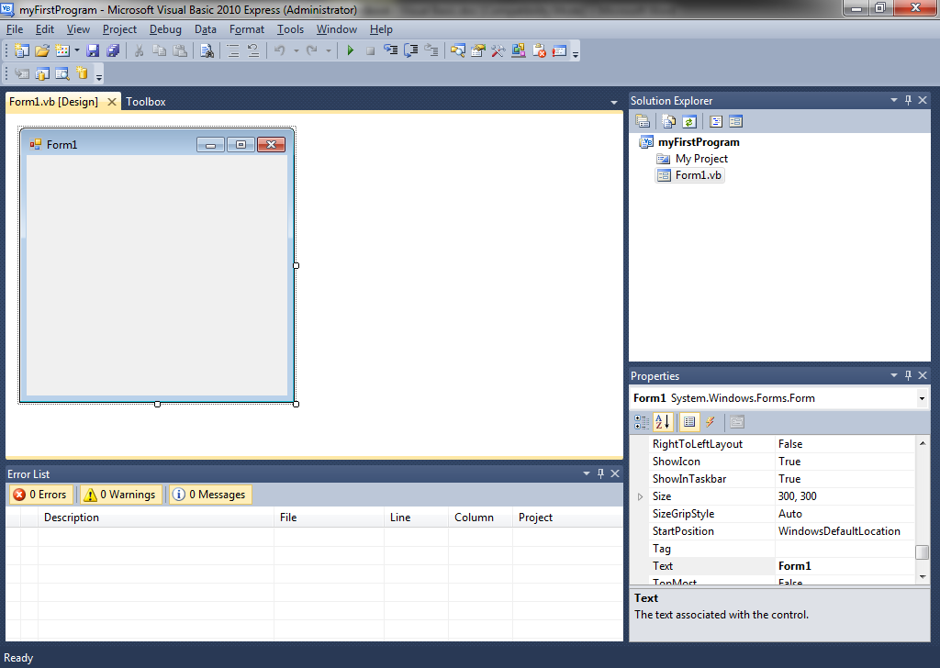

As you can see you are presented with an empty form which is effectively your first window for you your application.

Windows application is primary about using controls such as text boxes, buttons, labels,dropdown lists etc.. and how you interact with them. If you click on the toolbox you can see the different amount of controls that you can place on your form.

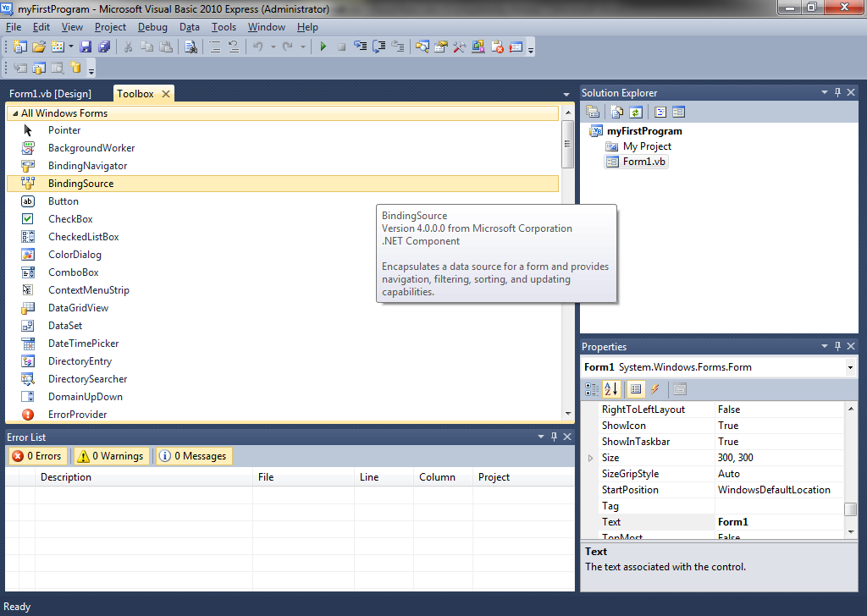
For our first program the control we are going to use is the button. Drag it across to your form.

Every object has it own set of properties. The button is an object with its own list of properties. When it is selected you can see this list on the right side of the screen. Change the Name property of the button to btnHello and the text property to OK.
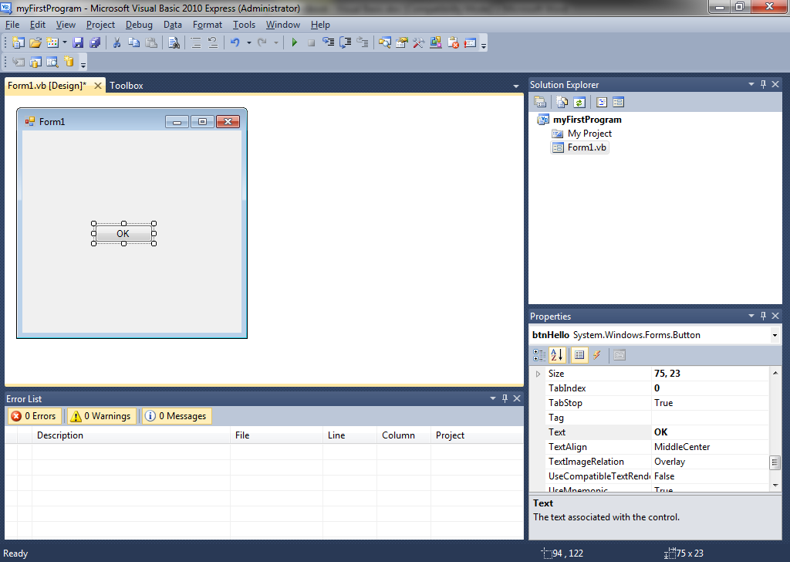

Windows applications are run by events. For instance clicking on a button will trigger an event that runs the code you program for it. Nothing happens in a windows application until an event has triggered it. There are many possible events for the different objects, including for loading the Form in the first place. We are going write the code for the clicking event of the button.

If you double click on the button itself you will be taken to the code window. You should see the following code.

Public Class Form1

Private Sub btnHello_Click(ByVal sender As System.Object, ByVal e As System.EventArgs) Handles btnHello.Click

End Sub
End Class

We need to add out code between the declaration and the End Sub. We are going to add the code

MsgBox("Hello World")

Which simply brings up a message box that says Hello World when you click on a button.

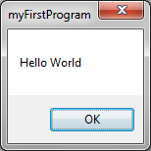

You have completed your first Visual Basic Windows application.

TextBoxes
Another common control is the textbox. Create the following form.

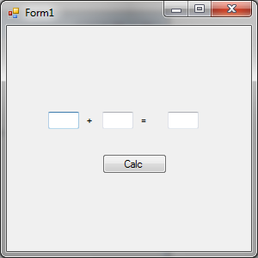
Name- txtNum1
Name- txtNum2
Name- txtSum
Labels
Name- btnCalc

The textboxes in this form act like variables and will store what ever value that you put in them. You can then reference them in any event triggered by this form. Double click on the button to bring up the code editor for that button and enter in the following code.

Public Class Form1

Private Sub btnCalc_Click(ByVal sender As System.Object, ByVal e As System.EventArgs) Handles btnCalc.Click

Dim num1, num2, product As Integer

num1 = txtNum1.Text
num2 = txtNum2.Text

product = num1 + num2

txtSum.Text = product

End Sub
End Class

As you can see you can access the values in the textboxes directly by referring to the names you have given them and then accessing the property Text.

Changing Properties
As mentioned before, every object, including forms, has their own properties. You can alter them at run time. In the example below we will look at changing the properties of the background colour of the form depending on what values the user enters in.

Create the following form in a new Visual Basic Windows Form Application project.
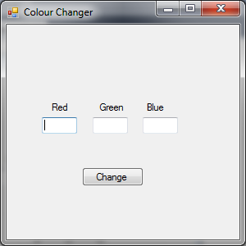
TextBox - txtRed
TextBox - txtRed
TextBox - txtBlue
Button - btnChange

And insert the following code for the button btnChange

Public Class Form1

Private Sub btnChange_Click(ByVal sender As System.Object, ByVal e As System.EventArgs) Handles btnChange.Click
Dim red, green, blue As Integer

red = txtRed.Text
green = txtGreen.Text
blue = txtBlue.Text

Me.BackColor = Color.FromArgb(red, green, blue)

End Sub
End Class

As you can see you can get the RGB numbers from the text boxes and then access the properties of the form itself and change it. In this case the BackColor property. Not that you can access the form itself by using the object Me. This label will always refer to the current form that you are in.

Chapter 12 – The Basic Calculator.

Building on the addition application we built earlier we are now going to build a basic calculator application.

Build the following form in a new VB project.

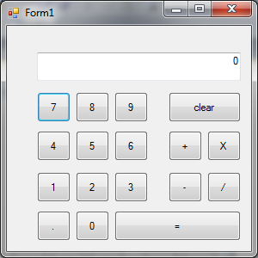
All number buttons are given the name btn and then the number, e.g. btn1,btn2 etc… The decimal is called btnDecimal. The operators are called as follows

btnClear
btnPlus
btnMult
btnMinus
btnDiv
btnEquals

And the text box is called txtDisplay

The following global variables are declared at the top of the code

Public RunningTotal As Decimal
Public NoOfNums As Integer
Public Operation As Char
Public Op As Boolean

RunningTotal –this is the ongoing total entered into the calculator
NoOfNums – this is the number of numbers that make up the running total.
Operation – The current mathematic operation underway
Op – whether an operation as taken place so that the display can now be overwritten.

As you can probably guess from the type of application there are going to be a lot click events for all the buttons. For each event the code is going to look something like this.

Private Sub btn0_Click(ByVal sender As System.Object, ByVal e As System.EventArgs) Handles btn0.Click
If Op Then
txtDisplay.Text = "0"
Op = False
Me.Refresh()
Else
txtDisplay.Text = txtDisplay.Text + "0"
End If
End Sub

First thing that is done is that we check the Boolean variable Op. If it is true then an operation has recently been carried out on the calculator and therefore as we start typing more numbers in – we need to overwrite what is already there. If this is not the case then we need to add our number to the existing string.

This code needs to be done for all the click events for the number buttons – changing the number itself when appropriate. For the decimal it is slightly different.

Private Sub btnDecimal_Click(ByVal sender As System.Object, ByVal e As System.EventArgs) Handles btnDecimal.Click
If Op Then
txtDisplay.Text = "0."
Op = False
Me.Refresh()
Else
txtDisplay.Text = txtDisplay.Text + "."
End If
End Sub

Notice that if we are overwriting then there has not been a number before – therefore by adding a decimal we are effectively saying that it is a decimal less than one –hence the need to start with “0.”

Now the code for each of the operators is simple.

Private Sub btnPlus_Click(ByVal sender As System.Object, ByVal e As System.EventArgs) Handles btnPlus.Click
CarryOperation("+")
Op = True
End Sub

To make this program more efficient we will create a procedure called CarryOperation which takes a char as the parameter. The parameter will be the operation that is to be carried out. In the events for the operators we simply call that procedure – passing the appropriate parameter and then set out Global Op variable to true. This code is the same for btnMult, btnDiv, btnMinus and btnEquals.

The code for out procedure CarryOperation is as follows.

Sub CarryOperation(ByVal NxOp As Char)

NoOfNums = NoOfNums + 1

If NoOfNums > 1 Then
Select Case Operation
Case "+"
RunningTotal = RunningTotal + txtDisplay.Text
Case "-"
RunningTotal = RunningTotal - txtDisplay.Text
Case "*"
RunningTotal = RunningTotal * txtDisplay.Text
Case "/"
RunningTotal = RunningTotal / txtDisplay.Text
End Select
Else
RunningTotal = txtDisplay.Text
End If

Operation = NxOp
txtDisplay.Text = RunningTotal

End Sub

When you use the calculator an example of the process goes something like this.

User action | Display | Process
User enters in 100 | 100 | 100 displayed
User enter in + | 100 | 100 displayed
User enters in 50 | 50 | 50 is added onto100
User enters in + | 150 | The result of previous operation is shown
User enters in 25 | 25 | 25 is added to 150
User enters in = | 175 | Result of previous operation is shown.

If you notice that the results of the operation is not shown until the user either inputs another operation or presses equals. So in the CarryOperation procedure we carry out the operation from the previous user input so we can display that to the screen and then change the current operator for the next time.

Below is the full listing for the Calculator Program.

Program Listing for Basic Calculator Program

Option Explicit On

Public Class Form1

Public RunningTotal As Decimal
Public NoOfNums As Integer
Public Operation As Char
Public Op As Boolean

Private Sub Form1_Load(ByVal sender As System.Object, ByVal e As System.EventArgs) Handles MyBase.Load
NoOfNums = 0
RunningTotal = 0
Op = True
End Sub

Private Sub btnDecimal_Click(ByVal sender As System.Object, ByVal e As System.EventArgs) Handles btnDecimal.Click
If Op Then
txtDisplay.Text = "0."
Op = False
Me.Refresh()
Else
txtDisplay.Text = txtDisplay.Text + "."
End If

End Sub

Private Sub btn0_Click(ByVal sender As System.Object, ByVal e As System.EventArgs) Handles btn0.Click
If Op Then
txtDisplay.Text = "0"
Op = False
Me.Refresh()
Else
txtDisplay.Text = txtDisplay.Text + "0"
End If
End Sub

Private Sub btn1_Click(ByVal sender As System.Object, ByVal e As System.EventArgs) Handles btn1.Click
If Op Then
txtDisplay.Text = "1"
Op = False
Me.Refresh()
Else
txtDisplay.Text = txtDisplay.Text + "1"
End If
End Sub

Private Sub btn2_Click(ByVal sender As System.Object, ByVal e As System.EventArgs) Handles btn2.Click
If Op Then
txtDisplay.Text = "2"
Op = False
Me.Refresh()
Else
txtDisplay.Text = txtDisplay.Text + "2"
End If
End Sub

Private Sub btn3_Click(ByVal sender As System.Object, ByVal e As System.EventArgs) Handles btn3.Click
If Op Then
txtDisplay.Text = "3"
Op = False
Me.Refresh()
Else
txtDisplay.Text = txtDisplay.Text + "3"
End If
End Sub

Private Sub btn4_Click(ByVal sender As System.Object, ByVal e As System.EventArgs) Handles btn4.Click
If Op Then
txtDisplay.Text = "4"
Op = False
Me.Refresh()
Else
txtDisplay.Text = txtDisplay.Text + "4"
End If
End Sub

Private Sub btn5_Click(ByVal sender As System.Object, ByVal e As System.EventArgs) Handles btn5.Click
If Op Then
txtDisplay.Text = "5"
Op = False
Me.Refresh()
Else
txtDisplay.Text = txtDisplay.Text + "5"
End If
End Sub

Private Sub btn6_Click(ByVal sender As System.Object, ByVal e As System.EventArgs) Handles btn6.Click
If Op Then
txtDisplay.Text = "6"
Op = False
Me.Refresh()
Else
txtDisplay.Text = txtDisplay.Text + "6"
End If
End Sub

Private Sub btn7_Click(ByVal sender As System.Object, ByVal e As System.EventArgs) Handles btn7.Click
If Op Then
txtDisplay.Text = "7"
Op = False
Me.Refresh()
Else
txtDisplay.Text = txtDisplay.Text + "7"
End If
End Sub

Private Sub btn8_Click(ByVal sender As System.Object, ByVal e As System.EventArgs) Handles btn8.Click
If Op Then
txtDisplay.Text = "8"
Op = False
Me.Refresh()
Else
txtDisplay.Text = txtDisplay.Text + "8"
End If
End Sub

Private Sub btn9_Click(ByVal sender As System.Object, ByVal e As System.EventArgs) Handles btn9.Click
If Op Then
txtDisplay.Text = "9"
Op = False
Me.Refresh()
Else
txtDisplay.Text = txtDisplay.Text + "9"
End If
End Sub

Private Sub btnClear_Click(ByVal sender As System.Object, ByVal e As System.EventArgs) Handles btnClear.Click
txtDisplay.Text = "0"
RunningTotal = 0
NoOfNums = 0
Op = True
End Sub

Private Sub btnPlus_Click(ByVal sender As System.Object, ByVal e As System.EventArgs) Handles btnPlus.Click
CarryOperation("+")
Op = True
End Sub

Private Sub btnMult_Click(ByVal sender As System.Object, ByVal e As System.EventArgs) Handles btnMult.Click
CarryOperation("*")
Op = True

End Sub

Private Sub btnMinus_Click(ByVal sender As System.Object, ByVal e As System.EventArgs) Handles btnMinus.Click
CarryOperation("-")
Op = True
End Sub

Private Sub btnDiv_Click(ByVal sender As System.Object, ByVal e As System.EventArgs) Handles btnDiv.Click
CarryOperation("/")
Op = True
End Sub

Private Sub btnEquals_Click(ByVal sender As System.Object, ByVal e As System.EventArgs) Handles btnEquals.Click
CarryOperation("=")
Op = True
End Sub

Sub CarryOperation(ByVal NxOp As Char)

NoOfNums = NoOfNums + 1

If NoOfNums > 1 Then
Select Case Operation
Case "+"
RunningTotal = RunningTotal + txtDisplay.Text
Case "-"
RunningTotal = RunningTotal - txtDisplay.Text
Case "*"
RunningTotal = RunningTotal * txtDisplay.Text
Case "/"
RunningTotal = RunningTotal / txtDisplay.Text
End Select
Else
RunningTotal = txtDisplay.Text
End If

Operation = NxOp
txtDisplay.Text = RunningTotal

End Sub
End Class

Chapter 13 – Using VBA (Visual Basic for Applications)
Visual Basic for Applications is a powerful tool that allows you to program the Microsoft Office products to tailor them to real client needs. It uses the Visual Basic program language. In this book we will be looking at VBA for Access, but as mentioned you can also use it in Excel, Publisher, Powerpoint, Publisher, Outlook and Word.

You can select Visual Basic through the Database Tools ribbon in Access. The screen blow is the IDE that you will work with. It is similar to Visual Studio Express.

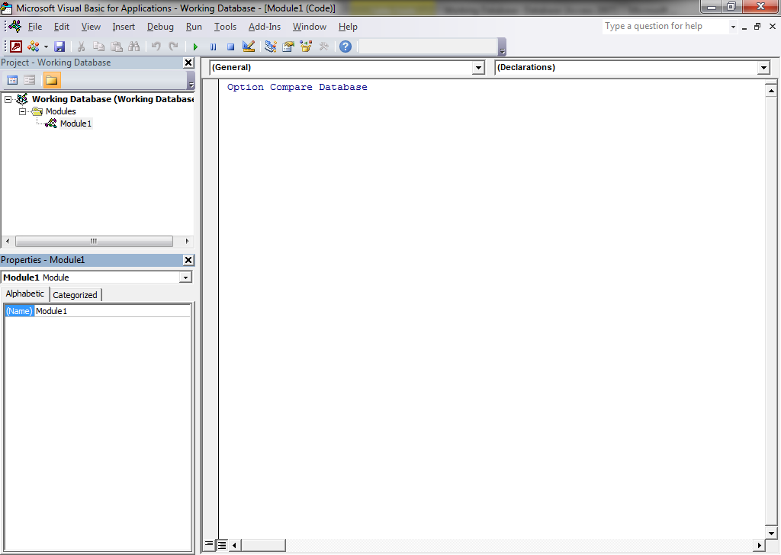
Code is entered here.
Modules created here
Properties of the modules.

You can use the above editor like you can in Visual Basic Express. Type the following in the code window

Sub HelloWorld()

MsgBox "Hello World", vbOKOnly, "My First VBA Program"

End Sub

You can run the routine by placing your cursor directly in the code and clicking on the PLAY button. This will run the procedure you are in.

MsgBox is a procedure that displays a message. The second parameter determines what type of message box it is. Below are the possibilities for that parameter:

vbOKOnly 0 Display OK button only.
vbOKCancel 1 Display OK and Cancel buttons.
vbAbortRetryIgnore 2 Display Abort, Retry, and Ignore buttons.
vbYesNoCancel 3 Display Yes, No, and Cancel buttons.
vbYesNo 4 Display Yes and No buttons.
vbRetryCancel 5 Display Retry and Cancel buttons.
vbCritical 16 Display Critical Message icon.
vbQuestion 32 Display Warning Query icon.
vbExclamation 48 Display Warning Message icon.
vbInformation 64 Display Information Message icon.
vbDefaultButton1 0 First button is default.
vbDefaultButton2 256 Second button is default.

Exercises
- Create a new module in your database and name it Hungry Mouse. Create a subroutine within this module to display the following message.
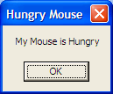

- Create another subroutine which displays the following message:
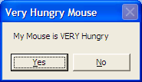

Event Driven Programming in VBA
As mentioned in previous chapters most of the code in Visual Basic is triggered by events, for instance by clicking on a button in a form. Or by updating a field in a form. Most of the tools that you can add to a user form will have a set of events associated with them
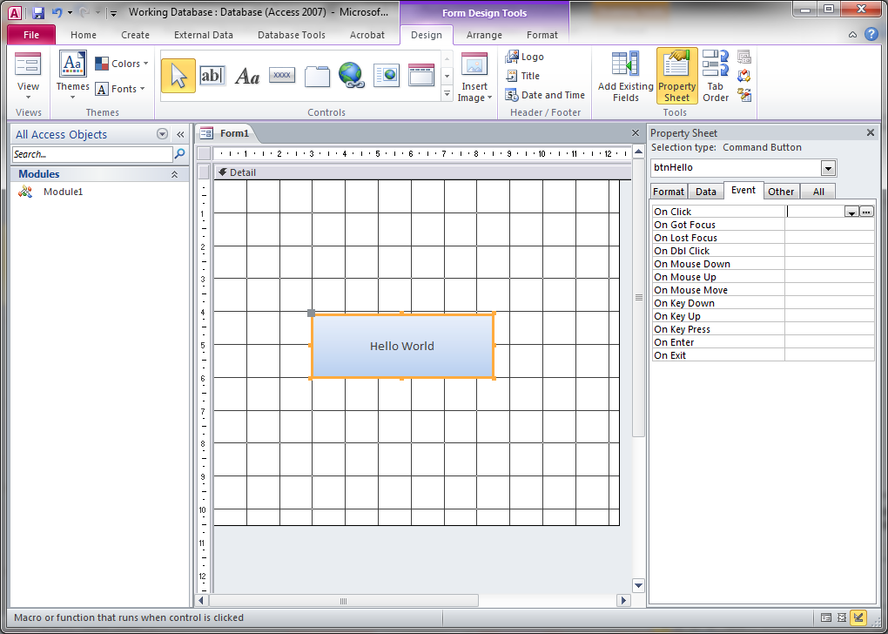
Form Design
Possible events for a button

To add the code for an event – just simply click on the button next to the event in the properties window and select Code Builder. This will set up a skeleton subroutine for that event which you can then add code to.

Exercises
- Create a form with two buttons in. 1 button runs your Mouse Hungry routine. The other button runs your Mouse Very Hungry routine.

Variables
As with any programming language VBA also uses variables. These variables can be of many types, and also user defined types.

In VBA you do not have to declare variables – just use them when you want. However is it good practice to declare them at the top, especially when it comes to error checking.

Variables are declared as such:

Dim VariableName As Datatype

It is always best to include the words “Option Explicit” at the top of every module which forces declaration of variables.

The variable types in VBA are virtually the same as normal VB – here is a summary of them

Data Type | Description | Bytes | Conversion
Byte | Any integer between 0 and 255 | 1 | Cbyte
Integer | Any integer with absolute value less than 32,767 | 2 | Cint
Long | Any integer with absolute value less than 2 billion | 4 | CLng
Single | Any number with absolute value less than 10³⁸ | 4 | CSng
Double | Any number with absolute value less than 10³⁰⁸ | 8 | CDbl
Currency | Any amount with absolute value less than 9X10¹⁴ | 8 | Ccur
Boolean | Variable that takes the value TRUE or FALSE | 2 | Cbool
Date | Any variable which contains a date | 8 | Cdate
String | Any variable which contains text | ? | CStr
Variant | Any variable whose data type is not known | 16+ | Cvar
Object | A reference to a Visual Basic Object | 4 | N/A

Functions
Functions in VBA are exactly the same as VB - they return a value.

The InputBox is a function that returns a string.

InputBox(prompt[, title] [, default] [, xpos] [, ypos] [, helpfile, context])

Exercises
- Create a form that has a button. Create an event that when this button is pressed an input box appears that asks the user to enter 1 number. Then another number . Afterwards a message box should appear stating:

The product of <firstNumber> and <secondNumber> is <Answer>

e.g.
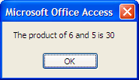

User Defined Functions
You can create your own functions using the format:

Function <name>(<par1> As <type?,…) As <return type>
<name> = <return value>
End Function

Note that the variable that you assign the return value to is the same name as the function name itself and does not have to be declared separately.

Exercises
- Using the GOAL Database create an update query that uses a function to ask the user what player they want. For the goals scored for that player – increment that by one. Note: Use Inputbox to get the criteria required.
- In your Goals database create a module called TenureAtClub. Create a function called Tenure to calculate the number of years each player has played for his or her club using the following formula:

Tenure = YearEnd – YearStart

Incorporate the function within a query as follows:

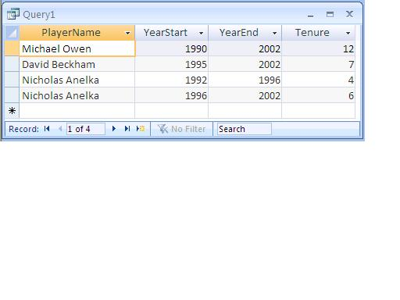

The DoCmd
There is one command in Access that does an awful lot of things. This is the DoCmd. You can open forms, run queries, reports, tables etc. A great many of them are self-explanatory. Just add the point after DoCmd and a whole list of procedures will appear in the help menu.

Exercises
- Create a subroutine that opens up the form that you created in Exercise 3 using the Docmd.OpenForm procedure. See if you can guess what you need to put in the parameters. Hint: you will only need the first 2.

Properties
As mentioned with VB, all objects used in forms have properties. The same applies with the forms in Access. Every form, report, control, table etc.. In Access has properties. These properties can be manipulated by VBA code. For example how about a silly program where when you click on a button it moves the button to the left.

Private Sub btnChase_Click()
Me.btnChase.Left = Me.btnChase.Left + 100
End Sub

“Me” is a special keyword that is basically the form you are on.
“btnChase” is the name of the button.
“Left” is the name of the property you are changing.
Try it out and see!!

Exercises
- Open the Database “Properties Example” and the form “Form Code Examples”
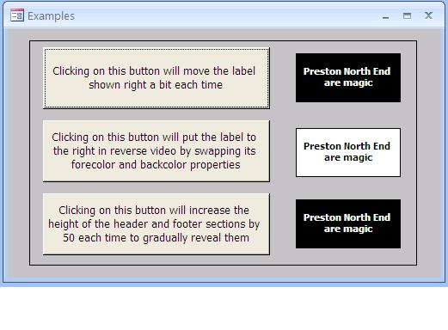
Can you do what the buttons are asking you to do?

- Open the database named Properties Examples 2 and open the form titled Teams (with buttons)
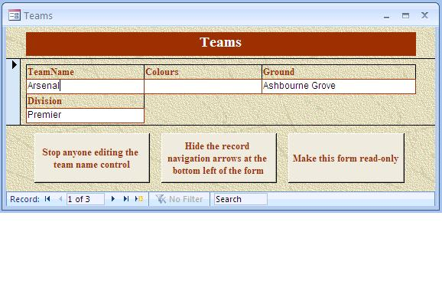
Can you do what the buttons are asking you to do here?

Amending Queries
A powerful tool that you can implement with VBA is to change queries dynamically. You can gather information during runtime and create an SQL statement based on that information. This SQL statement can then be substituted to a query that already exists.

Using the GOALS Database available on FROG create a query called qryPlayersAboveACertainAge. that simply returns players above the age of 25. We are also going to create a report that displays the results of the above query. Call this report rptListOfPlayers.

Next we are going to create a form called frmPlayersAboveACertainAge.

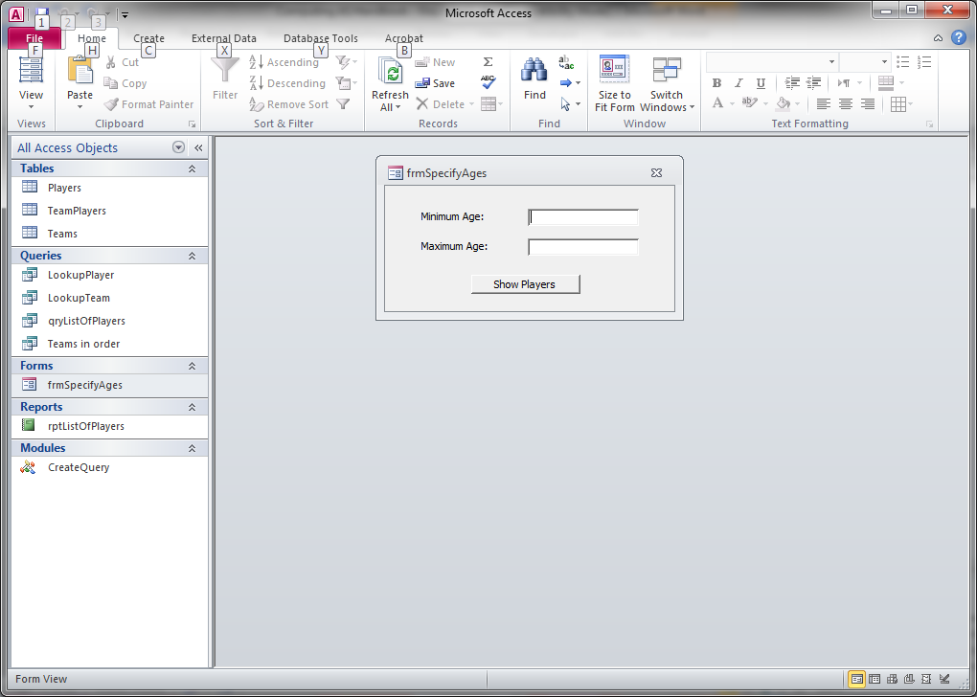
Name - txtMinAge
Name - txtMaxAge
Name - btnShowPlayers

The code below is for the click event of the button.

Private Sub btnShowPlayers_Click()

Dim q As QueryDef ' the query
Dim db As Database ' the database
Dim MinAge As String ' the maximum age
Dim MaxAge As String ' the minimum age

' specify the database
Set db = CurrentDb
' specify the query
Set q = db.QueryDefs("qryListOfPlayers")
' grab the maximum and minimum ages from the form
MinAge = Me.txtMinAge
MaxAge = Me.txtMaxAge

' set the SQL
q.SQL = "SELECT PlayerName, PlayerAge FROM Players WHERE PlayerAge BETWEEN " & MinAge & " And " & MaxAge

' open the report in preview mode
DoCmd.OpenReport reportname:="rptListOfPlayers", view:=acViewPreview

There are a couple of data types that you will be unfamiliar with in the variable declaration section. One is Database. This is an object that encompasses an Access Database. The other is QueryDefs. This is an object that encompasses a query in that Database. Once the query is changed by assigning a new value the report is run. This report automatically reruns the query with the new SQL.

Chapter 14 – Record sets in VBA

Opening a table

Record sets in VBA allows you to access and manipulate the tables directly in access. You declare a variable as a record set and then use that variable to then access all the fields, properties and data in the table.

You declare it like so:

Dim a_recordset AS ADODB.Recordset

You then need to initialise it.

Set a_recordset = New ADODB.Recordset

After you have initialised the recordset you need to open your selected table. To do this, you use the “Open” command as follows:

a_recordset.Open

The parameters for this function are:

- Name of the table you wish to open
This will be the name of the table you wish to open as a string

- What type of connection you wish to open
This will usually be the current project – so the syntax is as follows:

a_recordset.Open “Teams”, CurrentProject.Connection

- The Cursor type

adOpenForwardOnly - You are positioned at the beginning of the recordset, and can only move in one direction – forward.
adOpenStatic - Creates a copy of all the records in the recordset – changes made to the underlying table by other users won’t be detected.
adOpenKeyset – Creates a copy of the primary key field only for each record in the recordset and returns to the main table for the other fields as and when needed. This cursor type will show changes other users have made to existing records, but will not show records additions or deletions
adOpenDynamic - Returns at any point the latest set of records – but this comes at a high price in terms of performance.

- The Lock type

adLockReadOnly - You can not change any data
adLockOptimistic – You can change any data, but Access will only lock a record to prevent others changing it when you update your changes using the update method.
adLockPessimistic - You can change any data – the moment you scroll to a record, Access locks it to prevent other users changing it.
adLockBatchOptimistic - Only used for Batch updating (when you are programmatically changing a number of records simultaneously.

So one way of opening a table is:

a_recordset.Open “Teams”, CurrentProject.Connection, _
adOpenDynamic, adLockOptimistic

The underscore at the end of the first line needs to be put in if your statement goes over one line.

Referring to fields

There are several ways of referring to fields in a recordset

a_recordset.Fields(“TeamName”).Value

The value property of the specified field

a_recordset.Fields(“TeamName”)

The default property of a field is its value, so you can omit this.

a_recordset(“TeamName”)

The default collection for a recordset is to divide it into fields, so you don’t need to specify the collection name.

a_recordset(0)

The TeamName field is the first one in order

Recordset Functions

Some very useful functions when using recordsets to manipulate Data

A_recordset.Addnew
..
..
A_recordset.Update

Addnew starts a blank row in your table. You then add your data to your fields and then update at the end.

A_recordset.Delete

Once you have a row you wish to delete – calling this function deletes that row.

A_recordset.Edit
..
..
A_recordset.Update

If you want to edit a row – once you are at the correct row – calling Edit allows you to edit that row. An update must be called at the end to make the changes.

When searching for rows, either to delete them, edit them or display them you can use loops to work through the table as shown.

Do Until a_recordset.EOF ‘ end of file

‘ Code that is required
'must move onto next record, or will never finish
a_recordset.MoveNext

Loop

The EOF function returns true when you have reached the end of the table.

Some other useful functions that can be used in records sets are

Some other useful functions.

a_recordset.MoveNext ‘ move to the next record in the table
a_recordset.MoveFirst ‘ move to the first record in the table
a_recordset.MovePrevious ‘ move to the previous record in the table
a_recordset.MoveLast ‘ move to the last record in the table
a_recordset.FindFirst(“[FIELD_NAME]=‘VALUE’”]

The FindFirst function will find the first records that matched the criteria.

Exercises
- Using the Goals Database Create a form that asks a user to enter in a new player name and his age. Do not have this form linked to the Players Table. Add a Confirm Button. Add code to the click event of the confirm button that opens the table “Players” and adds the new player.
- Create the following three modules
  - A procedure called AddChelsea to add Chelsea into the Teams Table
  - A procedure called DeleteBlueTeams to delete all teams who play in blue
  - A procedure called ChangedArsenalGround to change Arsenal’s ground from Highbury to Ashbourne Grove.

These all can be done using append, delete and update queries but for the purpose of practicing we will use ADO recordsets.

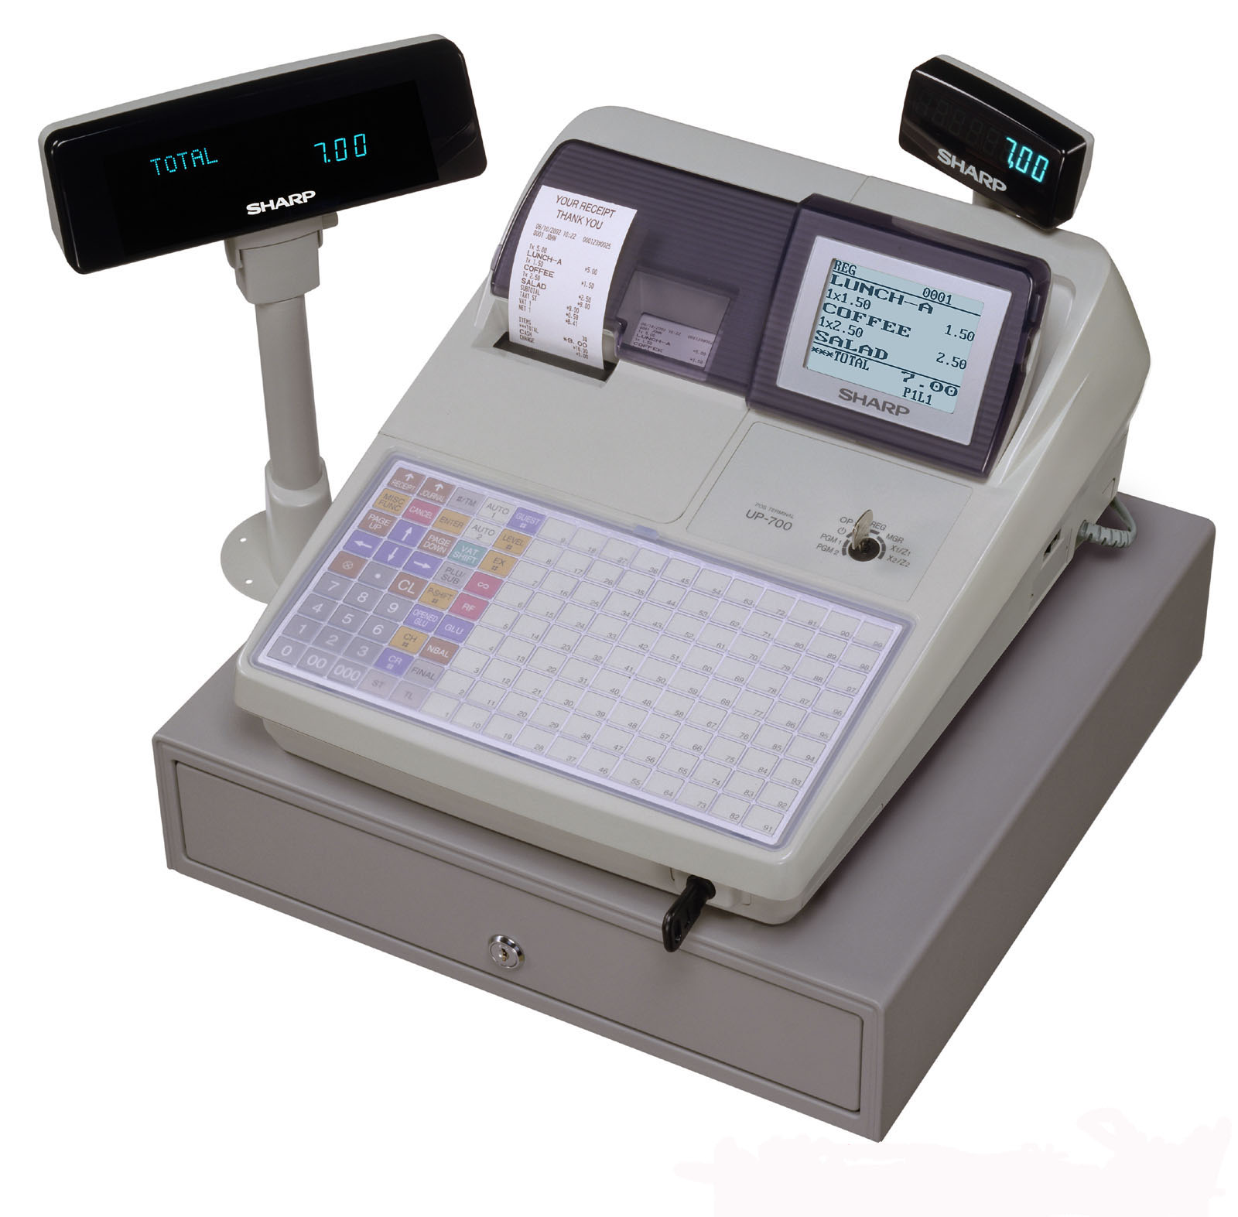

Programming Challenge
The National Lottery

Details of play
To play the lottery you need to buy a ticket that cost £1. You pick six numbers between 1 and 49. On draw night the machine will pick six numbers and a bonus ball. You normally win money if you match 3, 4, 5 and 5 + bonus. Match all six numbers and you have won the Jackpot!

Write a program that simulates the lottery by asking the user for 6 numbers and then shows on the screen for x number of draws how many times they matched 3,4,5, 5 + bonus or 6 numbers.

The program will be marked out of eight; 4 for the basic program and up to a further 4 extra marks for the following extension tasks:

- Create a simulation of the ‘lucky dip’ (where numbers are picked at random for a player)
- Calculate the number of years to win the lottery
- Calculate the profit and loss (£1 per draw outgoings, winnings are counted as income)
Programming Challenge
Mayan Calendar

This problem was set by the British Informatics Olympiad, sponsored by Lionhead Studios: one of the leading videogames developers in the UK.

In the Mayan calendar there were 20 days (called kins) in a uinal, 18 uinals in a tun, 20 tuns in a katun and 20 katuns in a baktun. We write our dates in the order day, month then year. The Maya wrote their dates in reverse, giving the baktun, katun, tun, uinal then kin.

The Mayan date 13-20-7-16-3 corresponds to 1-1-2000. Write a program which converts between the Mayan calendar and our own.
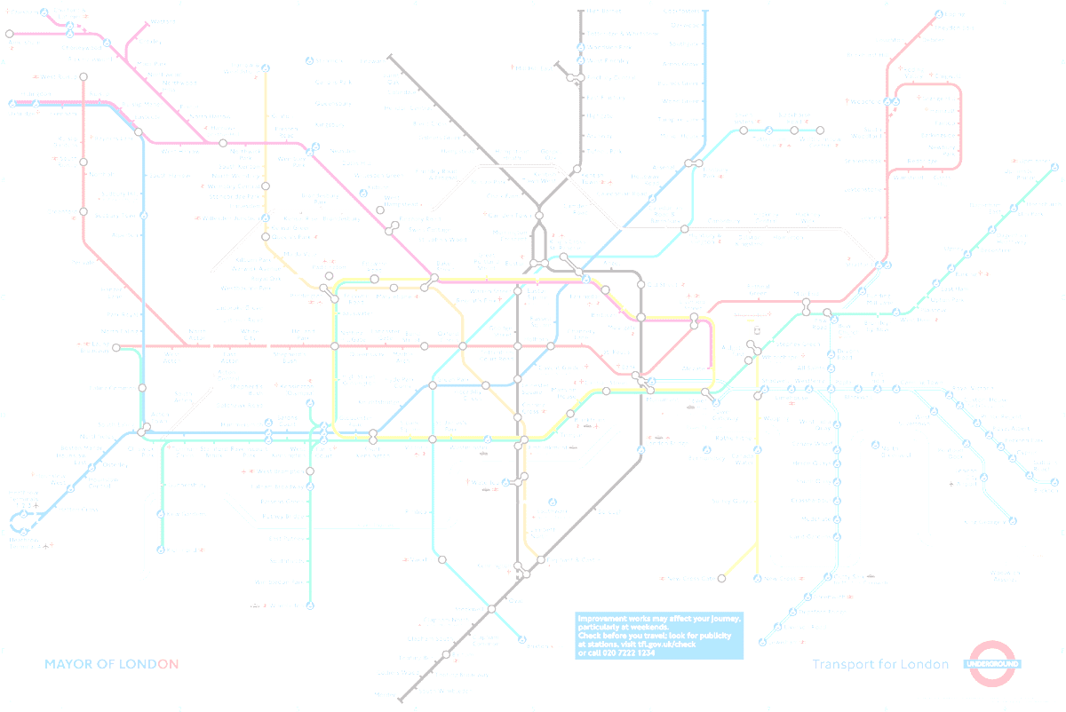

Programming Challenge
London Underground

This problem was set by the British Informatics Olympiad, sponsored by Lionhead Studios: one of the leading videogames developers in the UK.

It is a little known fact that the only station on the London Underground that can be formed without using any of the letters in the word mackerel is St John’s Wood. This is also true for the words piranha and sturgeon (although for different stations).

For a given list of stations, write a program that takes a word and determines if there is a single station that can be formed without using any of its letters.

Appendix A: Progress Self-Assessment

Task | Due In (Date) | Completed? | Mark
Chapter 1 Exercises
Chapter 2 Exercises
Chapter 3 Exercises
Chapter 4 Exercises
Chapter 5 Exercises
Chapter 6 Exercises
Chapter 7 Exercises
Chapter 8 Exercises
Chapter 9 Exercises
Chapter 10 Exercises
Additional exercises
Lottery Program
Checkout Software
Programming Test Date

