**Q1.**

The system bus connects together the processor, main memory and input/output components.

The system bus itself is split into three separate buses: data, address and control.

(a)     State what each of the following components does:

Processor __________________________________________________________

___________________________________________________________________

Main memory _______________________________________________________

___________________________________________________________________

Control bus _________________________________________________________

___________________________________________________________________

**(3)**

(b)     The diagram shows how components of a computer system can be connected.

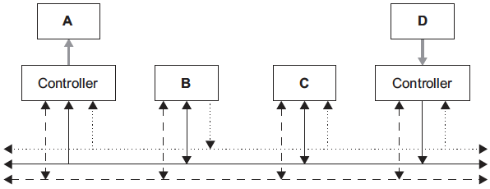

Write the correct name for each of the components **A**, **B**, **C** and **D** from the diagram using only the following:

Processor, Address Bus, Control Bus, Data Bus, Hard Disk Drive,

Main Memory, Visual Display Unit, Keyboard

**A** __________________________________________________________

**B** __________________________________________________________

**C** __________________________________________________________

**D** __________________________________________________________

**(4)**

**(Total 7 marks)**

**Q2.**

A computer system has a clock speed of 1 GHz, a 16-bit data bus and a 24-bit address bus. What would be the precise effect of

(a)     increasing the clock speed to 2 GHz?

___________________________________________________________________

___________________________________________________________________

___________________________________________________________________

**(1)**

(b)     increasing the size of the data bus to 32 bits?

___________________________________________________________________

___________________________________________________________________

___________________________________________________________________

**(1)**

(c)     increasing the width of the address bus to 32 bits?

___________________________________________________________________

___________________________________________________________________

___________________________________________________________________

___________________________________________________________________

**(2)**

**(Total 4 marks)**

**Q3.**

Some of the components of a computer system are:

Peripherals:

keyboard                     1

monitor                        2

1/0 Ports:

VDU controller            3

keyboard controller     4

Memory:

main memory              5

secondary storage      6

System Bus:

Data Bus                     7

Address Bus               8

(a)     In the diagram below, identify each component by writing its number, given in the list above, in the appropriate circle.

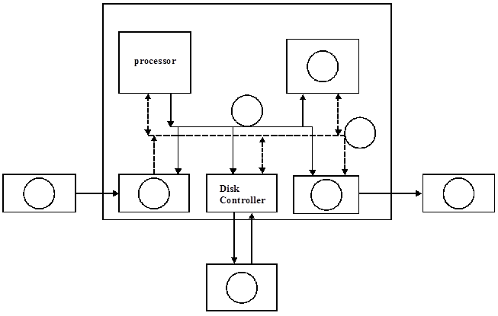

**(6)**

(b)     The above computer system uses the *stored program concept*. Explain this term.

___________________________________________________________________

___________________________________________________________________

___________________________________________________________________

___________________________________________________________________

**(2)**

**(Total 8 marks)**

**Q4.**

**Figure 1** shows some of the internal components of a processor and how the processor is connected to the main memory. The internal connections within the processor are not shown.

**Figure 1**

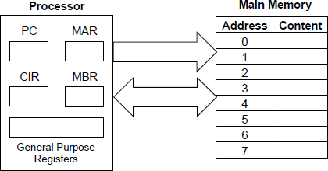

Describe how an instruction is fetched from main memory during the **fetch stage** of the fetch-execute cycle.

Your description should cover the use of registers and buses, together with the role of main memory.

_______________________________________________________________________

_______________________________________________________________________

_______________________________________________________________________

_______________________________________________________________________

_______________________________________________________________________

_______________________________________________________________________

_______________________________________________________________________

_______________________________________________________________________

_______________________________________________________________________

**(Total 4 marks)**

**Q5.**

During the **decode and execute stages** of the fetch-execute cycle the instruction that is being processed is stored in the CIR. Explain why the instruction could **not** be processed directly from the MBR.

_______________________________________________________________________

_______________________________________________________________________

_______________________________________________________________________

_______________________________________________________________________

________________________________________________________**(Total 2 marks)**