**PRODUCT DESIGN -----------------------------------**

**Structure Research and Line work**

Collect Images of patterns and textures using V/H 10 x

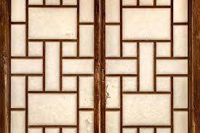

Produce 10-15 more experiments/studies demonstrating your ability to draw…….

Vertical

Diagonal

Horizontal

Thick

Thin

Graduated

Broken

Dotted line

