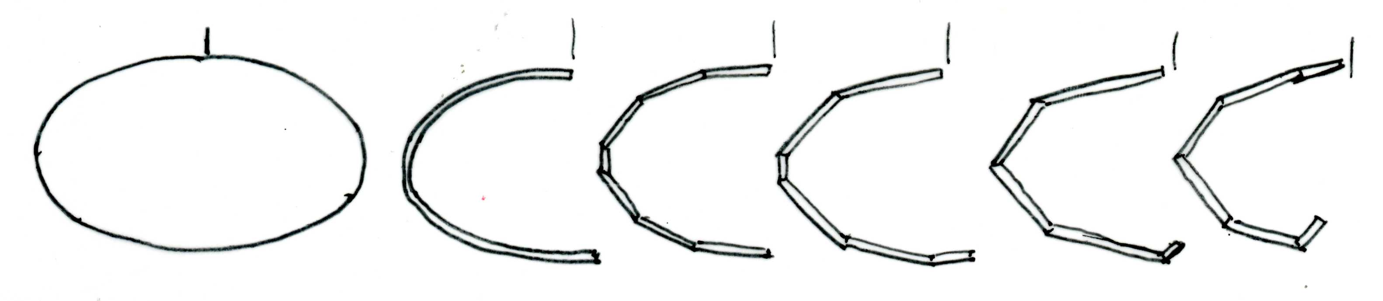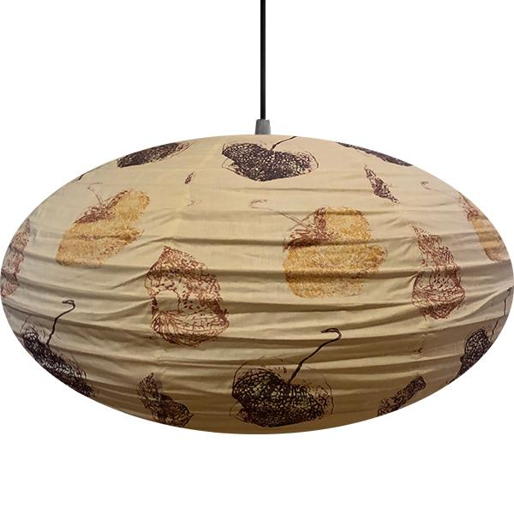

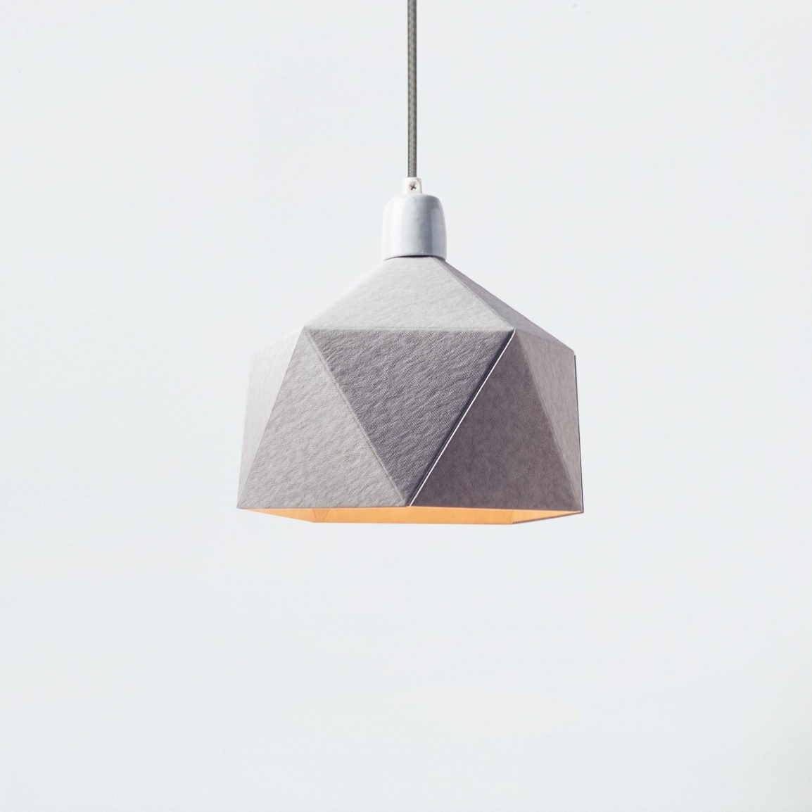

Layout:

Take your 3 or 4 images and shrink them so they are no more than 100mm in width.

Designing:

Trace the basic side profile using fine liner.

Now add a second line to give it ‘width’ and/or ‘thickness’. This is your starting profile

Now take this ‘profile’ and make ONE change as you redraw it.

Repeat the one change each time to draw several further adaptions.

These side frames will then be converted into your final lamp shape.

