**PRODUCT DESIGN -----------------------------------**

**Drawing Homework – Thick ‘n’ Thin lines + colour+ spatial**

This homework is to reinforce the techniques of using different thickness of lines to help improve the readability of a drawing or sketch.

Deadline:

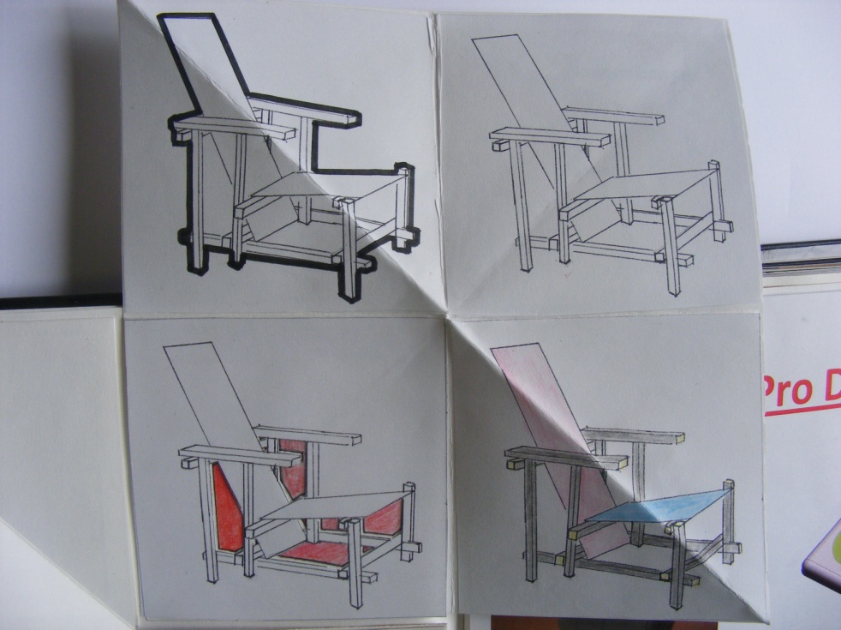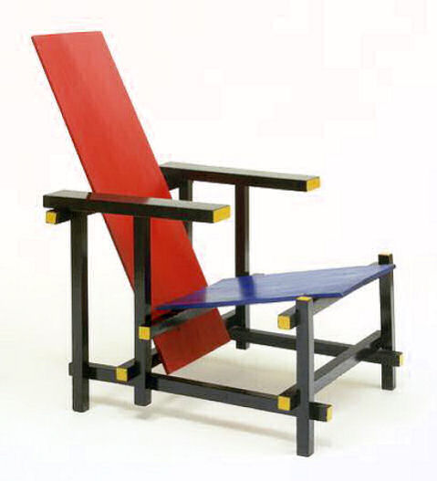One week from the day it was set i.e. your single hour lesson.

You will need:

* An image of Gerrit Rietveld’s Red and Blue Chair
* A pencil (not too dark)+ Fine liner
* Two sheets of ordinary paper (from classroom) for your drawings
* One ‘cartridge paper square’ from teacher

Task:

You will be producing the same drawing of the chair, in four different ways.

Trace the Red and Blue chair neatly using just a thin pencil outline. Scan or copy this image four times. Then produce one version of each of the following using a fine liner pen:

1.Thins lines – shows the chair as a simple line drawing

2. Thick lines – shows where the edges of surfaces/components meet the air i.e. you could put your hand behind.

3.Coloured –to show your ability to render with colour (can be coloured pencil or marker pen)

4. Spatial – shows how the frame works as a ‘space frame’ . Use a scalpel to cut and use a ‘lift up’ flap.