The basics of drawing and sketching

**Sketch Basics**

Sketching is a visual language, and as with any language, there are elements that go together to form more structured forms of communication. In sketching or drawing, we use line as one of the most basic components in visual communication. Line does not exist in reality, but it is a mere representation of the edge of an object, or in other words, the point at which we cannot see past the change in surface of an object.

Before you begin, remember to relax. There’s nothing worse than sketching when stressed out. Stress will kill your creativity, and the natural flow of things.

Elements: Lines  
Lines come in different thicknesses or weights. Depending on the tool you’re using, you may get a heavier or lighter line.

Line weight is a means of using heavier lines to bring important details to the “forefront” or attention of the viewer of a sketch. Proper use of line weights or thickness when sketching, can help you communicate important details such as overlap and depth.  
  
Lines can communicate different qualities as well. Gestural lines may be used to communicate feeling or emotion, or merely add interest to a sketch. Contour lines communicate form. Construction lines combined with heavier lines show the makeup of the form you are drawing. Following are a few examples of lines that are used in sketching:

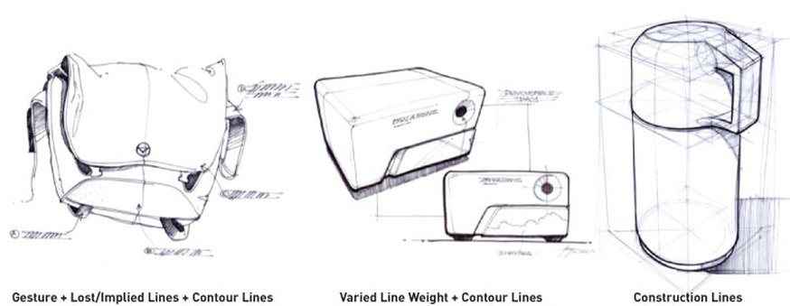

**‘Line weight’**

Line weight is something to practise with any new drawing pen so that you can add thickness and density at any stage of the drawing process.

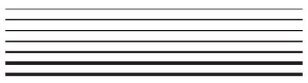

**‘Thick and Thin’**

The thick-thin method typically uses two line weights. The thick line being two or three times thicker than the thin line. So, if the thick line is 1.5 points, the thin line will be either 0.75 points or 0.5 points. It's a matter of taste.

You're probably wondering how to determine when to use a thick line and when to use a thin line. It's not as confusing as it sounds. In fact, it's quite simple. If an edge meets air, it needs a thick line. If an edge meets another visible edge, it needs a thin line. Thin lines are also used to show surface texture or detail.

[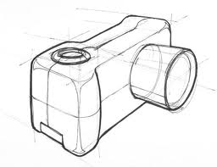](http://www.google.co.uk/url?sa=i&rct=j&q=&esrc=s&frm=1&source=images&cd=&cad=rja&uact=8&docid=QYV6X6Ft6PxzSM&tbnid=23exxbfrXgyCVM:&ved=0CAUQjRw&url=http://www.productdesignforums.com/topic/9826-taros-sketching-rendering/&ei=d18IVJvCOOGI7AaGtoHABw&bvm=bv.74649129,d.ZGU&psig=AFQjCNG6Oa5c4bEZOJFLOvLLrJhkvC6xbA&ust=1409921242023605)[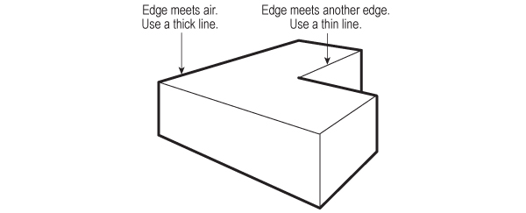](https://cdn.tutsplus.com/vector/authors/julie-felton/thick-thin-scenarios.jpg)

**Ellipses**

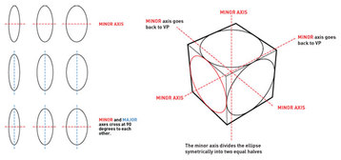

An ellipse is a circle in perspective. The viewing angle is referred to as the degree of the ellipse. Think of the degree as how “open” the ellipse appears when sketched. A perfect circle is viewed at 90 degrees. Anything less than 90   
degrees is an ellipse. Understanding the mechanics of drawing an ellipse is not difficult, however, mastering the technique can prove to be challenging.  
  
An ellipse has two axes, the major axis and the minor axis. The minor axis divides the ellipse into two equal halves across the narrowest dimension. The major axis divides the ellipse across the longest dimension. The major and minor axes are ALWAYS at 90 degrees or perpendicular to each other at the centre of the ellipse.

**Drawing in Perspective**

There are two main ways of drawing using perspective: ONE-POINT and TWO-POINT.

A One-Point Perspective has single vanishing point (VP). It is located right in front of viewer’s eyes on the horizon line that is always correlates with one’s eye-level.

A Two-Point Perspective has two vanishing points (VP1 and VP2). They are located either side of the viewer’s eyes on the horizon line.

When drawing in perspective, lines radiate from the vanishing point. Object’s edges and forms follow those perspective lines.

Objects on the drawing in perspective are becoming smaller and distance between them shorter, the further away from the viewer they are.

There are two essential rules of the one-point perspective as follows:  
1. Objects become smaller the further from the viewer they are.  
2. Parallel lines converge in the vanishing point.

**One-Point:**  
[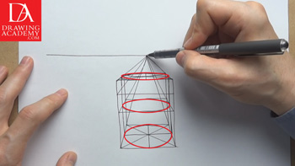](http://drawingacademy.com/images/drawings/Drawing-in-Perspective-by-Drawing-Academy-3-1-Drawing.jpg)

In drawing in perspective, the vanishing point is always located on the horizon line for parallel lines that are horizontal in real life. So railway tracks, for example, will have the vanishing point at the eye level.

However, if we take vertical parallel lines, let’s say two very high flag posts, the vanishing point for them will be high above the viewer’s head.

Let’s consider another example of the one-point perspective. For instance, a cube’s front plane that is facing the viewer will appear as a perfect square on the drawing in perspective. The cube side planes’ edges are parallel lines, and according to the one-perspective rule, will intersect in the vanishing point. As the cube stands on the horizontal surface, the vanishing point is located on the horizon right above the cube. The top and the bottom edges’ lines will radiate from this vanishing point. All vertical edges of this cube will appear perfectly upright at the right angle to the horizon.

The top, bottom and side planes of the cube will look distorted on the drawing in perspective. In real life they are square; on the drawing in perspective these squares will appear smaller than the front plane. This distortion is called foreshortening.

In drawing in perspective, the ability to draw realistic ovals is essential skill every designer must have. Every circle shape can appear in perspective as an oval. Perspective distorts the circle shape into an ellipse and such ellipse looks like an oval on a flat surface of the drawing.

**Two-Point Perspective:**

When you consider how to draw in perspective, the two-point perspective is the most used perspective method.

[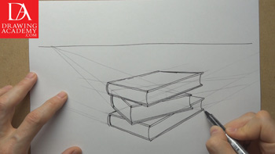](http://drawingacademy.com/images/drawings/How-to-Draw-in-Perspective-by-Drawing-Academy-3-2-Drawing.jpg)

Two-point perspective features two vanishing points. These two vanishing points (VP1 and VP2) will be always located on the horizon level in cases when an object has horizontal edges. All vertical edges of an object will remain vertical without any tilt. When it comes to how to draw in perspective, the two-point perspective is one of the most commonly used in drawing. Despite this kind of perspective has approximation when it comes to depicting geometrical objects; it is good enough for majority of cases.

When you think how to draw in perspective, keep in mind that differently placed objects will have different vanishing points. Each object in two-point perspective has its own vanishing points and sometimes those points may coincide with vanishing points of other objects, providing that those objects are located in space similarly to each other.

When drawing, be aware that not always will vanishing points be inside of the drawing area. In many instances, one or both vanishing points in two-point perspective might be arranged far beyond the drawing board edges (see above how the right VP is ‘off the page’). Anyway, as a proficient fine artist draws not only what he or she sees, but also what one knows, the rule of two-point perspective should be applied there.

The vanishing points of two-point perspective do not always have to be positioned on the horizon line.

Here’s a good link for other people’s drawing skills: <http://www.idsketching.com/sketchbook/sketch-a-day/>