ECONOMICS COURSE INFORMATION BOOKLET

Pass

Fail
Name …………………………………………..………… Teacher ………………………………………
Use the website http://www.tutor2u.net/economics to complete the following tasks

What is Microeconomics?

………………………………………………………………………………………………………………………………………………………………………………………………………………………………………………………………………………………………………………………………………………………………………………………………………………………………………………

In the space below cut out an article from a newspaper, magazine or a print out from a website about microeconomics that you have found interesting and stick (or paste) it in the space below.

What is Macroeconomics?

………………………………………………………………………………………………………………………………………………………………………………………………………………………………………………………………………………………………………………………………………………………………………………………………………………………………………………

In the space below cut out an article from a newspaper, magazine or a print out from a website about macroeconomics that you have found interesting and stick (or paste) it in the space below.

Economics as a social science

In the space below explain what is meant by the term social science:

…………………………………………………………………………………………………………………………………………………………………………………………………………………………………………………………………………………………………………………………………………………………………………………………………………………………………………………………………………………………………………………………………………………………………………………………………………………………………………………………………………………………………………………………………………………………………………………………………………………………………………………………………………………………………………………………………………………………………………………………………………………………………………………………………………………………………………………………………………………………………………………………………………………………………………………………………………………………………………………………………………………………………………………………………………………………………………………………………………………………………………

Why is Economics a social science?

………………………………………………………………………………………………………………………………………………………………………………………………………………………………………………………………………………………………………………………………………………………………………………………………………………………………………………………………………………………………………………………………………………………………………………………………………………………………………………………………………………………………………………………………………………………………………………………………………………………………………………………………………………………………………………………………………………………………………………………………………………………………………………………………………………………………………………………………………………………………………………………………………………………………………………………………………………………………………………………………………………………………………………………………………………………………………………………………………………………………………………………………………………………………………………………………………………………………………………………………………………………………

Books
There is a range of Economics books in the library. Remember you can search the library catalogue from any computer in college.
- Name one author of the textbook AQA ‘A level Economics’ (Year 1 and AS): Hodder Education? …………………………………………………………………………………………………………………………………………………………………………………………………………………………………………………………………………

Journals

- What are the names of the 3 Economics Journals in the library.

………………………………………………………………………………………………………………………………………………………………………………………………………………………………………………………………………………………………………………………………………………………………………………………………………………………………………………

- List two Economics books which are kept behind the Issue desk in the ILC Library, for reference use …………………………………………………………………………………………………………………………………………………………………………………………………………………………………………………………………………

- What is the shelf number where most Economics textbooks are found ………………………………………………………………………………………………………………………………………………………………………………………………………………………………………………………………………….

Using the Library

From Godalming Online, Login, select Student Information, then ILC Library, and then click on the Heritage icon
This is the Online College Library Catalogue; it lists all books, magazines and dvds in the ILC Library as well as all departmental resources and textbooks.

Login to your Library account using your usual computer login. (Use to renew books online)

Use the search box for questions 5, 6 and 7 below.

Question 5

- Select the title AQA Economics ‘A’ level Economics’(Year 1 and AS)and find the following information:
(a) The author’s name is Ray ………………………………………?
(b) The Publisher and Year of Publication? __________________________________________
(c) Number of copies in the library? ________________________________________________
(d) Shelf number in the Library? ___________________________________________________

Question 6

- Search for the title The Undercover Economist
(a) Who is the author? __________________________________________________________
(b) Shelf number in the Library? ___________________________________________________

Question 7

From Godalming Online, select Student Information, then ILC Library, and then click on the Websites icon. Scroll down and select the Philip Allan website
Select search box, select Economics Review. Type in Recession and press

Recommended websites

There are a many sources of Economic news and information, listed below are a few websites that you might find useful.

BBC news, BBC Economy tracker, Tutor2, HM treasury, Economics help, Guardian online, Telegraph online, Economist.com, Krugman blog, independent online.

YOUTUBE: Kahn academy and Pajholden

The Kahn academy and Pajholden are popular video blogs for students of Economics. The authors’ explanations of economic theory are extremely relevant to the AQA specification.
You should use their video blogs to clarify areas of confusion that you may have.

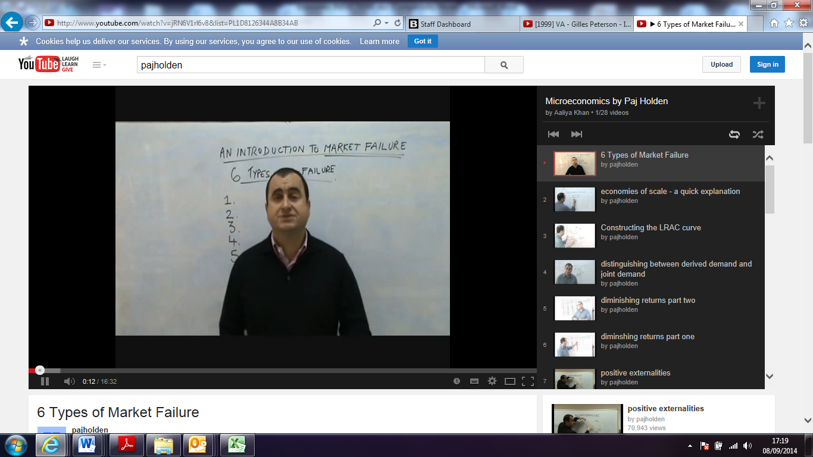

In the space below list the title of 5 of PajHolden’s videos.

1.
2.
3.
4.
5.

Assessment

AQA is the name of the exam board. The AQA Economics course if assessed 100% by exams – there is no coursework component! Full details of the subject content (specification) and exam structure can be found using the following link:

http://www.aqa.org.uk/subjects/economics/as-and-a-level/economics-7135-7136

In short, the AS level and the A level assessment is as follows:

AS Assessment
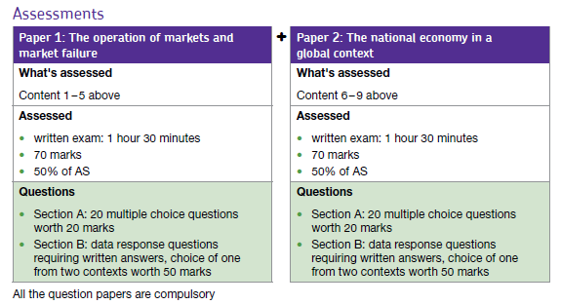

A Level Assessment
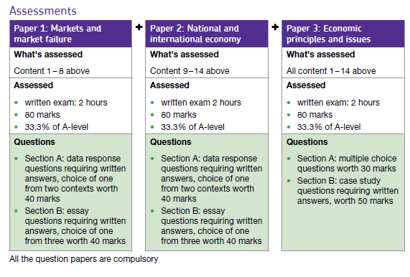

Mathematical requirements of the course.

Although there is not a lot of mathematical content in the course, there is some, and it does help if students are numerate and logical.

It is a requirement that students are familiar with percentages and how to calculate percentage change.

Explanation of how to calculate percentage change

Here are two ways to calculate a percentage change, use whichever method you prefer:

Method 1
Step 1: Calculate the change (subtract old value from the new value)
Step 2: Divide that change by the old value (you will get a decimal number)
Step 3: Convert that to a percentage (by multiplying by 100 and adding a "%" sign)
Note: if the new value is greater than the old value, it is a percentage increase, otherwise it is a decrease.

Method 2
Step 1: Divide the New Value by the Old Value (you will get a decimal number)
Step 2: Convert that to a percentage (by multiplying by 100 and adding a "%" sign)
Step 3: Subtract 100% from that
Note: if the result is positive it is a percentage increase, if negative, just remove the minus sign and call it a decrease.

Example: A pair of socks went from £5 to £6, what is the percentage change?
Answer (Method 1):
- Step 1: £5 to £6 is a $1 increase
- Step 2: Divide by the old value: £1/£5 = 0.2
- Step 3: Convert 0.2 to percentage: 0.2×100 = 20% rise.
Answer (Method 2):
- Step 1: Divide new value by old value: £6/£5 = 1.2
- Step 2: Convert to percentage: 1.2×100 = 120% (i.e. £6 is 120% of £5)
- Step 3: Subtract 100%: 120% - 100% = 20%, and that means a 20% rise.

The Formula
You can also put the values into this formula:
(New Value - Old Value) | × 100%
Old Value | × 100%
Example: There were 200 customers yesterday, and 240 today:
(240 – 200) | × 100% = (40/200) × 100% = 20%
200 | × 100% = (40/200) × 100% = 20%

Questions: Calculate the percentage change between the following numbers (show your workings)

- 4 to 5
- 5 to 1
- 1 to 17
- 17 to 15

- a) A second hand car was purchased for £8000. After three years the car's value had decreased by 35%
i) Find 35% of £8000
ii) Find the price of the car after three years.
b) A classic car was bought for £5000. Two years later it was sold in auction for £6500. What is the percentage increase in value?

- An athlete improves his time for running a race from 32 seconds to 28 seconds.
What is the percentage change in race time?

Stretch and challenge
- Ian earns £420 a week after a 5% rise. What was his pay before?
- An Iyonix PC is sold for £1200 at a reduction of 20% on its recommended retail price. What was the computer's original price?

Note: This section is marked out of 10. There is a mark for each question and there is an expectation that everyone will receive full marks.

Write your answers in the space below. Show your working out.

