**The Balance of Payments (Current Account)**

|  |  |
| --- | --- |
| **Balance of Payments** |  |

**The focus for Unit 2 is the Current Account of the BOP**

* Inflows of foreign currency are ……………………………………………………………………...

…………………………………………………………………………………………………………..

* Outflows of foreign currency are ……………………………………………………………………

…………………………………………………………………………………………………………..

**The Current Account**

* **Task**: Add the 4 components current account to complete the table below:

|  |  |
| --- | --- |
| **Item of the Balance of Payments Current Account** | **Net Balance (£)** |
| 1. |  |
| 2. |  |
| 3. |  |
| 4. |  |
| Current Account balance |  |

If a country is running a current account deficit, there is a net outflow of demand and

income from the circular flow

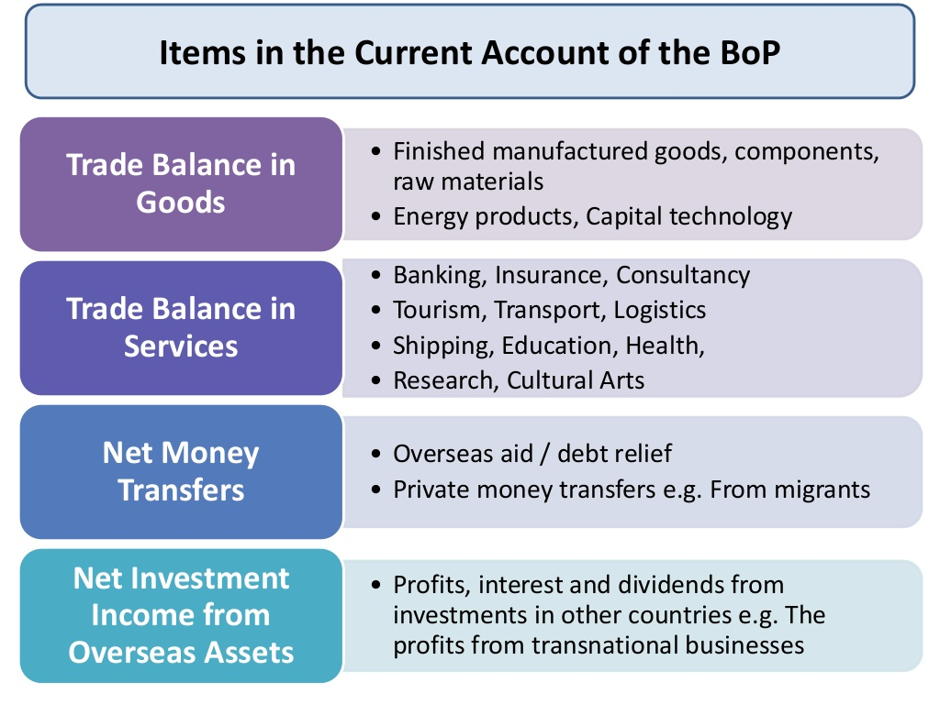

**Surpluses and Deficits on the Current Account**

* **Task**: Complete the following two sentences (use the words below to help you)

The current account is in **surplus** if ………………………………………………………………………………….

.……………………………………………………………………………………………………………………………

The current account is in **deficit** if ……………………………………………………………………………………

…………………………………………………………………………………………………………………………….

* exports (money flowing into the country), imports (money flowing out of the country), are greater than

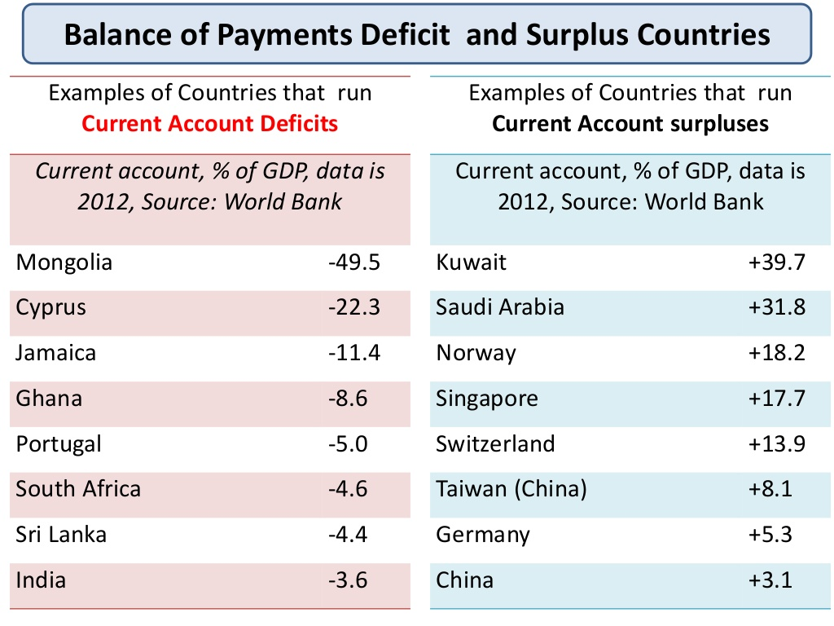

**Extension:** Are there any common characteristics between countries that run deficits/surpluses?

**Possible Causes of Surpluses and Deficits on the Current Account**

**Activity:** Write a sentence to identify the causes of a surplus/deficit

|  |  |
| --- | --- |
| **Causes of Surpluses** | **Causes of Deficits** |
| * **A weak exchange rate**  e.g. China’s undervalued exchange rate   Low interest rates (outflow of hot money)   * **International competitiveness** * **High productivity** * **High level of saving (High MPS)** * **Promotion of manufacturing sector**      * **Investment income being positive** | * **A strong exchange rate**  e.g. reliable currency (e.g. US $)   High interest rates   * **Lack of international competitiveness** * **Low productivity** * **Low level of saving (Low MPS)**      * **Decline of manufacturing sector**      * **Investment income falling** |

**Extension:** what could explain the current account deficit of the US and the surplus in China?

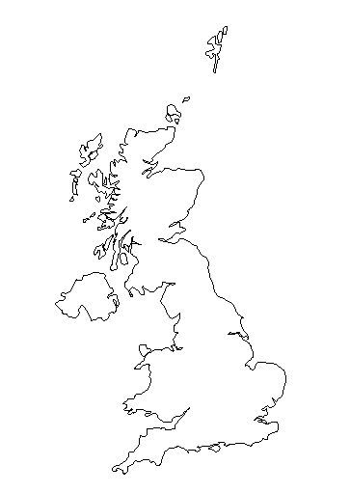

**Money flowing into the UK current account**

**Money flowing out of the UK current account**

* UK buys oranges from US
* UK citizens holidays in the US
* Profits and dividends sent to US from a American owned factory in the UK
* Transfer of money to US citizens by UK citizens
* UK sells apples to France
* UK sells insurance services to French firms
* Profits and dividends sent to UK from a British owned factory in France
* Transfer to the UK from the EU

Reasons for the UKs trade deficit