**p**

**Supply-Side Policies**

**What are supply side policies?**

………………………………………………………………………………………………………………….

............................................................................................................................................................

**Supply Side policies can increase the productive potential of the economy (LRAS/PPF) in 2 ways:**

**1**. An increase in the quantity of factor inputs

**2.** An increase in the quality of factor inputs

* So any increase in the quantity or quality (or productivity) of the factors of production will lead to an increase in the productive potential of the economy

**The factors of production are:**

**Supply-side Diagrams**

Keynesian Diagram Classical Diagram

**Supply side policies can achieve all the macroeconomic objectives simultaneously: economic** growth, employment, low inflation and competitiveness on the BoP current account.

**Evaluation: Is it really as simple as this?**

.  
All governments nowadays accept that supply side policies are essential to achieve sustainable economic growth. But there are 2 main conditions to be aware of if they are to work:

1. **They don’t take effect overnight** – they are long term policies – their effects on the long term growth trend, unemployment and the current account may take many years to be realised. This means governments must take a long term view, not always easy when elections take place every 5 years!
2. **Magnitude of effects:** due to their long-term nature and large array of different policies being implemented it can be difficult for policymakers to determine the exact magnitude of effects of supply-side policies. How much do education policies actually boost economic growth?
3. **Governments still need to manage aggregate demand carefully**. They must ensure that the growth in aggregate demand, which can be subject to short term fluctuations and shocks, doesn’t outstrip the rate of growth in aggregate supply. Otherwise inflation will enter the system, leading to boom-bust instead of sustainable economic growth.

Therefore to achieve all the policy objectives policymakers should use a combination of monetary and fiscal policy to control the rate of growth in aggregate demand in the short run, and supply side policies to control AS in the long run. A combination of long run supply side policies to increase the productive potential of the economy, and short run demand management policies to control the rate of growth in aggregate demand, should lead to a virtuous circle of sustainable economic growth. At least in theory!

**Video**

Using the video to help you, identify as many supply side policies as you can on a mind map below

<https://www.youtube.com/watch?v=8uMo-zib4jo>

Supply-side

Policies

**The Supply-Side Policies**

For each one you need to be able to:

* Explain what the policy is
* Explain how it improves AS
* Evaluate the policy

**1. Increased healthcare & education spending**

Increased education & healthcare 🡪 more productive workforce (increased quality of labour) & more able to work 🡪 ↑ productive potential 🡪 ↑ LRAS

EV

**2. Reducing income tax**

Reduced income tax 🡪 more reward for being employed 🡪 more incentive to work   
🡪 increased quantity & quality of labour 🡪 ↑ productive potential 🡪 ↑ LRAS

EV

**3. Reducing unemployment benefits**

Reduced benefits 🡪 less reward for being unemployed 🡪 more incentive to work 🡪 increased quantity of labour 🡪 ↑ productive potential 🡪 ↑ LRAS

EV

1. **Lower trade union power & reduced NMW**

Lower trade union power (or reduced NMW) 🡪 wages ↓ to market clearing level   
🡪 ↓ unemployment 🡪 increased quantity of labour 🡪 ↑productive potential 🡪 ↑ LRAS

EV

EV

1. **Reduced corporation tax**

Reduced corporation tax 🡪 more profit left after tax 🡪 more finance available for investment 🡪   
↑quantity & quality of capital (& possibly new technology) 🡪 ↑ productive potential 🡪 ↑ LRAS

EV

1. **Subsidies for investment and R&D**

Subsidies for R&D 🡪 firms more willing to invest in capital goods 🡪 increased quantity & quality of capital (& possibly new technology) 🡪 ↑ productive potential 🡪 ↑ LRAS

1. **Reduced red tape and bureaucracy**

Reduce bureaucracy for firms 🡪 less cost for firms 🡪 more incentive to produce 🡪 ↑ productive potential 🡪 ↑ LRAS

EV

1. **Encourage competition (free trade, privatisation, competition policy, small business support & loans)**

Encourage competition in the UK (subsidise start-up firms, competition policy, privatisation)   
🡪 greater efficiency in markets 🡪 ↑ productive potential 🡪 ↑ LRAS

Encourage foreign competition through free trade policies 🡪 greater efficiency in markets   
🡪 ↑ productive potential 🡪 ↑ LRAS

EV

EV

EV

EV

**Supply Side Policy History & Current Policies**

**History**

|  |  |
| --- | --- |
| **Trade Unions** | Peak of membership in 1979  Thatcher reduced union power to make industry more flexible and competitive  Mid-1990s unions were marginalised  New Labour did not reverse this in 1997 |
| **Wage Bargaining** | 1980s and 1990s reduced collective bargaining and move to individual bargaining as more flexible |
| **Benefits** | 1980s: reduce value of benefits and made it harder to collect them (conditions such as being on a training course needed)  1999 Working Families Tax Credit (replaced by the Child Tax Credit and Working Tax Credit in 2003) These increased the take home pay of low income families  2000s attempt to make benefit claiming more difficult |
| **Social Legislation** | Over time workers have gained more rights  1997: signed the Social Chapter  UK relatively lightly regulated compared to other EU countries |
| **Training & Education** | Good education for the top of the system but not for the rest of it  1980s: national curriculum, targets, OFSTED and competition between schools and encouraging more students to stay on at school  Attempts also to develop vocational training (with mixed results) Large spending on Education under New Labour |
| **Tax Rates** | Pre-Thatcher income tax 33% (basic) and 83% (top) Thatcher cut the top rate to 40% to increase the incentive to work. Also cuts in capital gains, NIC and inheritance tax |
| **Small Business** | 1979-1997: develop on enterprise culture (reduced income tax, tax allowances for investment & grants) and access to loans when banks won’t lend. Also advice given and red tape reduced. |
| **Innovation & Research** | 1997: promote innovation  Tax allowances for R&D |
| **Deregulation & Privatisation** | 1980s-1990s: privatisation Use of private markets in NHS (PFI) |
| **Free Trade** | Since 1979 promoted free trade & FDI |
| **Regional & Industrial Policy** | Pre-1979 focus on regional and industrial policy  Help poorer regions to attract business & jobs Industrial help e.g. textiles, shipbuilding  1999: regional development agencies |

|  |  |
| --- | --- |
|  | **Economic Policies** |
| **“Competitive Tax System”** | Changes in the tax system:   * **Reduce income tax rate** from 50% to 45% from 2013 * **Reduce corporation tax rate** from 26% to 24% from 2012 and then to 23% (2013) and 22% (2014) * **Corporation tax reforms** to encourage investment e.g. 10% less corporation tax on profits earned on patents |
| **“Investment and Exports”** | Infrastructure:   * **Developing a national road strategy** e.g. increase capacity * **Railways:** e.g. £130m in Northern Rail Hub * **Get Britain Building Fund:** increase fund by £150m in housing   Technology (developing the UK as a technology hub):   * **Corporation tax relief** e.g. video games, TV, animation * **Super-connected cities:** 10 UK cities gaining high-speed broadband / mobile network; £100m investment announced * **Investment in technology & research** e.g. £60m in aerodynamics, £100m for university research   Double UK Exports by 2020:   * **Encourage investment in UK cities** e.g. £1.2bn in infrastructure in Manchester * **Expand Export Finance** * **Help secure temporary private office space abroad** in high growth countries. |

|  |  |
| --- | --- |
| **“Educated & Flexible Labour Market”** | Improving skills:   * **Youth Contract:** to help 500,000 young people most in need of employment & education * **The Work Programme:** specialist support for longer-term unemployed, 332,000 already helped. * **Adult Apprenticeships:** funding increased by £250m a year by 2014-15 * **Enterprise Loans** (pilot): to encourage enterprise & new businesses for unemployed workers.   Increase labour market flexibility (employers can take on workers more easily):   * **Below inflation increases in NMW:** recommended by the Low Pay Commission * **Significant deregulation of employment law** e.g. increasing the unfair dismissal period from one to two years |
| **“Best Place for Business”** | Access to finance:   * **National Loan Guarantee Scheme:** to improve access to finance. £20bn guarantees to banks. * **Business Finance Scheme:** to improve access to non-bank finance. £700m invested in fund managers. * **Enterprise Guarantee Scheme**   Planning System:   * **National Planning Policy Framework:** encouraging pro-growth policies in local plans and sustainability. * **Simplify planning system:** e.g. reducing informational requirements   Reducing burdens on business (i.e. cost of regulation):   * **Reducing regulations** e.g. scrap or improve 84% of health & safety laws, rationalise environmental regulation |

**A**

Decide if the statements below are true or false

1. Supply-side policies have no impact on Aggregate Demand (T/F)
2. Reducing income tax will give workers the incentive to work harder (T/F)
3. Reducing unemployment benefits is a supply-side policy (T/F)
4. Supply-side policies are mainly aimed at shifting the SRAS curve to the right (T/F)
5. Increasing the money supply is a supply-side policy (T/F)

**B**

Which one of the following policies is most likely to lead to an increase in output and employment without increasing the rate of inflation?

**A** Expansionary fiscal policy

**B** Expansionary monetary policy

**C** Supply-side policies

**D** Exchange rate policy

Explain your answer in the space below. Include a diagram in your answer.

…………………………………………………………………………………………………………………

…………………………………………………………………………………………………………………

…………………………………………………………………………………………………………………

…………………………………………………………………………………………………………………

**C**

|  |  |  |
| --- | --- | --- |
| **Government Policy** | **Explanation of the impact on AD** | **Explanation of the impact on AS** |
| **A decrease in corporation tax** |  |  |
| **An Increase in unemployment benefit** |  |  |

**Supply-side MCQs**

**Q1**

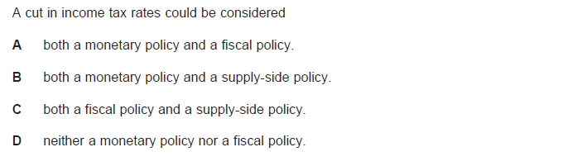

**Q2**

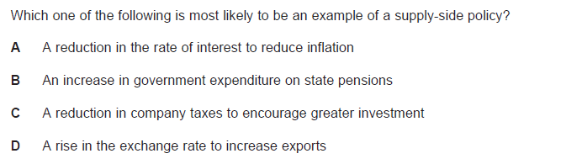

**Q3**

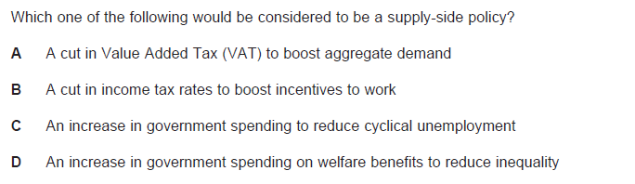

**Q4**

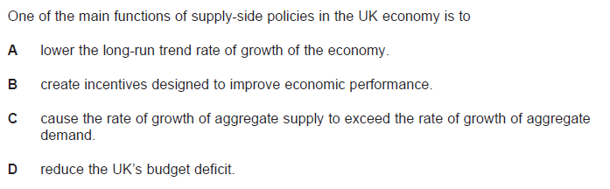

**Q5**

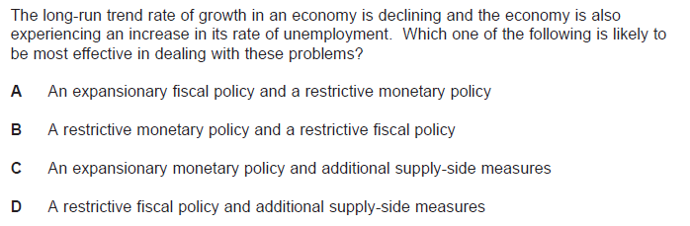

**Q6**

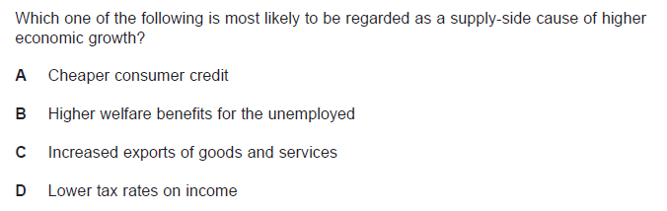

**25 marker**

**‘Supply-side policies will also contribute to lower inflation’**

**Using the data and your economic knowledge, evaluate the importance of supply side policies in helping to control inflation in the UK (25 Marks)**

**Plan**

* Introduction – Identify key terms and tell the examiner what you are going to say.
* 1st point (analysis) – Explain a supply-side policy are and the impact it has on inflation. Use an example to aid your explanation.
* Evaluation – Suggest a drawback/counterpoint of this policy.
* 2nd point (analysis) – Explain another supply-side policy and the impact it has on inflation. Use an example to aid your explanation.
* Evaluation – Suggest another drawback/counterpoint of this policy (HINT: What if the inflation is because import prices are high? Or because Aggregate Demand is too high?)
* 3rd point – Explain another policy that could be used to control inflation – e.g. Monetary Policy.
* Evaluation – Suggest reasons why this policy is better or worse than supply-side policies (or both)! (HINT: Link this to the macroeconomic objectives)
* Conclusion – Answer the question! What do you think?!! and why do you think it?!!

**Task**

On lined paper OR a computer… Write your introduction and first paragraph with evaluation.

Homework: Complete the rest of the essay...

Homework deadline: ………………………….