# Economic Growth

What is Economic Growth?

How is GDP measured?

How is GDP per capita measured?

Activity 1 Using the data below identify 1 significant point of comparison in the data (4 marks), using the full range of the data

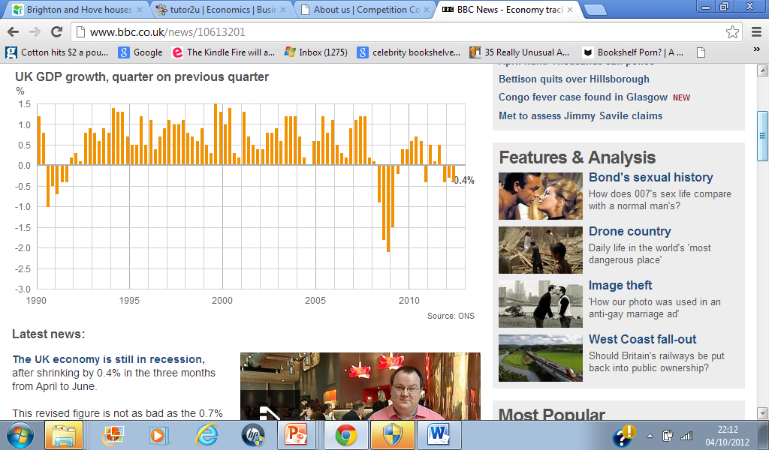

Write you answer here

………………………………………………………………………………………………………………………………………………………………………………………………………………………………………………………………………………………………………………………………………………………………………………………………………………………………………………………………………………………………………………………………

|  |  |
| --- | --- |
| **Benefits of Economic Growth** | **Drawbacks of Economic Growth** |
|  |  |

**Activity 2**

|  |  |  |  |  |
| --- | --- | --- | --- | --- |
|  | **France** | **Britain** | **Germany** | **Italy** |
| **Population**  **(millions)** | **60.9** | **60.3** | **82.6** | **58.1** |
| **Nominal GDP**  **(US$ bn)** | **2,252** | **2,374** | **2,899.4** | **1,854** |
| **Real GDP Growth**  **(%)** | **1.7** | **2.5** | **0.6** | **0.7** |
| **Inflation** | **1.9** | **1.7** | **1.3** | **2.3** |

Using the data above

1. Calculate the GDP per capita for the four countries
2. In which country is the value of money falling most rapidly?
3. Which country would you expect to have the highest GDP per capita in the future? Explain your reasoning.

**Write your answers to Activity 2 overleaf**

**Answer to Activity 2**

Write your answer here …

Activity 3: Draw a production possibility curve that shows Economic Growth.

**Define the term Economic Growth (5 marks)**