Market failure
Introduction

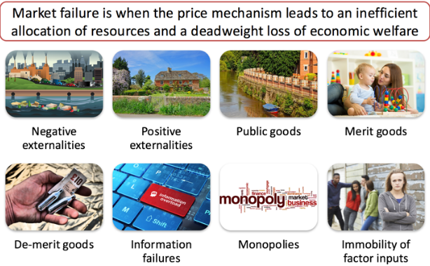

Name

Market failure

What is Market failure?
Market failure is when the free market fails to deliver an efficient allocation of resources. Therefore – economic and social welfare may not be maximized. This leads to a loss of economic efficiency.

Starter: Define the term free market.
……………………………………………………………………………………………………………………………………………………………………………………………………………………………………………………………………………………………………………………………………………………………………………………………………………………………………………………………………………………………………………………………………………………………………………………………………………………………………………………………………………………………………………………………………………………

Extension: Describe the following ‘functions of price’ (The price mechanism)

Rationing:
……………………………………………………………………………………………………………………………………………………………………………………………………………………………………………………………………………………………………………………………………………………………………………………………………………………………………………………………………………………………………………………………………………………………………………………………………………………………………………………………………………………………………………………………………………………

Signalling:
……………………………………………………………………………………………………………………………………………………………………………………………………………………………………………………………………………………………………………………………………………………………………………………………………………………………………………………………………………………………………………………………………………………………………………………………………………………………………………………………………………………………………………………………………………………

Incentivizing:
……………………………………………………………………………………………………………………………………………………………………………………………………………………………………………………………………………………………………………………………………………………………………………………………………………………………………………………………………………………………………………………………………………………………………………………………………………………………………………………………………………………………………………………………………………………

Listed below are the different ways in which a free market is thought to fail.

Complete and partial market failure
- Complete market failure occurs when the market simply does not supply products at all - we see "missing markets"
- Partial market failure occurs when the market does actually function but it produces either the wrong quantity of a product or at the wrong price.

Markets can fail for lots of reasons:
- Negative externalities (e.g. the effects of environmental pollution) causing the social cost of production to exceed the private cost
- Positive externalities (e.g. the provision of education and health care) causing the social benefit of consumption to exceed the private benefit
- Imperfect information or information failure means that merit goods are under-produced while demerit goods are over-produced or over-consumed
- The private sector in a free-markets cannot profitably supply to consumers pure public goods and quasi-public goods that are needed to meet people's needs and wants
- Market dominance by monopolies can lead to under-production and higher prices than would exist under conditions of competition, causing consumer welfare to be damaged
- Factor immobility causes unemployment and a loss of productive efficiency
- Equity (fairness) issues. Markets can generate an 'unacceptable' distribution of income and consequent social exclusion which the government may choose to change

Positive and Negative Externalities

Activity 1: Read the case study below provided and answer the questions.
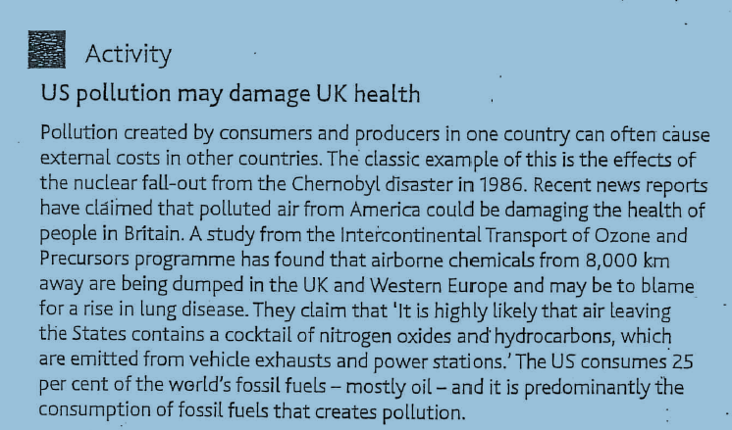

- Who is affected by the activities of companies in Russia and USA?
- Which economic agent (GOVERNMENT, CONSUMER or FIRMS) should pay for the pollution.
- “Recent news reports have claimed that polluted air from America could be damaging the health of people in Britain”. This statement is referring to a negative externality – what do you think a Negative externality is?

Key definitions

Costs and Benefits | Explanation
Private costs | The costs of production which are borne by the business which produces the product. For example, private costs will include wages and salaries, interest and the cost of raw materials and component as well as any research and development costs.
Externals costs (negative externalities) | Occur when some of the costs of production are borne by a 3rd party not involved with the production or consumption of the good.  For example, a factory may pollute a local river which means that it becomes useless to local fishing enthusiasts.
Social costs | ALL the costs, both PRIVATE and EXTERNAL that arise from the production process.
Private benefits | The benefits which the individual buyer and seller of a product, for example enjoyment/satisfaction a person might derive from purchasing a meal at a restaurant.
External Benefits (positive externalities) | These are benefits that accrue (are gained by) 3rd parties (not just to the producer or the consumer). They may arise from production or consumption.
Social benefit | Are ALL the benefits, both PRIVATE and EXTERNAL that arise from the consumption of a good

Formula
Private costs + External cost = Social costs
Therefore
External cost = _______________ -_______________
Private costs = _______________ - ________________

AND
Private benefits + External benefits = Social benefits
Therefore
External benefits = _____________ - __________________
Private benefits = _____________ - ___________________

Activity 1 :
What are the private costs and external costs involved in the production of a pair of Levi jeans? List them in the space below.
Your notes
Private costs | External costs
Activity 1: Discuss the following question in pairs.
Negative externalities can be caused by the production of goods or by the consumption of goods.
What are some of the Negative Externalities associated with each of the activities below and decide if the externality is consumption or production.
- Generating nuclear power (see example below)
- Smoking
- Consuming chewing gum
- Driving to school
- The expansion of Heathrow airport
- Overfishing of Cod
- Oil spill in the North Sea

Production externalities | Consumption externalities
Example : Generating nuclear power may lead to leakages of radioactive fuel (contamination) and the costs of managing waste are borne by later generations

Activity 2
What are the private benefits and social benefits of the following activities?
Type of activity | Private benefits | External Benefits
Immunizing yourself against disease

Completing a University degree

Choosing to eat a healthy diet

Plenary
- Positive externalities exist when
- Production creates private benefits
- Private benefits are less than social benefits
- Private benefits are greater than private costs
- Social costs exceed private costs.

- The table below indicates the private and external costs and benefits resulting from building a coal-burning power station.

 | £ million
Private benefit | 180
Private cost | 190
External benefit | 110
External costs | 140

The social cost minus the social benefit equals =

Merit goods, Demerit goods & public goods

Starter:
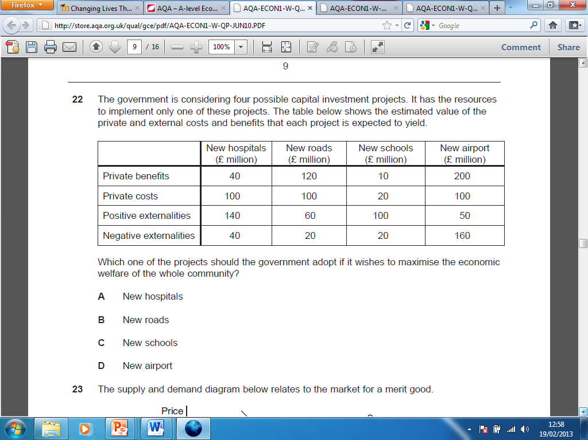

- Which of the answers A-D is correct
- Explain your answer …………………………………………………………………………………………………………………………………………………………………………………………………………………………………………………………………………………………………………………………………………………………………………………………………………………………………………………………………………………………………………………………………………………………………………………………………………………………………………………………………………………………………………………………………………………………………………………………………………………………………………………………………………………………………………………………………………………………………………………………………………………………………………………………………………………………………………………………………………………………………………………………………………………………………………

What is a Merit good?
A good that would be under-consumed in a free market, as individuals do not fully perceive the benefits obtained from consumption.
Merit goods are those goods and services that the Government feels that people will under-consume and which ought to be subsidized or provided free at the point of use so that consumption does not depend primarily on the ability to pay for the good or service. Both the public (state/government) and the private sector provide merit goods and services.
Furthermore the consumption of merit goods is thought to generate positive externalities (external benefits) that are greater than the private benefits. A merit good is a product that society values and judges everyone should have regardless of whether the individual wants them.
Activity 2
Using the definition for a merit good provided think of 5 examples of Merit goods
1.
2.
3.
4.
5.
Activity 3
Using your own knowledge and the information provided in the case study below (“Education is a merit good”) answer questions 1-3
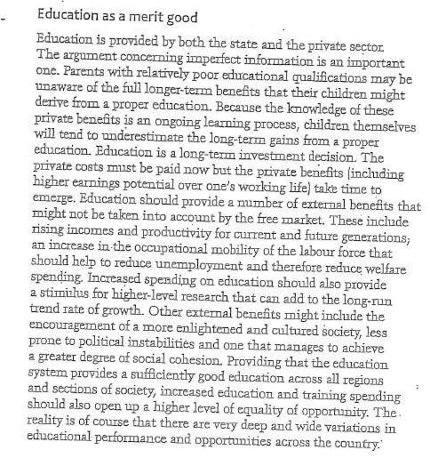

- What are the private benefits of Education?
- What are the external benefits of Education?
- Why according to the article would there be an under provision of schools if there was no Government provision of them.

Write your answers in the space below
……………………………………………………………………………………………………………………………………………………………………………………
……………………………………………………………………………………………………………………………………………………………………………………
……………………………………………………………………………………………………………………………………………………………………………………
……………………………………………………………………………………………………………………………………………………………………………………
……………………………………………………………………………………………………………………………………………………………………………………
……………………………………………………………………………………………………………………………………………………………………………………
……………………………………………………………………………………………………………………………………………………………………………………
……………………………………………………………………………………………………………………………………………………………………………………
……………………………………………………………………………………………………………………………………………………………………………………
……………………………………………………………………………………………………………………………………………………………………………………
……………………………………………………………………………………………………………………………………………………………………………………
……………………………………………………………………………………………………………………………………………………………………………………
……………………………………………………………………………………………………………………………………………………………………………………
……………………………………………………………………………………………………………………………………………………………………………………
……………………………………………………………………………………………………………………………………………………………………………………
……………………………………………………………………………………………………………………………………………………………………………………
……………………………………………………………………………………………………………………………………………………………………………………
……………………………………………………………………………………………………………………………………………………………………………………
……………………………………………………………………………………………………………………………………………………………………………………
……………………………………………………………………………………………………………………………………………………………………………………
……………………………………………………………………………………………………………………………………………………………………………………
……………………………………………………………………………………………………………………………………………………………………………………
……………………………………………………………………………………………………………………………………………………………………………………
……………………………………………………………………………………………………………………………………………………………………………………
……………………………………………………………………………………………………………………………………………………………………………………
……………………………………………………………………………………………………………………………………………………………………………………
……………………………………………………………………………………………………………………………………………………………………………………

Who provides merit goods?
- Both the state and private sector provide merit goods & services. We have an independent education system and people can buy private health care insurance.
- Consumption of merit goods is believed often to generate positive externalities- where the social benefit from consumption exceeds the private benefit.
- A merit good is a product that society values and judges that people should have regardless of their ability to pay. In this sense, the government is acting paternally in providing merit goods and services. Individuals may not act in their own interest because of imperfect information.
What are some good examples of merit goods?
Good examples of merit goods include health services, contraception, education, work training programmes, public libraries and museums, Citizen's Advice Bureaux and inoculations for children
Education as a merit good
- Parents may be unaware of the longer-term benefits that their children might derive from education.
- Education is a long-term investment decision. The private costs must be paid now but the private benefits (including higher earnings potential over one's working life) take time to happen. Education provides external benefits including rising incomes and productivity for current and future generations and an increase in occupational mobility to help to reduce unemployment.
- Increased spending on education should also provide a stimulus for higher-level research which can add to the long run trend rate of growth. Other external benefits might include the encouragement of a more enlightened and cultured society. Providing that the education system provides a sufficiently good education across all regions and sections of society, increased education and training spending should also open up more equality of opportunity.
Notice here that we are talking about the sorts of goods and services that society judges to be in our best welfare. Judgements involve subjective opinions – and we cannot escape from making value judgements when we are discussing merit goods.
Why does the government provide merit goods and services?
- To encourage consumption so that positive externalities of merit goods can be achieved for example free inoculation against infectious diseases
- To overcome the information failures linked to merit goods
- On grounds of equity – because the government believes that consumption should not be based solely on the grounds of ability to pay for a good or service

Information failure

Information failure occurs when people have inaccurate, incomplete, uncertain or misunderstood data and so make potentially 'wrong' choices
From pensions to computer games consoles, from investing in the stock or currency markets to ignorance about the consequences of borrowing and debt, all of us suffer from one or more information failures.
The key issue is whether the information failure is trivial or whether it has a big effect on individuals, their families and society as a whole.

There may well be a case for the government to intervene in the market in some way if information failures become serious.

Merit good (e.g Healthcare, education, insurance schemes for pensioners)

Under- provided by the market

Why?

 | People lack perfect information about their future needs | Give positive externalities but not taken into account | Government intervention
Health

Pensioners

Education

Demerit good

What is a demerit good?
A demerit good – A good that would be over consumed in a free market, as it brings less overall benefit to consumers than they realise.
These are often goods considered ‘bad’ for you. Examples include alcohol, cigarettes, drugs and the social effects of gambling. The consumption of merit goods can lead to negative externalities which consumers are not aware of because they have imperfect knowledge.

Activity 1
What are the private benefits to the individual of smoking and the (negative) external benefits to society?
Activity | Private benefits | Negative external benefits (Negative externality)
Smoking

Heroin addict

Why do people consume demerit goods? Sometimes consumers are not the best judges of their own interests.

Extension activity
What can Government do to reduce the consumption of Demerit goods? (e.g Smoking)
1.
2.
3.

Public goods.

Task

Decide if the following statements are True (T) or False (F)
- Merit goods are only provided by Governments
- Merits goods provide positive externalities
- The state sometimes subsidizes the provision of merit goods
- McDonald’s is an example of a merit good
- The private benefits of consuming a merit good are more than the social benefits.
- The private benefits of consuming a merit good are less than social benefits.
- Private cost + external costs = social costs
- The social benefits of consuming a merit good are greater than the private benefits
- Private benefits + Social benefits are equal to positive externalities
- Private benefits + positive externalities are equal to social benefits

What is a Public Good?
A good that possess the characteristics of non-excludability and non-rivalry in consumption

A Public good is another type of good that will lead to market failure. Here it is not a matter of whether too much or too little is provided but whether it is provided at all.

All Public goods are defined by two key characteristics.
- Non – Excludability: The benefits derived from the provision of pure public goods cannot be confined to only those who have actually paid for it. In this sense, those that do not pay can enjoy the benefits of consumption for no financial cost. This is known as the free-rider problem.
- Non – Rivalry in consumption: Consumption of a public good by one person does not reduce the availability of a good to others, therefore we all consume the same amount of public goods even though our valuation of the benefit we derive from them may differ.

Public goods are therefore not usually provided by the private sector because they couldn’t be provided for a profit.
Private goods: A good that is both excludable and rival in consumption therefore creating the conditions to make profit

Discussion: Imagine a world (exactly the same as ours) where there is no Government and firms will only produce goods when they can make a profit. Can you think of the circumstances that would allow a firm to make a profit on selling street lighting? And Lighthouses?
(Hint: Think about the technology that would be required and the method of payment)

Activity 1
Look back at the definitions of merit goods and public goods decide which best describes the goods below. Write a short explanation in the box below.
- Nursery provision (pre –school for very young children)
- Motorways
- National Parks (e.g The Lake District)
- The Police
- Museums and art galleries
- Libraries
- Fire service

Public good | Merit good
1.

2.

3.

4.

5.

6.

Activity 2
1. Left to the free market, Good X would not be produced at all. Yet the production and consumption of at least some of Good X increases the welfare of society. The government therefore has an incentive to intervene to ensure its provision. Good X is most likely to be a

A Public good.
B Free good.
C Merit good.
D Demerit good.

2. A pure public good (or service) is always

A provided by the government for all consumers.
B provided free of charge for all consumers.
C available for consumption by others when consumed by an additional person.
D heavily subsidised by the government.

Monopoly as a market failure

Read the definition of market failure below.
“Market failure happens when the price mechanism fails to allocate scarce resources efficiently or when the operation of market forces lead to a net social welfare loss”

?
Is Monopoly a market failure?

YES!

NO!
Shade in the appropriate speech box ….. be prepared to justify your answer ….

Explain why it could be argued that Monopolies signify a failure of markets

……………………………………………………………………………………………………………………………………………………………………………………
……………………………………………………………………………………………………………………………………………………………………………………
……………………………………………………………………………………………………………………………………………………………………………………
……………………………………………………………………………………………………………………………………………………………………………………
……………………………………………………………………………………………………………………………………………………………………………………
……………………………………………………………………………………………………………………………………………………………………………………
……………………………………………………………………………………………………………………………………………………………………………………
……………………………………………………………………………………………………………………………………………………………………………………
……………………………………………………………………………………………………………………………………………………………………………………
……………………………………………………………………………………………………………………………………………………………………………………
……………………………………………………………………………………………………………………………………………………………………………………

Explain why it could be argued that Monopolies signify a failure of markets

……………………………………………………………………………………………………………………………………………………………………………………
……………………………………………………………………………………………………………………………………………………………………………………
……………………………………………………………………………………………………………………………………………………………………………………
……………………………………………………………………………………………………………………………………………………………………………………
……………………………………………………………………………………………………………………………………………………………………………………
……………………………………………………………………………………………………………………………………………………………………………………
……………………………………………………………………………………………………………………………………………………………………………………
……………………………………………………………………………………………………………………………………………………………………………………
……………………………………………………………………………………………………………………………………………………………………………………
……………………………………………………………………………………………………………………………………………………………………………………
……………………………………………………………………………………………………………………………………………………………………………………

Factor immobility as a market failure

One cause of market failure is the immobility of factors of production. There are two main types of factor immobility, occupational and geographical immobility.

Immobility of labour – a cause of unemployment and market failure
One of the main causes of unemployment is that workers lack the skills required by expanding industries in the economy.

Occupational Immobility
Occupational immobility occurs when there are barriers to the mobility of factors of production between different sectors of the economy leading to these factors remaining unemployed, or being used in ways that are not efficient.
Some capital inputs are occupationally mobile – a computer can be put to use in many different industries. And commercial buildings such as shops and offices can be altered to provide a base for many businesses. However some units of capital are specific to the industry they have been designed for – a printing press or a nuclear power station for example!
People often experience occupational immobility. For example, workers made redundant in the steel industry or in heavy engineering may find it difficult to find a new job. They may have specific skills that are not necessarily needed in growing industries which causes a mismatch between the skills on offer from the unemployed and those required by employers looking for workers. This problem is called structural unemployment. Clearly this leads to a waste of scarce resources and represents market failure.

Geographical Immobility

Geographical immobility refers to barriers people moving from one area to another to find work. There are good reasons why geographical immobility might exist:
- Family and social ties
- The financial costs involved in moving home including the costs of selling a house and removal expenses.
- Huge regional variations in house prices leading to a shortage of affordable housing in many areas
- The high cost of renting property
- Differences in the general cost of living between regions and also between countries
- Poor transport links

