Exchange rates

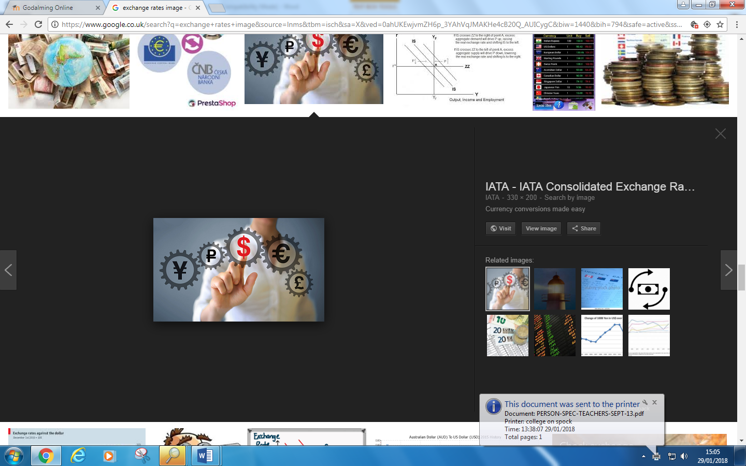

Specification
Exchange rate policy: specification
Candidates should understand the relationship between interest rates and the exchange rate and how the exchange rate might be an influence on policy objectives such as price stability and unemployment.

Exchange Rate Systems

Candidates should understand how exchange rates are determined in both fixed and floating exchange rate systems (whether completely free or managed periodically by the authorities). Candidates should be able to evaluate these exchange rate systems and have an understanding of their implications for the management of the domestic economy.

The Determination of Exchange Rates

Starter: Match the currencies with the country
Country | Currency
Denmark | Peso
China | Euro
Iran | pound
japan | Krone
Pakistan | Yuan Renminbi
Israel | Rial
Egypt | Yen
Argentina | Rupee
Austria | Shekel

Key terms & Background information
Exchange rate: The rate at which one currency can be converted into another (i.e the rate at which it can be bought and sold).

The effective exchange rate is: The weighted average value of a country's currency relative to all major currencies being traded within an index or pool of currencies. The weights are determined by the importance a home country places on all other currencies traded within the pool, as measured by the balance of trade.”

Where is currency traded?

Valuations of exchange rates are determined in the global foreign exchange markets which are open 24 hours a day
- On average $1.2 trillion is traded in these markets each day (equivalent to Italian GDP for a year!)
- London is the world’s biggest currency trading centre

Reminder

The exchange rate has appreciated in value / gone up / increased / is stronger / is higher
a
e.g. £1:$2 → £1:$3
The exchange rate has depreciated in value / gone down / decreased / is weaker / is lower
a
e.g. £1:$2 → £1:$1

Exchange Rates: Demand and Supply
ER
Q
S
D
ER*
Q*

TIPS…

- The Demand Curve is all about whether people without pounds (e.g. foreigners) need them.
- The Supply Curve is all about people who hold pounds (e.g. UK residents and firm) and whether we need to supply our pounds or not

What are the factors that cause a currency’s exchange rate to change?
Causes of Fluctuations: Speculation vs. Fundamentals
Exchange rates are altered by the movement of demand and supply curves. These movements are caused by two main categories:
a) Short-run speculation causes daily volatility
Exchange rates fluctuate every minute of every day. These fluctuations are often caused by the flow of hot money. This is the money that speculators use to ‘bet’ on financial markets.
Hot money flows to currencies/countries where:
- Interest rates are relatively high and are therefore going to gain more interest for speculators
- Expectations of future movements in the exchange rate are high, the speculators then benefit from the value of their money rising
b) Longer-term Fundamentals cause long-term trends
Exchange rates also change due to the fundamentals. These are those changes not caused by short-term speculation but should reflect the longer term value of the currency.
Changes in the following will alter the sterling exchange rate:
- UK Imports: increasing the supply of pounds
- UK Exports: increasing the demand for pounds
- FDI in the UK: increasing the demand for pounds.
In the very long-term (PPP theory): This theory will be looked at next year
Purchasing power parity theory suggests that exchange rates will change in line with prices between countries (relative inflation rates). In the very long-run exchange rates will be in equilibrium when purchasing power parities are equal between countries. This means that the prices of a typical basket of traded goods and services are equal. If they are not equal exchange rates will adjust until they are.

Activity 2: EXPECTATIONS AND SPECULATION

The exchange rate is currently £1 = $1.50.
You expect that in the future the value of sterling will appreciate (go up in value)
You spend $600,000 dollars to buy £s
- How many £s will your $600,000 buy?
- If the exchange rate rises to £1 = $1.60. How much additional $s do you now have?

Your notes

Activity 3: Complete the activity below by determining the effect on the exchange rate of the event outline in the question below:-
Write a short answers to activity 3 in the space provided below:-

(i)

(ii)

(iii)

(iv)

(v)

(vi)

(vii)

(viii)

notes

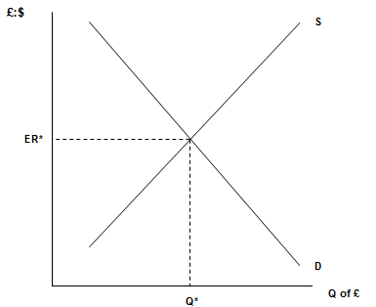
There’s been an increase in UK productivity
Decide what the impact of the following events will have on the UK’s exchange rate. Write a short comment in the space provided and draw the effect onto the diagram.
Example:-
This makes the Uk more attractive for FDI. The demand for sterling would rise and the value of the currency would appreciate.
D1

Decrease in interest rates in the US
Speculators believe that the value of sterling is over- valued against its major trading partners
There’s been an increase in the volume of imports into the UK

There’s been a decrease in UK economic growth
The bank of England adopts expansionary monetary policy
Extension activities
Part 1
In June 2016 the UK electorate vote in a referendum to leave the EU

Explain how the event above affected the value of sterling (£)
……………………………………………………………………………………………………………………………………………………………
……………………………………………………………………………………………………………………………………………………………
……………………………………………………………………………………………………………………………………………………………
……………………………………………………………………………………………………………………………………………………………
……………………………………………………………………………………………………………………………………………………………
……………………………………………………………………………………………………………………………………………………………
……………………………………………………………………………………………………………………………………………………………
……………………………………………………………………………………………………………………………………………………………
…………………………………………………………………………………………………………………………………………………………….

Part 2
Complete appendix 2 (if not already completed)
What are the different types of exchange rate?
(1) Free-floating exchange rate
(2) Managed floating system
(3) Adjustable peg
(3) Fully-fixed exchange rate system

Floating exchange rates

- The value of the currency is determined purely by market demand and supply of the currency
- No target for the exchange rate is set by the Government
- There is no need for official intervention in the currency market by the central bank
- Sterling has floated freely on the foreign exchange markets since the UK suspended membership of the ERM in September 1992

Managed float
- Currency is usually determined by market forces
- Some currency market intervention might be considered as part of demand management
- A managed-floating currency when the central bank may choose to intervene in the foreign exchange markets to affect the value of a currency to meet specific macroeconomic objectives

Semi fixed/ Adjustable peg
- The exchange rate is given a specific target
- The currency can move between permitted bands of fluctuation on a day-to-day basis
- Exchange rate becomes a target of monetary policy-making (e.g. interest rates are set to meet the exchange rate target such as when the UK was in the ERM).
- The central bank must intervene to maintain the value of the currency within the set targets if it moves outside the agreed range
- Re-valuations of the currency are seen as a last resort or when intervention is proving ineffective

Draw and explain the semi-fixed (adjustable peg) diagram below.
Draw and explain the semi-fixed (adjustable peg) diagram below.
Draw and explain the semi-fixed (adjustable peg) diagram below.

Fixed exchange rate
A fixed exchange rate, sometimes called a pegged exchange rate, is a type of exchange rate regime where a currency's value is fixed against either the value of another single currency, to a basket of other currencies, or to another measure of value, such as gold.

What methods can a government use to try and maintain the value of its currency at a pre agreed level? List your answers in the space below
Hint: How can a government or central bank increase/decrease the demand for sterling or increase/decrease the supply of sterling.

Methods that a government/ central bank can use to control Demand for a currency | Methods that a government/central bank can use to control Supply for a currency

Activity: Determine whether there statements below if they are a benefit or drawback of fixed or floating exchange rates.
Benefits and Drawbacks of Fixed and floating exchange rates

Statements
- They provide stability for firms and households – this encourages investment and trade.

- Speculation can lead to major, unpredictable changes in the rate.

- The Government can focus monetary policy on managing the domestic economy.

- They act as a constraint on domestic inflation – if a country has higher inflation than its trading partners, it will become uncompetitive (the currency will not depreciate to offset the inflation). Firms have to control costs to compete.

- There is less pressure on governments to control inflation in their economies and make sure it is in line with other countries to keep them competitive (as the pound can float downwards to adjust for any inflation.)

- There is no need for the central bank to keep foreign reserves.

- In theory they prevent speculation, as there is no point as the value of the exchange rate is fixed.

- It causes instability, which deters investment and trade.

- This system of exchange rates can help eliminate a balance of payments surplus or deficit E.g. / A deficit: If imports are rising, for example, the supply of pounds will be increasing; this will lead to a fall in the exchange rate. As the pound falls, exports become more competitive and imports become less appealing, which should eliminate the deficit.

- It can lead to higher rates of cost push inflation: if a country has inflation, its goods are uncompetitive; this will lead to a fall in demand for the currency and a fall in the exchange rate. This makes goods more competitive but also makes imports more expensive, which in the long run leads to more cost push inflation.

- A government must have the sufficient reserves to intervene to maintain the price of its currency.

- A country’s firms may be uncompetitive if the exchange rate is fixed at too higher rate.

- The Government must make intervention a priority – this may be at the expense of the domestic economy, e.g./ to keep the demand for pounds up they might increase the interest rate – this however could have a negative impact on the economy as it would dampen demand.
Advantage of Fixed exchange rate | Disadvantage of Fixed exchange rates
Advantage of Floating ER | Disadvantage of Floating ER

Your notes

Benefits of a floating exchange rate
Explain why a floating exchange rate allows governments to set interest rates to meet domestic objectives.
……………………………………………………………………………………………………………………………………………………………
……………………………………………………………………………………………………………………………………………………………
……………………………………………………………………………………………………………………………………………………………
……………………………………………………………………………………………………………………………………………………………
……………………………………………………………………………………………………………………………………………………………
……………………………………………………………………………………………………………………………………………………………
……………………………………………………………………………………………………………………………………………………………
……………………………………………………………………………………………………………………………………………………………
……………………………………………………………………………………………………………………………………………………………
……………………………………………………………………………………………………………………………………………………………
……………………………………………………………………………………………………………………………………………………………

Explain why a floating exchange rate offers a partial automatic correction for a current account deficit.
……………………………………………………………………………………………………………………………………………………………
……………………………………………………………………………………………………………………………………………………………
……………………………………………………………………………………………………………………………………………………………
……………………………………………………………………………………………………………………………………………………………
……………………………………………………………………………………………………………………………………………………………
……………………………………………………………………………………………………………………………………………………………
……………………………………………………………………………………………………………………………………………………………
……………………………………………………………………………………………………………………………………………………………
……………………………………………………………………………………………………………………………………………………………
……………………………………………………………………………………………………………………………………………………………
Benefits of a fixed exchange rates
Explain why a fixed exchange rate gives confidence for inward investment
……………………………………………………………………………………………………………………………………………………………
……………………………………………………………………………………………………………………………………………………………
……………………………………………………………………………………………………………………………………………………………
……………………………………………………………………………………………………………………………………………………………
……………………………………………………………………………………………………………………………………………………………
……………………………………………………………………………………………………………………………………………………………
……………………………………………………………………………………………………………………………………………………………
……………………………………………………………………………………………………………………………………………………………
……………………………………………………………………………………………………………………………………………………………
……………………………………………………………………………………………………………………………………………………………
……………………………………………………………………………………………………………………………………………………………

Explain why a fixed exchange rate helps to control domestic inflation
……………………………………………………………………………………………………………………………………………………………
……………………………………………………………………………………………………………………………………………………………
……………………………………………………………………………………………………………………………………………………………
……………………………………………………………………………………………………………………………………………………………
……………………………………………………………………………………………………………………………………………………………
……………………………………………………………………………………………………………………………………………………………
……………………………………………………………………………………………………………………………………………………………
……………………………………………………………………………………………………………………………………………………………
……………………………………………………………………………………………………………………………………………………………
……………………………………………………………………………………………………………………………………………………………
……………………………………………………………………………………………………………………………………………………………
Explain why fixed exchange rates help reduce firms cost (Hint: what is ‘Currency Hedging’?)
……………………………………………………………………………………………………………………………………………………………
……………………………………………………………………………………………………………………………………………………………
……………………………………………………………………………………………………………………………………………………………
……………………………………………………………………………………………………………………………………………………………
……………………………………………………………………………………………………………………………………………………………
……………………………………………………………………………………………………………………………………………………………
……………………………………………………………………………………………………………………………………………………………
……………………………………………………………………………………………………………………………………………………………
……………………………………………………………………………………………………………………………………………………………
……………………………………………………………………………………………………………………………………………………………
……………………………………………………………………………………………………………………………………………………………

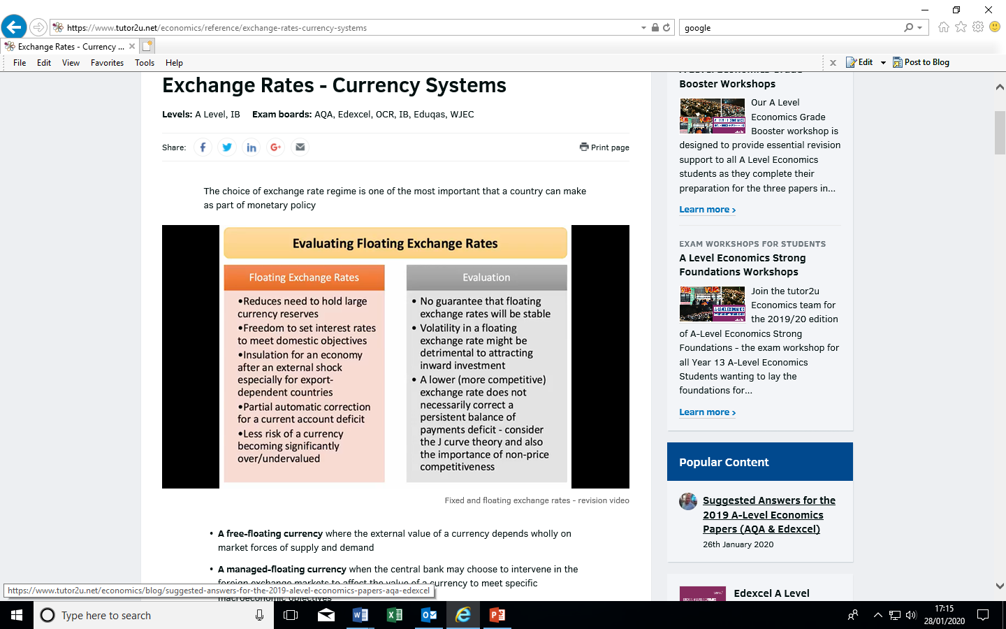
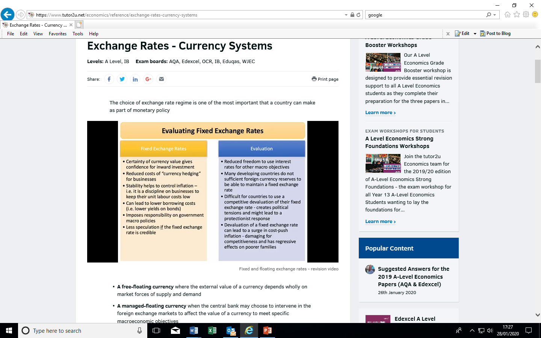

The Exchange Rate Mechanism (ERM)
Appendix 1
You are about to watch a short clip that shows the events of Black Wednesday, as they unfolded. Listed below are a series of questions that you should answer whilst watching the clip. https://www.youtube.com/watch?v=XqTwJIckGiE

Background
Before the creation of the Euro each country in the European Union had its own national currency. This created uncertainty when countries wanted to trade with each other. The ERM was formed to try and reduce these uncertainties and encourage more trade.
Another reason for wanting to join the ERM was that countries would no longer be able to devalue in order to stay competitive. This meant that all firms in the ERM had to be careful to control cost so that their prices didn’t rise making them uncompetitive.
At the time of the ERM crisis the UK Prime Minister was John Major and the Chancellor of the Exchequer was Norman Lamont.
At the time of Black Wednesday the national currencies of the major European countries were as: France – Franc, Germany – Deutschemark, Italy – Lira.
The European Exchange Rate Mechanism (ERM) was set up in March of 1979 to reduce exchange rate variability and stabilize monetary policy across Europe before introducing a common currency that would eventually be known as the euro. Simply put, the ERM set an upper and lower margin in which exchange rates could vary, known as a semi-peg.
Britain initially declined to join the ERM when it originated, but later adopted a semi-official policy that shadowed the Deutsche Mark. In October of 1990, the country decided to join the ERM after a shake-up in leadership, preventing its currency from fluctuating more than 6 percent in either direction by intervening in the currency markets with countertrades.

Black Wednesday's Underlying Causes
When Britain joined the ERM, the rate was set to 2.95 Deutsche Marks per Pound Sterling with a 6 percent permissible move in either direction. The problem was that the country's inflation rate was three times that of Germany's, interest rates were at 15 percent, and the country's economic boom was far into a period of unsustainable growth, which set the stage for a bust period.
Currency traders took note of these underlying problems and began short selling the Pound Sterling.

Questions
- At what exchange rate was sterling fixed against the Deutsche mark

………………………………………………………………………………………………………………………………………………………………………………………………………………………………………………………………………………………………………

Draw the appropriate exchange rate diagram for the operation of an adjusted peg (semi fixed exchange rate mechanism). Use whatever data you have to determine the upper and lower limits. Be careful to label your diagram properly.

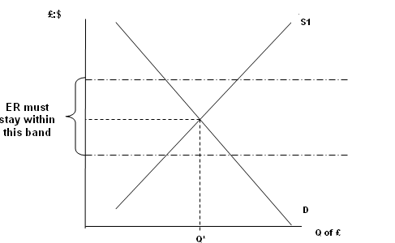

- Why was it important that the UK Government matched German interest rates? (Note: In 1992 The Bank of England was not operationally independent from Government)

…………………………………………………………………………………………………

…………………………………………………………………………………………………

…………………………………………………………………………………………………

…………………………………………………………………………………………………

…………………………………………………………………………………………………

………………………………………………………………………………………………….

- Why was there pressure on the pound to fall, your answer should consider the demand side factors and the supply side factors for sterling on foreign exchange markets (your explanation needs to outline the role of speculators)

Factor affecting the demand for pounds
…………………………………………………………………………………………………

………………………………………………………………………..…………………………

………………………………………………………………………………………………….

Factor affecting the supply of pounds
…………………………………………………………………………………………………

……………………………………………………………………………………………………………………………………………………………………………………………………..

- What measure did the Italian government do to try and maintain the value of the Lira ?

…………………………………………………………………………………………………………………………………………………………………………………………………………………………………………………………………………………………………………………………………………………………………………………………………………………………………………………………………………………………………………
- Why couldn’t the British Government raise interest rates to match the German interest rate?
…………………………………………………………………………………………………

…………………………………………………………………………………………………

…………………………………………………………………………………………………

…………………………………………………………………………………………………

…………………………………………………………………………………………………

…………………………………………………………………………………………………..

- What methods (interventions in the foreign exchange markets) did the UK Government use to try and maintain the value of sterling? (How much was spent trying to keep the pound within the ERM framework?)
…………………………………………………………………………………………………

…………………………………………………………………………………………………

…………………………………………………………………………………………………

…………………………………………………………………………………………………

…………………………………………………………………………………………………

…………………………………………………………………………………………………

Appendix 1: (Continued)

The Exchange Rate Mechanism (ERM)

The EMS again pegged currencies to the dominant currency: in this case the German Deutschmark. Exchange rates had to remain within a band of roughly plus or minus 2.25 percent

1. The Germany economy boomed after reunification and the German Government decided to put up interest rates to try and stop the economy overheating. Illustrate the impact on the UK’s exchange rate of interest rate rises in Germany

£ : DM

2. Why would other economies, such as the UK, have to follow Germany’s lead? Select one answer and then explain it in the space below.

A. In order to stop unemployment rising in the UK

B. In order to maintain the pegged exchange rate with Germany

C. In order to reduce inflation due to an overheating economy

D. In order to reduce the UK’s exchange rate

……………………………………………………………………………………………………………

……………………………………………………………………………………………………………

……………………………………………………………………………………………………………

……………………………………………………………………………………………………………

3. The consequence of these interest rate rises were detrimental to the UK’s economy. Why would leaving the ERM be beneficial? Select one answer

A. The UK Government could use interest rates to help stave off recession

B. The Euro would not benefit the UK even if it continued in the ERM

C. The UK Government wanted to increase interest rates to maintain price stability

D. The UK could then use fiscal policy to manage AD more effectively

……………………………………………………………………………………………………………

……………………………………………………………………………………………………………

……………………………………………………………………………………………………………

……………………………………………………………………………………………………………

4. Why did the ERM collapse? Select one answer

A. There were fewer countries who wanted to go into the Euro so the commitment to the ERM was lost

B. Speculators bought up non-German currencies (such as the pound) as they wanted to continue to make profits as interest rates were rising

C. All countries wanted to join the Euro and so getting out of the ERM was the only way this was possible.

D. Speculative selling of the non-German currencies as speculators believed Governments would not let their economies go into deeper recession in order to stay in the ERM

……………………………………………………………………………………………………………

……………………………………………………………………………………………………………

……………………………………………………………………………………………………………

……………………………………………………………………………………………………………

Appendix 2: Extension activity
Decide what effect the following events will have on the exchange rate of sterling. Write a brief explanation to support your analysis.
Increase corporation tax in the UK
The UK announces plans to significantly reduce unemployment benefits
Speculators believe the Euro is overvalued

Key Determinants of Exchange Rates
UK government debt reaches a new high.
A massive increase in trade union membership leads to a rise in trade union militancy
President Trump announces a tax plan that proposes a massive decrease in income and corporation taxes.

Appendix 3

The Big Mac Index
THE Economist's Big Mac index is a fun guide to whether currencies are at their “correct” level. It is based on the theory of purchasing-power parity (PPP), the notion that in the long run exchange rates should move towards the rate that would equalise the prices of a basket of goods and services around the world. At market exchange rates, a burger is 44% cheaper in China than in America. In other words, the raw Big Mac index suggests that the yuan is 44% undervalued against the dollar.

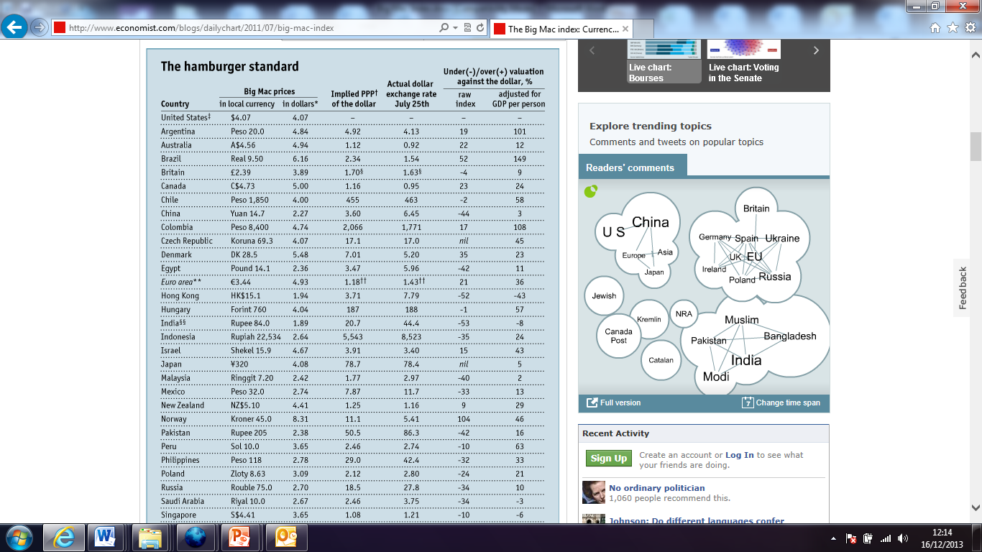

In terms of PPP china should have an exchange rate of $1= $3.60 but this isn’t the case. Why?
Here are some quick questions to check that you understand the BIG MAC INDEX.
  - How much is a big mac in the $US? _______
  - How much is a big mac in China (in terms of Yuan Renminbi) ______
  - What is the actual exchange rate of the Yuan Renimbi against the US dollar ______
  - What is the value of the value of the Yuan Renminbi against the US dollar using the price of Big Macs as the basket of goods in both markets? In effect what is the implied Exchange rate at Purchasing Power Parity (PPP)_________
  - According to the theory of PPP, Is the Yuan Renminbi overvalued or undervalued against the actual exchange rate?
…………………………………………………………………………………………………………………………………
…………………………………………………………………………………………………………………………………
………………………………………………………………………………………………………………………………….

